**Mooc 3.1.3a- How does AI Works**

Objectives : Presentation of AI4T template for AI characterization

Contributors : Inria, Jiajun PAN, Azim ROUSSANALY, Anne BOYER - Based on [Report on template for analysing AI-related features in learning resources](https://drive.google.com/file/d/1to-tUFkhSOaSGQr4JGCETscxbvbLxyzI/view?usp=sharing)

Although Artificial Intelligence Educational Resources -AIERs- are becoming increasingly common, there is currently no tool to comprehensively map the characteristics of AIERs and help users make informed use of these resources.

The LORIA[1] Research Laboratory has designed a template for AI characterisation[2] in order to help users, and here specifically teachers, to better understand the resources they or their students use.

Organised in different layers that cover all the features of the AIER, from usage scenarios to the transparency mechanism to explain the decision proposed by the AI, this template is a tool to help better understand what makes up an AIER.

*Click on the image below and have a look at the ready-to-use format of The Template for Analysing AI Educational resources.*

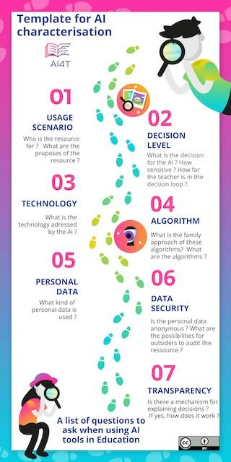

The Template in a ready-to-use format[3] can also been uploaded and filled in for your own AI Educational tools and resources.

1. Loria (Lorraine Research Laboratory in Computer Science and its Applications) is part of a research unit (UMR 7503), common to [CNRS](http://www.cnrs.fr/index.php), the [University of Lorraine](http://vers.univ-lorraine.fr/) and [INRIA](http://www.inria.fr/en/). It is a member of the AI4T consortium and brings its expertise in AI in education (and on learning analysis) to AI4T Erasmus+ project.
2. [Report on template for analyzing AI-related features in learning resources](https://github.com/inrialearninglab/ai4t/blob/mooc-v2/docs/O1-Mooc/module-3-how-does-AI-work/3-1-ai-in-all-its-forms/REPORT_ON_THE_TEMPLATE_1.0.pdf) - Jiajun PAN, Azim ROUSSANALY, Anne BOYER - AI4T Erasmus+ project, 2022.
3. [Ready to Use template for AI resources Characterisation](https://github.com/inrialearninglab/ai4t/blob/mooc-v2/docs/O1-Mooc/module-3-how-does-AI-work/3-1-ai-in-all-its-forms/AI4T-Template_Ready_to_use.pdf) - Inria Learning Lab, Jiajun PAN, Azim ROUSSANALY, Anne BOYER - AI4T Erasmus+ Project - 2022