**Mooc 4.1.4 -Teacher-in-the-Loop**

Objectives : Understand the teacher in the Loop model and use it as a tool to promote “users in control” for AI systems in Education

Contributors : Inria

In the field of education and training “*All stakeholders should consider the implications of yielding powers to emerging technologies to take pedagogical decisions, which otherwise would be taken by a teaching professional with adequate pedagogical and subject-specific content knowledge*”[1].

For AI systems in education to be trustworthy, adequate monitoring is required **using the Teacher-in-the-Loop model.**

In its report, *“*Emerging technologies and the teaching profession, Ethical and pedagogical considerations based on near-future scenarios”[2], the Joint Research Centre proposes: “*For educational applications and services that rely on autonomous decision-making three different approaches can be envisaged to deal with the distribution of responsibility between humans and an algorithm/machine*”[3]: Teacher-in-the-Loop, Teacher-out-of-the-Loop, Teacher-over-the-Loop.

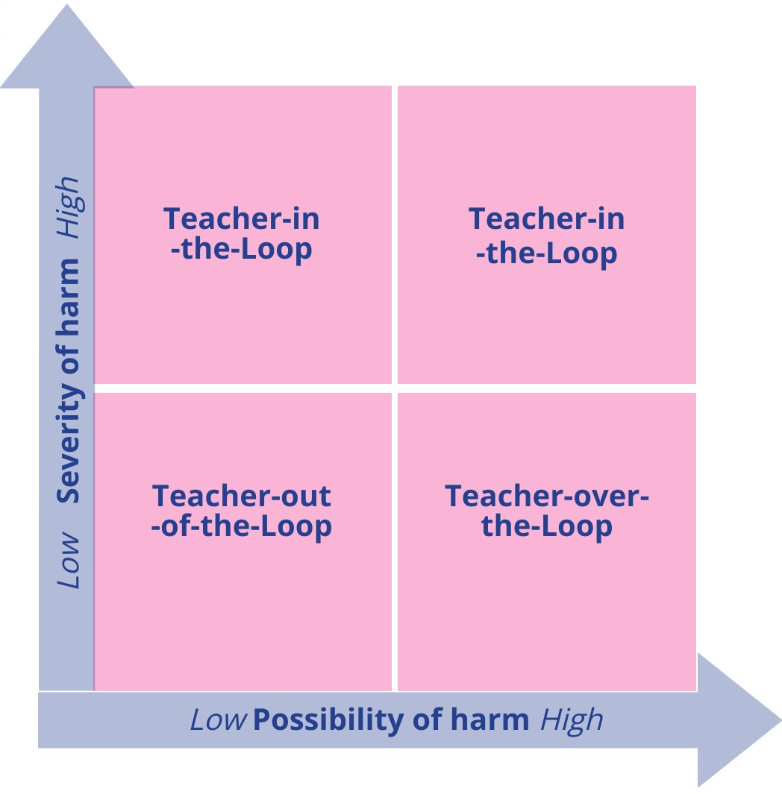

Figure 1: DIFFERENT DEGREES OF HUMAN OVERSIGHT WHEN DEALING WITH AUTONOMOUS DECISION-MAKING IN EDUCATION AND TRAINING. (Adapted from “Emerging technologies and the teaching profession” report).

* ***Teacher-in-the-loop***: Consider an application that autonomously evaluates high-stakes exams, or conducts a diagnosis of a learning disability. In such situations, an incorrect decision could cause severe harm to the end user (e.g. a loss of opportunity, unfair practices). Decisions or applications which could cause harm or have serious implications for the end user should first recommend a decision to an educator with enough transparent information available so that the educator can review it - and only then decide whether to execute the final decision or not (Figure 1, top-right).
* ***Teacher-over-the-loop***: Other types of decisions exist where it is enough that an educator maintains an overview of the decision taken by an application. This could be the case, for example, when an adaptive learning platform recommends a learning activity to a learner to achieve an intended learning outcome (Figure 1, bottom-right).
* ***Teacher-out-of-the-loop***: In a situation where there is a low probability and low severity of harm caused by, for example, an educational app that is used out of school, the educator’s oversight is not required (Figure 1, bottom-left).

interactive presentation teacher in the loop

Embedding

<div style="width: 100%;"><div style="position: relative; padding-bottom: 56.25%; padding-top: 0; height: 0;"><iframe frameborder="0" width="1200" height="675" style="position: absolute; top: 0; left: 0; width: 100%; height: 100%;" src="https://view.genial.ly/6336f61021d012001891e5f2" type="text/html" allowscriptaccess="always" allowfullscreen="true" scrolling="yes" allownetworking="all"></iframe> </div> </div>

Access link: <https://view.genial.ly/6336f61021d012001891e5f2/horizontal-infographic-diagrams-teacher-in-the-loop-model>

1. Emerging technologies and the teaching profession: Ethical and pedagogical considerations based on near-future scenarios- Vuorikari Riina, Punie Yves,Marcelino Cabrera - Joint Research Center report - 2020
2. idem
3. Idem, page 5.