## FRONTEND-1 - Implement HTML/CSS layout for the Sports Betting web-application

**Conversation**

The design of the application’s layout is the following:

Login screen  
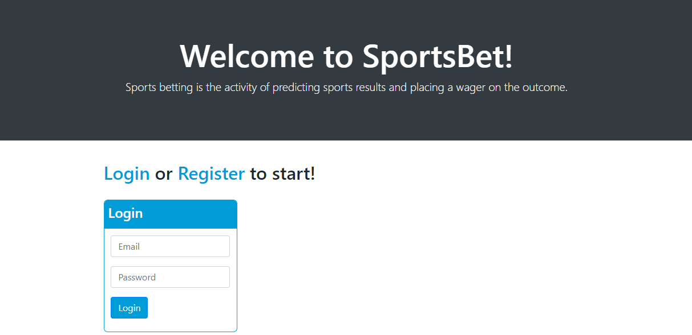

**Home screen:**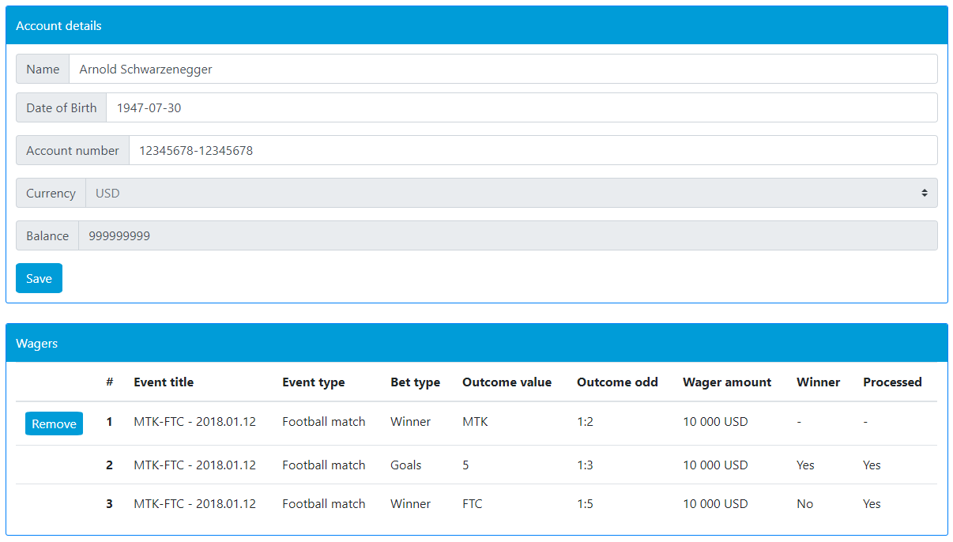

Implement these layouts with Bootstrap framework version 4.1 (<https://getbootstrap.com/docs/4.1/getting-started/download/>).

Use external style sheet instead of internal or inline styles

**Confirmation**

Expected result: static HTML and CSS files with the given content and layout.

Google Chrome v59 or higher should be supported.