Group 934

Team H.U.H.

Project documentation

# Architecture Overview

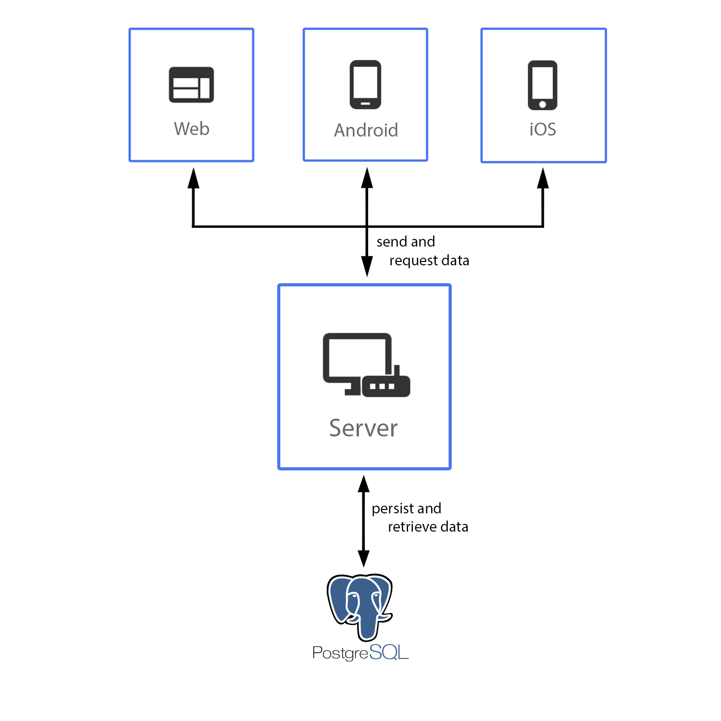

# Use Case Diagram:

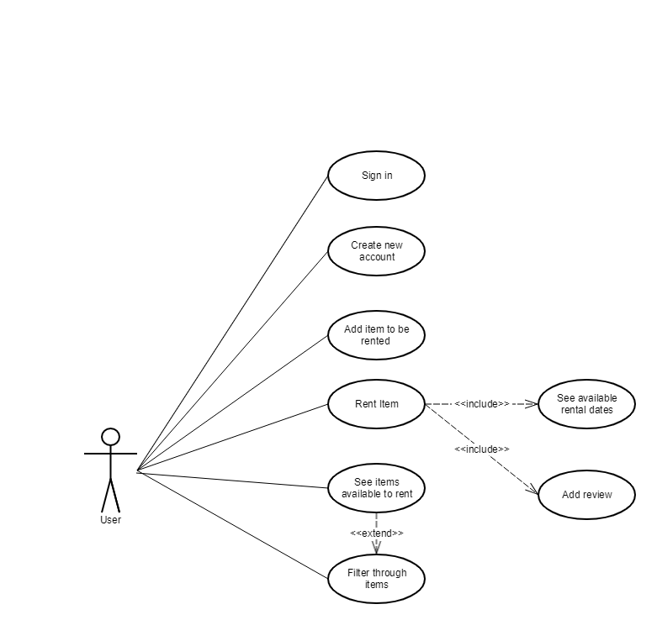

# Sequence Diagram for the Rent Operation

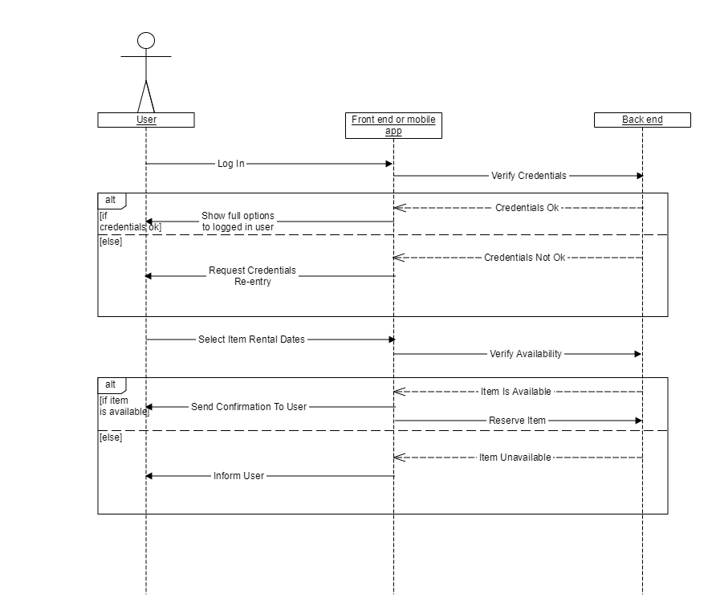

# Database Diagram

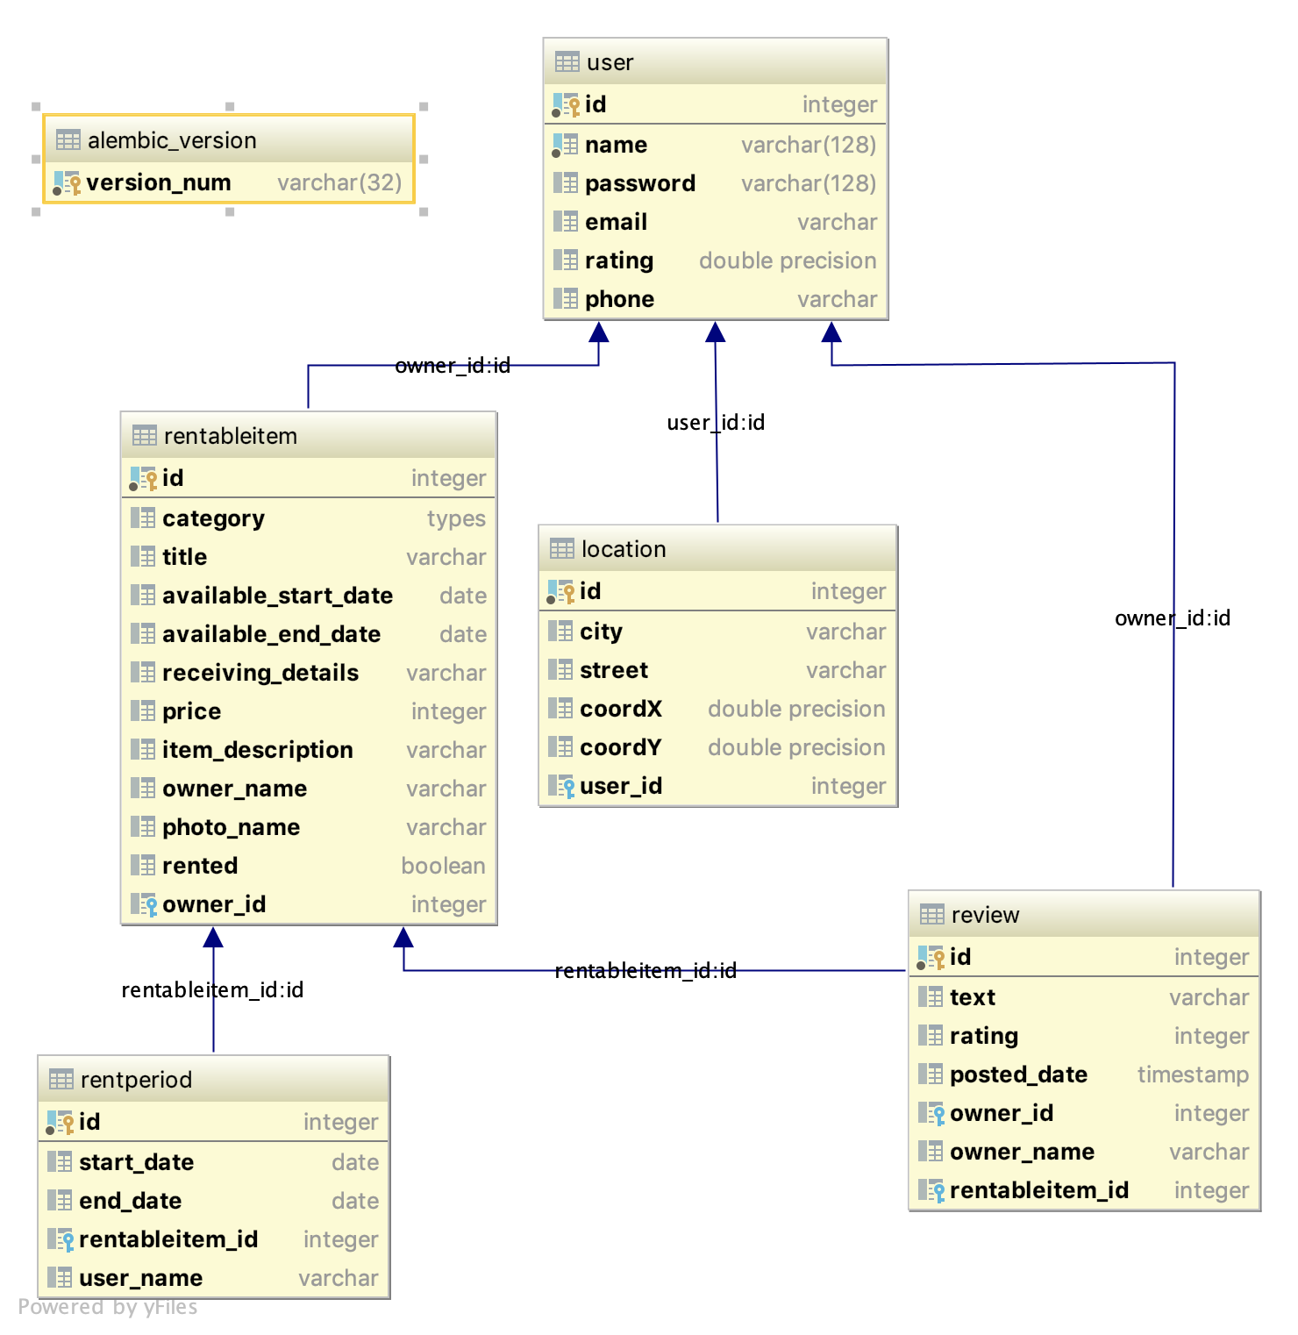

# Server Documentation

**Flask:**

* Is a microframework for Python based on Werkzeug, Jinja 2 and good intentions. And before you ask: It's [BSD licensed](http://flask.pocoo.org/docs/license/)!

**Flask-SQLAlchemy:**

* Is an extension for [Flask](http://flask.pocoo.org/) that adds support for [SQLAlchemy](http://www.sqlalchemy.org/) to your application. It requires SQLAlchemy 0.8 or higher. It aims to simplify using SQLAlchemy with Flask by providing useful defaults and extra helpers that make it easier to accomplish common tasks.
* The SQLAlchemy Object Relational Mapper presents a method of associating user-defined Python classes with database tables, and instances of those classes (objects) with rows in their corresponding tables.

**PostgreSQL:**

* Is a powerful, open source object-relational database system that uses and extends the SQL language combined with many features that safely store and scale the most complicated data workloads.

**Marshmallow:**

* is an ORM/ODM/framework-agnostic library for converting complex datatypes, such as objects, to and from native Python datatypes.

**Flask-Bcrypt:**

* Is a Flask extension that provides bcrypt hashing utilities for your application.
* Due to the recent increased prevelance of powerful hardware, such as modern GPUs, hashes have become increasingly easy to crack. A proactive solution to this is to use a hash that was designed to be “de-optimized”. Bcrypt is such a hashing facility; unlike hashing algorithms such as MD5 and SHA1, which are optimized for speed, bcrypt is intentionally structured to be slow.

**Cross-Origin Resource Sharing (**[**CORS**](https://developer.mozilla.org/en-US/docs/Glossary/CORS)**):**

* Is a mechanism that uses additional [HTTP](https://developer.mozilla.org/en-US/docs/Glossary/HTTP) headers to tell a browser to let a web application running at one origin (domain) have permission to access selected resources from a server at a different origin. A web application makes a **cross-origin HTTP request** when it requests a resource that has a different origin (domain, protocol, and port) than its own origin.

# Android Application Documentation

**OkHttp:**

* It iss an efficient HTTP & HTTP/2 client for Android and Java applications.
* It comes with advanced features such as connection pooling (if HTTP/2 isn’t available), transparent GZIP compression, and response caching to avoid the network completely for repeated requests.
* It’s also able to recover from common connection problems and, on a connection failure, if a service has multiple IP addresses, it can retry the request to alternate addresses.
* At a high level, the client is designed for both blocking synchronous and nonblocking asynchronous calls.

[**Retrofit**](http://square.github.io/retrofit/)**:**

* Is a type-safe HTTP client for Android and Java – developed by Square ([Dagger](http://square.github.io/dagger/), [Okhttp](http://square.github.io/okhttp/)).
* Retrofit models REST endpoints as Java interfaces, making them very simple to understand and consume.

**Glide:**

* Is a fast and efficient image loading library for Android focused on smooth scrolling. Glide offers an easy to use API, a performant and extensible resource decoding pipeline and automatic resource pooling.
* Glide supports fetching, decoding, and displaying video stills, images, and animated GIFs. Glide includes a flexible api that allows developers to plug in to almost any network stack. By default Glide uses a custom HttpUrlConnection based stack, but also includes utility libraries plug in to Google’s Volley project or Square’s OkHttp library instead.

**Dagger 2:**

* Is dependency injection framework. It is based on the Java Specification Request (JSR) 330. It uses code generation and is based on annotations. The generated code is very relatively easy to read and debug.

## **Material Design:**

## Create a visual language that synthesizes the classic principles of good design with the innovation and possibility of technology and science.

## Develop a single underlying system that unifies the user experience across platforms, devices, and input methods.

## Expand Material’s visual language and provide a flexible foundation for innovation and brand expression.

# IOs Application Documentation

**URLSession:**

* The [URLSession](https://developer.apple.com/documentation/foundation/urlsession) class and related classes provide an API for downloading data from and uploading data to endpoints indicated by URLs. The API also enables your app to perform background downloads when your app isn’t running or, in iOS, while your app is suspended. A rich set of delegate methods support authentication and allow your app to be notified of events like redirection.

**Snap Kit:**

* lets developers like you integrate some of Snapchat’s best features across your platform
* [Creative Kit](https://docs.snapchat.com/docs/creative-kit) integrates stickers, filters, links, and more from your app into our camera.
* [Login Kit](https://docs.snapchat.com/docs/login-kit) makes it easier for Snapchatters to log in to your app faster.
* [Bitmoji Kit](https://docs.snapchat.com/docs/bitmoji-kit) brings Bitmojis into your app for more expressive communication.
* [Story Kit](https://docs.snapchat.com/docs/story-kit) enables you to filter and embed publicly shared Snapchat Stories into your app or website.

# Web Application Documentation

**Redux:**

* Predictable. Redux helps you write applications that behave consistently, run in different environments (client, server, and native), and are easy to test.
* Centralized. Centralizing your application's state and logic enables powerful capabilities like undo/redo, state persistence, and much more.
* Debuggable. The Redux DevTools make it easy to trace when, where, why, and how your application's state changed. Redux's architecture lets you log changes, use "time-travel debugging", and even send complete error reports to a server.
* Flexible. Redux works with any UI layer, and has a large ecosystem of addons to fit your needs.

# **Node.js:**

* As an asynchronous event driven JavaScript runtime, Node is designed to build scalable network applications. In the following "hello world" example, many connections can be handled concurrently. Upon each connection the callback is fired, but if there is no work to be done, Node will sleep.

**Npm:**

* Is the package manager for JavaScript and the world’s largest software registry. Discover packages of reusable code — and assemble them in powerful new ways.
* At its core, **webpack** is a static module bundler for modern JavaScript applications. When webpack processes your application, it internally builds a dependency graph which maps every module your project needs and generates one or more bundles.