Tema 3

**Imagini de TEST:**

 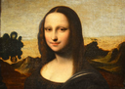

**Metoda A:**

Daca aplicam algoritmul folosind indivizi cu o singura figura atunci toti indivizii vor tinde la o figura care are fitness-ul cat mai bun, astfel ca in final vom avea toti indivizii foarte asemanatori, suprapunandu-se si neaducand un plus de informatie imaginii:

Folosind dreptunghiuri pentru floare:

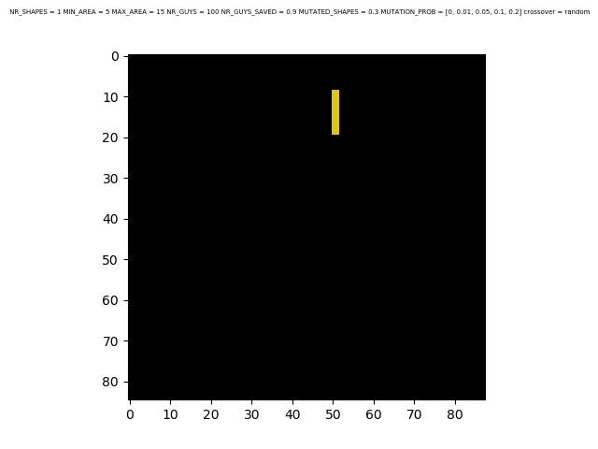

Folosind elipse pentru floare:

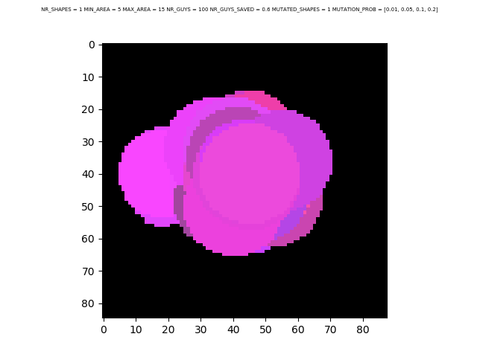

Folosind elipse pentru Mona Lisa:

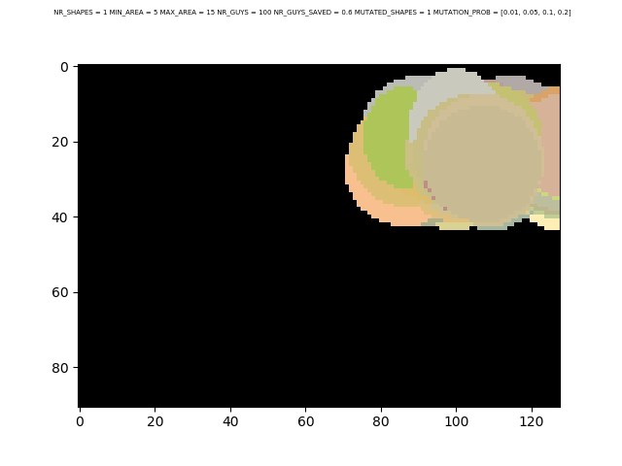

**Metoda B:**

Metoda B are rezultate mult mai bune deoarece functia de fitness tine cont de toate figurile care formeaza imaginea.

**Folosind dreptunghiuri pentru floare:**

Cel mai bun rezultat a fost obtinut folosind parametrii:

NR_SHAPES = 50 | MIN_AREA = 5 |MAX_AREA = 15 | NR_GUYS = 100 |NR_GUYS_SAVED = 0.3

MUTATED_SHAPES = 0.1 | MUTATION_PROB = [0.01, 0.05, 0.1, 0.2] | crossover = random

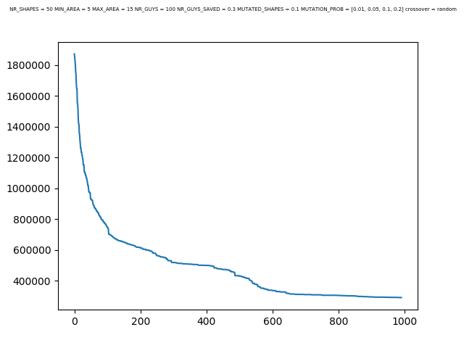

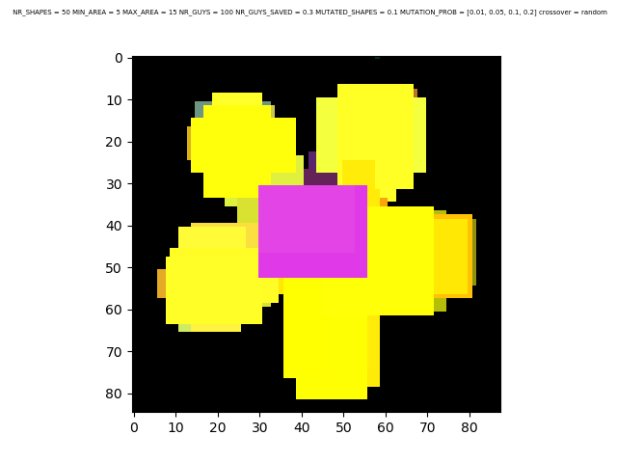

NR_SHAPES = 50 | MIN_AREA = 5 | MAX_AREA = 15 | NR_GUYS = 100 | NR_GUYS_SAVED = 0.1

MUTATED_SHAPES = 0.1 | MUTATION_PROB = [0.01, 0.05, 0.1, 0.2] | crossover = random

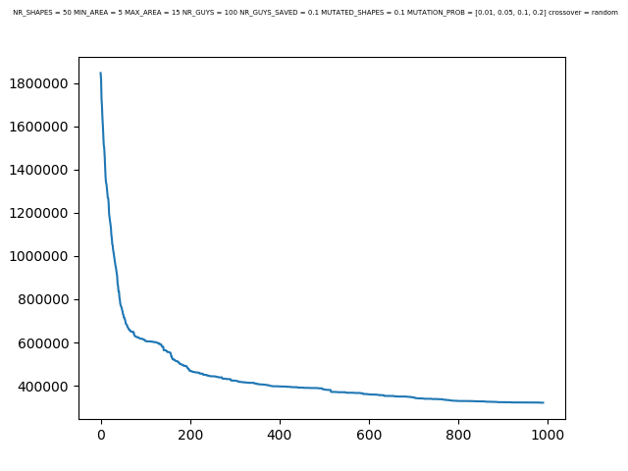

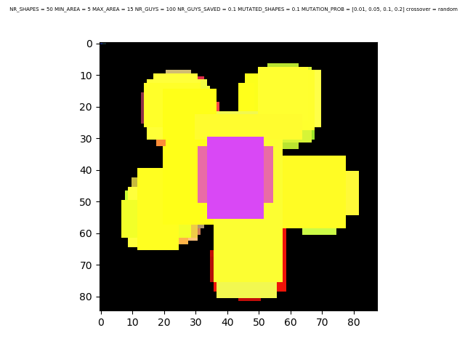

NR_SHAPES = 50 | MIN_AREA = 5 | MAX_AREA = 15 | NR_GUYS = 100 | NR_GUYS_SAVED = 0.7

MUTATED_SHAPES = 0.1 | MUTATION_PROB = [0.01, 0.05, 0.1, 0.2] | crossover = random

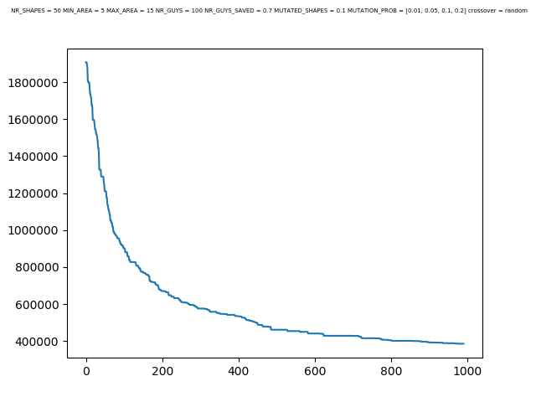

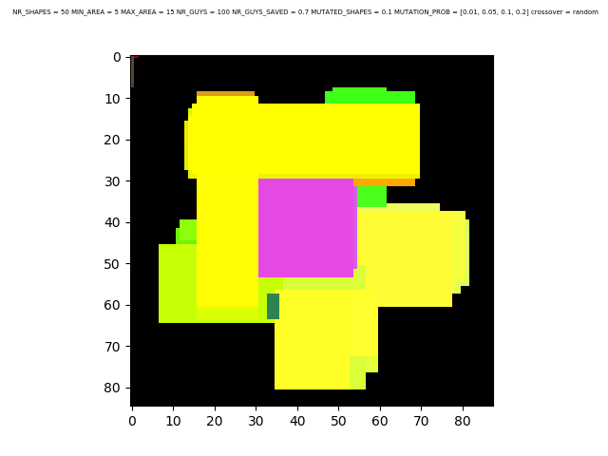

NR_SHAPES = 50 | MIN_AREA = 5 | MAX_AREA = 15 | NR_GUYS = 100 |NR_GUYS_SAVED = 0.3

MUTATED_SHAPES = 0.3 | MUTATION_PROB = [0.01, 0.05, 0.1, 0.2] | crossover = random

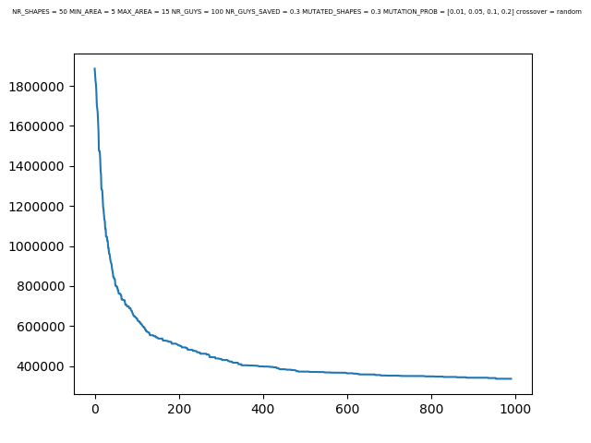

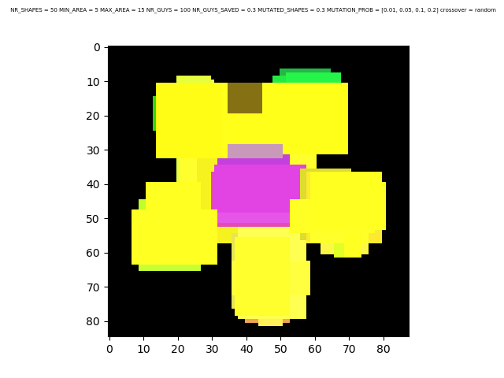

NR_SHAPES = 50 | MIN_AREA = 5 | MAX_AREA = 15 | NR_GUYS = 100 | NR_GUYS_SAVED = 0.7 MUTATED_SHAPES = 0.7 | MUTATION_PROB = [0.01, 0.05, 0.1, 0.2] | crossover = random

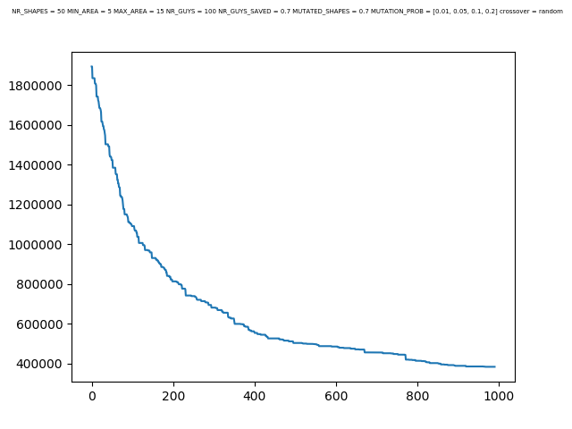

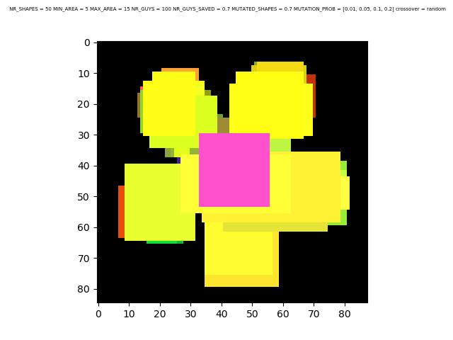

NR_SHAPES = 500| MIN_AREA = 5 | MAX_AREA = 15 | NR_GUYS = 100 |NR_GUYS_SAVED = 0.3 MUTATED_SHAPES = 0.3 | MUTATED_SHAPES = 0.3 |MUTATION_PROB = [0.01, 0.05, 0.1, 0.2]

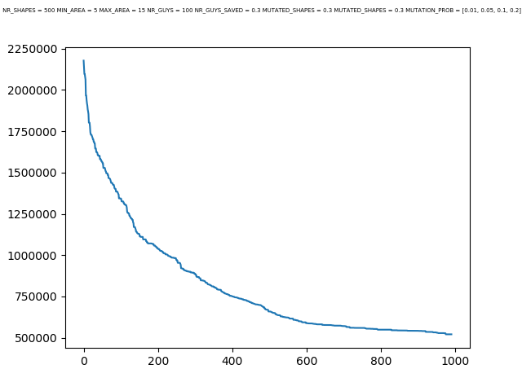

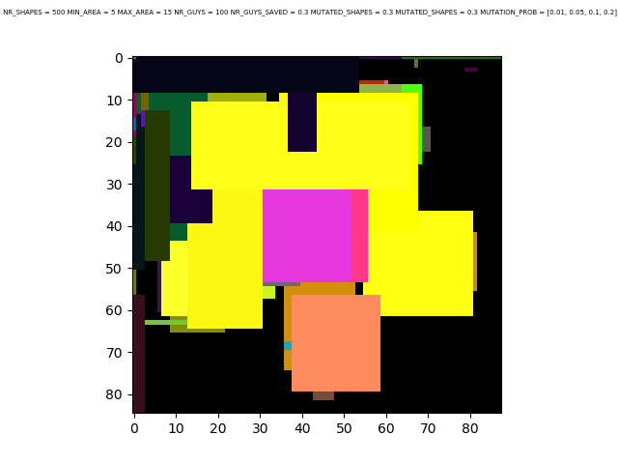

**Folosind dreptunghiuri pentru Mona Lisa:**

NR_SHAPES = 300 | MIN_AREA = 30 |MAX_AREA = 50 |NR_GUYS = 100 |NR_GUYS_SAVED = 0.3 MUTATED_SHAPES = 0.3 | MUTATION_PROB = [0, 0.01, 0.05, 0.1, 0.2] | crossover = random 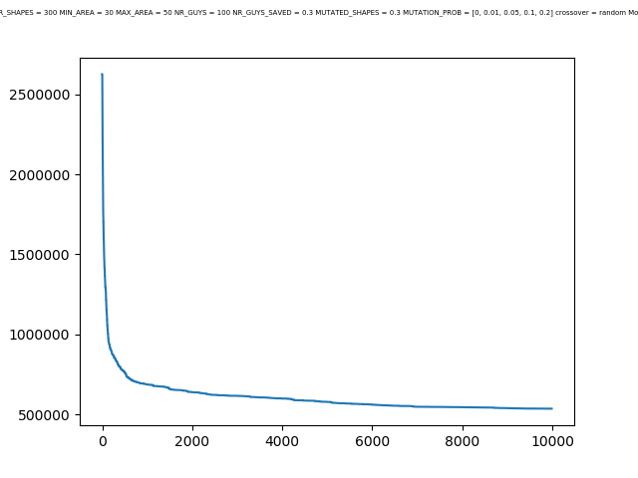

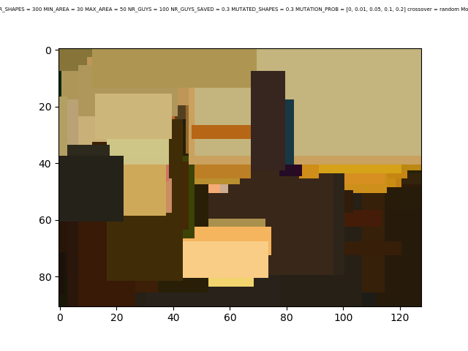

**Folosind dreptunghiuri pentru Mona Lisa:**

NR_SHAPES = 50 | MIN_AREA = 5 | MAX_AREA = 15 |NR_GUYS = 100 | NR_GUYS_SAVED = 0.31 MUTATED_SHAPES = 0.3 | MUTATION_PROB = [0, 0.01, 0.05, 0.1, 0.2] | crossover = random

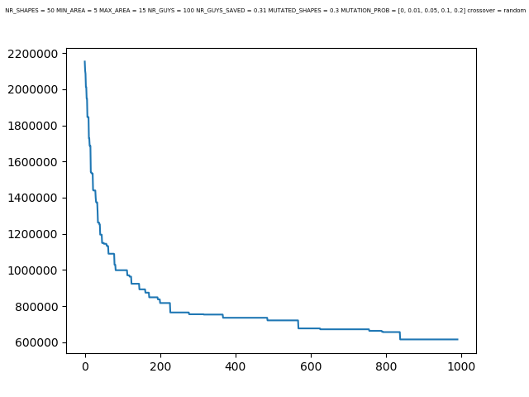

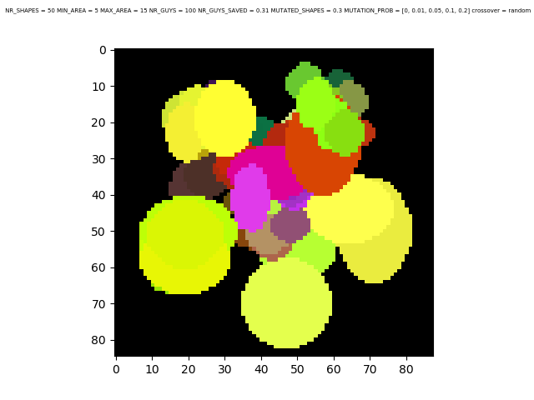

NR_SHAPES = 50 | MIN_AREA = 5 | MAX_AREA = 15 | NR_GUYS = 100 | NR_GUYS_SAVED = 0.3 MUTATED_SHAPES = 0.3 | MUTATION_PROB = [0.05, 0.1, 0.2]

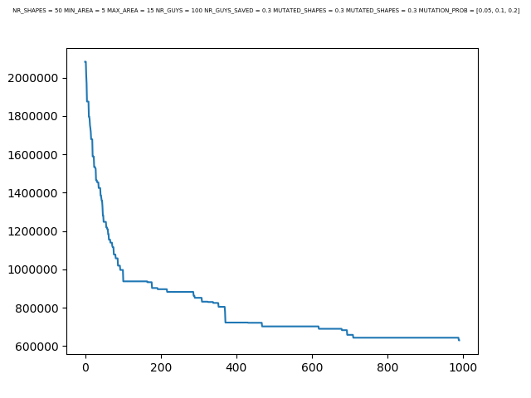

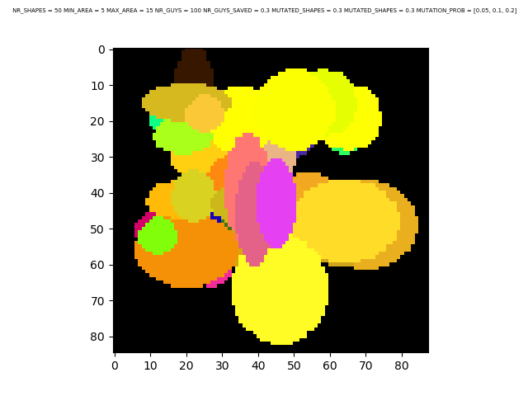

NR_SHAPES = 50 | MIN_AREA = 5 | MAX_AREA = 15 | NR_GUYS = 100 |NR_GUYS_SAVED = 0.05 MUTATED_SHAPES = 0.1 | MUTATION_PROB = [0.01, 0.05, 0.1, 0.2] | crossover = random