RESULTADO 5: SEGUNDA COMPETENCIA:
WOULD LIKE…
EXERCISES
1. Fill in the blanks with "to" or " ---"
https://www.englishpedia.net/my-grammar/basic/would-you-like/exercises/would-you-like-exercise.htm

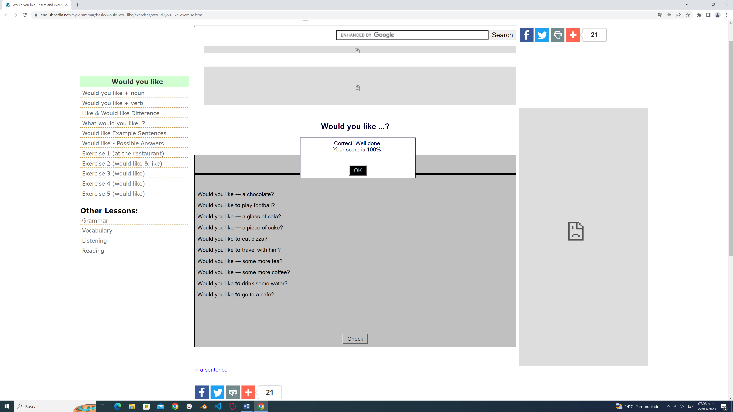

2. Ejercicio online usando would like to:
https://www.examenglish.com/grammar/A2_would_like.htm

3. Choose the correct answer:
https://www.englishpedia.net/my-grammar/basic/would-you-like/exercises/would-like-at-the-reataurant-exercise.htm

4. Choose the correct answer.
https://www.englishpedia.net/my-grammar/basic/would-you-like/exercises/would-like-test.html

Answer the wh-questions:
1.What place would you like to know? Why?
I would like to know Spain, Because I want to visit Spotify Camp Nou and Santiago Bernabéu

2. Who would you like to travel to that place with?
I would like to travel Spain with my mom and my sister

3. What famous person would you like to meet? Why?
I would like to meet with Sofía de Borbón

4. Which language would you like to learn? Why?
I would like to learn Portuguese, Because I think that the Portuguese is the love language

5. Where would you like to be in this moment?
I would like to be in Amazonas in this moment

6. What would you like to do if you are in Cartagena?
I would like to drink a beer with my family in Cartagena

7. What wouldn´t you like to do if you are in USA?
I wouldn´t like to do a crime

Answer the yes/no questions:

- Would you like some more tea?
No, I wouldn´t like some more tea
- Would you like some more coffee?
Yes, I would
- Would you like to drink some water?
No, I wouldn´t like to drink some water
- Would you like to go to a café?
No, I wouldn´t like to go to a café
- Would you like to play football?
Yes, I would
- Would you like to eat pizza?
Yes, I would like to eat pizza

ANSWER THE QUESTION:
- If you have the chance to go to Cartagena this weekend, what would and wouldn´t you like to do?
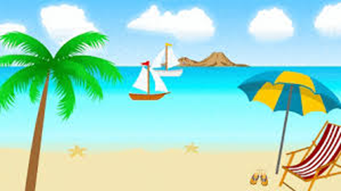

I would like to…  (Write 5 sentences) | I wouldn´t like to…  (Write 5 sentences)
- I would like to visit Castillo de San Felipe de Barajas  - I would like to eat bandeja costeña  - I would like to take some photo  - I would like to visit La señora gorda  - I would like to go to DiscoClub | - I wouldn´t like to lose myself  - I wouldn´t like to get indigestion  - I wouldn´t like to travel alone  - I wouldn´t like that the person speak English to me  - I wouldn´t like to get drunk
Put the words in order to make sentences.
Example: improve /would/ English/ they/ like/ to /their.
They would like to improve their English.

- would / family / to / my / visit / like / soon /London
I would like to visit my family in London soon.
- Students/ to/ the /would /break /a /take /like
Students would like to take a break.
- stay / wouldn`t / to / I / late /up /like /tonight
I wouldn't like to stay up late tonight.
- go / would / why / like /Miami / to /to /she?
Why would she like to go to Miami?
- would/ tea,/ drink /to /some /please/ like /I
I would like to drink some tea, please.
- like / would /eat /to /you /what?
What would you like to eat?
- would / go/ to /where /they /tonight /like?
Where would they like to go tonight?
- here/ wouldn`t / live / we /like /to
We wouldn't like to live here.
- see / wouldn`t /again/ to /Tom/ like/ Sarah.
I would like to see Tom again, but Sarah wouldn't.
- to/ I /like /buy /by the /a / would/ house/ ocean
I would like to buy a house by the ocean.

