Лабораторная работа по дисциплине
«Логическое и функциональное программирование»

Лабораторная работа №2

Выполнил:
Студент 3 курса
Крылов А.В.
Группа:
ИКПИ-11
Преподаватель:
Белая Т. И.
Принял:
___________

Постановка задачи

Разработать экспертную систему, предназначенную для принятия решения о приёме на работу в компьютерную фирму нового сотрудника.

Техническое задание

ЭС должна включать в себя 2 режима работы:
- Консультация – режим работы, в котором пользователь-неспециалист может пройти опрос и получить рекомендацию от программы
- Управление Базой Знаний – режим работы, в котором пользователь-специалист может просматривать, добавлять, редактировать и удалять имеющиеся факты, результаты и коэффициенты взаимосвязи факта с профессиями

Для разработки был использован стек технологий:
- Rust
- Cargo
- Slint
- CSV

Скриншоты работы программы
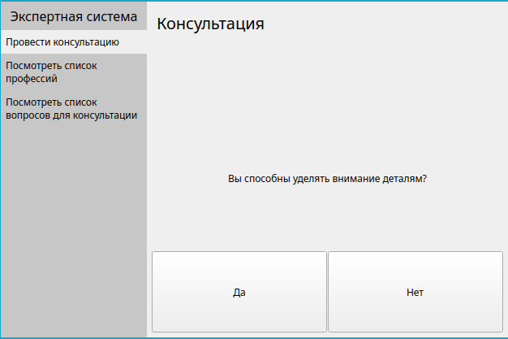

Рисунок 1 – Главное меню ЭС
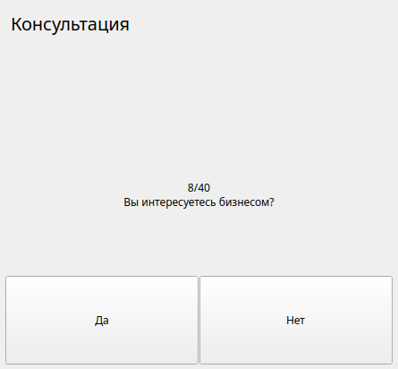

Рисунок 2 – Консультация

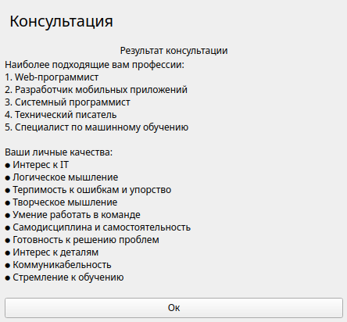

Рисунок 3 – Результат консультации
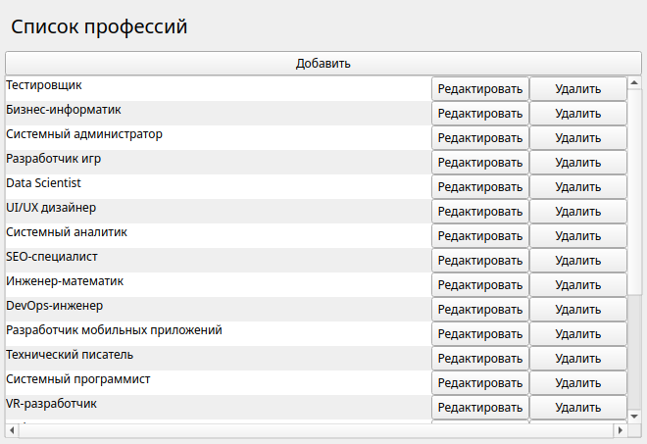

Рисунок 4 – Просмотр списка профессий

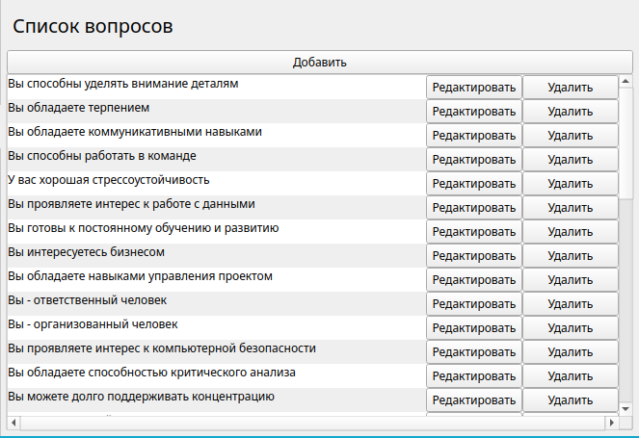

Рисунок 5 – Просмотр списка вопросов

Исходный код

main.rs
mod app;
use app::*;

fn main() {
let app = App::new();
app.run();
}

app.rs
use std::rc::Rc;

use rand::Rng;
use slint::{format, Model, VecModel};

slint::include_modules!();

pub struct App {
app_window: AppWindow,

profession_model: Rc<VecModel<Profession>>,
question_model: Rc<VecModel<Question>>,
mapping_model: Rc<VecModel<QPMapping>>,

prof_coef_model: Rc<VecModel<PCoef>>,
}

impl App {
pub fn new() -> Self {
let app = App::setup_db();

app.setup_callbacks();

app
}

pub fn run(&self) {
self.app_window.run().unwrap();

self.save_db();
}

fn setup_db() -> Self {
let app_window = AppWindow::new().unwrap();

let mut rdr = csv::ReaderBuilder::new()
.delimiter(b';')
.from_path("db/profs.csv")
.unwrap();
let profs: Vec<Profession> = rdr.deserialize().flatten().collect();
let profession_model = Rc::new(slint::VecModel::from(profs));
app_window
.global::<ModelAdapter>()
.set_profession_list(profession_model.clone().into());

let mut rdr = csv::ReaderBuilder::new()
.delimiter(b';')
.from_path("db/questions.csv")
.unwrap();
let qs: Vec<Question> = rdr.deserialize().flatten().collect();
let question_model = Rc::new(slint::VecModel::<Question>::from(qs));
app_window
.global::<ModelAdapter>()
.set_question_list(question_model.clone().into());

let mut rdr = csv::Reader::from_path("db/qp_mapping.csv").unwrap();
let qpms: Vec<QPMapping> = rdr.deserialize().flatten().collect();
let mapping_model = Rc::new(slint::VecModel::from(qpms));
app_window
.global::<ModelAdapter>()
.set_mapping_list(mapping_model.clone().into());

let mut current_question = question_model.clone().row_data(0).unwrap_or(Question {
index: -1,
question: "".into(),
});
current_question.question += "?";
app_window
.global::<ModelAdapter>()
.set_current_question(current_question.clone());

let coefs: Vec<PCoef> = profession_model
.iter()
.map(|p| PCoef {
index: p.index,
coef: 1.,
})
.collect();
let prof_coef_model = Rc::new(slint::VecModel::from(coefs));
app_window
.global::<ModelAdapter>()
.set_profession_coefs(prof_coef_model.clone().into());

Self {
app_window,
profession_model,
question_model,
mapping_model,
prof_coef_model,
}
}

fn setup_callbacks(&self) {
self.app_window.global::<ModelAdapter>().on_update_mapping({
let mapping_model = self.mapping_model.clone();
move |p_index, q_index, value| {
let (i, mut m) = mapping_model
.iter()
.enumerate()
.find(|(_, m)| m.p_index == p_index && m.q_index == q_index)
.unwrap();
m.value = value;
mapping_model.set_row_data(i, m);
}
});

// Profession
self.app_window.global::<ModelAdapter>().on_add_profession({
let profession_model = self.profession_model.clone();
let question_model = self.question_model.clone();
let mapping_model = self.mapping_model.clone();
move || {
let max_index = profession_model.iter().map(|p| p.index).max().unwrap_or(-1);
let new_index = max_index + 1;
profession_model.push(Profession {
index: new_index,
prof_name: "Новая профессия".into(),
traits: "Личные качества, характерные для новой профессии".into(),
});

mapping_model.extend(question_model.iter().map(|q| QPMapping {
p_index: new_index,
q_index: q.index,
value: rand::thread_rng().gen_range(0.0..=1.),
}));
}
});

self.app_window
.global::<ModelAdapter>()
.on_remove_profession({
let profession_model = self.profession_model.clone();
let mapping_model = self.mapping_model.clone();
move |p_index| {
let model_index = profession_model
.iter()
.position(|p| p.index == p_index)
.unwrap();
profession_model.remove(model_index);

let mm: Vec<QPMapping> = mapping_model
.iter()
.filter(|m| m.p_index != p_index)
.collect();
mapping_model.set_vec(mm);
}
});

self.app_window
.global::<ModelAdapter>()
.on_update_profession({
let profession_model = self.profession_model.clone();
move |index, prof_name, traits| {
let (i, mut p) = profession_model
.iter()
.enumerate()
.find(|(_, p)| p.index == index)
.unwrap();
p.prof_name = prof_name;
p.traits = traits;
profession_model.set_row_data(i, p);
}
});

self.app_window
.global::<ModelAdapter>()
.on_index_to_question({
let question_model = self.question_model.clone();
move |q_index| {
let q = question_model.iter().find(|q| q.index == q_index).unwrap();
q.question
}
});

// Question
self.app_window.global::<ModelAdapter>().on_add_question({
let profession_model = self.profession_model.clone();
let question_model = self.question_model.clone();
let mapping_model = self.mapping_model.clone();
move || {
let max_index = question_model.iter().map(|q| q.index).max().unwrap_or(-1);
let new_index = max_index + 1;
question_model.push(Question {
index: new_index,
question: "Новый вопрос".into(),
});

mapping_model.extend(profession_model.iter().map(|p| QPMapping {
p_index: p.index,
q_index: new_index,
value: rand::thread_rng().gen_range(0.0..=1.),
}));
}
});

self.app_window
.global::<ModelAdapter>()
.on_remove_question({
let question_model = self.question_model.clone();
let mapping_model = self.mapping_model.clone();
move |q_index| {
let model_index = question_model
.iter()
.position(|q| q.index == q_index)
.unwrap();
question_model.remove(model_index);

let mm: Vec<QPMappiDefault Paragraph Styleng> = mapping_model
.iter()
.filter(|m| m.q_index != q_index)
.collect();
mapping_model.set_vec(mm);
}
});

self.app_window
.global::<ModelAdapter>()
.on_update_question({
let question_model = self.question_model.clone();
move |index, question| {
let (i, mut q) = question_model
.iter()
.enumerate()
.find(|(_, q)| q.index == index)
.unwrap();
q.question = question;
question_model.set_row_data(i, q);
}
});

self.app_window
.global::<ModelAdapter>()
.on_index_to_profession({
let profession_model = self.profession_model.clone();
move |p_index| {
let p = profession_model
.iter()
.find(|p| p.index == p_index)
.unwrap();
p.prof_name
}
});

// Consult
let app_weak = self.app_window.as_weak();
self.app_window
.global::<ModelAdapter>()
.on_restart_consult({
let profession_model = self.profession_model.clone();
let question_model = self.question_model.clone();
let prof_coef_model = self.prof_coef_model.clone();
let app_window = app_weak.unwrap();
move || {
// Сбросить коэффициенты
let coefs: Vec<PCoef> = profession_model
.iter()
.map(|p| PCoef {
index: p.index,
coef: 1.,
})
.collect();
prof_coef_model.set_vec(coefs);

// Заново установить первый вопрос
let mut current_question = question_model.row_data(0).unwrap_or(Question {
index: -1,
question: "".into(),
});
current_question.question += "?";
app_window
.global::<ModelAdapter>()
.set_current_question(current_question);
}
});

let app_weak = self.app_window.as_weak();
self.app_window
.global::<ModelAdapter>()
.on_question_answer({
let prof_coef_model = self.prof_coef_model.clone();
let mapping_model = self.mapping_model.clone();
let question_model = self.question_model.clone();
let profession_model = self.profession_model.clone();
let app_window = app_weak.unwrap();
move |answer| {
let current_question =
app_window.global::<ModelAdapter>().get_current_question();

// Обновление коэффициентов профессий
for i in 0..prof_coef_model.row_count() {
let mut current_prof_coef = prof_coef_model.row_data(i).unwrap();
let mut coef_value = mapping_model
.iter()
.find(|m| {
m.p_index == current_prof_coef.index
&& m.q_index == current_question.index
})
.unwrap()
.value;

if !answer {
coef_value = 1. - coef_value;
}

current_prof_coef.coef *= coef_value;
prof_coef_model.set_row_data(i, current_prof_coef);
}

// Проверка коэффициентов
let sum = prof_coef_model.iter().map(|pc| pc.coef).sum::<f32>();
if sum == 0. {
app_window
.global::<ModelAdapter>()
.set_consult_status(ConsultStatus::NoResults);
return;
}

// Поиск следующего вопроса
let mut next_question_index = question_model
.iter()
.position(|q| q.index == current_question.index)
.unwrap()
+ 1;
while next_question_index < question_model.row_count() {
let next_question = question_model.row_data(next_question_index).unwrap();

let mut coef_sum = 0.;
for m in mapping_model
.iter()
.filter(|m| m.q_index == next_question.index)
{
coef_sum += m.value
* prof_coef_model
.iter()
.find(|pc| pc.index == m.p_index)
.unwrap()
.coef;
}

if coef_sum != 0. {
break;
}
next_question_index += 1;
}

// Установление нового вопроса или завершение консультации
match question_model.row_data(next_question_index) {
Some(mut next_question) => {
app_window.global::<ModelAdapter>().set_current_question({
next_question.question = format!(
"{}/{}\n{}?",
next_question_index + 1,
question_model.row_count(),
next_question.question
);
next_question
});
}
None => {
let mut top5_profs: Vec<PCoef> =
prof_coef_model.iter().filter(|pc| pc.coef != 0.).collect();
top5_profs.sort_by(|a, b| b.coef.partial_cmp(&a.coef).unwrap());

let mut result_string =
String::from("Наиболее подходящие вам профессии:\n");
for (i, pc) in top5_profs.iter().enumerate().take(5) {
let prof_name = profession_model
.iter()
.find(|p| p.index == pc.index)
.unwrap()
.prof_name;
result_string.push_str(&format!("{}. {}\n", i + 1, prof_name));
}

result_string.push_str("\nВаши личные качества:\n");
let traits: String = profession_model
.iter()
.find(|p| p.index == top5_profs[0].index)
.unwrap()
.traits
.into();
let traits: Vec<_> = traits
.split('.')
.map(|line| std::format!("● {}\n", line.trim()))
.collect();
result_string.extend(traits);

app_window
.global::<ModelAdapter>()
.set_result_text(result_string.into());
app_window
.global::<ModelAdapter>()
.set_consult_status(ConsultStatus::ShowingResults);
}
}
}
});
}

fn save_db(&self) {
let mut wtr = csv::WriterBuilder::new()
.delimiter(b';')
.from_path("db/profs.csv")
.unwrap();
let profs: Vec<Profession> = self.profession_model.iter().collect();
for p in profs {
wtr.serialize(p).unwrap();
}

let mut wtr = csv::WriterBuilder::new()
.delimiter(b';')
.from_path("db/questions.csv")
.unwrap();
let qs: Vec<Question> = self.question_model.iter().collect();
for q in qs {
wtr.serialize(q).unwrap();
}

let mut wtr = csv::Writer::from_path("db/qp_mapping.csv").unwrap();
let qpms: Vec<QPMapping> = self.mapping_model.iter().collect();
for m in qpms {
wtr.serialize(m).unwrap();
}
}
}

app_window.slint
import { SideBar } from "sidebar.slint";
import { ProfessionListPage } from "profession_page.slint";
import { Profession, ModelAdapter } from "model_adapter.slint";
import { QuestionListPage } from "question_page.slint";
import { ConsultPage } from "consult_page.slint";

export * from "model_adapter.slint";

export component AppWindow inherits Window {
title: "ЛР№2, Крылов А.В. ИКПИ-11";
preferred-width: 600px;
preferred-height: 400px;

HorizontalLayout {
side-bar := SideBar {
title: "Экспертная система";
model: [
"Провести консультацию",
"Посмотреть список профессий",
"Посмотреть список вопросов для консультации"
];
}

if side-bar.current-item == 0: ConsultPage {}
if side-bar.current-item == 1: ProfessionListPage { }
if side-bar.current-item == 2: QuestionListPage { }
}
}

consult_page.slint
import { HorizontalBox, ListView, Button } from "std-widgets.slint";

import { Page } from "page.slint";
import { ModelAdapter, ConsultStatus } from "model_adapter.slint";

export component ConsultPage inherits Page {
title: "Консультация";
max-height: 500px;

if ModelAdapter.question_list.length == 0: Text {
height: 50%;
text: "Список вопросов пуст";
horizontal-alignment: center;
}

if ModelAdapter.question_list.length != 0 && ModelAdapter.consult_status == ConsultStatus.AskingQuestions: VerticalLayout {
Text {
text: ModelAdapter.current_question.question;
wrap: word-wrap;
horizontal-alignment: center;
}

HorizontalLayout {
Button {
max-height: 100px;
text: "Да";
clicked => {
ModelAdapter.question_answer(true);
}
}

Button {
max-height: 100px;
text: "Нет";
clicked => {
ModelAdapter.question_answer(false);
}
}
}
}

if ModelAdapter.consult_status == ConsultStatus.ShowingResults: VerticalLayout {
Text {
text: "Результат консультации";
horizontal-alignment: center;
}

Text {
text: ModelAdapter.result_text;
horizontal-alignment: left;
}

Button {
max-height: 100px;
text: "Ок";
clicked => {
ModelAdapter.consult_status = ConsultStatus.AskingQuestions;
ModelAdapter.restart_consult();
}
}
}

if ModelAdapter.consult_status == ConsultStatus.NoResults: VerticalLayout {
Text {
text: "К сожалению, нам не удалось найти подходящую для вас профессию";
wrap: word-wrap;
horizontal-alignment: center;
}

Button {
max-height: 100px;
text: "Ок";
clicked => {
ModelAdapter.consult_status = ConsultStatus.AskingQuestions;
ModelAdapter.restart_consult();
}
}
}
}

model_adapter.slint
@rust-attr(derive(serde::Serialize, serde::Deserialize))
export struct Profession {
index: int,
prof_name: string,
traits: string,
}

@rust-attr(derive(serde::Serialize, serde::Deserialize))
struct Question {
index: int,
question: string,
}

@rust-attr(derive(serde::Serialize, serde::Deserialize))
export struct QPMapping {
p_index: int,
q_index: int,
value: float,
}

export enum ConsultStatus {
AskingQuestions,
ShowingResults,
NoResults,
}

export struct PCoef {
index: int,
coef: float,
}

export global ModelAdapter {
in property <[Profession]> profession_list;
in property <[Question]> question_list;
in property <[QPMapping]> mapping_list;

callback update_mapping(/* p_index */ int, /* q_index */ int, float);

callback add_profession();
callback remove_profession(/* index */ int);
callback update_profession(/* index */ int, /* prof_name */ string, /* traits */ string);
pure callback index_to_question(int) -> string;

callback add_question();
callback remove_question(/* index */ int);
callback update_question(/* index */ int, /* question */ string);
pure callback index_to_profession(int) -> string;

// Консультация
in property <ConsultStatus> consult_status: AskingQuestions;
in property <Question> current_question;
in property <[PCoef]> profession_coefs;
callback restart_consult();
callback question_answer(bool);
in property <string> result_text;
}

page.slint
import { VerticalBox, HorizontalBox } from "std-widgets.slint";

export component Page inherits VerticalBox {
in property <string> title: "title";

HorizontalBox {
Text {
font-size: 20px;
text <=> root.title;
}
}

@children
}

profession_page.slint
import { HorizontalBox, GroupBox, ListView, TextEdit, Button, Palette, Slider, VerticalBox } from "std-widgets.slint";

import { Page } from "page.slint";
import { ModelAdapter, QPMapping } from "model_adapter.slint";

component ProfessionListItem inherits Rectangle {
in-out property <string> text;
in property <int> index;
in property <int> p_index;
in-out property <string> traits;

background: Math.mod(index, 2) == 0 ? white : Palette.background;

p_edit := PopupWindow {
width: 500px;
height: 500px;
close-on-click: false;

Rectangle {
background: Palette.background;
border-color: Palette.border;
border-width: 1px;
}

VerticalLayout {
GroupBox {
title: "Название профессии:";
TextEdit {
max-height: 100px;
text <=> text;
}
}

GroupBox {
title: "Личные качества (разделённые точками):";
TextEdit {
max-height: 100px;
text <=> traits;
}
}

GroupBox {
title: "Коэффициенты для вопросов:";
ListView {
for m in ModelAdapter.mapping_list: HorizontalBox {
if m.p_index == p_index: HorizontalLayout {
Text {
text: ModelAdapter.index_to_question(m.q-index);
wrap: word-wrap;
}

s := Slider {
width: 100px;
orientation: horizontal;
minimum: 0;
maximum: 1;
value: m.value;
}

Text {
width: 25px;
text: s.value;
}

Button {
width: 100px;
text: "Сохранить";
clicked => {
ModelAdapter.update_mapping(m.p-index, m.q-index, s.value);
}
}
}
}
}
}

Button {
text: "ОК";
clicked => {
ModelAdapter.update_profession(p_index, text, traits);
p-edit.close();
}
}
}
}

HorizontalLayout {
Text {
text: text;
wrap: word-wrap;
}

Button {
width: 100px;
text: "Редактировать";
clicked => {
p-edit.show();
}
}

Button {
width: 100px;
text: "Удалить";
clicked => {
ModelAdapter.remove_profession(p_index);
ModelAdapter.restart_consult();
}
}
}
}

export component ProfessionListPage inherits Page {
title: "Список профессий";
VerticalLayout {
Button {
text: "Добавить";
clicked => {
ModelAdapter.add_profession();
ModelAdapter.restart_consult();
}
}

ListView {
for p[i] in ModelAdapter.profession_list: ProfessionListItem {
text: p.prof-name;
index: i;
p_index: p.index;
traits: p.traits;
}
}
}
}

question_page.slint
import { HorizontalBox, GroupBox, ListView, TextEdit, Button, Palette, Slider, VerticalBox } from "std-widgets.slint";

import { Page } from "page.slint";
import { ModelAdapter, QPMapping } from "model_adapter.slint";

component QuestionListItem inherits Rectangle {
in-out property <string> text;
in property <int> index;
in property <int> q_index;

background: Math.mod(index, 2) == 0 ? white : Palette.background;

q_edit := PopupWindow {
width: 500px;
height: 500px;
close-on-click: false;

Rectangle {
background: Palette.background;
border-color: Palette.border;
border-width: 1px;
}

VerticalLayout {
GroupBox {
title: "Формулировка вопроса:";
TextEdit {
max-height: 100px;
text <=> text;
}
}

GroupBox {
title: "Коэффициенты для профессий:";
ListView {
for m in ModelAdapter.mapping_list: HorizontalBox {
if m.q_index == q_index: HorizontalLayout {
Text {
text: ModelAdapter.index_to_profession(m.p-index);
wrap: word-wrap;
}

s := Slider {
width: 100px;
orientation: horizontal;
minimum: 0;
maximum: 1;
value: m.value;
}

Text {
width: 25px;
text: s.value;
}

Button {
width: 100px;
text: "Сохранить";
clicked => {
ModelAdapter.update_mapping(m.p-index, m.q-index, s.value);
}
}
}
}
}
}

Button {
text: "ОК";
clicked => {
ModelAdapter.update_question(q_index, text);
q-edit.close();
}
}
}
}

HorizontalLayout {
Text {
text: text;
wrap: word-wrap;
}

Button {
width: 100px;
text: "Редактировать";
clicked => {
q-edit.show();
}
}

Button {
width: 100px;
text: "Удалить";
clicked => {
ModelAdapter.remove_question(q_index);
ModelAdapter.restart_consult();
}
}
}
}

export component QuestionListPage inherits Page {
title: "Список вопросов";
VerticalLayout {
Button {
text: "Добавить";
clicked => {
ModelAdapter.add_question();
ModelAdapter.restart_consult();
}
}

ListView {
for q[i] in ModelAdapter.question_list: QuestionListItem {
text: q.question;
index: i;
q_index: q.index;
}
}
}
}

sidebar.slint
import { HorizontalBox, VerticalBox, Palette } from "std-widgets.slint";

component SideBarItem inherits Rectangle {
in property <bool> selected;
in-out property <string> text <=> label.text;

callback clicked <=> touch.clicked;

min-height: l.preferred-height;

states [
pressed when touch.pressed: {
state.opacity: 0.8;
}
hover when touch.has-hover: {
state.opacity: 0.6;
}
selected when root.selected: {
state.opacity: 1;
}
]

state := Rectangle {
opacity: 0;
background: Palette.background;

animate opacity { duration: 150ms; }
}

l := HorizontalBox {
y: (parent.height - self.height) / 2;
spacing: 0px;

label := Text {
vertical-alignment: center;
wrap: word-wrap;
}
}

touch := TouchArea {
width: 100%;
height: 100%;
}
}

export component SideBar inherits Rectangle {
in property <[string]> model: [];
in property <string> title <=> label.text;
out property <int> current-item: 0;
// The currently focused tab

width: 180px;
background: Palette.background.darker(0.2);

VerticalBox {
padding-left: 0px;
padding-right: 0px;
alignment: start;

label := Text {
font-size: 16px;
horizontal-alignment: center;
}

navigation := VerticalLayout {
alignment: start;
vertical-stretch: 0;
for item[index] in root.model: SideBarItem {
clicked => {
root.current-item = index;
}

text: item;
selected: index == root.current-item;
}
}
}
}

build.rs
fn main() {
slint_build::compile("ui/app_window.slint").unwrap();
}

Cargo.toml
[package]
name = "l2"
version = "0.1.0"
edition = "2021"

# See more keys and their definitions at https://doc.rust-lang.org/cargo/reference/manifest.html

[dependencies]
csv = "1.3.0"
rand = "0.8.5"
serde = { version = "1.0.200", features = ["derive"] }
slint = { version = "1.5.1", features = ["serde"] }

[build-dependencies]
slint-build = "1.5.1"

Вывод

В ходе лабораторной работы была реализована ЭС, предназначенная для принятия решения о приёме на работу в компьютерную фирму нового сотрудника.

