1. TCP stuff

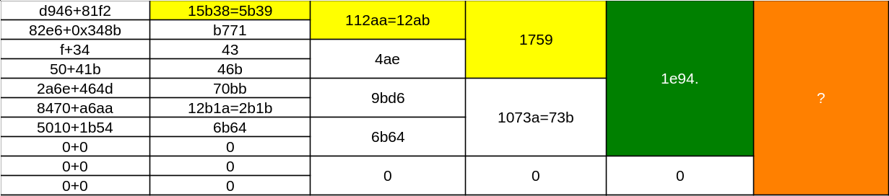

1. IPv4 stuff

|  |  |  |  |  |
| --- | --- | --- | --- | --- |
| **4500+0028** | 4528 | 75F1 | FD30 | 1B4A1>B4A2> 4b5d |
| **f0c8+4000** | 130C8>30C9 |
| **2c06+0000** | 2c06 | **873F** |
| **d946+81f2** | 15B38>5B39 |
| **82e6+348b** | B771 | B771 | B771 |

**FRAME CHECK SEQUENCE - F4 DA 3A 02**