MUTUAL FUND ANALYTICS CAPSTONE PROJECT
Bluestock Internship Program
Prepared By:
Vali Shaik
Project Duration:
01 June 2026 – 10 June 2026
Tools Used:
Python, Pandas, NumPy, Matplotlib, SQLite, Power BI, GitHub
Submitted To:
Bluestock Internship Team

- Executive Summary
- Project Objectives
- Data Sources
- ETL Pipeline Design
- Database Design
- Exploratory Data Analysis
- Performance Analytics
- Dashboard Development
- Advanced Analytics
- Key Findings
- Limitations
- Recommendations
- Conclusion

1. Executive Summary
The Mutual Fund Analytics Capstone Project was developed to analyze mutual fund performance, investor behavior, and industry trends using real-world financial datasets. The project integrates data engineering, exploratory data analysis, financial performance evaluation, dashboard development, and advanced risk analytics into a single end-to-end analytics solution.
The primary objective was to build a data-driven platform capable of evaluating mutual fund schemes, identifying investor patterns, measuring risk-adjusted returns, and providing actionable insights through interactive dashboards and advanced analytical techniques.
The project utilized Python, Pandas, NumPy, Matplotlib, SQLite, and Power BI for data processing, analysis, visualization, and reporting. Key outcomes include performance scorecards, Alpha-Beta analysis, Sharpe Ratio evaluation, Value at Risk (VaR), Conditional Value at Risk (CVaR), investor cohort analysis, SIP continuity assessment, and an automated fund recommendation system.
The final solution enables investors and analysts to better understand mutual fund performance, risk exposure, investor engagement, and market trends through a comprehensive analytics framework.
2. Project Objectives
The major objectives of this project were:
• Build a structured mutual fund analytics pipeline using multiple financial datasets.
• Clean, transform, and integrate raw mutual fund data into analysis-ready datasets.
• Perform exploratory data analysis to understand market trends, investor demographics, and category-level behavior.
• Calculate performance metrics including Alpha, Beta, Sharpe Ratio, Sortino Ratio, and Maximum Drawdown.
• Develop an interactive Power BI dashboard to visualize mutual fund performance and industry trends.
• Implement advanced risk analytics including Historical VaR and CVaR.
• Analyze investor cohorts and SIP continuity patterns.
• Develop a simple recommendation engine for mutual fund selection based on investor risk appetite.
• Generate actionable insights and recommendations for investors and financial analysts.
3. Data Sources
The project utilized multiple datasets covering mutual fund schemes, historical NAV data, benchmark indices, investor transactions, portfolio holdings, SIP inflows, AUM statistics, and category inflows.
Major datasets included:
• Fund Master Data
• Scheme Performance Data
• Historical NAV Data
• Benchmark Index Data
• Investor Transaction Data
• Portfolio Holdings Data
• SIP Inflow Statistics
• Category-wise Inflow Data
• Industry Folio Count Data
• AUM by Fund House Data
These datasets collectively provided information on fund performance, investor activity, portfolio composition, and overall industry growth.
4. ETL Pipeline Design
The ETL (Extract, Transform, Load) pipeline was designed to automate the preparation of mutual fund datasets for analysis. The pipeline followed a structured workflow consisting of data extraction, cleaning, transformation, validation, and storage.
Extraction involved loading multiple CSV datasets containing mutual fund schemes, NAV history, investor transactions, benchmark indices, portfolio holdings, SIP inflows, and industry statistics.
Transformation activities included:
• Handling missing values
• Standardizing date formats
• Removing duplicates
• Validating numerical fields
• Renaming columns for consistency
• Creating derived metrics such as daily returns
Processed datasets were stored in a structured format to support exploratory analysis, dashboard creation, and advanced analytics. The ETL process ensured data quality, consistency, and reproducibility across all project stages.
The pipeline significantly reduced manual effort and improved reliability by creating analysis-ready datasets from raw financial data.
5. Database Design
A SQLite database was used to organize and manage the processed mutual fund datasets. The database served as a centralized repository for storing structured financial and investor information.
The database schema included tables for:
• Fund Master
• Scheme Performance
• Historical NAV
• Benchmark Indices
• Investor Transactions
• Portfolio Holdings
• SIP Inflows
• Category Inflows
• Industry Folio Statistics
Primary and foreign key relationships were established using AMFI scheme codes and date fields wherever applicable. These relationships enabled efficient querying and integration of data across multiple tables.
The database design supported analytical workflows such as performance evaluation, investor behavior analysis, and dashboard reporting. SQLite was selected due to its lightweight architecture, ease of integration with Python, and suitability for local analytical projects.
6. Exploratory Data Analysis
Exploratory Data Analysis (EDA) was performed to understand trends in mutual fund performance, industry growth, investor behavior, and category-level inflows.
Key areas of analysis included:
• Assets Under Management (AUM) distribution across fund houses
• Monthly SIP inflow trends
• Category-wise net inflows
• Investor demographics by age group, state, and city tier
• Benchmark index movements
• Fund return distributions
Several visualizations were developed using Matplotlib and Power BI to identify patterns, outliers, and growth opportunities. The EDA phase provided the foundation for performance analytics and advanced risk modeling.
7. Performance Analytics
Performance analytics was conducted to evaluate mutual fund schemes using both return-based and risk-adjusted performance metrics.
The following measures were calculated:
• Alpha – excess return generated relative to benchmark performance.
• Beta – sensitivity of fund returns to market movements.
• Sharpe Ratio – risk-adjusted return based on total volatility.
• Sortino Ratio – risk-adjusted return considering downside volatility only.
• Maximum Drawdown – largest historical decline from peak NAV.
• Fund Scorecard – composite scoring framework combining returns, risk, alpha, Sharpe ratio, drawdown, and expense ratio.
Analysis revealed significant variation in performance across categories, with several equity funds consistently delivering superior risk-adjusted returns. The fund scorecard enabled ranking and comparison of schemes using a standardized framework.
8. Dashboard Development

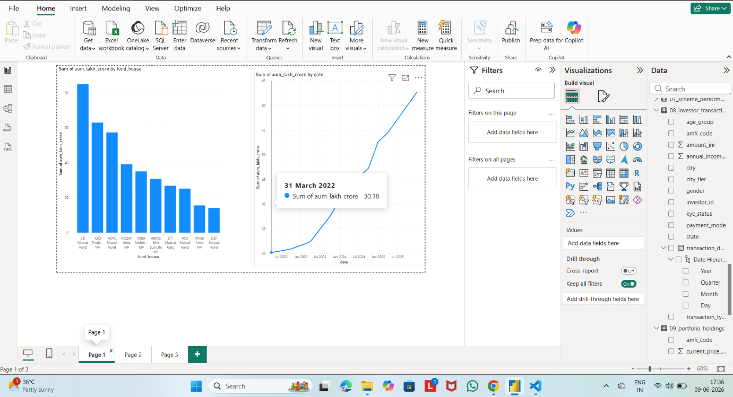

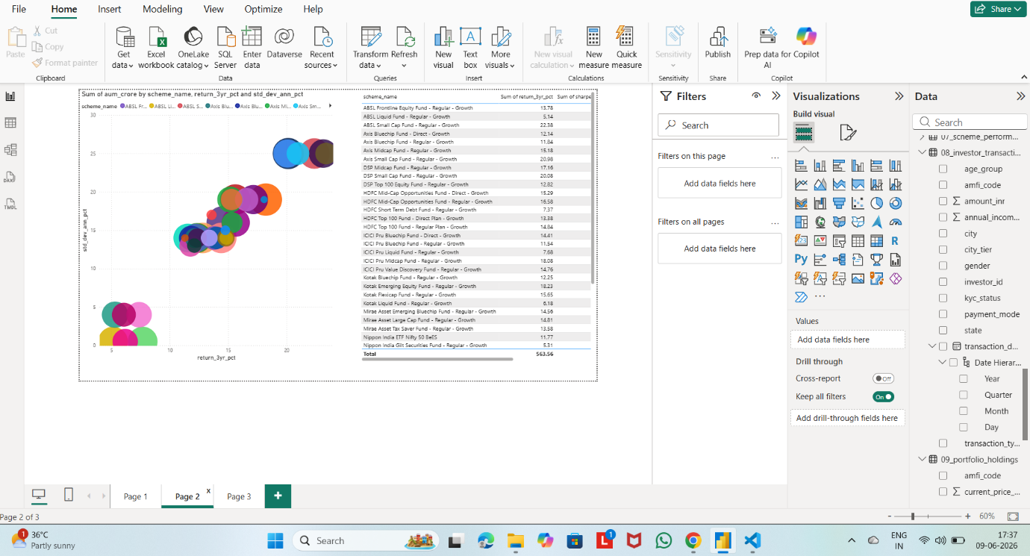
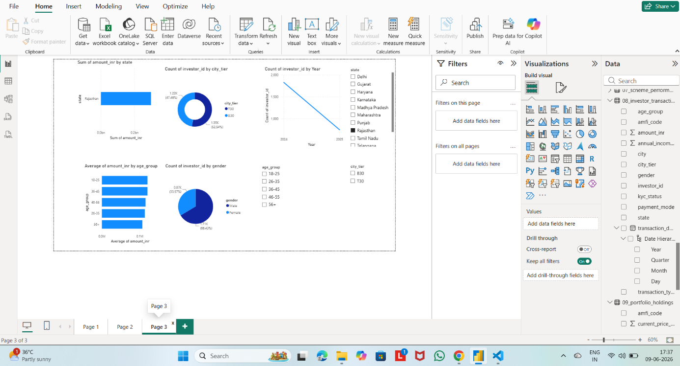

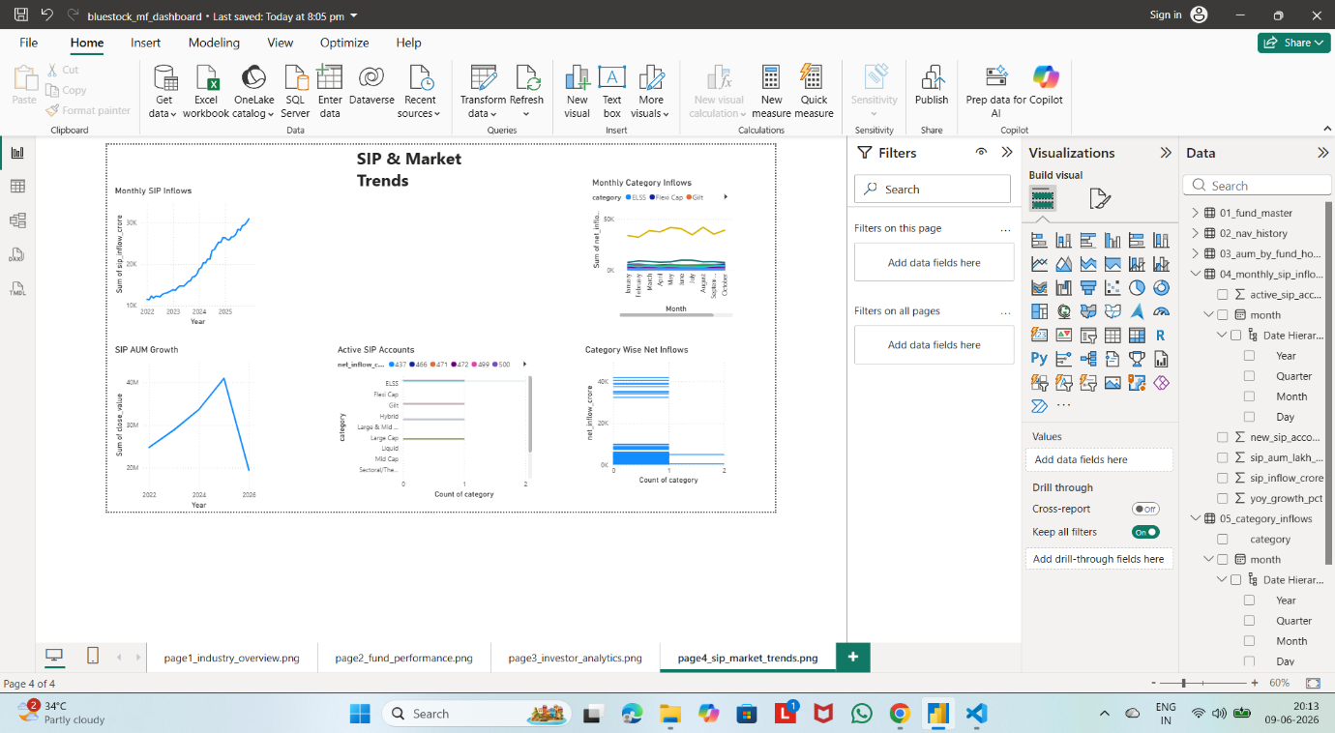
An interactive Power BI dashboard was developed to provide a consolidated view of mutual fund industry trends, scheme performance, investor behavior, and SIP growth patterns.
The dashboard consists of four pages:
- Industry Overview
- Fund Performance
- Investor Analytics
- SIP & Market Trends
Interactive slicers, drill-down functionality, and dynamic visualizations allow users to explore mutual fund data efficiently. The dashboard improves decision-making by presenting complex financial information in a clear and intuitive format.
9. Advanced Analytics
Advanced analytics techniques were implemented to evaluate downside risk, investor behavior, and portfolio concentration.
Major analyses included:
• Historical Value at Risk (VaR 95%)
• Conditional Value at Risk (CVaR 95%)
• Rolling 90-Day Sharpe Ratio
• Investor Cohort Analysis
• SIP Continuity Assessment
• Mutual Fund Recommendation Engine
• Herfindahl-Hirschman Index (HHI) for portfolio concentration
Results identified high-risk schemes, investor retention challenges, and concentration risks within certain portfolios. These advanced methods provided deeper insights beyond traditional return-based analysis.
10. Key Findings
- Several small-cap and mid-cap funds exhibited the highest return potential but also carried elevated downside risk.
- Rolling Sharpe analysis demonstrated that risk-adjusted performance varies significantly over time and across fund categories.
- Investor cohort analysis indicated growing participation from recent investors, contributing substantial investment volumes.
- SIP continuity analysis identified a segment of investors with irregular contribution behavior, indicating potential attrition risk.
- Portfolio concentration analysis revealed that certain funds maintain highly concentrated holdings, increasing concentration risk.
11. Limitations
• Analysis was limited to available historical datasets.
• External macroeconomic variables were not incorporated.
• Future performance cannot be guaranteed based on historical trends.
• Some advanced risk measures may be sensitive to data availability and sample size.
12. Recommendations
• Investors should evaluate risk-adjusted returns rather than absolute returns alone.
• Regular SIP monitoring can improve investor retention and continuity.
• Diversified portfolios should be preferred to reduce concentration risk.
• Fund selection should consider Sharpe Ratio, Alpha, and downside risk measures together.
• Future versions may incorporate real-time NAV updates and predictive analytics.
13. Conclusion
The Mutual Fund Analytics Capstone Project successfully demonstrated an end-to-end financial analytics workflow covering data engineering, exploratory analysis, performance evaluation, dashboard development, and advanced risk analytics.
The project provides a scalable framework for analyzing mutual fund performance and investor behavior while delivering actionable insights through both analytical reports and interactive dashboards. The integration of traditional financial metrics with advanced analytics techniques enhanced the overall decision-making capability of the solution.
This project highlights the value of data-driven approaches in modern investment analysis and demonstrates practical applications of data science within the financial services domain.

