NIFTY100 FINANCIAL ANALYTICS DASHBOARD
Prepared By:
Vali Shaik
Tools Used:
• Python
• Pandas
• SQLite
• SQL
• Power BI
• GitHub
Project Duration:
Sprint 1 – Data Foundation

Executive Summary

The Nifty100 Financial Analytics Project was developed to build an end-to-end data analytics solution for financial data analysis. The project involved extracting data from multiple Excel datasets, validating data quality, loading the information into a SQLite database, performing SQL-based analysis, and visualizing results using Power BI dashboards.

The project successfully integrated multiple datasets covering company information, profit and loss statements, balance sheets, cash flows, stock prices, market capitalization, sector classification, and peer group information. The final solution provides meaningful insights into company performance, sector performance, and market capitalization trends.

Project Objectives

The main objectives of this project are:

• Build a centralized SQLite database for Nifty100 data.
• Load and validate financial datasets.
• Implement data quality validation checks.
• Perform financial analysis using SQL.
• Develop interactive Power BI dashboards.
• Generate business insights from financial data.

Datasets Used

Dataset | Rows
Companies | 92
Profit & Loss | 1276
Balance Sheet | 1312
Cash Flow | 1187
Documents | 1585
Stock Prices | 5520
Market Cap | 552
Sectors | 92
Peer Groups | 56

Database Design

The project uses SQLite as the central data repository. Data was loaded into normalized tables to improve consistency and maintain referential integrity.

The database contains the following tables:

• companies
• profit and loss
• balance sheet
• cashflow
• documents
• stock _ prices
• market_ cap
• sectors
• peer_ groups

Data Quality Validation

Multiple validation rules were implemented to ensure data quality.

Implemented checks include:

• Primary Key Validation
• Company-Year Uniqueness
• Foreign Key Validation
• Balance Sheet Validation
• Operating Profit Margin Validation
• Positive Sales Validation
• Cash Flow Validation
• Tax Rate Validation
• URL Validation

Validation results were stored in validation_failures.csv for review.
SQL Analytics

Several SQL analytical queries were developed to identify top-performing companies and sectors.

Key analyses performed:

• Top 10 Companies by ROE
• Top 10 Companies by ROCE
• Market Capitalization Analysis
• Sector Performance Analysis
• Sector-wise Average ROE
• Sector-wise Average ROCE

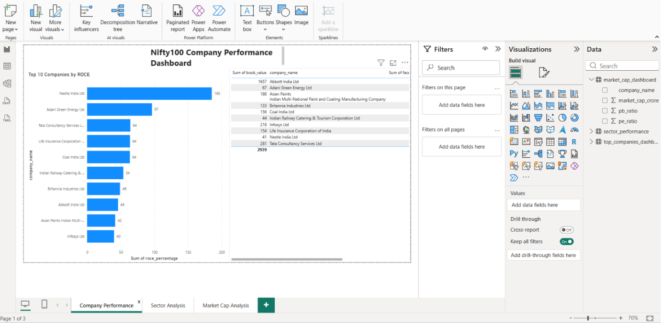
Figure 1: Company Performance Dashboard
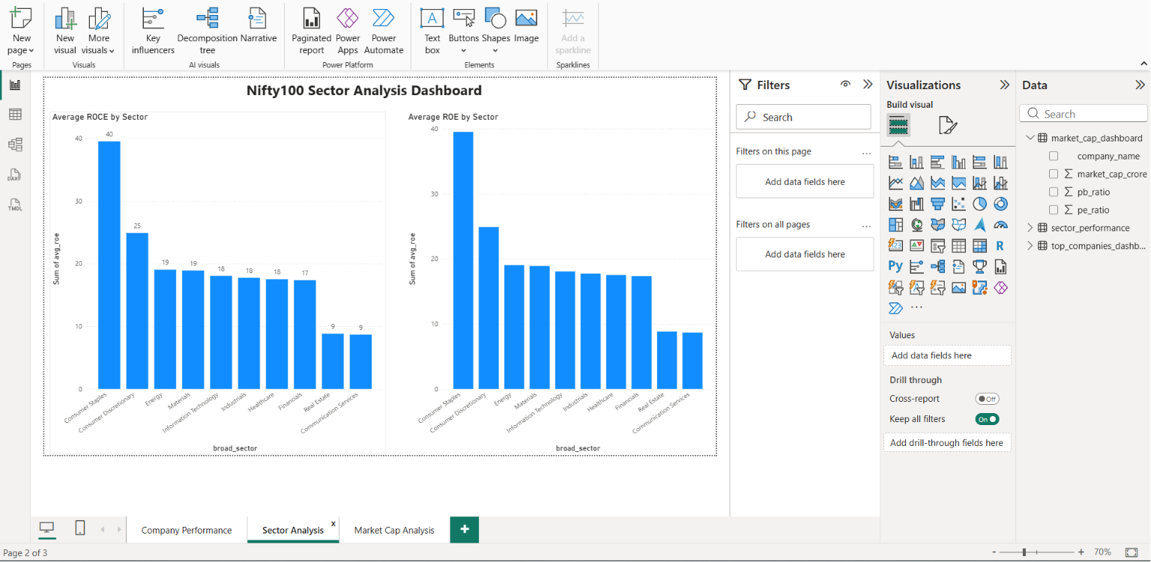
Figure 2: Sector Analysis Dashboard

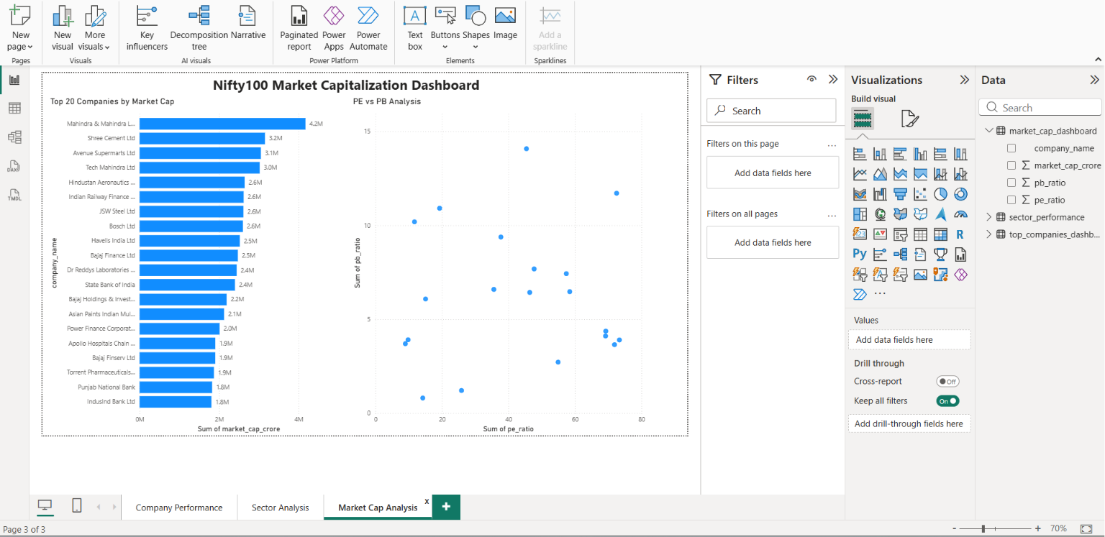
Figure 3: Market Capitalization Dashboard

Key Findings
• Nestle India achieved the highest ROE and ROCE among analyzed companies.
• Consumer Staples sector recorded the highest average ROE and ROCE.
• Financials sector had the largest number of companies within the Nifty100 dataset.
• Market capitalization analysis highlighted the largest companies within the index.

Conclusion
The project successfully delivered a complete financial analytics solution using Python, SQLite, SQL, and Power BI. Data quality validation ensured reliability, while dashboards and analytical queries generated meaningful business insights.

The developed solution can be extended further by integrating live market data and advanced financial ratio analysis.

