Big Data Analysis Technologies
Vasiliki Pantelopoulou
Github repo: Threads-and-Processes
2025
Contents
Subproblem 1 1
Υποεργασία 2 2
Παραλλαγή για περισσότερα νοσοκομεία 4
Υποεργασία 3 5
Υποεργασία 4 8

Subproblem 1
The purpose of this subtask is to implement and evaluate a Java program that performs the multiplication of a two-dimensional matrix by a one-dimensional vector, utilizing multithreading techniques. The task is based on an example with fixed values for the dimensions of the matrix and vector, as well as the number of threads, while the execution time is recorded to assess performance.
The program calculates the product of a matrix A of dimensions N×M with a vector v of length M, producing a new result vector result of length N. This operation is executed in parallel by k threads, where each thread is responsible for a portion of the matrix rows. Since N and k are powers of 2, each thread processes N/k rows of the matrix so that the workload is evenly distributed.
In the main program, the matrix and vector are first created and filled with random values using the functions fillMatrix and fillVector. Then, the number of rows assigned to each thread is determined, and k objects of the Thread class are created to perform the multiplication task through the Multiply class. Each thread computes the sum for the subset of rows it handles. It is noted that no synchronization is required between threads, since each one writes to distinct parts of the result array. Therefore, once all threads are started, the main program waits for their completion in order to print the final result vector and the execution time in milliseconds.
To compare the efficiency of the threads, measurements were taken for matrices of dimensions 2048×2048, 4096×4096, and 8192×8192, using 1, 2, 4, and 8 threads. The results are shown in the table below:
Threads | Dimensions | Execution Time
1 | 2048 | 11.63 ms
2 | 2048 | 8.47 ms
4 | 2048 | 9.71 ms
8 | 2048 | 16.98 ms
1 | 4096 | 31.82 ms
2 | 4096 | 22.30 ms
4 | 4096 | 17.04 ms
8 | 4096 | 20.22 ms
1 | 8192 | 114.09 ms
2 | 8192 | 61.74 ms
4 | 8192 | 38.97 ms
8 | 8192 | 30.17 ms

The results show that as the matrix size and the number of threads increase, the program runs faster, especially for large dimensions. For small matrices, threads do not help much, because the time needed to start and coordinate them is greater than the benefit they provide. For medium-sized matrices, the best speed is achieved with about four threads, while for large matrices, eight threads appear to be the most efficient. Overall, parallel computation performs very well when the problem is large enough to justify the use of multiple threads.

Subproblem 2
The program simulates the operation of an Intensive Care Unit (ICU) using two cooperating threads. The first thread, Disease, periodically generates a random number of new cases and attempts to admit them into the available ICU beds. If there are not enough beds, the excess cases are rejected. The second thread, Hospital, every few seconds randomly cures a number of patients, freeing up the corresponding beds.
The simulation runs for a specific number of iterations and, at the end, displays the total number of rejections, recoveries, and the final ICU occupancy. The timing of the two threads is defined by the variable’s disease_period and cure_period, for example, 1000 ms and 5000 ms, respectively.
The shared variables (occupied, TotalRejected, TotalRecovered) are protected using synchronized, so that when one thread updates these values, the other must wait, preventing errors due to simultaneous access. This ensures that the ICU data remains accurate and up to date.
Since admissions occur more frequently than treatments, ICU occupancy typically increases gradually, and when the bed capacity limit is reached, subsequent cases are rejected. Each time the Hospital thread cures patients, occupancy decreases, and the total recoveries increase.
Below are sample results of the program for the following initialization values:
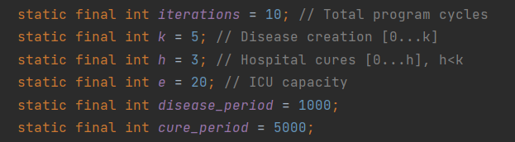
initialization values

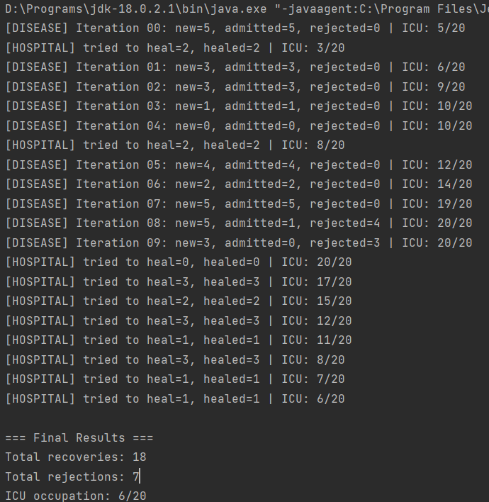
Results

Variation for Multiple Hospitals
Next, a variation of the program was implemented to support more than one hospital. Instead of having a single ICU, three hospitals are created (NumberOfHospitals = 3), each with its own bed capacity (e = 20). The beds of each hospital are stored in an array occupied[], where each element represents how many beds are currently occupied in the corresponding hospital.
The Disease thread remains unique and generates new patient admissions in each cycle. For every cycle, the new cases are distributed sequentially among the hospitals: the program checks each hospital in order and tries to admit as many patients as possible into its available beds. If a hospital becomes full, it moves on to the next one. If, after checking all hospitals, there are still patients who cannot be admitted, those cases are rejected and added to the total number of rejections.
At the same time, each hospital has its own Hospital thread, which operates independently and randomly cures a number of patients, freeing the corresponding beds. All threads share common variables (the occupied array for the occupancy of each hospital and the total counters for rejections and recoveries), which are protected with synchronized and a shared lock, as in the initial implementation, to avoid conflicts.
Essentially, the core logic remains the same, while at the end, the program calculates and displays the occupancy of each hospital separately, as well as the total number of rejections and recoveries for all hospitals combined.
Below are sample results of the program for the following initialization values:
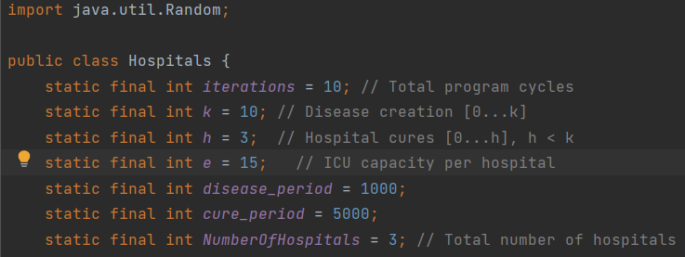
initialization values
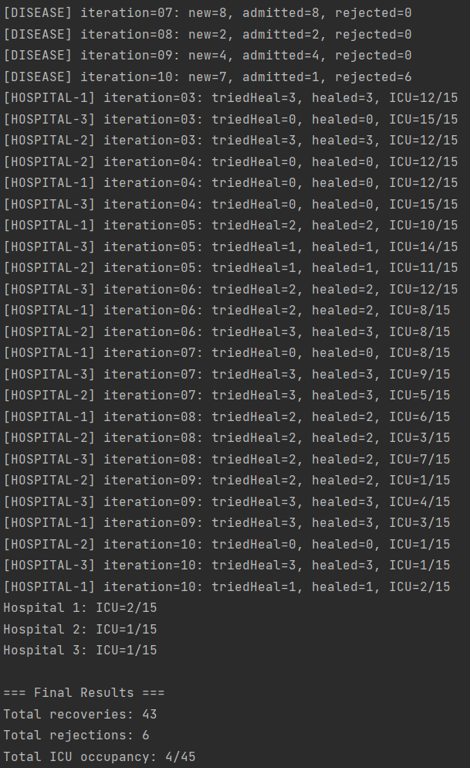
Results

Subproblem 3
This project implements a simple client–server communication system using TCP sockets in Java. The server maintains a hash table that stores (key, value) pairs, while the client allows the user to perform operations on this table through typed commands.
When the server starts, a ServerSocket is created for a specific port, and an empty hash table is initialized with a maximum size of 2²⁰. The Hashtable class is used because it is thread-safe; moreover, the insertion, deletion, and search methods are protected with synchronized (hashtable) to ensure atomicity for complex operations.
The server then enters a listening loop, waiting for clients to connect. For each new client that connects, a separate thread is created to handle that client, enabling concurrent client servicing. Each thread reads the user’s input and calls the handle method, which processes the command. Finally, it returns the appropriate response to the client using a PrintWriter.
The handle method parses the incoming string, identifies the operation based on the first value (0–3), and calls the appropriate function (insert, delete, or search). The supported commands are shown in the following table:
Commands | Description | Result
1 <key> <value> | Insert | "1" αν επιτυχές, "0" αλλιώς
2 <key> | Delete | "1" αν επιτυχές, "0" αλλιώς
3 <key> | Search | Την τιμή του στοιχείου ή "0" αν δεν υπάρχει
0 0 | Terminate connection
Supported Commands
Communication is carried out through strings exchanged between the client and the server. When the client sends the command ‘0 0’, the corresponding connection is terminated, while the server remains active and continues to accept new clients.
It should be noted that, for both the server and the client, the necessary arguments have been configured in the Run Configuration Settings of IntelliJ IDEA to ensure correct program execution. Specifically, the server is given the port parameter ‘5000’, on which it listens for incoming connections, while the client is assigned the IP address ‘127.0.0.1’ (the server’s address) and the same port number to establish a successful connection.
Below is a representative example of the program’s operation:
Initially, the server is started and waits for incoming connections. Then, one or more clients can start and connect to the server simultaneously. Each client can send commands and receive immediate responses without interfering with the others.
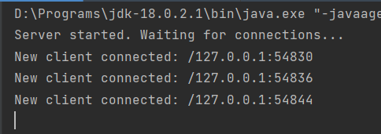
Server

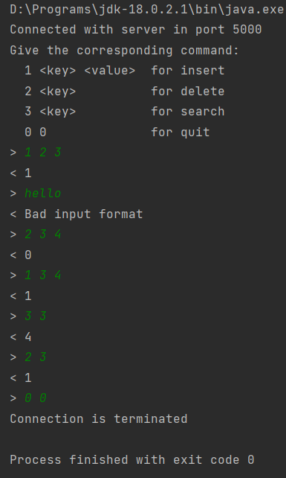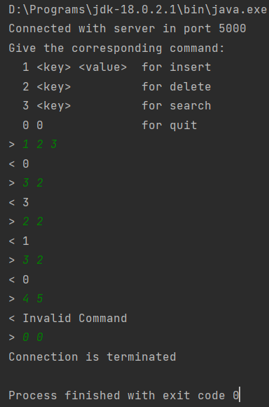
Client1 Client2

Subproblem 4
This project implements a process communication system of the server–producer–consumer type using TCP sockets. More specifically, each server contains an integer variable called storage, which stores the total stock of products. Its value is randomly initialized within the range [1, 1000] at startup.
The server listens on two different ports — one for producers and one for consumers. For example, in a system with three servers, ports 8881, 8882, 8883 can be used for producers and 9991, 9992, 9993 for consumers. Each server creates two threads: one to handle connections from producers and another for consumers. For every new connection, a separate thread is created, allowing simultaneous access from multiple clients. All critical operations that involve the shared storage variable are protected using synchronized (lock) to ensure the atomicity of actions.
The producer and consumer processes operate independently and repeat the procedure indefinitely. At each step, they randomly select one of the available servers, establish a connection, send the corresponding command (ADD or REMOVE), receive the server’s response, and close the connection. After each transaction, they wait for a random period between 1 and 10 seconds before repeating the process with another randomly chosen server.
Communication between the server and clients occurs via string commands.
- Producers send commands in the form ADD X, where X is a random number between 10 and 100. The server checks if adding X exceeds the storage limit of 1000. If not, it updates the storage and responds with OK along with the updated stock value. If the limit is exceeded, it rejects the request and responds with LIMIT EXCEEDED.
- Consumers send commands in the form REMOVE Y, where Y is a random number between 10 and 100. If removing Y does not reduce the storage below 1, the operation is completed, and the server responds with OK and the updated stock. Otherwise, it replies with NOT ENOUGH STOCK.
For the execution of the program, the required arguments for the server, consumer, and producer were defined through the Run Configuration Settings of IntelliJ IDEA. Specifically, three servers were created, each receiving arguments (8881, 9991), (8882, 9992), and (8883, 9993), respectively. The producers and consumers are assigned the IP 127.0.0.1 and their respective port lists separated by commas — (8881,8882,8883) for producers and (9991,9992,9993) for consumers.
Finally, by enabling the Allow parallel run option, multiple producer and consumer processes can run simultaneously, with each one randomly connecting to one of the available servers.
Below is an example illustrating the program’s operation:
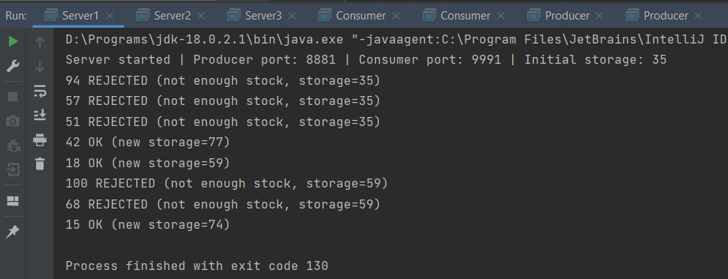
Server 1

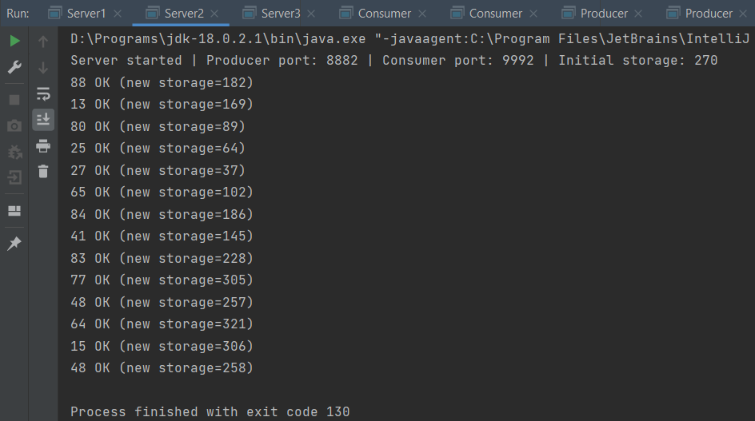
Server 2

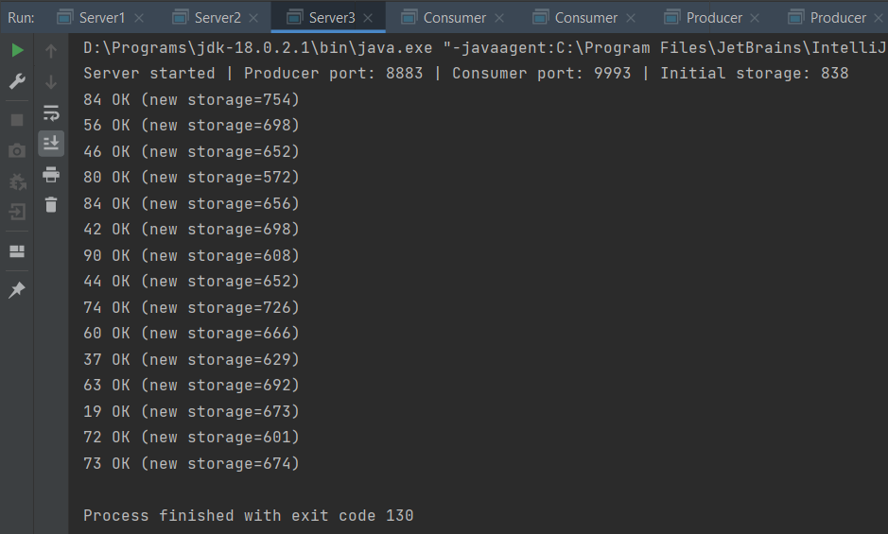
Server 3

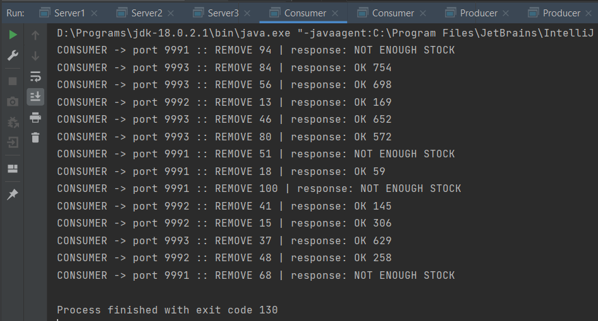
Consumer 1
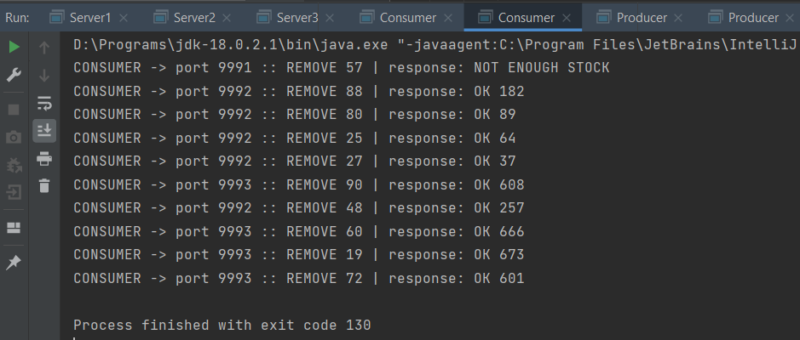
Consumer 2

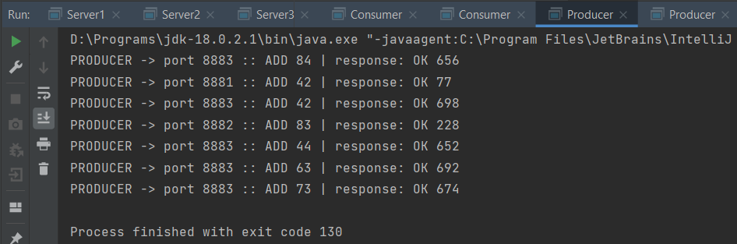
Producer 1

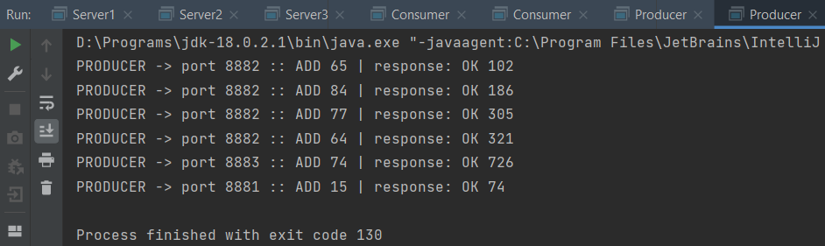
Producer 2

