**Valiance Partners**

**User Guide**

**Veeva Delete 4.5**

*Developed By*

**

110 Allen Rd. Suite 402

Basking Ridge, New Jersey 07920

©2018 Valiance Partners All Rights Reserved By permission   
This publication, or any part thereof, may not be reproduced or transmitted in any form or by any means, electronic or mechanical, including photocopying, recording, storage in an information retrieval system, or otherwise, without prior written permission of Valiance Partners.

**Version 4.5**

**Last Update 25 October 2019**

Microsoft and MS are registered trademarks, and Windows is a trademark of Microsoft Corporation.

Acrobat Reader is a trademark of Adobe, Inc.

Adobe Acrobat is a trademark of Adobe, Inc.

All Rights Reserved. Veeva and Vault are trademarks of Veeva Systems, Inc. and may be registered in certain jurisdictions.

# System Requirements

* Administrator Access to install tools on the PC
* Internet access and login credentials to a Veeva target system.
* Sufficient disk space to record progress logs.
* .Net framework 4.0 Client Profile or higher
* 32-bit Office 2010 or Microsoft Access Database Engine 2010 redistributable[1]
* Some features require Vault API v16.0 or greater.

# Installation

The tool is available from \\valiance2\vp\Veeva Delete\software

# Contents

System Requirements 3

Installation 3

Contents 3

Overview 4

Preparing a List to Delete 4

Basic Operation 4

Results 4

User Interface 5

Menu Options 6

Form Controls: Target Connection (Vault) 6

Form Controls: Source Selection. 6

Form Controls: Deletion Type 7

Form Controls: API Control 7

Form Controls: Logging control. 7

Form Controls: Deletion 8

Form Status Area 9

Progress Bar 9

Status Bar 9

Vault API Limit Management 9

# Overview

Veeva Delete is a utility to help undo migrations of Documents, Binders and Objects from test environments. All versions or specific version may be deleted per a VQL search or an item file.

## Preparing a List to Delete

The list of items to delete may be given in a VQL search, or a CSV, Excel or Access file.

* The item to delete must be given in an “id” column.
* An Excel or Access file must give the list in the first sheet or table (in alphabetical order), which must include a “status” column, which will be updated with the deletion status.
* When deleting individual versions, the version should be given in the “major_version_number__v” and “minor_version_number__v” fields.
* A CSV file with more than one field must have the values separated by commas.
* A VQL search may specify a “FIND” search value and/or and a “WHERE” filter.
* 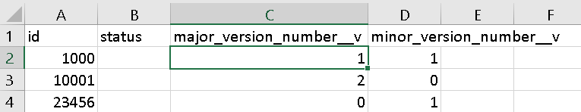Object cascade deletion is supported where the list is given in Excel or Access.

Figure . Example Excel deletion list for individual document versions

## Basic Operation

* Settings are used to select the type of item to delete, the deletion method, whether to delete one or all versions, and optionally a specific version to delete for all items.
* A list of items to delete is chosen as described above.
* A log file is chosen to record deletion progress.
* While deleting, deletion may be stopped before all items have been deleted.
* Undo is not supported.
* Application settings can be saved for later reuse. The user is prompted to save the current settings if there are unsaved settings when closing.

## Results

The selected items are deleted if possible, and success or failure responses from Veeva are tracked and logged. For Excel and Access source item lists, the “status” column is updated with the status of the deletion attempt.

A successful cascade deletion request creates a vault deletion job, which may fail. The job status can be checked separately in Vault.

# User Interface

The application provides the following entry and control features:

Figure 2. Screen shot of the application showing main entry and control features 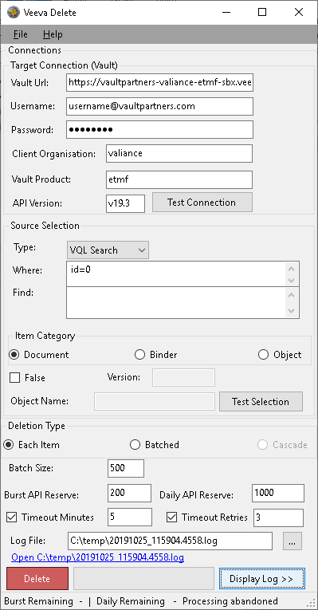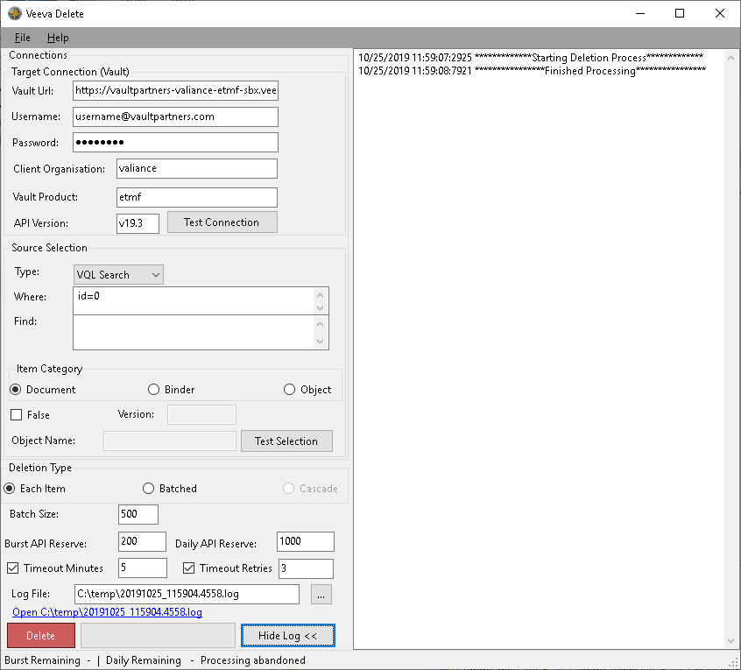

## Menu Options

* File: allows the application settings to be saved and reloaded.
  + Save State: if the settings - apart from password - have been changed, asks if they should be saved, and saves these settings if confirmed.
  + Load State: reload previously saved settings
* Help: gives information about the application.
  + User Guide: open this user guide.
  + About: provide application name version details for technical support queries.

## Form Controls: Target Connection (Vault)

* Vault Url: should be a http or https URL to connect to a vault
* Username: the user details for connecting to the vault
* Password: the password!
* API Version: the version of the API to use. Some features require a minimum v16.0
* Client Organisation: the organisation that owns the vault content.
* Vault Product: the document management product at the Vault Uri.
* Test Connection: check if the connection details are complete and working.

## Form Controls: Source Selection.

* 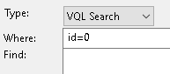Type: choose one of four supported item list types.
  + VQL Search: which records to delete, with one or both of:
    - Where: enter an VQL filter condition.
    - Find: enter a VQL keyword search value.
  + 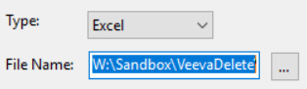CSV, Excel or Access: give a corresponding file with the list of items to delete file.
    - Filename: enter the file name.
    - “…”: browse to choose a file.
* Item Category: Document, Binder or Object items may be deleted
  + Binder/Document: choose whether to delete all versions or one version.
    - One Version: check to delete one version instead of all versions.
      * Version: enter the major.minor version number to delete a specific version of all items with “One Version” deletion. If not entered, the “One Version” numbers should be given in the major and minor version number columns of the deletion list.
  + Object: the type of object to delete must be given.
    - Object Name: enter the API name of the type: e.g. application__v.
* Test Selection: counts the number of rows in the source selection after checking that it has the columns needed to delete items per the chosen item category.

For the VQL search source type, the number of items counted is the number of matching items in Vault, for files source types it is the number of items listed.

## Form Controls: Deletion Type

Different deletion types are available depending on the source type and item type.

* Each Item: deletion requests will be sent with an API call per item. Always used for binder deletion, also available for document deletion.
* Batched: deletions will be requested in batches of batches of up 500 per API call. Used by default deletion for document and object deletion.
* Cascade: a “Delete Cascade” API call is sent for each item. Available on object deletion only, where the source selection type is Excel or Access.

## Form Controls: API Control

* Timeout: optional number of milliseconds to wait for an API response before timing out.
* Batch Size: the number of items to include on each API call on batched deletes.
* Burst API Reserve: the number of API calls to reserve within the burst limit.
* Daily API Reserve: the number of API calls to reserve within the rolling daily limit.

## Form Controls: Logging control.

* Log File: the name of a file to record log messages into should be entered here.
  + 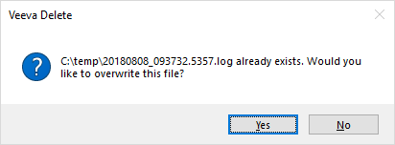 When starting a deletion run, if a file with the same name already exists, the user is given the option to abandon the process or overwrite the file.
  + If the extension is not “.log”, the extension “.log” is added to the file name.

If the specified folder does not exist, the log file will not be created.

* “…”: opens a dialog to confirm the log file name and location. A default log file name is calculated from the date and time.
* Open (log file) link: opens the log in the default application for the .log file type.
* Display Log: adds a viewing area to monitor the deletion progress.
* Hide Log: hides the log monitoring area.

The log monitor area contains the full log and will slow down larger jobs if visible.

Figure 3. The main form with the log monitoring area displayed.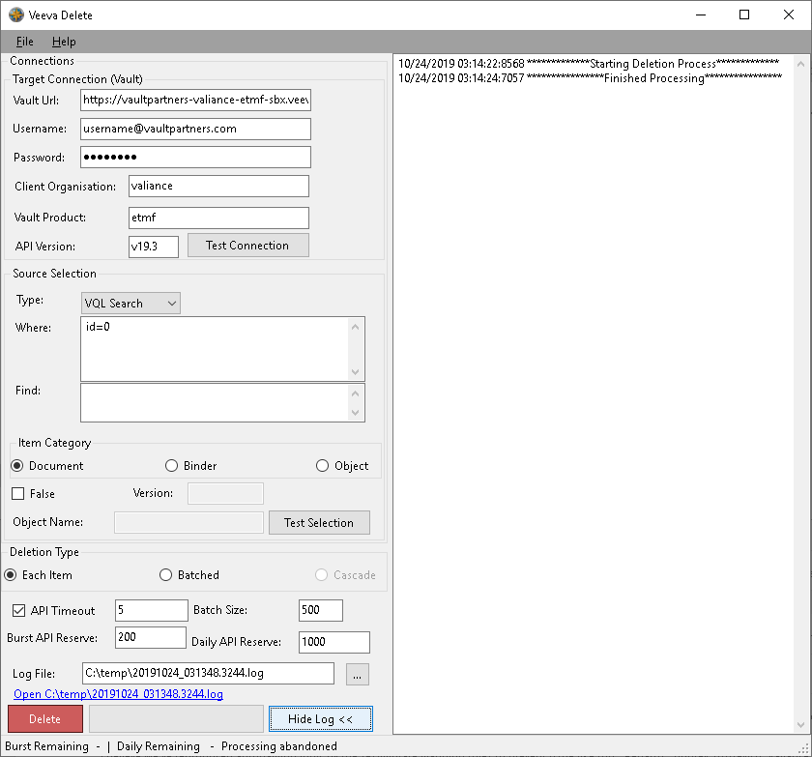

## Form Controls: Deletion

* Delete: checks if all required information has been entered, confirms deletion with the user and if confirmed starts the deletion process. The confirmation response defaults to no.
* Stop: available while a list of items is being deleted, stops further deletions.

The application cannot undo deletions. Ensure the correct items have been selected before hitting Delete.

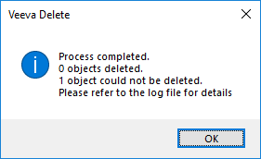

When the deletion process has completed, or is stopped, a summary of the number of successful and failed deletions is shown. Individual item deletion statuses can be found in the log, and in the status field on Excel or Access sources.

## Form Status Area

### Progress Bar

Shows the proportion of items processed so far, including successfully deleted items and items that could not be deleted.

### Status Bar

* Burst Remaining: the remaining burst limit, given by Veeva API responses.
* Daily Remaining: the remaining daily limit, given by Veeva API responses.

Limits are initially blank, until a request has been sent to Veeva.

# Vault API Limit Management

API calls can be kept in reserve. When a reserved level is reached, deltion is paused until the next five-minute burst window, or the next hour of the rolling daily window.

The API limit could be used up by other activities. Where the vault API advises that an API limit was exceeded, the affected deletion request is retried after the appropriate pause.

1. * The Microsoft Access Database Engine 2010 Redistributable currently available at: <https://www.microsoft.com/en-ie/download/details.aspx?id=13255>

  