OSNOVA Platform Features Guide

1. Elements
Each entity (lesson, test, survey, or event) has its own unique identification number (ID) and is an independent element that can be added to any course or test.
When creating a learning module in a course or test, the administrator has access to the "Add Element" button. Clicking it opens a universal modal window containing a tree of all entities created on the platform, grouped by their respective tabs:
- Courses (expands to the structure of modules and elements of a specific course);
- Tests;
- Surveys;
- Events.
Using the search bar by title inside this window, you can quickly find the required element. After selecting the desired element from the list, the administrator can import it directly into the current module with a single click.
________________________________________________________________________________

2. Folders
Folders are a tool for convenient structuring, management, and systemization of materials on the platform. In the "Courses", "Tests", "Surveys", and "Events" tabs, folders are always pinned at the very top of the list.
- Creating a folder: A folder is created using the "Create Folder" button in the header of the page. Clicking the button brings up a modal window where the administrator enters the folder name and selects one of 7 available round icon colors (red, orange, yellow, green, gray, blue, purple).
- Nesting: The first created folder becomes the parent folder. Folders created inside it become child folders (unlimited nesting depth is supported). The path to the current folder is clearly displayed in the form of breadcrumbs in the header.
- Ways to move materials (courses, tests, surveys, events) and folders themselves:
1. Drag & Drop: An element or folder can be grabbed by the menu icon (⋮) and dragged onto another folder. When hovering over the target, the folder is highlighted with a blue border, signaling that it can be dropped.
2. Move Modal Window: When selecting "Move" from the element's context menu, a window opens showing the hierarchical folder tree of the organization. In it, you can visually select the target folder or move the element to the "Start Screen" (the root).
- Folder Management: When hovering over a folder, a menu of additional actions (⋮) appears, allowing to:
- Edit the name or change the folder color;
- Move it to another folder or to the root;
- Delete the folder. When deleting a folder, a warning is displayed stating that all nested materials and subfolders will be permanently deleted.
________________________________________________________________________________

3. Learning Materials
This section is a builder for courses and tests. A course consists of modules, within which elements are located (lessons, lessons with homework, tests, surveys, events).
In the header of the course details page, the following functions are available:
- Preview: Allows you to see the course materials from the student's perspective.
- Assign Course: Opens a modal window where you can select users (students) and enroll them in this course.
- Course Settings: A tab for editing course parameters (title, description, cover, language of study — Russian or Uzbek, course cost when choosing "Paid" access type, setting a discounted price).
When hovering over a module or element, an access type icon is displayed:
- Open (green open lock) — available to students immediately;
- Closed (gray lock) — hidden from students;
- Scheduled (blue calendar with clock) — opens automatically at the specified date and time;
- Limited Period (yellow timer) — available only between the specified start and end dates.
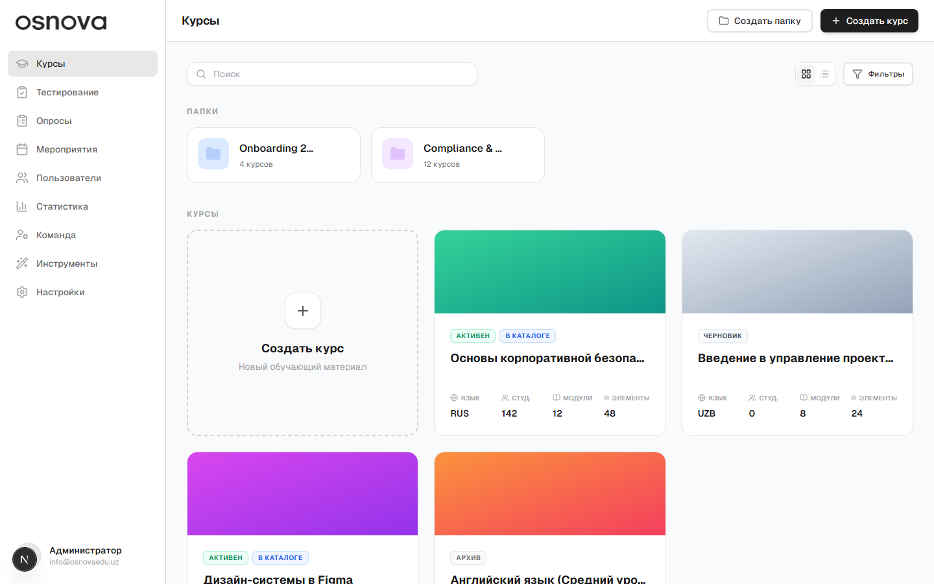
Courses overview page with folders and materials list
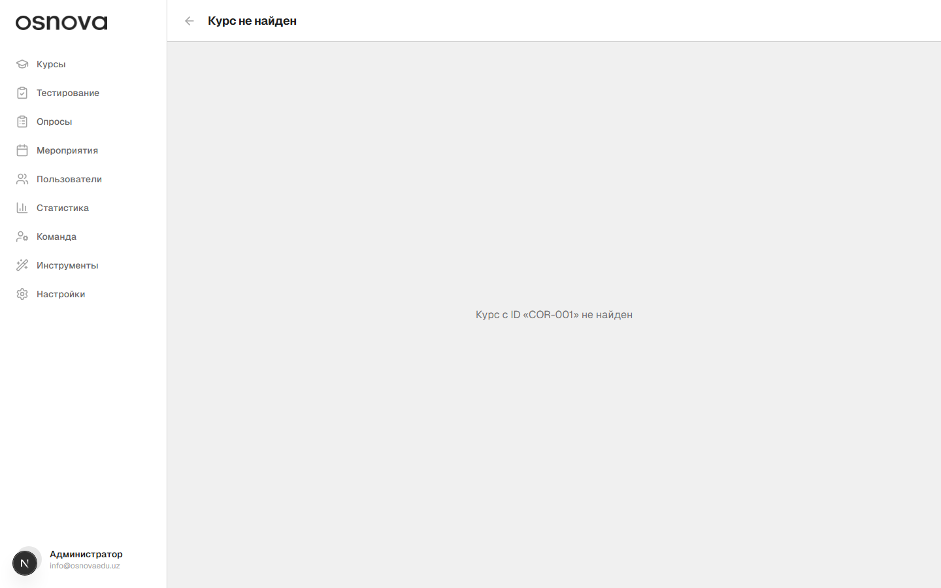
Detailed view of course content with modules and elements

3.1 Lesson Creation Tools
The lesson editor is a block-based constructor that allows you to assemble a lesson page from various media and text blocks.
Lesson settings panel (at the top of the page):
- Access Type: Dropdown list (Open, Closed, Scheduled, Limited Period) with date/time configuration.
- File Access: Restriction for the student (Full access, Preview only without download, Download only).
- Lesson Rating: A toggle to activate ratings (students can give a lesson 1 to 5 stars).
- Detailed Feedback: A toggle allowing students to leave text comments.
- Timer Lock: A toggle that sets the minimum time a student must spend on the lesson page (in minutes) before being able to complete it.
- Homework: Enabling homework with the ability to submit files and chat with the tutor in a dedicated chat.
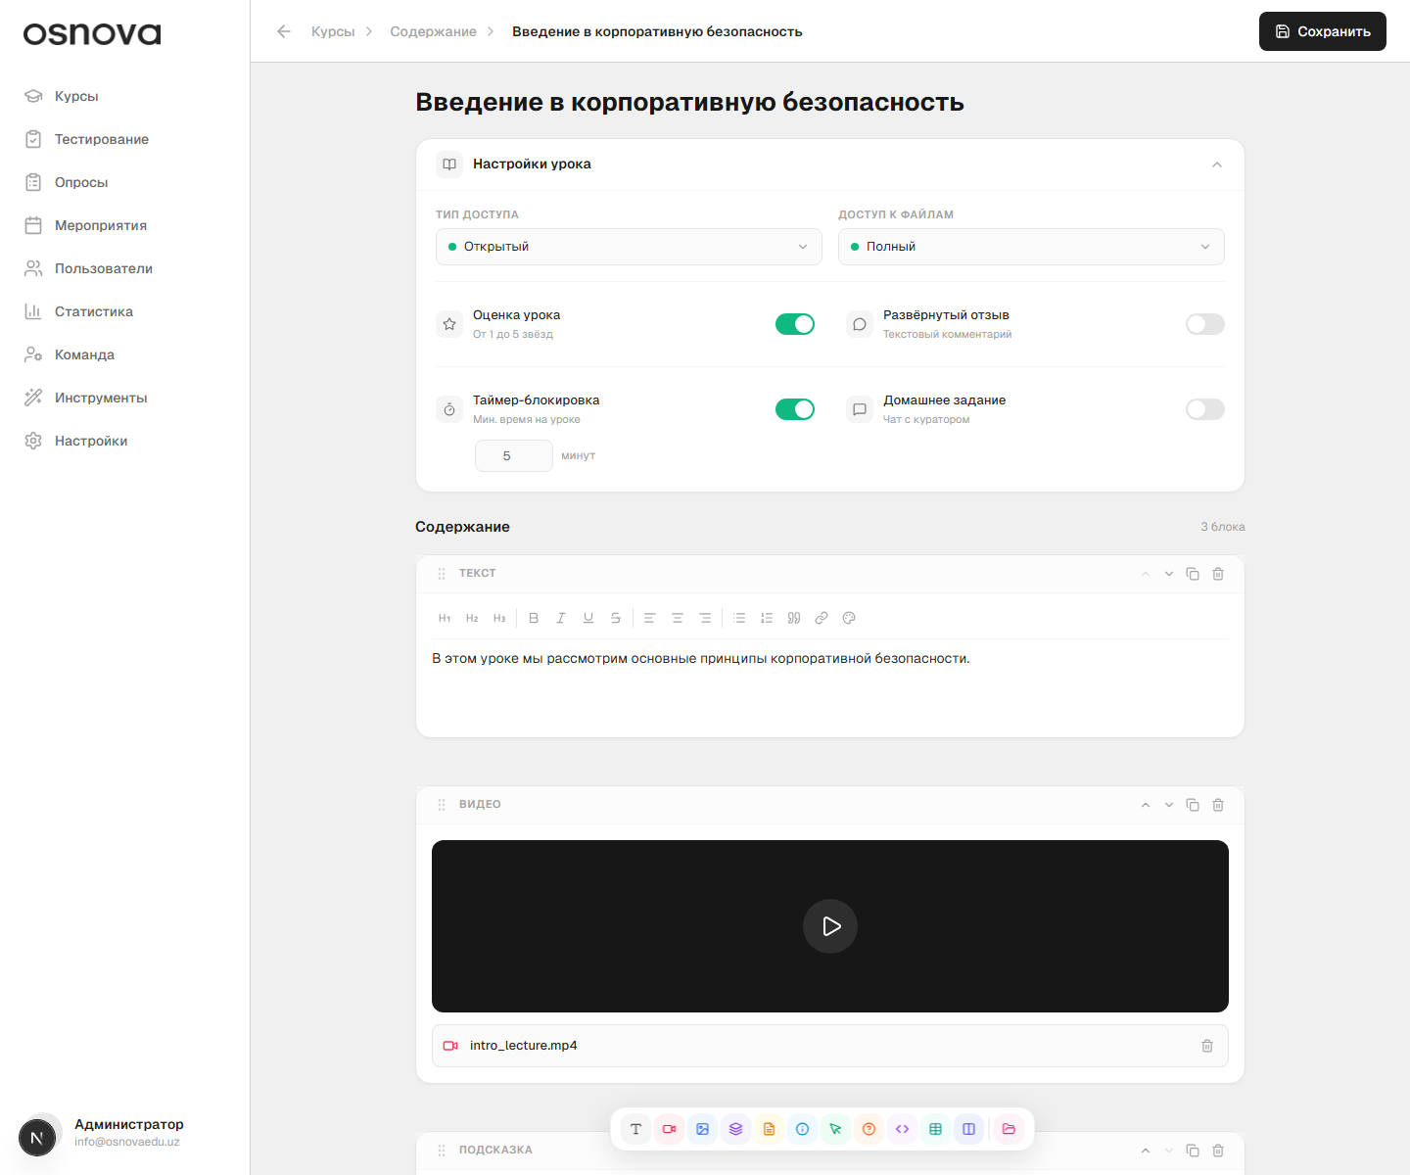
Lesson editor with block content constructor
Content Constructor (Bottom floating toolbar):
The administrator can add the following types of blocks to a lesson:
1. Text: A fully featured text editor. Allows formatting headings (H1, H2, H3), making text bold, italic, underlined, strikethrough, aligning it (justify/center/left/right), creating bulleted and numbered lists, formatting quotes, inserting links, and choosing text color using a palette.
2. Video: A block for uploading video files (MP4, MOV, AVI up to 2 GB) with subsequent preview in the video player.
3. Image: Image upload with the ability to add a centered caption underneath.
4. Slider: An image gallery where slides can be reordered by drag & drop and unnecessary ones can be deleted.
5. File: A block for attaching reference materials (PDF, DOCX, XLSX, PPTX) with individual permission settings (preview or download).
6. Callout: A special note block with customizable background and icon colors. Available icons: lightning, info, warning, question, idea, shield, error, success, or "no icon".
7. Button: An interactive button with a link to an external resource. The text, button color, and text color on it are configured. Additionally, the button can function as a content divider (the lesson content below the button remains hidden until the student clicks it).
8. Exercise: An embedded self-check mini-test for the student while reading the lesson. It supports question types: "One correct answer" (radio button), "Multiple answers" (checkboxes), and "Yes/No". The question can be supplemented with an image. The exercise block also supports the content divider function.
9. Code (Iframe): A field for inserting external HTML/JS code (e.g., interactive maps, video hosting players, or widgets) that automatically scales to the user's screen.
10. Table: A tool for creating tables with unlimited addition of rows and columns. It supports text formatting inside cells, highlighting the first row as a Header, setting individual background colors for specific cells, and manually changing column widths by dragging their borders.
11. Columns: A grid that splits content into 2 or 3 vertical columns. Inside each column, the administrator can add their own nested blocks (text, image, video, table, file).
All created blocks can be duplicated, deleted, moved up/down with arrows, or dragged with the six-dot handle. Also, divider lines can be inserted between blocks, and new elements can be added at specific positions in the lesson.
________________________________________________________________________________

3.2 Test Creation Tools
The testing creation and editing interface is split into two main tabs: "Settings" and "Questions".
"Settings" Tab:
- Basic Information: Text fields to enter the test title, description for students, and an area to upload a rectangular cover image.
- Access: Setting the visibility of the test (Open, Closed, Scheduled, Limited Period) with a date calendar.
- Passing Rules:
- Mandatory Test: When enabled, the student cannot progress further in the course until they successfully pass this test.
- Time Limit: Configuring a timer for test completion in hours and minutes.
- Number of Attempts: Setting a limit on the number of attempts to pass the test (0 for unlimited).
- Passing Threshold: The minimum number of correct answers required for a successful pass.
- Show Results: A toggle allowing students to see their mistakes and correct answers after completing the test.
- Question Settings:
- Shuffle Questions: Activates a random order of questions for each student.
- Number of Questions in Test: Allows presenting only a random subset of questions from the total pool to the student (e.g., 10 random questions out of 50 loaded).
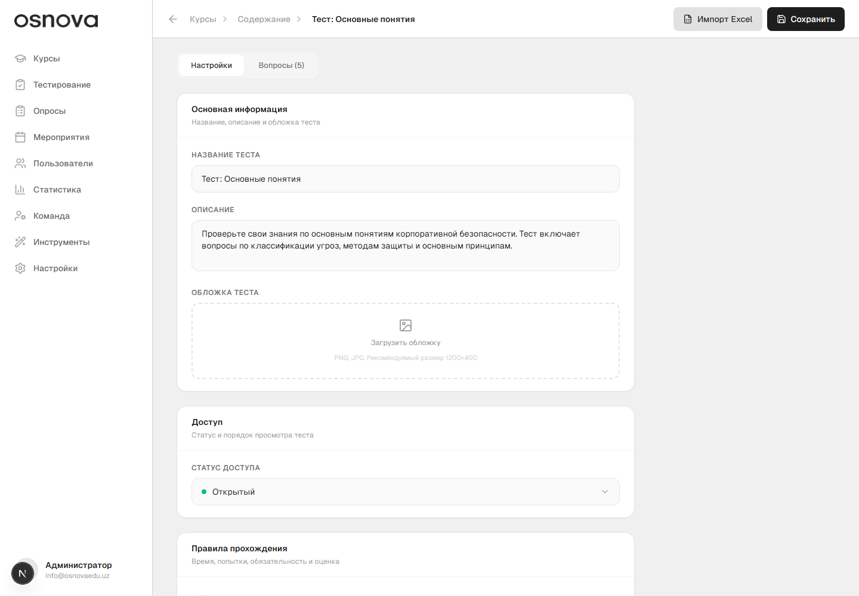
Testing rules settings tab
"Questions" Tab:
The screen is divided into two parts: a left sidebar with the list of questions and a central editing area for the selected question.
- Questions Sidebar:
- A search bar to find questions by their text.
- A list of questions with their sequence numbers and type icons. Next to each question, a colored status circle is shown: green (the question is ready and has a correct answer), blue (the question has text but no correct answer selected), or gray (empty question).
- Ability to reorder questions by drag & drop.
- Buttons to quickly create new questions by type.
- Central Question Editing Panel:
- A field to enter the question text.
- A button to attach an image to the question.
- Question Type Selection:
1. One correct answer: A list of choices with a single correct option selected via a radio button.
2. Multiple correct answers: A list of choices where all correct options are marked with checkboxes.
3. Ordering: A list of items that the student must arrange in the correct sequence.
4. Matching (Pairs): A builder of pairs consisting of left and right text parts. For the student, the right-column items will be shuffled and must be connected by lines.
5. Yes/No: Selecting one of two pre-made statements ("True" or "False") as the correct answer.
- For "One answer" and "Multiple answers" types, the administrator can add images to each individual answer option and write a text explanation (explaining the mistake/correct choice) that the student will see when reviewing results.
- Any question can be duplicated or permanently deleted using the corresponding buttons.
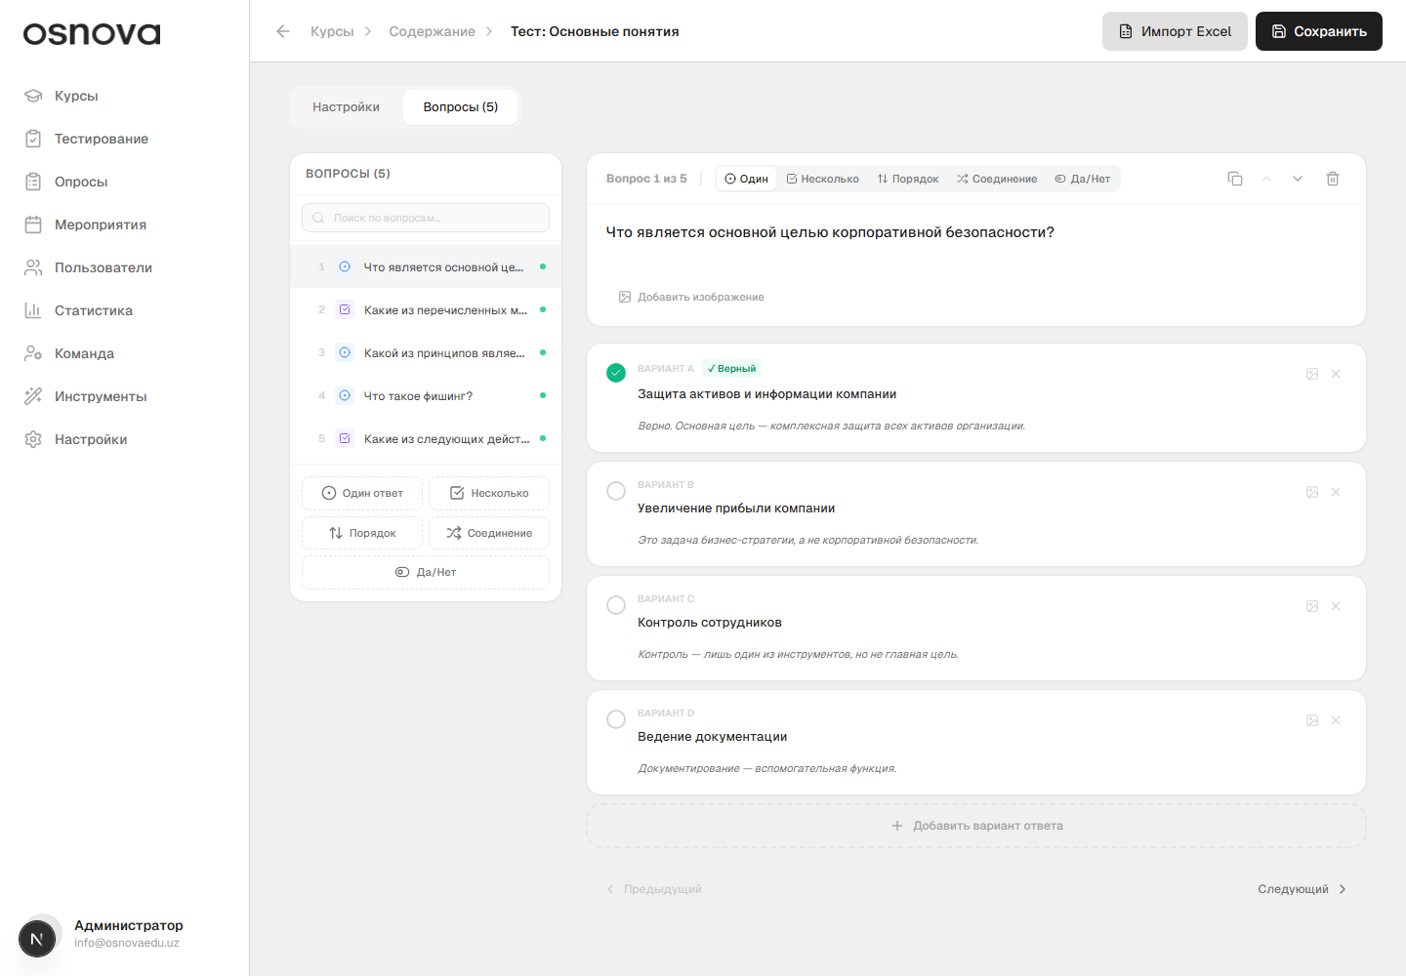
Test questions builder tab with side list
________________________________________________________________________________

4. Surveys
This section is designed to collect feedback, conduct questionnaires, and perform research. Survey cards are shown in a general list indicating the number of assigned students, the number of responses collected, and the current status (Active, Draft, Completed).
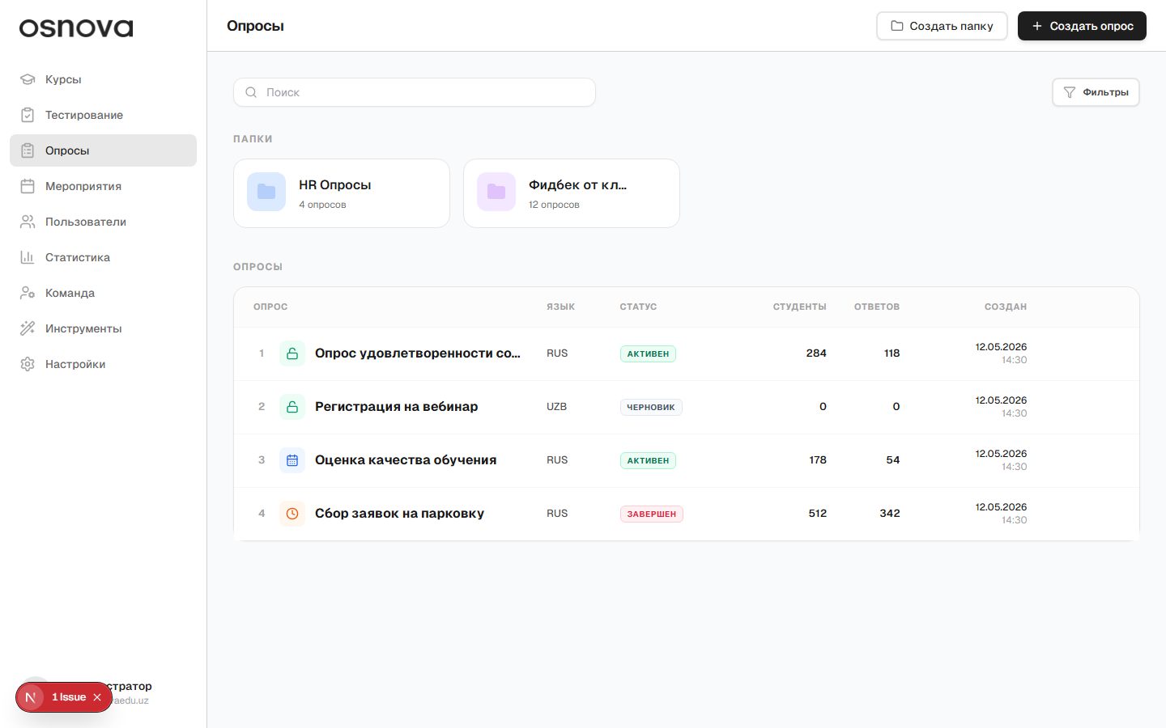
Surveys list showing number of responses and statuses

4.1 Survey Creation Tools
The survey builder is visually and functionally similar to the lesson editor, but it focuses on feedback collection forms and contains no logic for correct/incorrect answer checking.
Survey Settings:
- Survey title and language (Russian/Uzbek).
- Access type (Open, Closed, Scheduled, Limited Period) to control the questionnaire availability time.
Survey Questions Builder (Floating toolbar):
In addition to general information blocks (text, image, video, slider, table, columns, button, callout, iframe code), the survey editor contains three specialized interactive blocks:
1. Scale: A question for numerical evaluation. The administrator can configure a scale from 1 to 5. The toggle "Use emoticons" is supported — instead of numbers, the student will see 5 emotional emoticons (from annoyed to excited: 😠, ☹️, 😐, 🙂, 🤩).
2. Open-Ended Question: A field for students to enter free-form answers. The administrator selects the format: Short Answer (single-line text field) or Detailed Answer (multi-line text field for detailed feedback).
3. Question (Choice of Options): A form with multiple choice options. It supports types: "Single Choice" (radio button), "Multiple Choice" (checkboxes), and "Yes/No". Illustrations and explanatory text can be added to response choices.
Mandatory Responses:
For each block added to the survey, a "Mandatory" checkbox is available in its management panel (BlockToolbar). If checked, the student will not be able to submit the survey without answering this specific question.
________________________________________________________________________________

4.2 Viewing Survey Results and Reports
After collecting responses, the administrator can study the survey results on its statistics page. The page is divided into two tabs: "Summary" and "Individual Answers".
"Summary" Tab (Aggregated Statistics):
- General Metrics: Key survey indicators are shown at the top:
- Total number of assigned students;
- Number of actually collected responses (users who completed the survey);
- Completion Rate — the proportion of respondents out of the total assigned;
- Average time spent by users on completing the survey.
- Statistics for Each Block: Each question is presented as a summary chart or percentage table:
- Scale and Emoticons: Displays the average rating and percentage distribution of votes for each score (1 to 5 stars or by emoticon type).
- Yes/No: A clear chart with the percentage ratio of "True" and "False" responses.
- Choice of Options: Percentage shares for each selected answer option (hover to show the exact number of respondents).
- Open-Ended Text Answers: Displayed as a structured list with author information (Full Name, Email, date). Internal pagination and a search bar to filter reviews by keywords are provided for text answers.
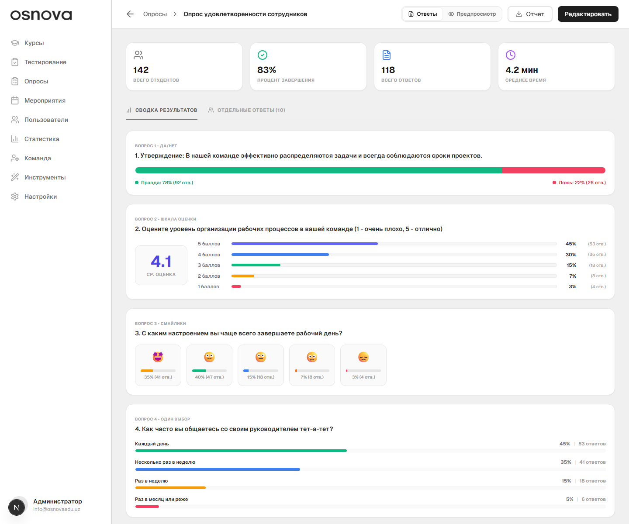
Summary analytics of survey results with charts and metrics
"Individual Answers" Tab (Personal Questionnaires):
An interface for detailed viewing of the questionnaire of each specific student.
- Students Sidebar: Contains a list of all users who responded, with their avatars and full names. The panel features a search bar to instantly find a specific person's questionnaire by name or email, as well as pagination.
- Central Questionnaire Viewing Panel: When selecting a user in the sidebar, a copy of their completed survey form opens in the center. The administrator sees the exact wording of the survey questions and how the selected student answered them (selected choices, ratings on the scale, filled-in text fields).
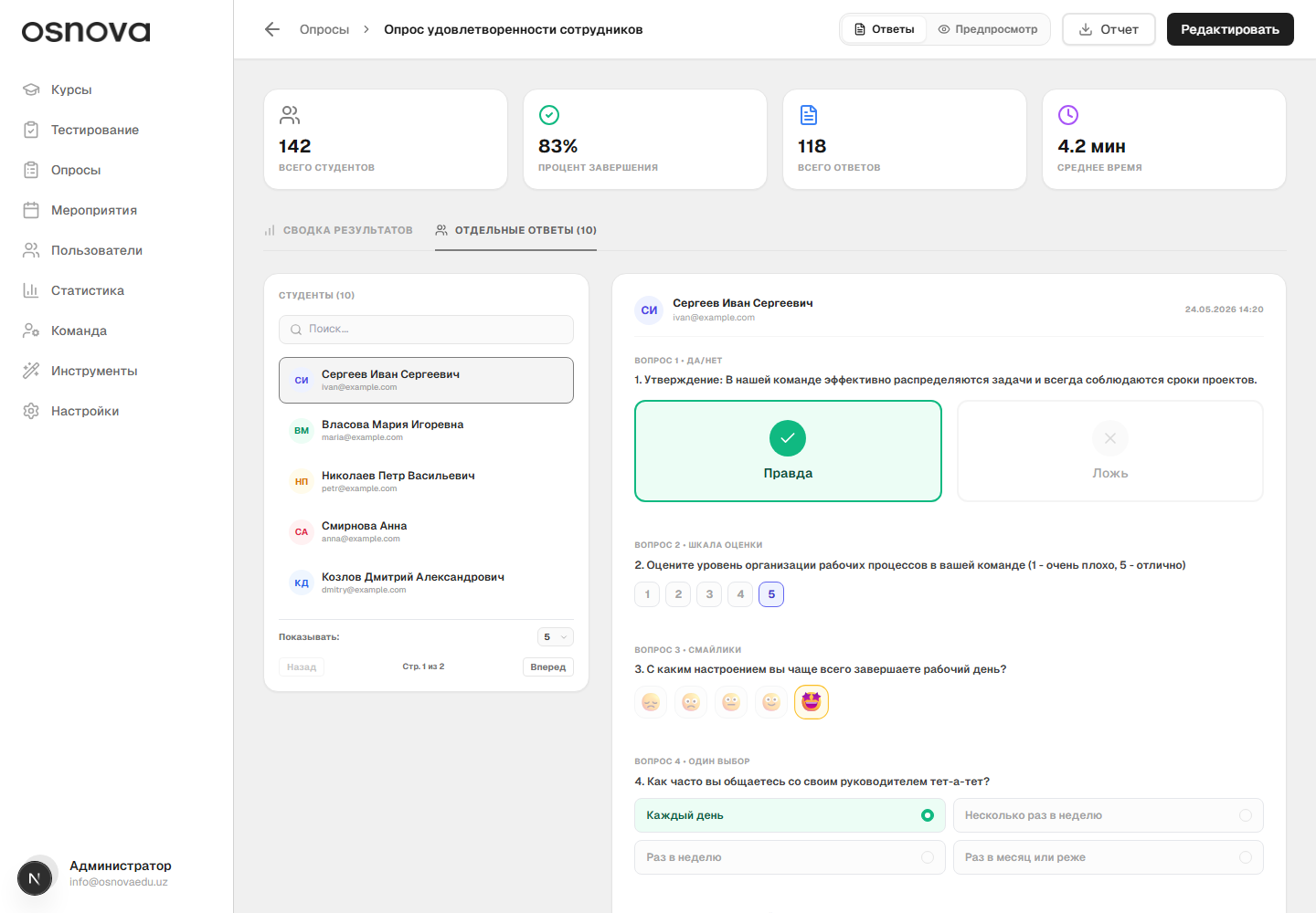
Individual student questionnaire view with responses
Exporting Reports:
On the right in the page header is the "Export" button with a dropdown menu allowing data extraction in CSV or Excel (XLS) formats:
- If the "Summary" tab is active, an aggregated table is exported (list of questions, response types, and total percentages/shares);
- If the "Individual Answers" tab is active, the complete database of results is downloaded (a table where rows list students with their personal data, and columns show their sequential answers to each question).
________________________________________________________________________________

5. Events
This section is designed for planning and conducting webinars, training sessions, workshops, conferences, and other educational events.
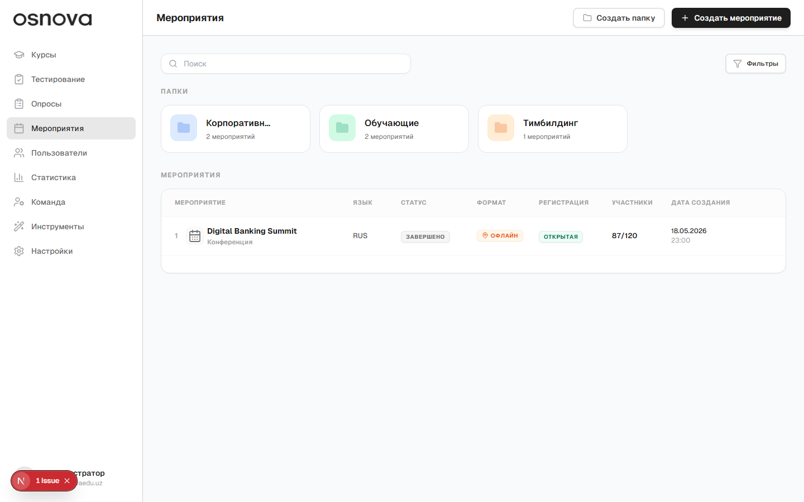
Events list with event cards and statuses

5.1 Event Content Constructor
Unlike a static schedule, an event page on the OSNOVA platform is built using a block-based principle, fully identical to the lesson and survey builders.
The administrator can use the floating toolbar at the bottom of the screen to fill the event program with various blocks:
- Detailed text descriptions and rules of participation;
- Presentation sliders and speaker illustrations;
- Embedded video recordings (e.g., a trailer or a recording of a past webinar);
- Methodological files for download (presentations, guides);
- Tables and divider interactive buttons.
This allows flexible styling of the event program, distributing information by days and modules.

5.2 Event Creation and Parameters
When creating a new event, the following parameters are configured:
- Name and Description: The event topic and introductory information.
- Format:
- Online: A field for entering a direct link to the broadcast (Zoom, YouTube, Google Meet, etc.);
- Offline: A field to enter the exact physical address and specify a room or hall.
- Language: Selection of the broadcast language (Russian, Uzbek, or English).
- Speakers: A field to list the names of invited experts.
- Dates and Times: Support for adding multiple dates and time slots (for multi-day events).
- Registration Parameters:
- Registration Type: Open (any student on the platform can sign up) or Closed (access only by administrative invitations).
- Registration Dates: A calendar of the start and end of the period during which the registration button will be active for students.
- Participant Limit: The maximum number of available seats (the system will automatically block registration when the limit is reached).

5.3 Registration and Tracking Participant Attendance
On the event details page, the administrator sees a list of all registered participants. Tools for manual control and automatic import are available.
Ways to Add Participants:
1. Manual Addition: Clicking "Add Participants" opens a modal window listing all platform users. The administrator can quickly filter students by city of residence, school/university, find the right person via the search bar, and add the selected ones (or click "Add all by filters").
2. Import List: The "Import" button allows uploading a ready participant list from a CSV or Excel file. An interactive upload area is provided in the import window. After selecting the file, the system reads and validates the data, showing a preview table of recognized rows (Full Name, Email, role, city) and the number of successfully validated participants before confirming the import.
Attendance Tracking and Arrival Time:
To track student attendance at the event (especially for offline formats), special interactive tools are provided in the participant table:
- Interactive Day Grid: The table automatically creates separate columns for each day of the event (e.g., "Day 1", "Day 2", "Day 3").
- Attendance Check: In the cell of each day for each participant, a dropdown list of statuses is available:
- Registered (the student registered for the event but has not arrived yet);
- Present (when checking this status, the system automatically records the current date and arrival time of the student at the event);
- Absent.
- Quick Actions: Using checkboxes in table rows, you can select a group of students and with a single click of the buttons in the table header mark them as "Present" or "Absent" for the selected day of the event.
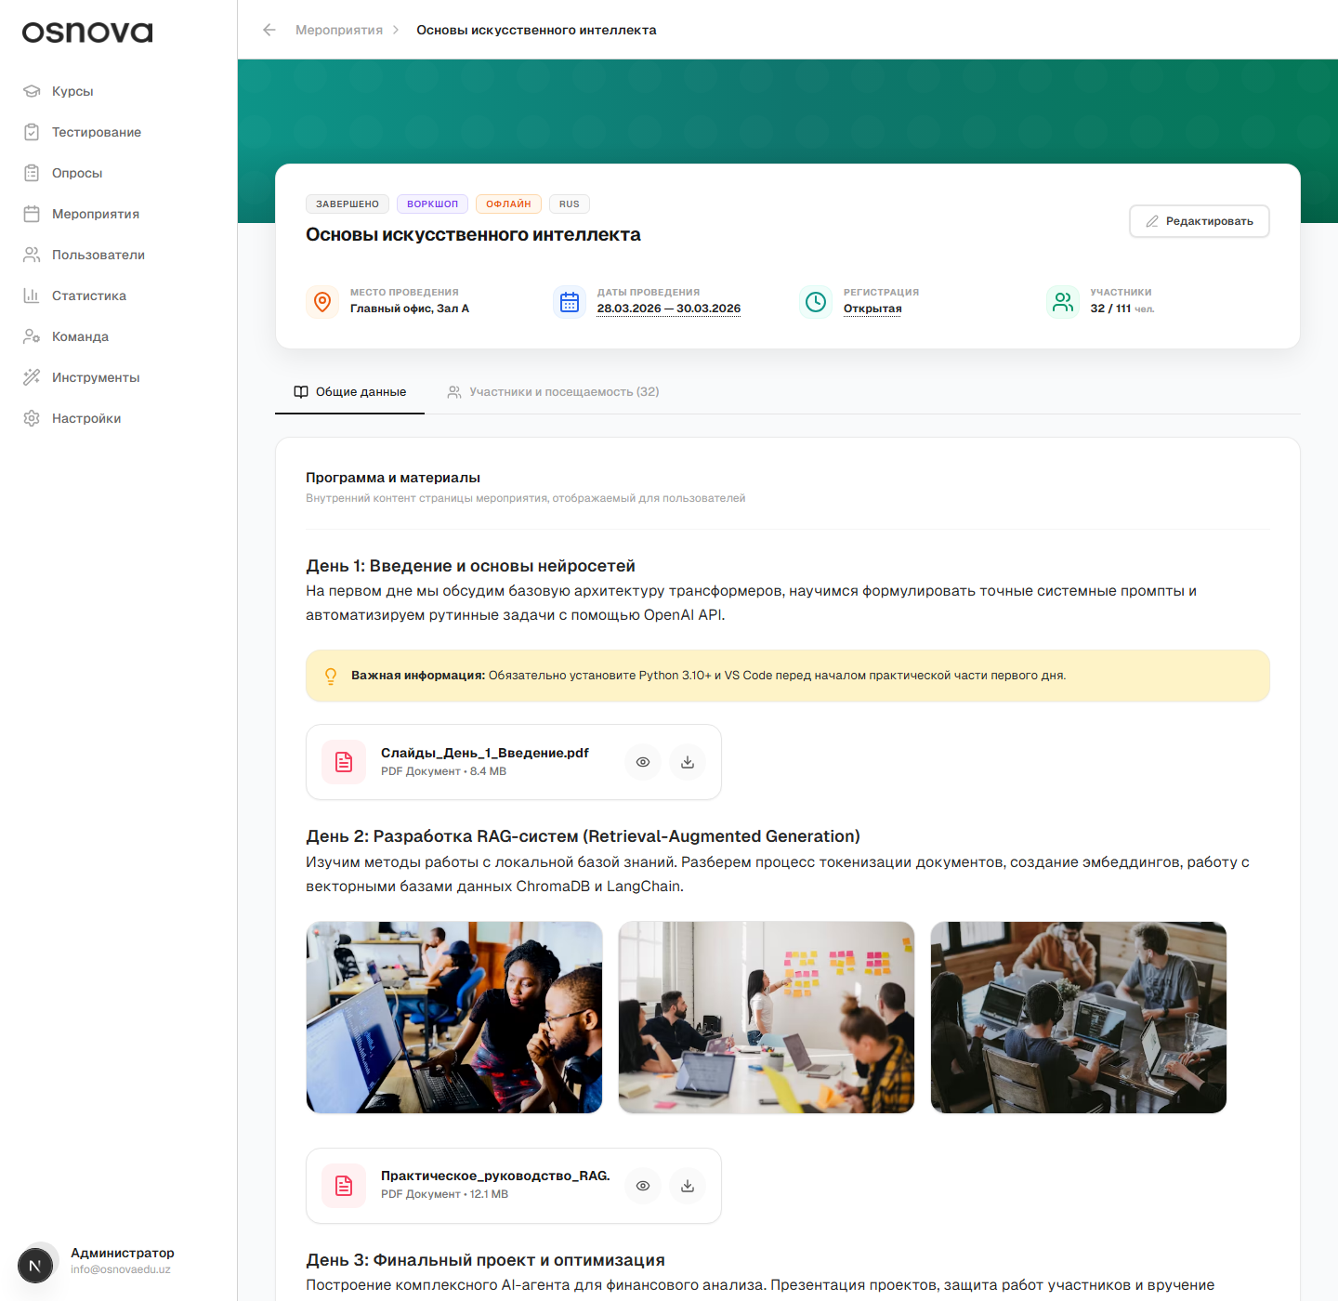
Detailed event view, tracking participants and attendance
________________________________________________________________________________

6. Managing Users
The "Users" section is designed for administering accounts of students and organization staff, managing their data, and tracking activity.

6.1 Overview Page and Filtering
All users are presented as a single table with columns: Full Name, Gender, Region, Priority Fields, Additional Fields, Last Visit Date, Registration Date.
At the top of the page is the filter panel, organized strictly in a single line for maximum convenience:
1. Search: Search by last name, first name, middle name, email, or phone number;
2. Gender: Dropdown list (All, Male, Female);
3. Region: Dropdown list (All, plus 14 regions of Uzbekistan);
4. Priority Fields: Dropdown list for filtering by the first priority custom field (e.g., Branch or Department);
5. Additional Filters: A button opening a panel for the remaining custom fields for fine-tuned filtering.
In the bottom right corner of the page is the "Download Excel" button with an icon. Clicking it generates and downloads an Excel table of all users. The download mechanism respects current filter settings: if no filters are applied, the entire user database is downloaded with all filled fields (personal data, visits, custom fields); if a filter is active (e.g., 200 users from a specific region are selected), only the data of these 200 filtered users will be downloaded.
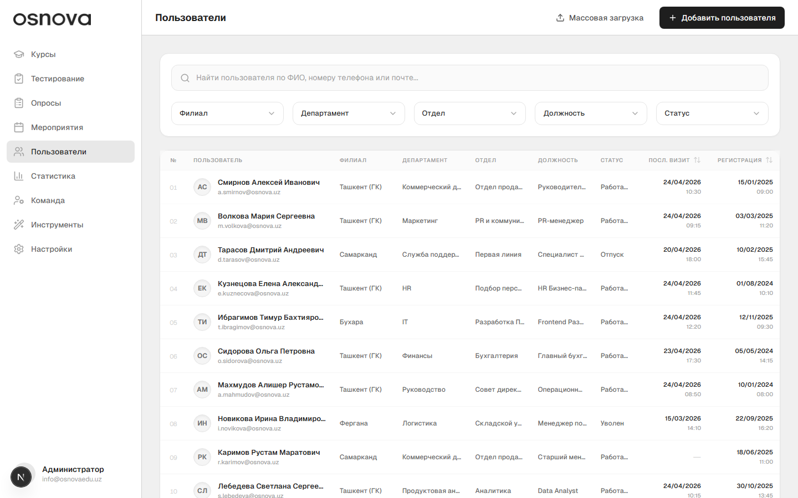
Users list page with single-line filters

6.2 Adding Users and Custom Fields
Clicking "Add User" opens a modal window divided into logical blocks:
- Personal Data: Last name, first name, middle name, date of birth, gender, region of residence.
- Priority Fields (up to 5): Important organizational parameters configured in the platform settings panel (e.g., Branch, Department, Section, Position, Status).
- Additional Fields: Secondary custom text fields (unlimited quantity).
- Role: Assigning a system role to the user in the system.
- Authorization Data: Phone number, Email, password, and password confirmation with a show/hide characters button.
All priority and additional fields are dynamic. They are created, renamed, deleted, and reordered via drag & drop in the "Settings" -> "User Fields" section. When these settings change, the user addition/editing forms and filters on the overview page are rebuilt instantly.
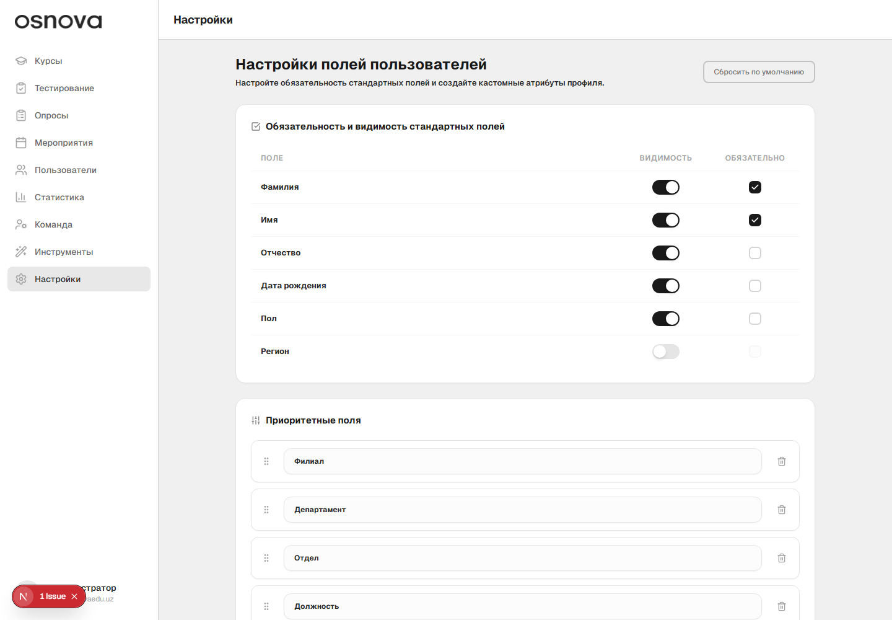
Settings of custom priority and additional user fields

6.3 Bulk Loading via Excel
The bulk loading modal window allows importing hundreds of users at once using a prepared Excel table.
- Dynamic Template: A "Download Template" button is available in the window. The system automatically generates a `.xlsx` file of the current structure by reading the current custom field settings:
- The first column is always "Full Name" (during import, the system automatically splits a single string into Last Name, First Name, and Middle Name);
- Columns for standard fields (Date of Birth, Gender, Region) are added if they are marked as visible in the settings. In the cells of these columns, data validation is embedded (dropdown lists to choose gender `F/M` or select a region from the 14 valid options to eliminate manual entry errors);
- Columns for all configured priority and additional fields are automatically added in the order and with the names specified by the administrator.
- Upload: The prepared file is dragged into a special area (Drag & Drop zone) of the window or selected via file explorer to perform the import. When the set of custom fields changes in the settings, the template is automatically rebuilt, ensuring the imported file matches the current database schema.

