{Suim Park && Valini Rangasamy}

GOAL OF THIS PROJECT

A project that will allow small/medium size business to manage their employees,   
keep track of their salaries, allowances and deductions and print out their employees’ pay stubs.

EMPLOYEE PAYROLL SYSTEM

JAVA 3 PROJECT PROPOSAL

**TITLE OF THE PROJECT:** EMPLOYEE PAYROLL MANAGEMENT SYSTEM

**NAME OF MEMBERS:** SUIM PARK, VALINI RANGASAMY

**DESCRIPTION OF THE PROJECT AND PURPOSE:** The goal of this project is to create a desktop application for small to medium size business that will allow these companies to manage their payroll system easily. The user will be able to:

* Keep a record of all their employees in the company
* Add/insert personal information to the database when a new employee is hired.
* Update/Delete personal information of existing employees
* Keep a record of allowances, overtime hours and bonuses for their employees
* Make updates to the allowances amount of their employees
* Keep a record of the CPP EI and tax deductions for their employees
* Make updates to the deductions amount of their employees
* Search the database for employee information/ allowances/deductions/total salary
* Search the database by department or by employee id to print pay stubs (pdf format)

**TECHNOLOGIES USED FOR THE PROJECT:**

* JDK for the functionality of the application
* SWING library to create the user interface
* MS SQL to create our database which is located on Azure ‘Cloud’
* iText, an open source library that makes PDF from Java
* GitHub Respository
* TRELLO to keep track of our project tasks list

**Database structure - (UML diagrams with relations)**

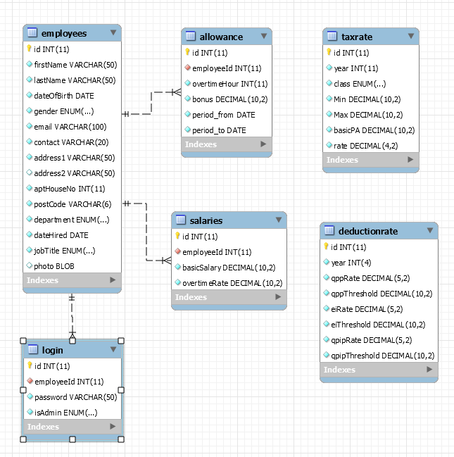

**Screenshots of all the meaningful windows we are planning in our project**

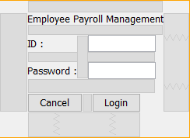**Login window**

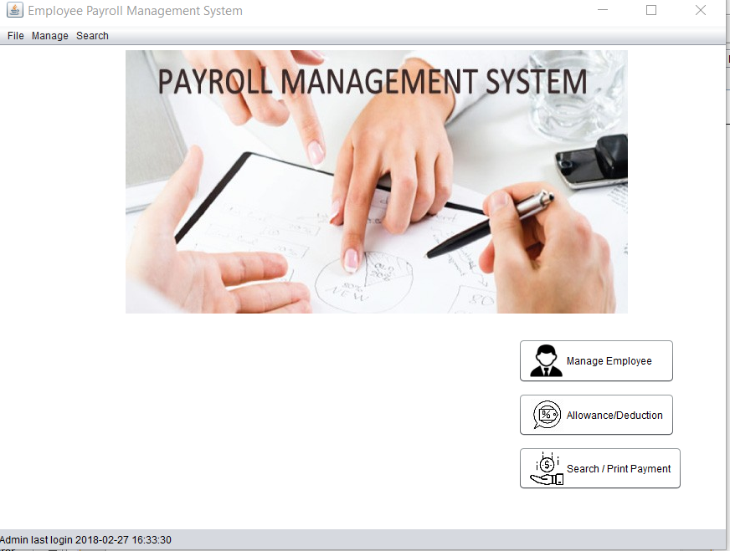**Main window**

**ManageLogin window**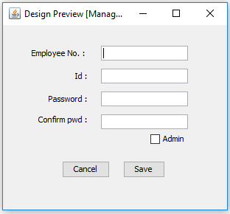

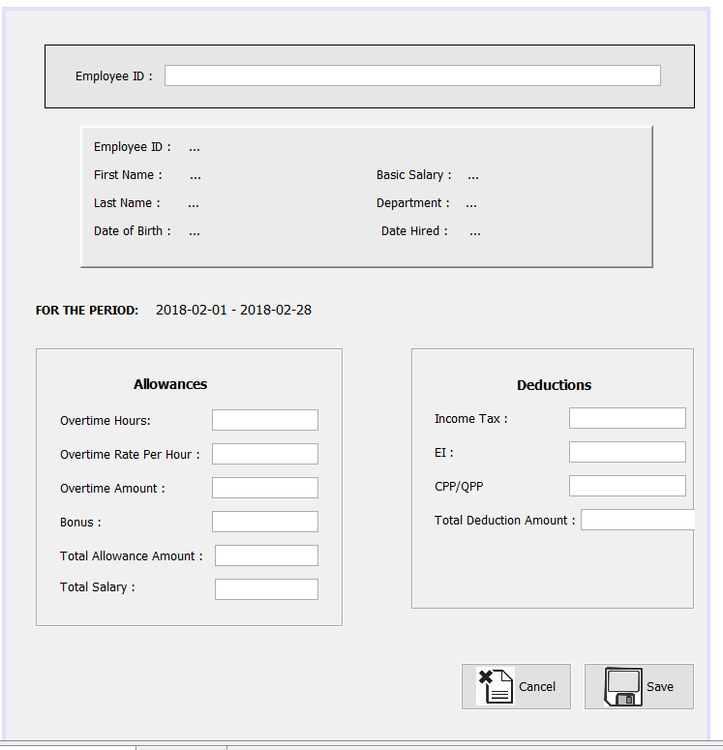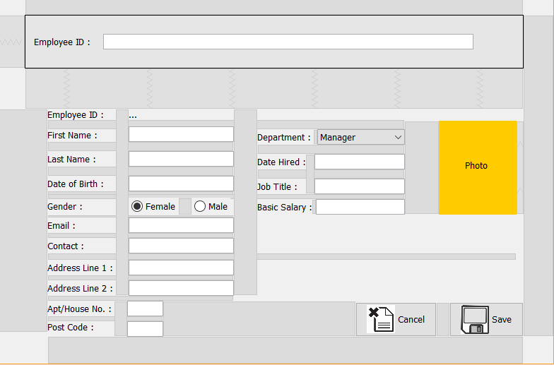**Employee Management Window**

**Employee Allowances and Deductions Window**

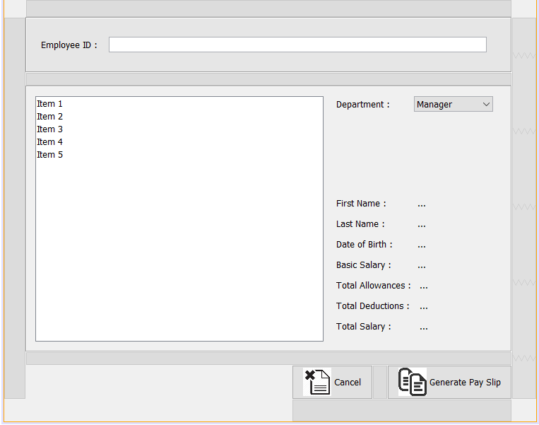**Search and Print Pay Slip Window**

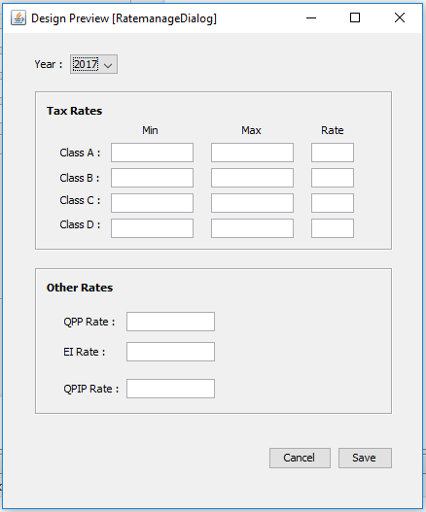

**RateManageDialog**