Helm:
Helm is a package manager for Kubernetes Application .
Helm help you define/create ,update & remove the application in k8s .

Helm 3 Architecture
In helm 3 there is no tiller component. Helm client directly interacts with the kubernetes API for the helm chart deployment.

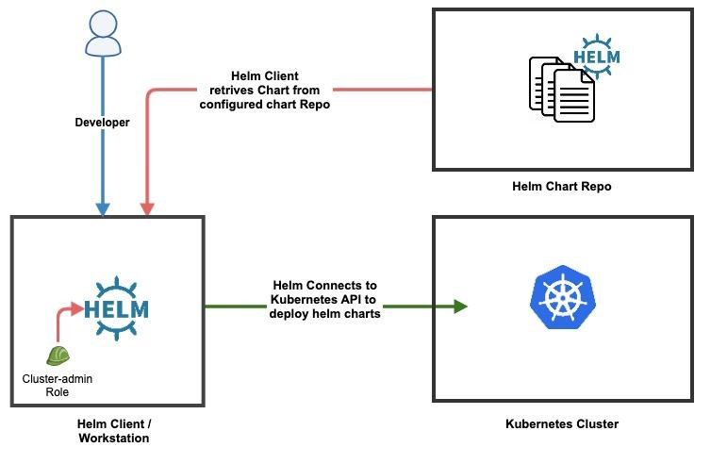
Helm 2 Architecture

In helm 2 there is a helm component called tiller which will be deployed in the kubernetes kube-system namespace. Tiller components is removed in helm 3 versions.

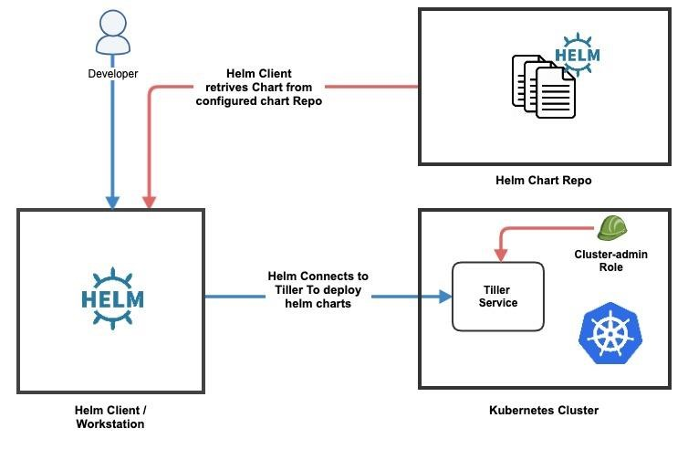

K
##Create Helm manually:

mkdir App --> cd App

#Chart.yaml
Vim Charts.yaml → metadata about the chart (name, version, etc.)

apiVersion: v1
name: app
version: 0.2.0
appVersion: 1.0
description: my custom nginx app

Template: template YAML files (Deployment, Service, etc.).

cd templates/ --> vim deployment.yaml
cd templates --> vim svc.yaml

write the scipts in files

#Values.yaml → default configuration values.
vim values.yaml

replicaCount: 3

service:
type: NodePort
port: 80
targetPort: 80

Vim Deployment.yaml

apiVersion: apps/v1
kind: Deployment
metadata:
name: app-deployment
labels:
app: app
spec:
replicas: 3
selector:
matchLabels:
app: app
template:
metadata:
labels:
app: app
spec:
containers:
- name: app
image: app:latest
ports:
- containerPort: 80

Vim svc.yaml

apiVersion: v1
kind: Service
metadata:
name: app-service
spec:
selector:
app: app
ports:
- protocol: TCP
port: 80
targetPort: 80
type: NodePort

Install :

Helm install app .

Upgrade
helm upgrade myapp

helm list –all or helm list -a
helm history <release-name)
Rollback:
helm rollback myapp 1 (revissions)

Delete Release (remove Deployment, Service)
helm delete --purge my-nginx -->delete deployment svc ingress or delete all

