VPC Peering :

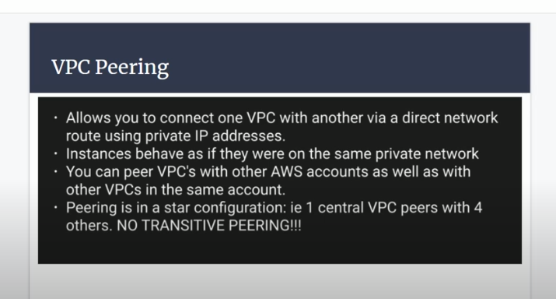

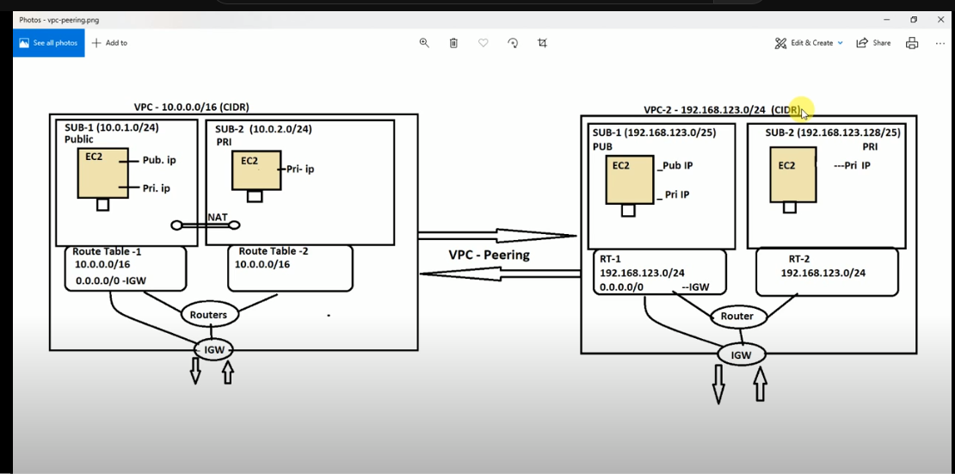

Create two vpc

Subnets

Route tables

Igw

Attach RT to subnets

Attach pub-RT to igw

Two VPC

Name :vpc-10

Name: VPC-192

Create vm in vpc-10

Public subnet vm

Create vm in vpc-192

Public subnet vm

Connect both machines

Ping vpc-192 machine

Ping vpc-10 machine

\*\*It will not ping …why bothe are two different vpc

Vpc-peering

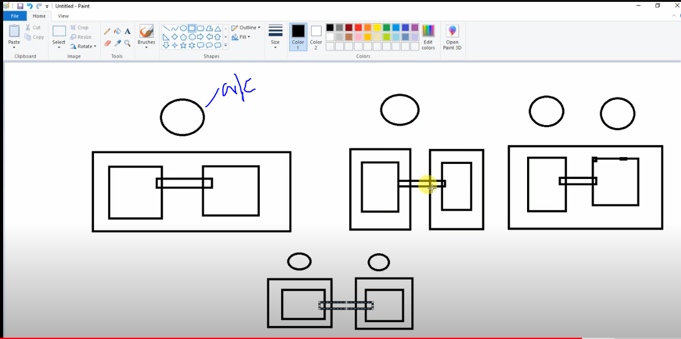

Create a peering steps :

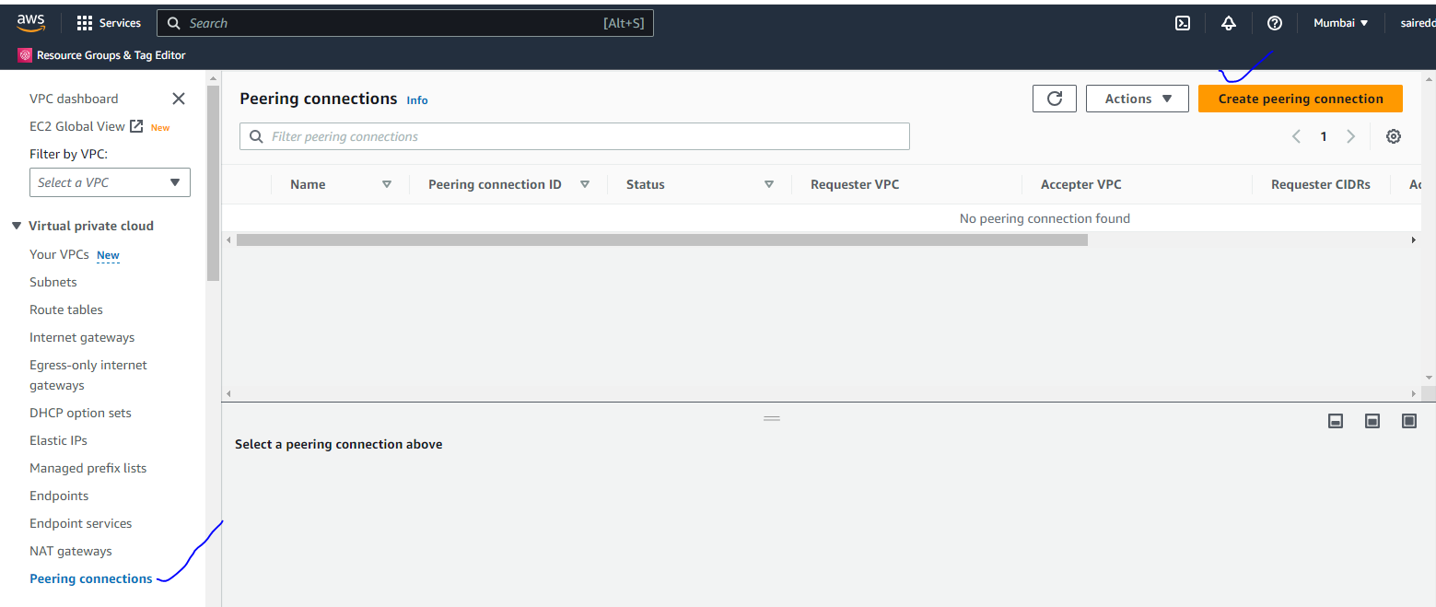

Click on create peering

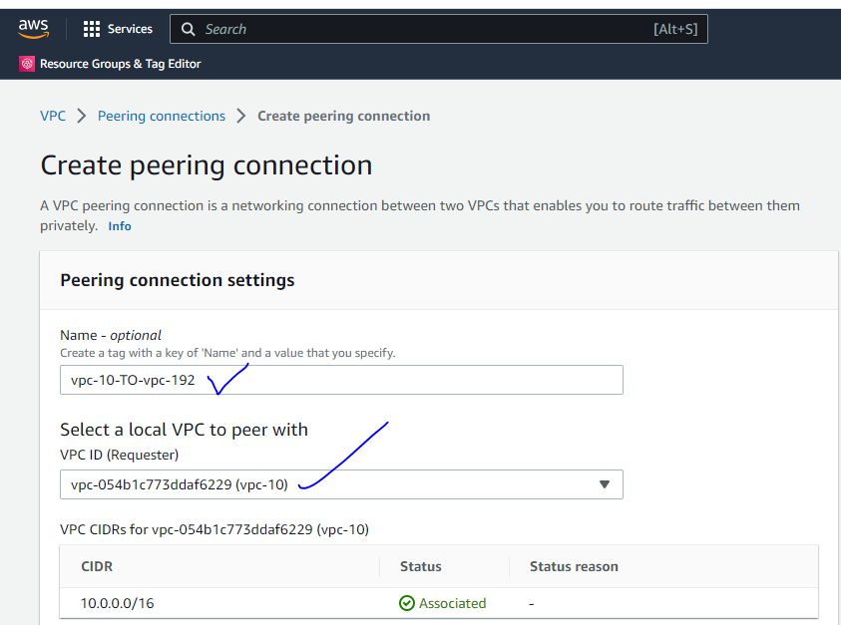

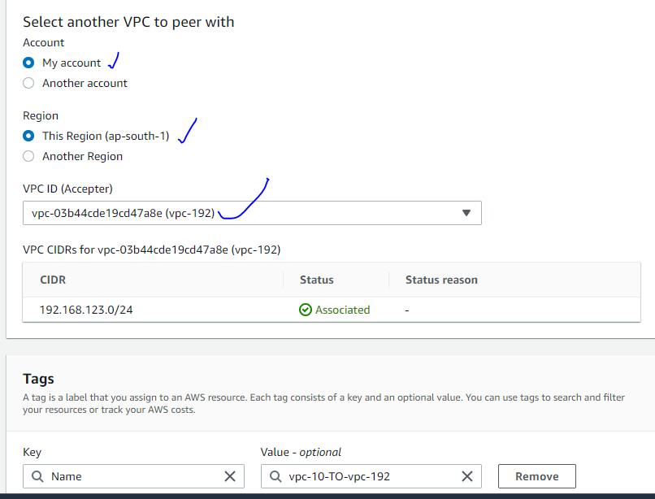

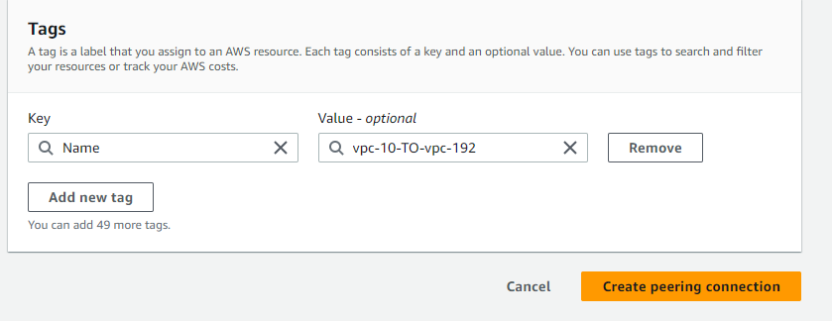

Click on Create peering

It will pending state you can accept the request

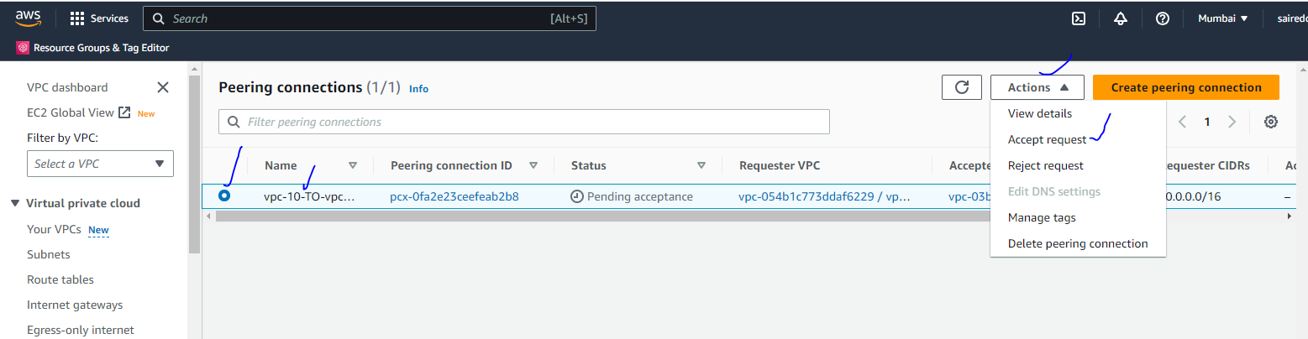

Click on accept the request

It will be active

Go to Route tables

Click on routes

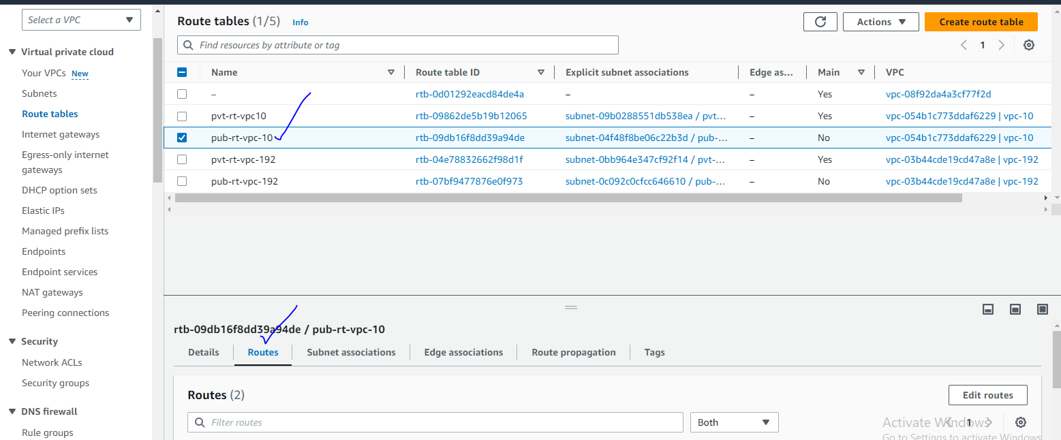

Click on Edit routes

10 to 192 peering the routes

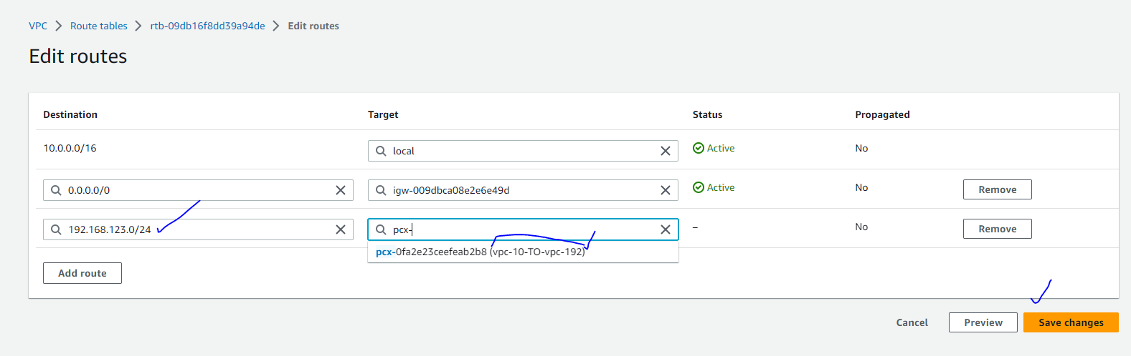

192.168 to 10 peering the routes

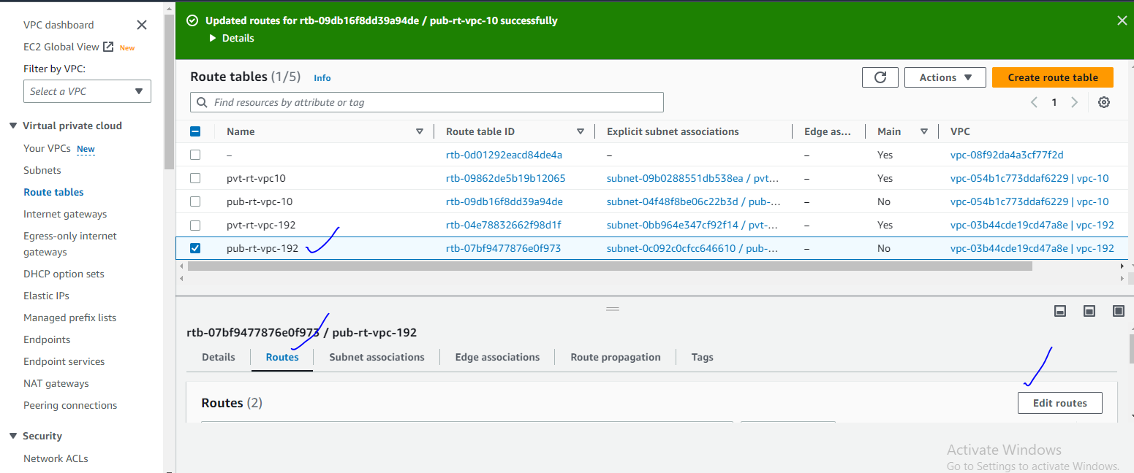

Click on Edit the routes

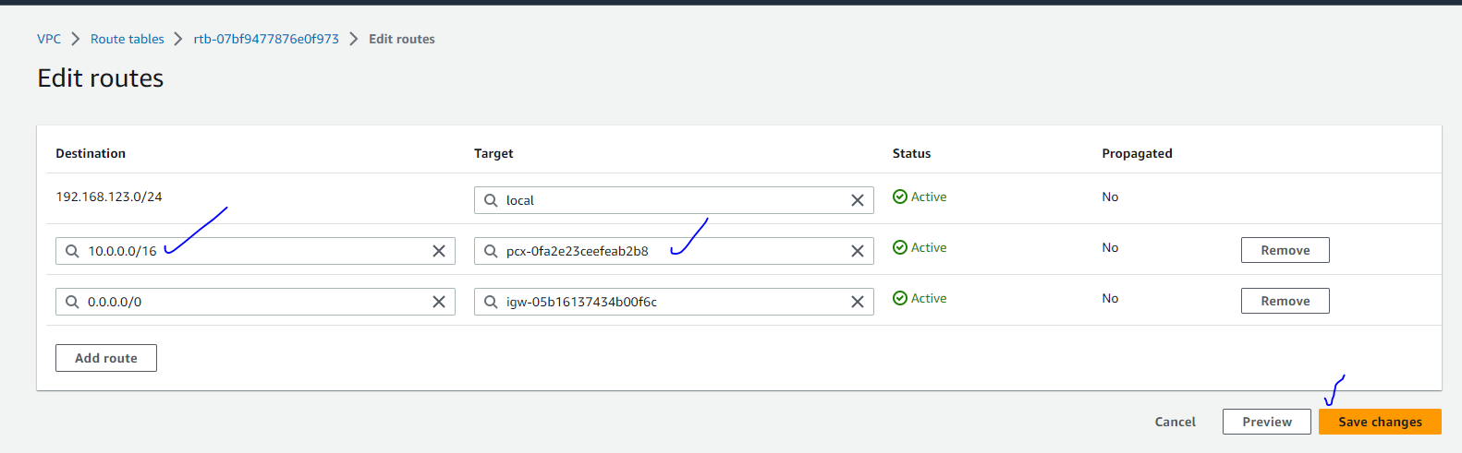

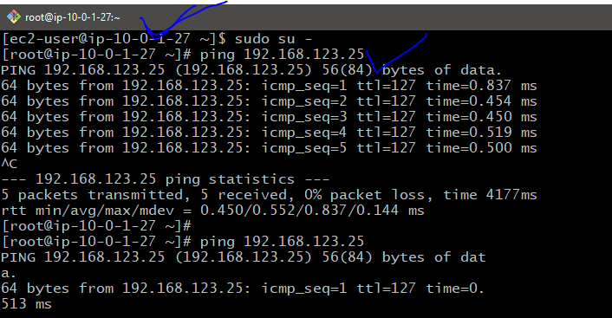

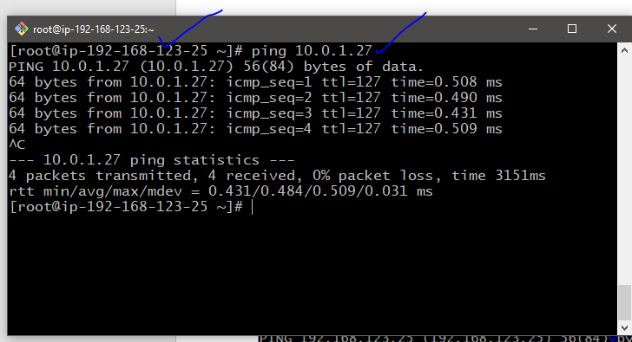

NO TRANSITIVE PEERING :

