

J I A N G S U U N I V E R S I T Y

信息论课程设计

学院： 计算机与通信工程学院
班级： 信息安全2002
学号： 3200604051
姓名： 谢璟隆

2022年12月 24日

- 任务说明
- 算术编码的编码和译码
要求：输入字符集为{a,b},且p(a)=1/4,p(2)=3/4.对长度L<=60（至少30）的序列进行算术编码，并进行反向译码；
输入文件:in1.txt，含至少两组输入，每组为满足要求的串；
输出文件:out1.txt，对每组输入的编码和译码结果

- 实验环境
Windows10
Visual Studio2022
- 代码实现
from collections import defaultdict
INT_MAX = float('Inf')
def Min_Distance(dist, visit):
(minimum, Minimum_Vertex) = (INT_MAX, 0)
for vertex in range(len(dist)):
if minimum > dist[vertex] and visit[vertex] == False:
(minimum, minVertex) = (dist[vertex], vertex)
return Minimum_Vertex
# Dijkstra Algorithm for Modified
# Graph (After removing the negative weights)
def Dijkstra_Algorithm(graph, Altered_Graph, source):
# Number of vertices in the graph
tot_vertices = len(graph)
sptSet = defaultdict(lambda: False)
dist = [INT_MAX] * tot_vertices
dist[source] = 0
for count in range(tot_vertices):
curVertex = Min_Distance(dist, sptSet)
sptSet[curVertex] = True
for vertex in range(tot_vertices):
if ((sptSet[vertex] == False) and
(dist[vertex] > (dist[curVertex] +
Altered_Graph[curVertex][vertex])) and
(graph[curVertex][vertex] != 0)):
dist[vertex] = (dist[curVertex] + Altered_Graph[curVertex][vertex])
# Print the Shortest distance from the source
for vertex in range(tot_vertices):
print('Vertex ' + str(vertex) + ': ' + str(dist[vertex]))
# Function to calculate shortest distances from source
# to all other vertices using Bellman-Ford algorithm
def BellmanFord_Algorithm(edges, graph, tot_vertices):
# Add a source s and calculate its min
# distance from every other node
dist = [INT_MAX] * (tot_vertices + 1)
dist[tot_vertices] = 0
for i in range(tot_vertices):
edges.append([tot_vertices, i, 0])
for i in range(tot_vertices):
for (source, destn, weight) in edges:
if ((dist[source] != INT_MAX) and
(dist[source] + weight < dist[destn])):
dist[destn] = dist[source] + weight
# Don't send the value for the source added
return dist[0:tot_vertices]
# Function to implement Johnson Algorithm
def JohnsonAlgorithm(graph):
edges = []
# Create a list of edges for Bellman-Ford Algorithm
for i in range(len(graph)):
for j in range(len(graph[i])):
if graph[i][j] != 0:
edges.append([i, j, graph[i][j]])
# Weights used to modify the original weights
Alter_weigts = BellmanFord_Algorithm(edges, graph, len(graph))
Altered_Graph = [[0 for p in range(len(graph))] for q in
range(len(graph))]
# Modify the weights to get rid of negative weights
for i in range(len(graph)):
for j in range(len(graph[i])):
if graph[i][j] != 0:
Altered_Graph[i][j] = (graph[i][j] +
Alter_weigts[i] - Alter_weigts[j]);
print('Modified Graph: ' + str(Altered_Graph))
# Run Dijkstra for every vertex as source one by one
for source in range(len(graph)):
print('\nShortest Distance with vertex ' +
str(source) + ' as the source:\n')
Dijkstra_Algorithm(graph, Altered_Graph, source)
# Driver Code
graph = [[0, -5, 2, 3],
[0, 0, 4, 0],
[0, 0, 0, 1],
[0, 0, 0, 0]]
JohnsonAlgorithm(graph)
- 实验过程
算法截图：
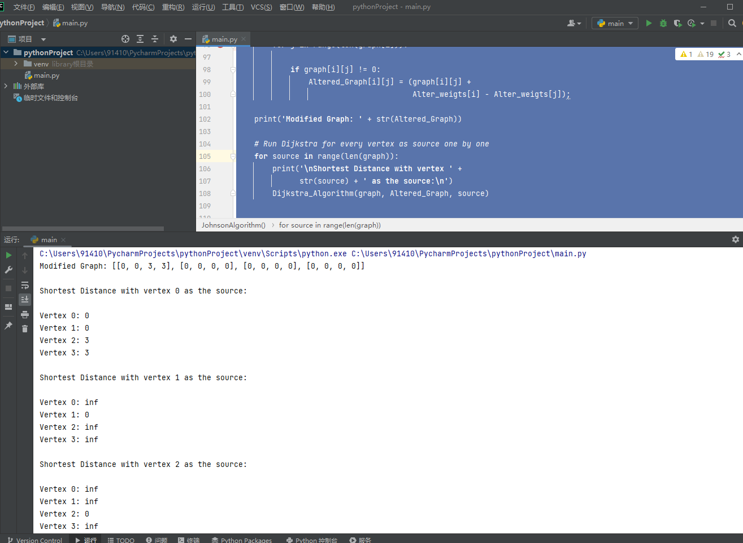
- 实验成果
复杂性分析: 时间复杂度O(V^2 · logV)

