library(ggplot2movies)

library(dplyr)

library(tidyverse)

?movies

View(movies)

# histogram of movies' length

gmovies.hist <- ggplot(data = movies, aes(length))

gmovies.hist + geom_histogram(color = "blue", fill = "lightgreen") +

scale_x_continuous(limits = c(0, 200))

**Distribution of length of movies**

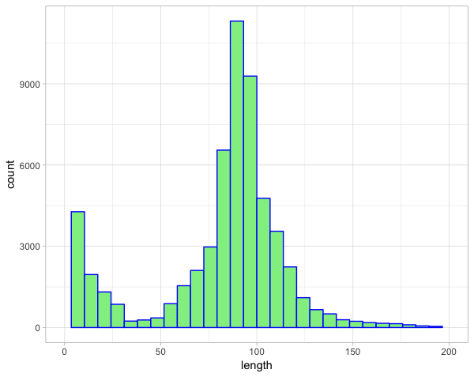

The histogram clearly shows that the most occurred length was 80-90 minutes. Also there is a small sector of movies with length of 0-40 minutes, it relates to short movies which always took their place in cinema industry

# top 10 movies

top10 <- movies %>%

arrange(desc(rating)) %>%

head(10) %>%

mutate(title = fct_reorder(title, rating))

top10.bar <- ggplot(top10, aes(title, rating, fill = title))

top10.bar +

geom_col() +

coord_flip() +

theme(legend.position = "none")

**Top 10 movies for the whole time**

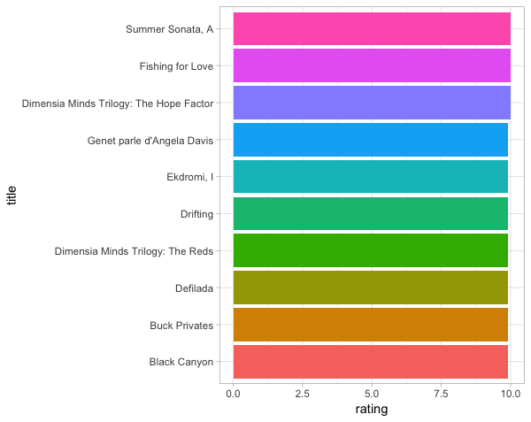

# gathering all genres in one column to make it factor

genres <- movies %>%

gather(Action, Animation, Comedy, Drama, Documentary, Romance, Short,

key = "genre",

value = "grades")

# boxplot

movies.box <- ggplot(genres, aes(factor(genre), rating))

movies.box + geom_boxplot(aes(fill = genre)) +

scale_y_continuous(limits = c(5, 10)) +

theme(axis.text.x = element_text(angle = 90, hjust = 1))

**Rating of movies by genre**

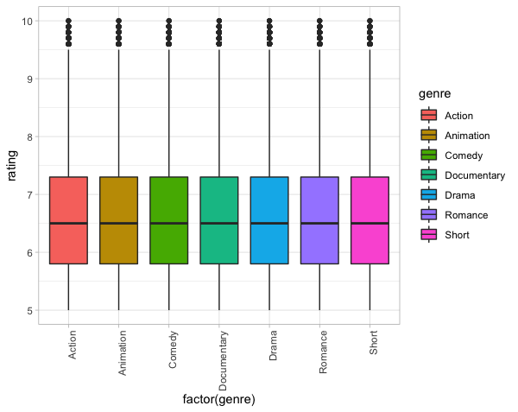

From the boxplot we can see that there is no big difference in rating by genres. It tells us that in every genre there are some movies which get good rating and there are some movies that get lower rating as well

# facet wrap of bar chart for movies after 1920

genres.bar <- genres %>%

filter(year >= 1920)

movies.bar <- ggplot(genres.bar, aes(year))

movies.bar + geom_bar(aes(fill = genre)) +

theme(axis.text.x = element_text(angle = 90, hjust = 1)) +

facet_wrap( ~ genre)

**Facet wrap of bar charts for movies after 1920 divided on genres**

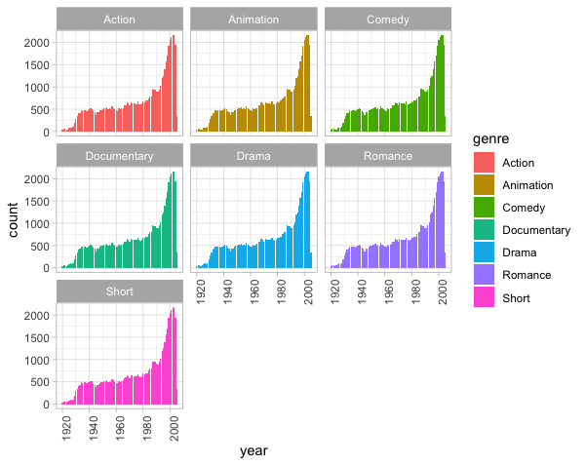

Looking at this graph we can say for sure that during the time people started making a lot more movies. However, there is no big difference in number of movies made in different genres