library(grid)

library(lattice)

library(ggplot2)

library(sandwich)

library(ggplot2movies)

library(dplyr)

library(tidyverse)

data(Investment, package="sandwich")

# Investment dataset

# 1

trellis.par.set(theme = canonical.theme("postscript", color=FALSE))

grid.newpage()

pushViewport(viewport(x=0, width=.33, just="left"))

print(xyplot(GNP~Investment, data=Investment_data,

auto.key=list(space="right")),

newpage=FALSE)

popViewport()

pushViewport(viewport(x=.33, width=.33, just="left"))

print(xyplot(GNP~Years, data=Investment_data,

auto.key=list(space="right")),

newpage=FALSE)

popViewport()

pushViewport(viewport(x=.66, width=.33, just="left"))

print(xyplot(Interest~Investment, data=Investment_data,

auto.key=list(space="right")),

newpage=FALSE)

**A grid presenting the correlation of GNP and Investment, changing of GNP on time series and correlation between Interest rate and Investment**

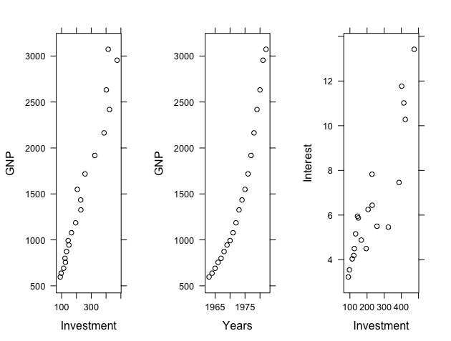

# 2

pushViewport(viewport(x=0, width=.50, just="left"))

print(xyplot(Investment~GNP, Investment_data, pch=0,

panel=function(x, y) {

panel.lmline(x, y)

panel.xyplot(x, y)

}),

auto.key=list(space="right"),

newpage=FALSE)

popViewport()

pushViewport(viewport(x=.50, width=.50, just="left"))

print(xyplot(Interest~Years,Investment_data, type="l"),

auto.key=list(space="right"),

newpage=FALSE)

popViewport()

**Correlation of GNP and Investment with the best fit line; changing of interest rate over the years**

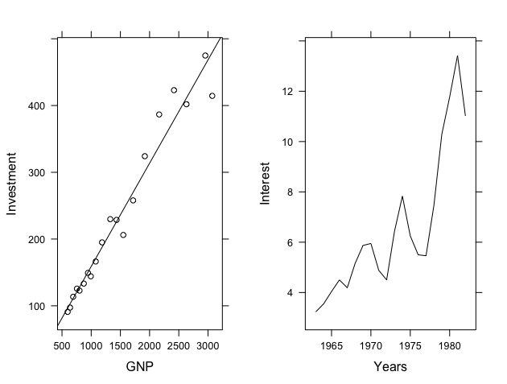

# movies

# dividing by genres

movies <- within (movies, {

Genre = ifelse (Action == 1, "Action" ,

ifelse(Animation == 1,'Animation',

ifelse(Comedy == 1, "Comedy",

ifelse(Drama == 1, "Drama",

ifelse(Documentary == 1, 'Documentary',

ifelse(Romance == 1, "Romance",

ifelse(Short==1, 'Short', '')))))))})

# 1

grid.newpage()

pushViewport(viewport(x=0, width=2/4, just="left"))

print(ggplot(movies, aes(x=length)) +

geom_histogram(color = "blue", fill = "lightgreen") +

scale_x_continuous(limits = c(0, 200)),

newpage=FALSE)

popViewport()

pushViewport(viewport(x=1/2, width=1/2, just="left"))

print(ggplot(movies, aes(x=rating)) +

geom_histogram(color = "red", fill = "light blue") +

scale_x_continuous(limits = c(0, 10)),

newpage=FALSE)

popViewport()

**Distribution of length and rating of all films**

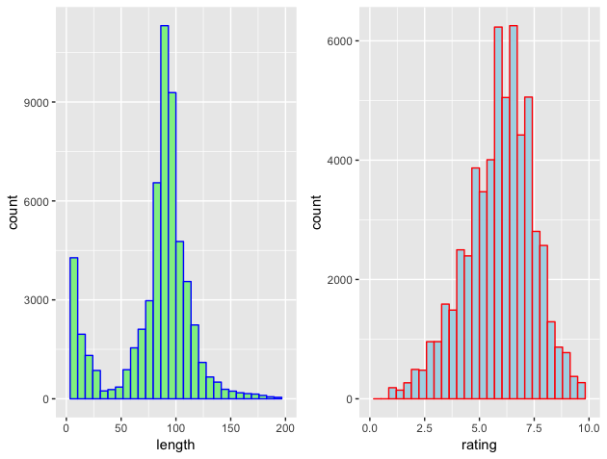

# 2

grid.newpage()

pushViewport(viewport(x=0, width=1/2, just="left"))

print(ggplot(movies, aes(factor(Genre), rating)) +

geom_boxplot(aes(fill = Genre)) +

scale_y_continuous(limits = c(5, 10)) +

theme(axis.text.x = element_text(angle = 90, hjust = 1),

legend.position = "none"),

newpage=FALSE)

popViewport()

pushViewport(viewport(x=1/2, width=1/2, just="left"))

print(ggplot(genres.bar, aes(Genre)) +

geom_bar(aes(fill= Genre)) +

theme(axis.text.x = element_text(angle = 90, hjust = 1),

legend.position = "none"),

newpage=FALSE)

**Rating of films by genres and number of films made in each genre**

