library(ggplot2)

library(dplyr)

? economics

View(economics)

# psavert to date

# 1) with qplot

qplot(date, psavert, data = economics)

The change of personal savings rate on time series

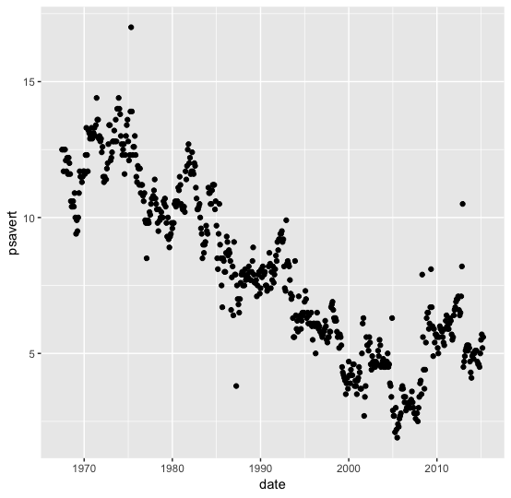

# 2) with ggplot2

econ.point <- ggplot(economics)

lmcoef <- coef(lm(psavert ~ date, economics))

econ.point + geom_point(aes(x = date, y = psavert)) +

geom_abline(intercept = lmcoef[1], slope = lmcoef[2])

The change of personal savings rate on time series with “abline” function

A picture containing wall, photo


It is clearly shown on the graph that personal savings rate of people decreased significantly during the period of 40 years from 1967 to 2007. After that they increased on 2-3% from 2007 to 2015.

econ.unemp <- ggplot(economics)

lmcoef <- coef(lm(unemploy ~ pop, economics))

econ.unemp + geom_point(aes(x = pop, y = unemploy), colour = "brown") +

geom_abline(intercept = lmcoef[1], slope = lmcoef[2])

Dynamics of unemployment with increasing of population

A close up of a map


This scatterplot shows that even considering some fluctuations we can say that there is a tendency between increasing of population and unemployment. Fluctuations in this case tell that the issue of unemployment is pretty complicated and depends on many different factors except the population

econ.hist <- ggplot(economics, aes(uempmed))

econ.hist + geom_histogram(color = "blue", fill = "yellow")

Distribution of median duration of unemployment in weeks

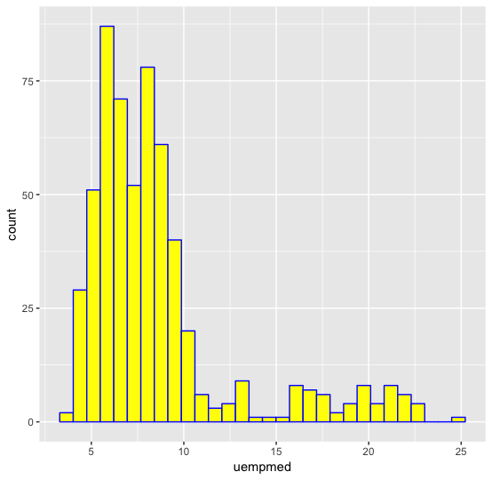

As it shown on the graph the most occurred median duration of unemployment from 1967 to 2015 was 6 – 8 weeks

econ.filtered <- economics %>%

filter(psavert > 6, pce > 10000) %>%

arrange(desc(pce)) %>%

head(10)

ggplot(econ.filtered, aes(

x = pce,

y = pop,

size = psavert,

label = date

), guide = FALSE) +

geom_point(colour = "blue",

fill = "darkgreen",

shape = 21) + scale_size_area(max_size = 16) +

scale_x_continuous() +

scale_y_continuous() +

geom_text(size = 3) +

theme_bw()

For this graph I filtered the data summarizing top 10 cases where psavert > 6 and

pce > 10000 showing their population at the same time

A screenshot of a cell phone


Looking on the bubble chart we can clearly see a positive correlation between the personal consumption expenditures and the number of population even in cases where personal savings rate not changing significantly