

Semantic Web

Exercises

Created by: Niko Kodzhabashev

# Simple Website Structure

Create a web page like the following:

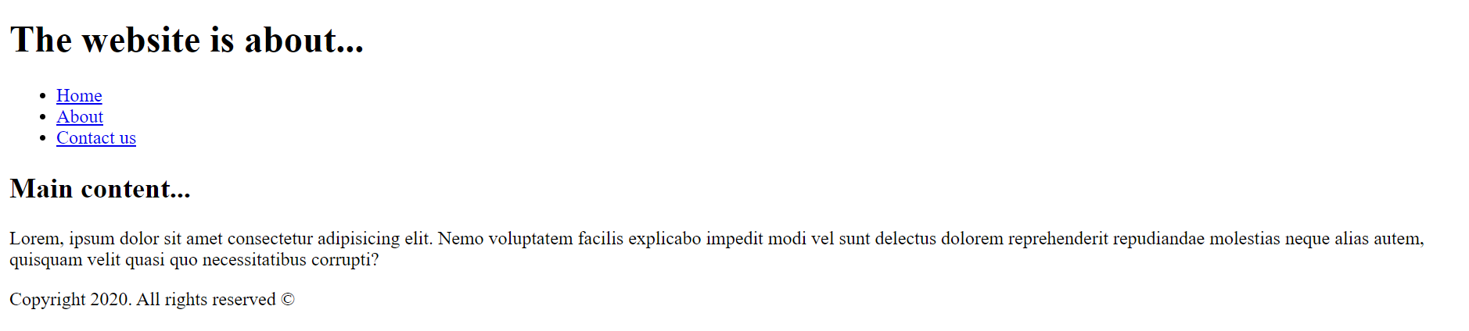

Constraints:

* Set the document title to “**Simple Website Structure**”
* Use **header** tag for the website header and navigation
  + Use **h1** tag for the header
  + Use **nav** tag with unordered list inside about the navigation
* Use **main** tag for the website main content
  + Use **p** tag for the text below
* Use **footer** tag for the website end section
  + Check how to create the copyright symbol [herre](https://www.w3schools.com/html/html_entities.asp)

# Lists

Create a web page like the following:

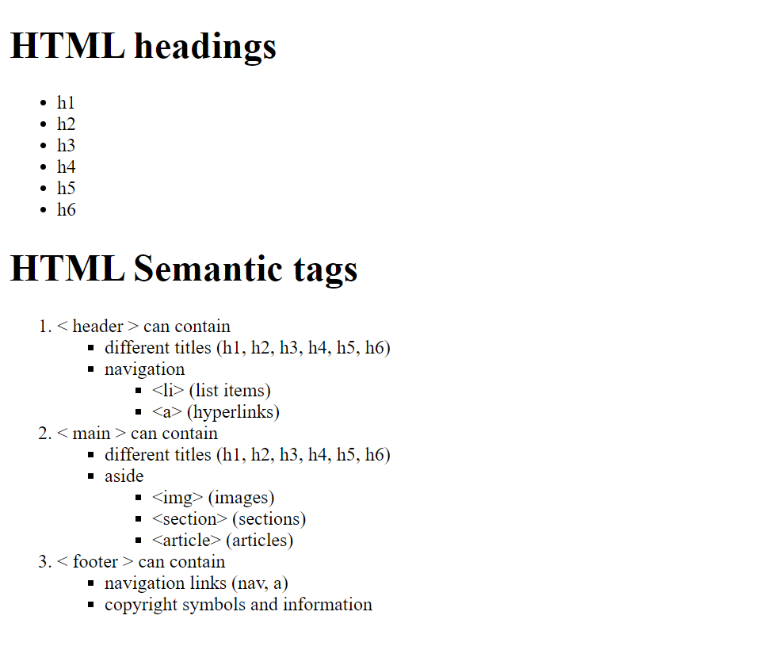

Constraints:

* Set the document title to “**Lists**”
* Use **h1** tag for the following headings:
  + HTML headings
  + HTML Semantic tags
* Use ordered list for the first level list
* Use unordered list with **type** **square** for the secondary lists. Check the different list types [here](https://www.javatpoint.com/html-unordered-list).
* Escape **< >** symbols with [HTML Entities](https://www.w3schools.com/html/html_entities.asp).

# * Real-life HTML

Now you know all the semantic tags and it is time to write the HTML of a real page.

Take all the images and needed information from [here](https://www.skillsassembly.com/#about). Do **NOT** apply any CSS styles to the page. Create **only** the HTML structure.

Looking at the following screenshot try to write the needed tags and to create the document structure correctly.



Constraints:

* Set the document **title**
* Use **img** tag for the logo
* Use **nav** tag with list items and hyperlinks for the website navigation
* Use **h2** tag for the text colored in yellow
* Use **h1** tag for “About us” title
  + Use **p** tags for text below
  + Use **img** tags to display the gallery
* Use **h2** tag for the “Our Aspiration” title
  + Check why is not a good practice to have more than one **h1** tag in a web page [here](https://www.webfx.com/internet-marketing/can-H1-improve-SEO.html)

# Clean-up HTML

Sometimes the HTML that we have is not written well so it’s out work to [refactor](https://www.google.com/search?q=refactoring&rlz=1C1CHBF_en-GBGB850GB850&oq=refact&aqs=chrome.1.69i57j0l7.4026j0j9&sourceid=chrome&ie=UTF-8) it. Refactor the given HTML and remove all unused tags, class names and so on.

The goal is to have semantic written HTML that gives the developer [readability](https://www.google.com/search?q=code+readability&rlz=1C1CHBF_en-GBGB850GB850&oq=code+readabi&aqs=chrome.0.0j69i57j0l6.5587j0j9&sourceid=chrome&ie=UTF-8).

 <div class="w3-row w3-light-grey w3-hide-medium w3-hide-small">

        <div class="w3-col l6" style="padding-top:40px;padding:3%;padding-bottom:45px">

            <h3>SQL Example:</h3>

            <div class="w3-code sqlHigh notranslate w3-card-2 w3-border-green" style="height:180px"><span

                    class="sqlcolor" style="color:black">

                    <span class="sqlkeywordcolor" style="color:mediumblue">SELECT</span> * <span class="sqlkeywordcolor"

                        style="color:mediumblue">FROM</span> Customers<br>

                    <span class="sqlkeywordcolor" style="color:mediumblue">WHERE</span> Country=<span

                        class="sqlstringcolor" style="color:brown">'Mexico'</span>;<span class="sqlnumbercolor"

                        style="color:">

                    </span> </span></div>

            <a href="/sql/trysql.asp?filename=trysql_select_where" target="_blank"

                class="w3-button w3-theme w3-hover-green w3-hover-shadow">Try it Yourself »</a>

        </div>

        <div class="w3-col l6 w3-center" style="padding:3%">

            <h1>SQL</h1>

            <p class="w3-xlarge">A language for accessing databases</p>

            <a href="/sql/default.asp" class="w3-button w3-dark-grey">LEARN SQL</a>

            <a href="/sql/sql_ref_keywords.asp" class="w3-button w3-dark-grey">SQL REFERENCE</a>

        </div>

    </div>

Constraints:

* Remove all the [inline](https://www.codecademy.com/articles/html-inline-styles) styles
* Remove the useless nesting
* Add [alt attribute](https://www.w3schools.com/tags/att_img_alt.asp) to all images
* Use semantic HTML tags, not div tags

# HTML Form

Create the following form:

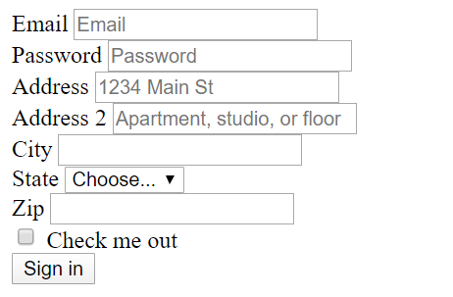

Constraints:

* [Check out](https://www.w3schools.com/html/html_forms.asp) the different form tags
* Add placeholders where is needed