Conceptual Business Model Banking System

Current Saving

Account type

Account Branch

Branch

Account

Loan Balance

Borrower

Depositor

Loan

Corporat e user

Customer

Retail User

Car House

Loan

ATM

# Services

Credit card

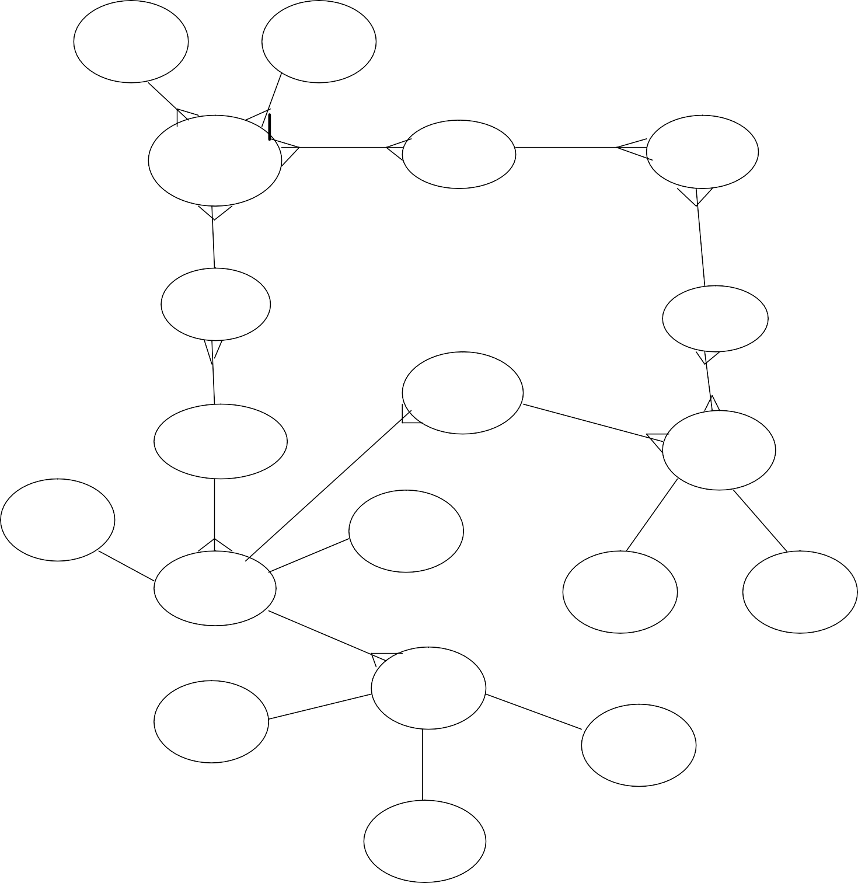

Debit card

**10 Ideas:-**

1. The Ideal Banking system provides banking services to the entire world rather than a single neighborhood town /Country and hence, it has an unlimited global reachability.
2. The Ideal banking offers services to its customers, which enjoys an inelastic demand in the world market.
3. The Ideal banking system provides all types of banking services of both retail banking and business banking to all customers irrespective of their age, gender, previous qualification and country of origin.
4. The Ideal Banking system provides high-quality banking services to everybody irrespective of their economic, social, linguistic and cultural background.
5. The Ideal Banking system needs minimum employees in identified areas of operation and must utilize optimum service from them.
6. The Ideal Banking system operates on a low overhead. It does not need an expensive location, many branches, and huge amount of infrastructure. Only a few Banks are required to provide quality service to the entire world.
7. The Ideal Banking system does not require major investments in equipment and other infrastructure or repetition of a large number of branches in every state and every country. In other words, it does not require huge capital.
8. The ideal banking system is relatively free of all kinds of government regulations or restrictions.
9. The ideal banking system is portable or easily moveable. This means a customer registered in one bank should be able to get the services wherever he moves and in whichever city he lives.
10. The ideal banking system satisfies its customers’ intellectual needs. There are no constraints
11. like minimum amount transaction, to be registered.



|  |
| --- |
|  |
|  |
| C_Street |
| C_City |

Part 2: Relational Data Model for Banking System:-

|  |
| --- |
| **Branch** |
| B_Name |
| Assets |
| B_City |

|  |  |
| --- | --- |
|  | |
|  | **Loan** |
| L_No |
| Amount |
| B_Name |
|  |

|  |
| --- |
| **Account** |
| Acc_No |
| Balance |
| B_Name |

|  |  |
| --- | --- |
| **Depositer** |  |
| C_Name |
|  |
| Acc_No |
| **Customer**  C_Name | |

Primary Key:-

C_Name

**Borrower**

L_No

1. B_Name
2. Acc_No
3. C_Name
4. L_No
5. C_Name

Foreign Key:-

1. B_Name
2. Acc_No
3. C_Name
4. L_no

1) Find B_Name which is situated in Delhi and having assets < 1,00,00.

**Select B_Name from Branch where B_City = ‘ Delhi’ and assets < 1,00,00;**

2) Find L_No and amount of Loan which are from branch situated in Delhi .

**SELECT b.L_No, a. Amount**

**FROM Branch a**

**INNER JOIN Loan b**

**ON a. B_Name = b .B_Name;**

3) Find C_Name with have loan from Branch with assest < 1,00,000

**Select C_Name from Branch, Loan, borrow where Branch . B_Name = Loan .**

**B_name and Loan . L_No = Borrow . L_No.**

**Part 4: Sensitive Data and Data quality Issues:-**

PERSONALLY IDENTIFIABLE INFORMATION (PII)

1. Customer License Number
2. Customer Name
3. Customer Phone Number
4. Customer Address
5. Customer Aadhar number
6. Credit card information
7. Passport information
8. PAN Number
9. Credit card number

CONSUMER FINANCIAL INFORMATION (CFI)

1. Transaction Number
2. Payment method
3. Account number
4. Deposit Amount
5. Credit Amount
6. CIF number

Banking networks have been persuaded by the Banking Codes and Standards Board of India to adopt a uniform code of conduct that enforces many pro-client clauses.

Indian Banking Associations have their own codes with strict penalties for non-compliant members.

CUSTOMER PROPRIETARY NETWORK INFORMATION (CPNI)

If customer do any enquiry or complain regarding to fault then system authority may be enquiry timer, date, duration and destination number of each call, the type of network a consumer subscribes to, and any other information that appears on the consumer's telephone bill.  
  
PROTECTED HEALTH INFORMATION (PHI)

It provide Health Care Providers, Health Plans, Health Care Clearinghouses services for customers

Banks are susceptible to many forms of risk which have triggered occasional systemic crises.

[Liquidity Risk](https://en.wikipedia.org/wiki/Liquidity_risk)-where many depositors may request withdrawals in excess of available funds.

[Credit Risk](https://en.wikipedia.org/wiki/Credit_risk)- the chance that those who owe money to the bank will not repay it.

[Interest Rate Risk](https://en.wikipedia.org/wiki/Interest_rate_risk)-  the possibility that the bank will become unprofitable, if rising interest rates force it to pay relatively more on its deposits than it receives on its loans.

**Poor data quality leads to errors in decision making, which can be costly.**

**The quality of data is also critical for compliance reason**