Table of Contents

Introduction 3

Purpose 3

Scope of the Project 4

Background 4

Reference Materials 5

Meeting Summaries: 6

Assumptions and Constraints: 8

Methodology: 8

Functional Requirements 15

Entity – Relationship Diagram 20

Activity Diagram 22

Use Case Diagram 23

Class Diagram 24

Functional requirement for website 26

Hardware Interface 29

Software Interface 29

Data conversion requirements 30

Requirements: 30

Hardware Requirement 30

Software Requirements 31

Specific functional requirements: 31

Allow user to update: 32

Security 33

Administration system: 33

Quality assurance: 34

Usability: 34

Efficiency: 34

Adaptability: 34

Extensibility: 35

Training requirement: 35

Requirement Traceability Matrix: 36

Recoverability: 38

System Availability: 38

General Performance: 39

Capacity: 40

Introduction

This Software Requirement Specification document provides a complete description of all the functionalities and the specifications of the Work Study Management System. The developers and the testers can use this document as reference for developing the design and test plan documents. The proposed software system will be used to management of student’s activities in the school. It will be able to accept and generate report, to record information about student and supervisor, to enter the number of hours’ students have worked, and supervisors use the system for maintenance management practices and tools.

## Purpose

The purpose of this document is to present a detailed Online Work Study management. It will explain the different functional and nonfunctional requirements of the system, the interfaces of the system, what the system will do or how the system will interact with the external users, the constraints under which it will operate. This Software Requirement Specification document will provide a clear understanding of what is expected by the student in the proposed Work Study Management System. This will give a clear idea on how the software should be developed by the development team for the end users. This WSMS will provide a solid base or foundation for the project. From this WSMS, the designers can design low level design documents and the testers can create test plans and various test case documents.

The main goal of the project is to design a scalable and extensible system for managing activities of student who engage themselves in work study. The system will be designed to ensure that the user requirements mentioned in the document be full filled and must conform to the required standards. The new proposed system will operate efficiently by eliminating all the time consuming issues, paperwork and provide top notch services to the student as well as the management and staff. The system can be considered as a perfect software solution for the hospitality industry since it contains all the modules which are necessary for all the aspects of the school. The proposed software is a multi-platform software that will work in all the operating systems and on most browsers.

## 

## Scope of the Project

The core part of the project is the design for the management and financial system for the Work study department. The WSMS is to management system is intended to replace paper work and to legally pay students. There are three types of end users for this Work Study Management system. The first ones are the student can use to choose where he or she would like to work. The other end users are the administration and the work study management who are given separate authentication to the System.

The supervisor uses this to insert hours of student. The student can choose the place to work. When the student can call or talk to the administrator.

## Reference Materials

The company will be documenting all the stages in the software development life cycle. All the documents will be created according to standards.

## Assumptions and Constraints:

* The project should be completed within specified period and should include Planning, Designing, Development, Testing and Deployment.
* The project should be completed within specified budget.
* All the Entry and Exit criteria of all the stages should be met.
* The product should be user-friendly, reliable and should maintain the school standards without compromising quality.
* The system architecture and design should be open and up to standard such that additional functionalities can be added later without much effort.

# Methodology:

We have used both structured analysis as well as object oriented analysis for the development of this Software Requirement Specification document. Analysis can be defined as understanding the business needs as well as processing the requirements. We have designed the structural chart, Data Flow Diagram and Entity Relationship diagram for the structured analysis of the project. Similarly, we have developed Class Diagrams, Use case diagrams and Activity diagrams for the Object Oriented view of the project.

The structured analysis makes the project into a small, well defined set of activities and specifies the sequence and interaction between these activities. They portray diagrammatic and modeling techniques to give a precise idea on how to develop the system. One of the key tools used in the structured analysis is the Data Flow Diagrams. The data flow diagrams will help to identify the flow of data within an application and how the data moves between different processes in the system. A Data flow diagram will show what information will be input to the system and what information will be output from the system, where the data will come from and where it is stored and how the flow and control of data will go from one process to another. The Entity Relationship diagram will help to identify the different entities in the system and how it will be interacting with other entities in the system. The Activity diagram defines the major activities that are happening in the system.

Software Development Methodology:

The software development life cycle model that we used for developing this project is the increment or the agile method.

**Requirements Specification**

The Requirements Specification is the initial phase of any software development model. In order to begin a project, we need get the requirements from the clients or the student. After the initial proceedings are done, it is the responsibility of the System Analysts or the Business Analysts to collect the required information from the clients or student. The System Analysts use different kinds of methods to collect the requirements from the student. This includes interviews, questionnaires, communication through telephone and email, evaluating the school documents, referring the similar applications existing in the school etc. The requirements are the core part of the software development. The requirements should be well defined, complete and should be realistic. Once the requirements specification is completed, they will be well documented. The documents thus formed which makes up the output of the Requirements Specification stage and input of the Design and Analysis stage is known as Software Requirement Specification (SRS) document.

**Analysis and Design**

The Analysis and Design is the second stage of the Increment model. The requirements which are available in the form of the Software Requirement Specification (SRS) document is analyzed in this phase. The Development Plan, and created in versions. Test Plan documents are created in this stage. The Development in Versions includes the technology that they need to use in developing the software, the environment used, software and hardware tools to be used, the right resources, exit and entry criteria etc. The Test Plan document includes the testing methodologies, test harness, tools and software’s to be used, resources, test estimates, test schedules etc. The input of the Design stage will be the Functional Specification (FS) document. During the Design process, two set of documents will be produced known as High Level Design (HLD) document and Low Level Design (LLD) document. The HLD will give a high level view of the structure of the software which is going to be developed whereas the LLD will go into the depth. The test team will start developing the test cases based on the Software Requirement Specification document. The outputs of the Analysis and Design stage are HLD’s and LLD’s.

**Development & Implementation**

The input of this stage is the High Level Design documents and the Low Level Design documents. The developers will start coding or developing the software in this stage. They will do the Unit Testing once the development will be completed. The Project Manager will divide and allocate the work among the developers. The developers will be frequently communicating with the System Analysts or the Business Analysts for clarifications. The output of this stage will be a software product which can be compiled and working. Once the software module is completed they will inform the Testing team for further testing.

**Testing**

Testing is the process by which we make sure that the software is running without errors and it meets all the student or requirement specification. The input of this stage is the software module. The testing can be broadly divided into two- Black box and white box. Black box testing means testing the functionalities of an application and White box means testing the internal design & structure of the application.

Once the developed module has been deployed, then the Test team will do a Smoke Testing in order to make sure that all the major functionalities are working on a high level view. If any show stoppers exist, then the test team will reject the build otherwise they will accept the build and do further testing activities. After the Smoke Testing, the testers will execute the test cases based on the priority from high to low. If there is any mismatch between the expected result and the actual result, then they will log a defect in the defect tracking tools and assign it to the developers. The developers will fix the defects and send it back to the tester for verification. The tester will do the fix verification in the next build. The tester will close the issue if it is fixed, otherwise reopen it and reassign to the corresponding developer. Once the corresponding exits criteria such as when to stop the testing is met, the testers will deploy the build into the production servers.

**Deployment**

Deployment means the installation of the product software in the corresponding client sites. Once the software is deployed in the client sites, an end user testing will be done at the client sites. The end user testing done at the development sites is known as Alpha testing and at the client sites is known as Beta testing. The project team needs to prepare the user manual or installation documents for the clients or the students.

**Maintenance**

The final stage of the incremental model is known as the Maintenance phase. There may be issues related to data base or any upgrade in most of the cases and in those cases, the client needs to be in contact with the project team who developed the software. Sometimes after some years, the clients may need to implement new functionalities or customize their application according to their needs. In that case also, the maintenance phase is also necessary.

Requirements Specification

Maintenance

Testing

Development / Implementation

Design & Analysis

Deployment

**Functional Requirements**

Functional requirements for the purposed system which define the fundamental actions of the system contain all the information of the software requirements for the development of the booking system for this project.

1. **Student interface functional requirements**
   1. Create an account
      1. Student will have be given the following access as per the functional requirement.
      2. The system shall enable student to check the records.
   2. payment
      1. The system shall provide payment for any type of work.
   3. Details of place of work
      1. The system shall enable student to check and review all the details of place of work.
   4. Check details of supervisor
      1. The system shall have next button or cancel button for the details of a supervisor.
      2. The system shall enable student to visit registration page, allow student to confirm the registration.
2. **Management team interface**
   1. Login function
      1. The system shall allow only management team member to access the particular system.
      2. The system should recognize the member of the management.
      3. The system shall give different access to management team.
   2. View or edit
      1. The system should allow management to check student details.
      2. The system should allow team members to add information.
      3. The system should allow the team to change the information.
3. **Booking**
   1. The system shall record all the following information of student
      1. student_ID
      2. student_Fname
      3. student_Sname
      4. student_Address
      5. student_Mobile
      6. student_Email
4. **Database administrator**
   1. The system should allow the administrator to access the system only with username and password.
   2. The system should allow the administrator to edit any files and folders.
   3. The system should accept any command from the administrator.
   4. The system should provide all the details to admin:
      1. Work_Categ_ID
      2. Category
      3. Work_payment
      4. Supervisor_ID
      5. *Student_ID*

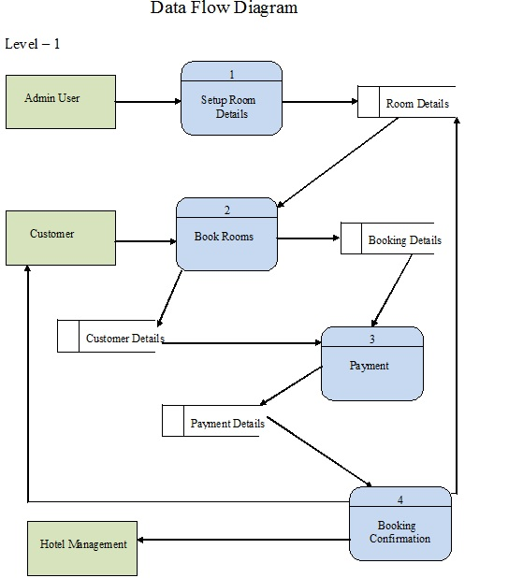

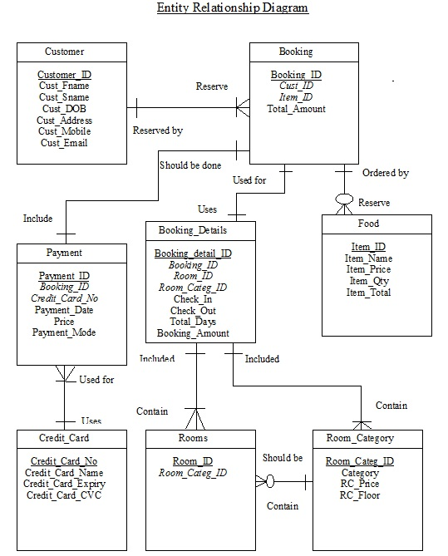

Activity Diagram

Choose Place of

work

Homepage

Login

Work Catalogue

Finish order

Confirm order

Finish choosing

## Use Case Diagram

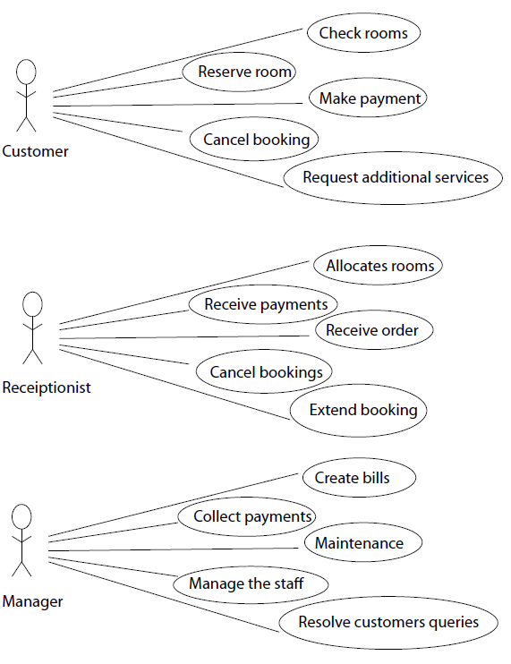

## Class Diagram

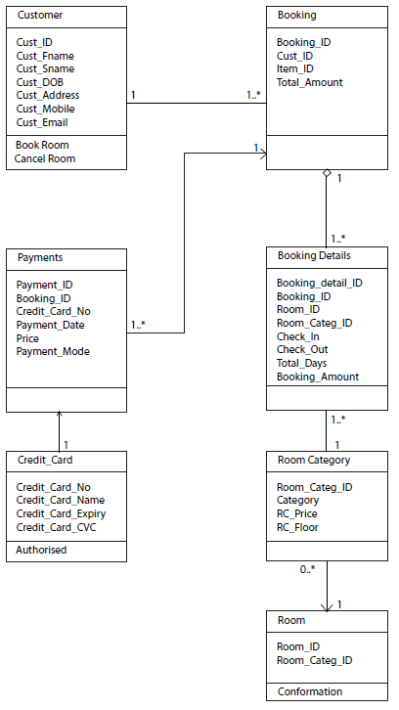

# Functional requirements for the website

1. **Overview of the website**

The site should be designed to allow users to search the system database. The system should allow students to view information of place chosen to work and supervisor. Supervisors can see student records in the database, accept the payment and provide confirmation. Other functions that could increase the usability of a website is:

1. Provide amount to be paid for place of work.
2. **System platform and interface**

Website should be accessible to every user using web browsers that is version 4.0 or higher. The website should use suitable visual interfaces. The site should maintain the inventory of websites visited by the users from different areas in its database.

* + - 1. Website layout and design
      2. Home Page

Home page is the first page of the website which is the index page for web designer. It will provide all the information about the work and its activities. It should give detail information and about the work. The page will have a graphic appearance. You need to be registered before you log on it. The page shows types, amount to be paid for each job and work form which contain information about student.

## Hardware Interface

The system should run on Microsoft windows based system.

## Software Interface

The system will store all data dividing into 4 parts as per the character of database which are type of work, amount for that particular work, and student details. The system shall permit only the Management team and database administrator to edit the database and the system will allow student to cancel the registration. System will have work detail database which stores all the information on a particular work.

## Data conversion requirements

The database plays a vital role in the school and it should be stored in a proper way that required information can be retrieved easily from stored warehouse such as work details is stored in the room database. The users should be allowed to access the information about a particular work which are available and what are the amount of money paid for that particular work, where security systems should be used by system so that confidential information does not get accessed by unauthorized person. The database system should be organized so that management can retrieve the information in a simple and summarized form.

REQUIREMENTS

## Hardware Requirement

Here is some requirement of project which relates to the client side and server side, is defined below. It just explains necessity of some hardware and software to perform a project task.

| **CLIENT SIDE** | **SERVER SIDE** |
| --- | --- |
| Computing device | Intel Core /AMD |
| Mouse | 512 MB RAM |
| Keyboard | Network Interface Card |
| Network Interface Card |  |
| 128 MB RAM |  |
| 64 bit color display |  |
| 1024x768 standard |  |

### 

## Software Requirements

| **CLIENT SIDE** | **SERVER SIDE** |
| --- | --- |
| Windows 10 | Windows Server 2012 |
| Mozilla Firefox | My SQL |
| Adobe Flash Plug-in | Firewall |
|  |  |
|  |  |
|  |  |

## 

# Specific functional requirements:

Functional requirements are those aspects that refer to the function of the system. It includes the explanation of functions used.

|  |  |
| --- | --- |
| Priority | Description |
| Must | This function must be included. The completed project cannot succeed without it. Critical functions must be given preferential treatment over all other functionality |
| Should | It is highly recommended function. In a project we have seen that highly recommended person is the “admin”. It is the key function of the project. |
| Could | It is an important function but we can also call them low rated function. If we don’t include that function in the project it may cause loss of efficiency of the project. |
| Would | These functions are very important. This means without those functions we cannot complete our project. Like without the student part this project will not be successful. |

## **Allow user to update:**

A user will be allowed to update his personal information.

|  |  |
| --- | --- |
| Description | It is important to update and change their information regularly. If the user wants to change their personal information, they should be allowed to do. |
| Technical issues | Users have access to update information but other accounts must not be accessible to them. |
| Cost | This project is not excepting any cost in this area. |
| Risks | Sometimes some user can misuse other people’s personal information. So that is why they have a limited authority to change only their information. |
| Dependencies | It is not dependent on other factors. |
| Priority | “medium” |

## Security

The system will be secured from outside attacks and unauthorized access. The system should be protected from all other outside premises.

|  |  |
| --- | --- |
| Critically | As this site is going to be accessed through the internet so it is important that it has security functions for outside attacks. It should be also ensured that the system is always protected from other premises like malware. The security options should also be implemented for the protection against internal attacks from the same network. |
| Technical issues | As the site contains the personal information of users, the security options must be implemented in order to prevent theft or misuse of the information. |
| Cost | The project will be following security measures in the coding itself, yet client has to arrange for precaution against external attacks by using antivirus and firewall software. |
| Dependencies | None |
| Priority | “high” |

## **Administration system:**

An interface would be provided to the website by which clients can manage all the functionalities on the website. Here administrator can also view and modify the details provided by the student.

|  |  |
| --- | --- |
| Critical | Some restrictions must be placed to manually add new users, delete unnecessary data, and also to keep all the records of all old student. |
| Technical issue | For all the users on the system, after some time the passwords should be changed. For this, when a user logs in, they need to notify to change password. |

# Quality assurance:

## Usability:

A new user must find the functions that he is looking for on the system easily. EXAMPLE: If a new student wants to get information about the work and services, these details should be categorized in a way which makes it easy for users to access them. The layout and performance of functionalities of the system should be pleasing to the user. For the administrator, the updating of the system should be easy and secure. The system should also look professional, representing the functionalities in a categorized manner.

## Efficiency:

As there can be various requirements accessed by the users, the system may need some specific updating. But too much time should not be spent on updating. There can be some functionality which decreases the human work and automatically responds to the user’s requirements.

## Adaptability:

The system should be able to easily accept changes. Any time something new is introduced to system, it is necessary that it can accept the changes easily.

## Extensibility:

When we develop system, it should be created in a way which would support extensibility. If a new student or supervisor detail is to be added, the procedure should be easy and less time consuming.

## Training requirement:

Training is necessary for the system to meet its full potential. The training is a crucial part of the project because if the client doesn’t know the functionality given to him, he would not be able to utilize the application successfully. The training will make use of the following:

* Perfect version of the application.
* Back up CD for the application.
* Instructions and Manual for the system.
* Web server instructions.

The training will also involve specifications as to how the client will successfully follow some specific tasks.

* Insert user and other relevant procedures.
* Resetting the users’ passwords.
* Generating work and services
* Explanation of using the application in a regulated way to end users.
* Using help function effectively.
* General trouble-shooting procedures.

# Requirement Traceability Matrix:

The requirements traceability matrix (RTM) reflects full user and system requirements for a system or part of the system. RTM captures all the requirements and their traceability in one document, and the document must be submitted at the end of the life cycle.

RTM is used to record the relationship of requirements for the design, development, testing, and version of the software requirements for a specific version of the software. Changes to requirements are also recorded and tracked in the RTM. RTM is maintained throughout the life cycle of release and has to be reviewed at the end of the release. It is a very useful document to track time, change management and risk management in software development.

The requirements Traceability Matrix, provides a detailed idea about the importance of RTM in SDLC.

The requirements traceability matrix (RTM) traces back to the online Work Study Management system (working space/working group) and provides compatibility between the group/workspace, approved the requirements, design specifications and test scripts.

The table below displays the RTM for the conditions that have been approved to be included in online Work Study Management system. The following information is provided for each

S = System Requirement

U = User Requirement

|  |  |  |
| --- | --- | --- |
| ID | User Requirements | Forward Traceability |
| U1 | User should register or can be a guest | S1, S2, S3 |
| U2 | Guest should look for a particular work | S4, S5 |
| U3 | Guest should choose place of work | S6, S7, S8 |
| U4 | Guest should check for information of that particular work | S9, S10 |
| U5 | Guest should enter the check-in/check-out dates | S11, S12, S13 |
| U6 | Guest should confirm the dates | S14, S15 |
|  |  |  |
| U8 | Guest should enter his/her ID details | S18, S19 |
| U9 | Guest should confirm the registration | S20, S21, S22 |

|  |  |  |
| --- | --- | --- |
| ID | Functional Requirements | Backward Traceability |
| S1 | System should display the login/register page | U1 |
| S2 | System should accept the users registration if all the fields are entered correctly | U1 |
| S3 | System should store the data | U1 |
| S4 | System should allow the guest to check the work | U2 |
| S5 | System should show the available places of work to the guest | U2 |
| S6 | System should ask for the number of persons going to check-in | U3 |
| S7 | System should not accept more than one student | U3 |
| S8 | System should accept the student | U3 |
| S9 | System should show give details of a supervisor | U4 |
| S10 | System should accept the registration | U4 |
| S11 | System should ask for details to enter | U5 |
| S12 | System should ask for the check-in/check-out dates | U5 |
| S13 | System should process the price | U5 |
| S14 | System should accept the conformation | U6 |
| S15 | System should confirm | U6 |
| S16 | System should show the different modes of payment options available | U7 |
| S17 | System should contact the user bank to check for the sufficient funds | U7 |
| S18 | System Should store the place of work in the database | U8 |
| S19 | System should show the conformation of the work | U8 |
|  |  |  |
| S21 | System should display the invoice | U9 |
| S22 | System should show save as option | U9 |

## Recoverability:

A good system must recover easily from any faults. This explains the importance of the data recovery software like the runtime GetDataBack.

# System Availability:

The system should be designed in such a way that the system is available 24/7 and it should not undergo any downtime due to the heavy traffic of the web users. While developing the system, the market researchers must estimate the traffic flow for the website and should design according to it. The availability of a system is typically measured as a factor for its reliability as reliability increases, so does the availability. The availability of a system can also be increased by strategy focuses on increasing of test and maintain and not on reliability. Improving maintainability is generally easier than reliability. Maintaining estimates (repair cost) are also generally more accurate. Because uncertainties in the reliability estimate in most cases is very large, it is nevertheless likely to dominate the availability problem, even while maintaining levels are very high.

We provide system maintenance so that we can use the information derived to maintain and upgrade our online services and business IT systems. This maintenance can have an effect on our online services; we decided to avoid inconveniencing the users. During this scheduled maintenance, however, we cannot guarantee the integrity of all the information submitted or retrieved. But we intend to provide a window that says that the Web site is under maintenance and is not available until the maintenance has been completed.

## General Performance:

Even a few seconds of delay is enough to cause an unpleasant user experience. Users are no longer in control, and they have been deliberately annoyed having to wait for a computer. Thus, the short delay, users give up unless they are determined to complete the task. The result is you can easily lose half your sales (to those customers, less done) simply because your site is slow for a few seconds on each page.

Users can delay the feeling, and so know the outcome is to be generated by the computer but they still feel in control of the overall experience and that they are moving freely rather than waiting for the computer. This degree of eligibility is needed for good navigation. Within the period of 1 – 10 seconds, users surely feel at the mercy of the computer and wish it was faster, but they can handle it. After 10 seconds, they start to think about other things, making it harder to get their brains back on track as soon as the computer finally responds.

A 10-second delay is often a site for users to leave immediately. And even if they stay, it's harder for them to understand what's going on, making it less likely that they will overcome difficult tasks.