CAPSTONE PROJECT – PRE-SUBMISSION DOCUMENT

1. Business Problem Understanding and Objective Formulation
BuildMax Infrastructure Ltd. executes complex EPC projects across multiple sectors. Managing schedules, costs, resources, and contractors is challenging, while reactive monitoring often identifies risks only after delays or budget overruns occur, resulting in increased costs and missed deadlines. Problem statement: Develop a data-driven predictive solution that analyses historical project information to identify projects likely to experience schedule delays and, subject to data validation, budget overruns. The solution aims to support earlier risk identification and preventive management action.
• Primary objective: Build a binary classification model using the target variable project_delay_flag to predict whether a project is delayed.
• Identify Actual expenditures exceeding planned budgets, labor allocation, sub-contractor delay, material supply chain distribution.
• Compare multiple machine learning algorithms and select a model based on suitable evaluation metrics.
• Secondary objective: Assess budget-overrun prediction using planned and actual cost, after validating the relationship with cost_variance_pct.
Dataset: BuildMax_Project_Intelligence.csv — 50,500 records and 34 attributes.
Primary target: project_delay_flag.
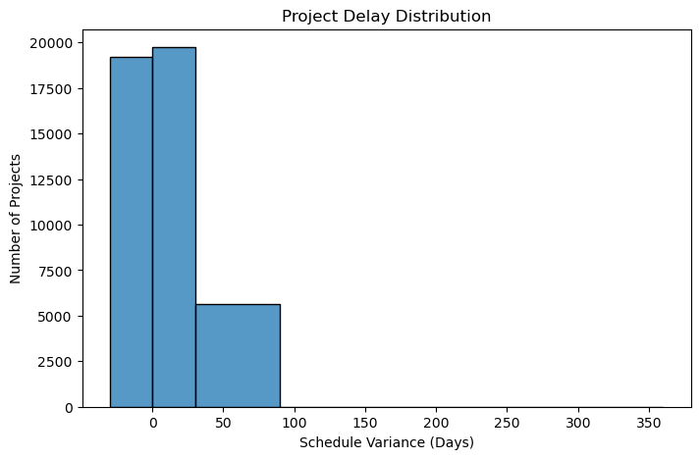
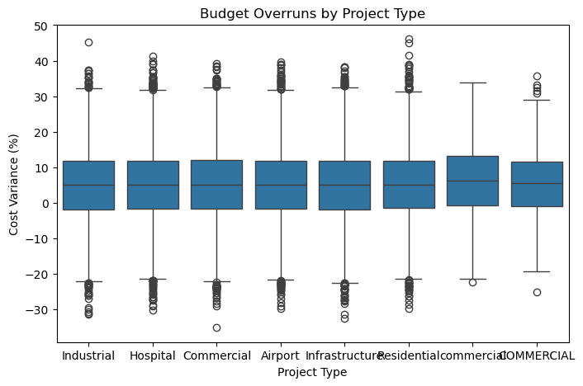

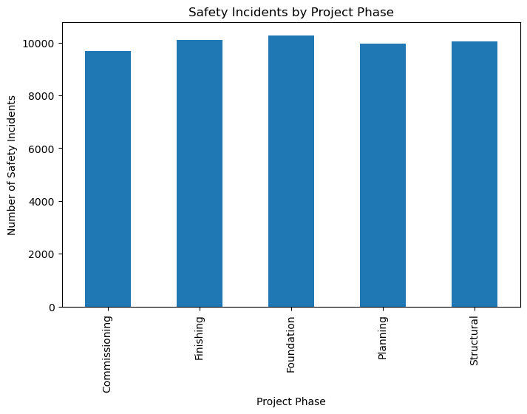
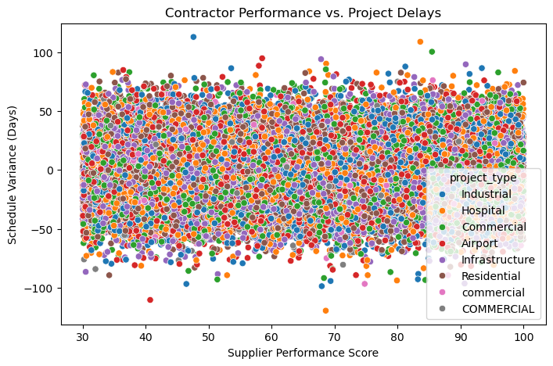

2. Challenges and Constraints
• Data quality: Missing values, duplicate records, inconsistent categories, and potential outliers require investigation and treatment.
• Class imbalance: Delayed and non-delayed projects may be unevenly represented; stratified splitting and appropriate evaluation/imbalance techniques will be considered.
• Feature selection: Identify relevant predictors while avoiding redundant or weak features.
• Data leakage: Exclude information that would only be known after project completion or after the intended prediction point.
• Model selection: Balance recall, precision, F1-score, ROC-AUC, interpretability, and generalization rather than relying on accuracy alone.
• Budget target validation: Check consistency among planned cost, actual cost, and cost_variance_pct before defining the secondary target.
• Prediction timing: The dataset does not provide dated snapshots for each project; the initial study will classify historical project risk and will not claim real-time forecasting.

3. Background Study / Literature Review
Prior work in construction and project management has explored statistical and machine learning methods for schedule-risk and cost-overrun analysis. Logistic Regression provides an interpretable baseline; Decision Trees expose rule-based relationships; and ensemble methods such as Random Forest and Gradient Boosting can model nonlinear interactions in structured project data. Support Vector Machines provide an additional comparative classifier. Feature-importance methods and SHAP can help explain model outputs. The project will review relevant peer-reviewed studies and document the selected methods and evaluation choices in the final report.

4. Proposed Methodology / Solution Approach
Data understanding and EDA: Inspect schema, target distribution, missingness, duplicates, feature distributions, correlations, and data quality.
Preprocessing: Impute missing values appropriately; verify/remove duplicates; standardize categories; encode categorical variables; scale numerical features where required.
Feature engineering and selection: Select relevant predictors; assess redundancy; exclude post-outcome fields and any variables unavailable at the intended prediction point.
Model development: Use a stratified train/test split and cross-validation. Train Logistic Regression, Decision Tree, Random Forest, Gradient Boosting/XGBoost, and optionally SVM.
Evaluation and interpretation: Compare confusion matrix, precision, recall, F1-score, ROC-AUC, and accuracy. Emphasize recall for delayed projects and use feature importance/SHAP for interpretation.
Secondary budget analysis: Validate cost fields and define a transparent overrun target before attempting a separate classification model.

5. Proposed Workflow / Block Diagram
Proposed Workflow / Block Diagram
Historical EPC Project Dataset
(50,500 Records / 34 Features)
|
v
Data Understanding & EDA
|
v
Data Preprocessing
(Missing Values, Duplicates,
Encoding and Data Cleaning)
|
v
Feature Engineering & Selection
|
v
Train-Test Split
|
v
Model Development
|
+-----------+-----------+
| | |
v v v
Logistic Decision Random
Regression Tree Forest
| | |
+-----------+-----------+
|
XGBoost / SVM
|
v
Model Evaluation
(Precision, Recall, F1,
ROC-AUC, etc.)
|
v
Best Model Selection
|
v
Feature Importance & SHAP
|
v
Project Delay Prediction
|
v
Management Risk Insights

Secondary Analysis:
Budget Overrun Prediction

6. Proposed Timeline
Phase | Activities | Duration
1 | Business understanding and literature review | Week 1
2 | Data understanding and exploratory analysis | Week 2
3 | Preprocessing and feature engineering | Week 3
4 | Model development and experimentation | Week 4
5 | Evaluation, comparison, and interpretation | Week 5
6 | Final analysis, report, and presentation | Week 6

7. Expected Deliverables and Outputs
• Cleaned and preprocessed dataset with documented data-quality decisions.
• Identification of important factors associated with project delays.
• Implemented and compared classification models, with documented validation and test results.
• Selected project-delay prediction model with predicted class and risk probability outputs.
• Model interpretation using feature importance and, where feasible, SHAP.
• Secondary budget-overrun analysis, if cost-target validation supports it.
• Final capstone report, methodology, evaluation results, and presentation.
Expected business outcome: Support BuildMax in identifying projects with elevated delay risk, understanding contributing factors, prioritizing management attention, and taking preventive action. The study will establish a foundation for predictive, data-informed EPC project management.

