CHATBOT FOR SIMPLE QEUSTIONS

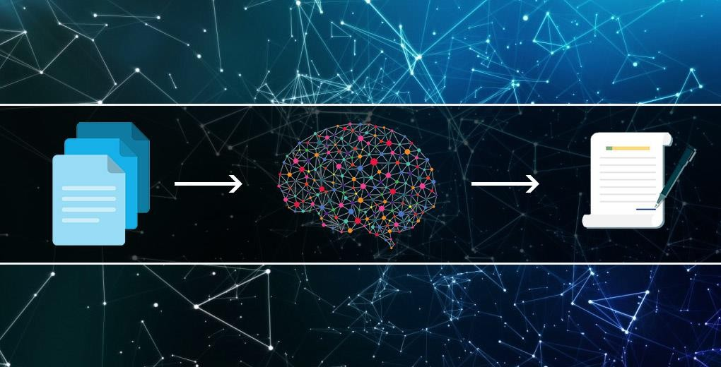

**TABLE OF CONTENTS**

**ABSTRACT---------------------------------------------------------------------------------------------------------------------- 02**

**INTRODUCTION--------------------------------------------------------------------------------------------------------------- 03**

**ABOUT THE PROJECT-------------------------------------------------------------------------------------------------------- 10**

**ALGORITHM------------------------------------------------------------------------------------------------------------------- 12**

**CODE SCREEN CODES------------------------------------------------------------------------------------------------------- 16**

**CONCLUSION------------------------------------------------------------------------------------------------------------------- 17**

**ABSTRACT**

The Chatbot for Simple Questions is an AI-driven conversational agent designed to answer basic queries and provide information in a user-friendly manner. Leveraging natural language processing (NLP) techniques and machine learning algorithms, this chatbot can understand and respond to a wide range of common questions, making it a valuable tool for enhancing customer service, providing quick information, and improving user engagement. The main objective is to improve accessibility by providing instant answers to frequently asked questions, reducing the need for human intervention and increasing accessibility to information. Additionally, it aims to enhance user experience by offering a seamless and interactive user interface that ensures quick and accurate responses to user queries. Furthermore, the chatbot helps streamline operations by reducing the workload on customer service representatives through efficient handling of routine inquiries.

The key features include natural language understanding (NLU), which utilizes NLP to comprehend and process user inputs accurately, handling variations in phrasing, spelling errors, and colloquial language. The chatbot also exhibits contextual awareness, maintaining context throughout the conversation for more coherent and relevant responses and understanding follow-up questions to provide answers accordingly. It offers multichannel integration, being deployable across various platforms including websites, mobile apps, and social media channels, ensuring consistent performance and user experience across different mediums. The chatbot also incorporates machine learning for continuous improvement, learning from interactions to refine its responses and enhance accuracy over time. Its knowledge base can be customized, allowing integration with specific databases to provide specialized information, and it supports multiple languages, making it accessible to a diverse user base by understanding and responding in various languages. The chatbot includes analytics and reporting features, providing insights into user interactions, common queries, and areas for improvement, aiding in better decision-making and service enhancement.

The development process for the Chatbot for Simple Questions involves a combination of data collection, algorithm training, and rigorous testing to ensure reliability and accuracy. User inputs are gathered from diverse sources to build a robust training dataset, which is then used to fine-tune the machine learning models that power the chatbot. Continuous monitoring and updates are essential to adapt to new types of questions and evolving user needs. Security measures are implemented to protect user data and ensure privacy, while user feedback mechanisms are integrated to gather insights and make iterative improvements. This holistic approach ensures that the chatbot remains a dynamic and effective tool, capable of delivering high-quality, personalized responses and maintaining user trust and satisfaction.

### Introduction

#### What is Artificial Intelligence (AI)?

Artificial Intelligence (AI) is a branch of computer science focused on creating systems capable of performing tasks that typically require human intelligence. These tasks include learning, reasoning, problem-solving, understanding natural language, perception, and even exhibiting creativity.

#### Key Areas of AI:

1. **Machine Learning (ML):** A subset of AI where algorithms are used to find patterns or insights in data. The systems "learn" from data and improve over time without being explicitly programmed for specific tasks. Common techniques include supervised learning, unsupervised learning, and reinforcement learning.
2. **Natural Language Processing (NLP):** The ability of a machine to understand, interpret, and generate human language. Applications include chatbots, language translation, sentiment analysis, and speech recognition.
3. **Computer Vision**: The capability of AI systems to interpret and make decisions based on visual input. This includes image and video recognition, object detection, and facial recognition.

#### What is Machine Learning (ML)?

Machine Learning (ML) is a subset of Artificial Intelligence (AI) that involves the development of algorithms and statistical models that enable computers to learn from and make predictions or decisions based on data. Instead of being explicitly programmed to perform a specific task, machine learning systems improve their performance over time as they are exposed to more data.

#### Key Concepts in Machine Learning:

1. **Data:** The foundational element for ML, which includes the information the system learns from. Data can be structured (like databases) or unstructured (like text and images).
2. **Algorithms:** These are the mathematical and computational procedures used by ML systems to learn from data. Examples include decision trees, neural networks, and support vector machines.
3. **Model:** A model is the output generated by the ML algorithm after training on data. It represents the learned patterns and can be used to make predictions.
4. **Training:** The process of feeding data into an ML algorithm to help it learn. During training, the model adjusts its parameters to minimize errors.
5. **Testing**: Evaluating the model's performance on a separate set of data that was not used during training to assess its accuracy and generalization.
6. **Features:** Individual measurable properties or characteristics of the data used by the model for learning.
7. **Labels:** In supervised learning, labels are the known outcomes or categories associated with the training data.

Types of Machine Learning:

1. **Supervised Learning:**
   * The algorithm learns from labeled data, where the input data and the corresponding correct output are provided.
   * Common applications include classification (e.g., spam detection) and regression (e.g., predicting house prices).
2. Unsupervised Learning:
   * The algorithm learns from unlabeled data, identifying patterns and structures within the data.
   * Common applications include clustering (e.g., customer segmentation) and dimensionality reduction (e.g., principal component analysis).
3. Semi-Supervised Learning:
   * A combination of supervised and unsupervised learning, where the algorithm learns from a small amount of labeled data and a larger amount of unlabeled data.
4. Reinforcement Learning:
   * The algorithm learns by interacting with an environment, receiving feedback in the

Key Techniques and Algorithms:

* **Linear Regression**: Used for predicting a continuous outcome based on one or more input variables.
* **Logistic Regression**: Used for binary classification problems.
* **Decision Trees:** A tree-like model used for classification and regression tasks.
* **Random Forests:** An ensemble method that uses multiple decision trees to improve accuracy and prevent overfitting.
* **Support Vector Machines (SVM):** A classification technique that finds the optimal hyperplane separating different classes.
* **Neural Networks:** A set of algorithms modeled after the human brain, used for complex pattern recognition tasks.
* **K-Means Clustering:** An unsupervised learning algorithm for partitioning data into clusters.

Applications of Machine Learning:

* Healthcare: Disease diagnosis, personalized treatment plans, and medical image analysis.
* **Finance:** Credit scoring, fraud detection, and algorithmic trading.
* **Retail:** Recommendation systems, inventory management, and customer segmentation.
* **Transportation:** Autonomous vehicles, traffic prediction, and route optimization.
* **Entertainment:** Content recommendation on streaming platforms, video and music suggestions.

Challenges in Machine Learning:

* **Data Quality:** ML models require high-quality, relevant data for accurate predictions.
* **Overfitting and Underfitting:** Ensuring the model generalizes well to new data without being too specific or too simple.
* **Interpretability**: Understanding how complex models, especially deep learning models, make decisions.
* **Scalability:** Handling large datasets and computational requirements efficiently.
* **Bias and Fairness:** Addressing biases in the data and ensuring fair outcomes.

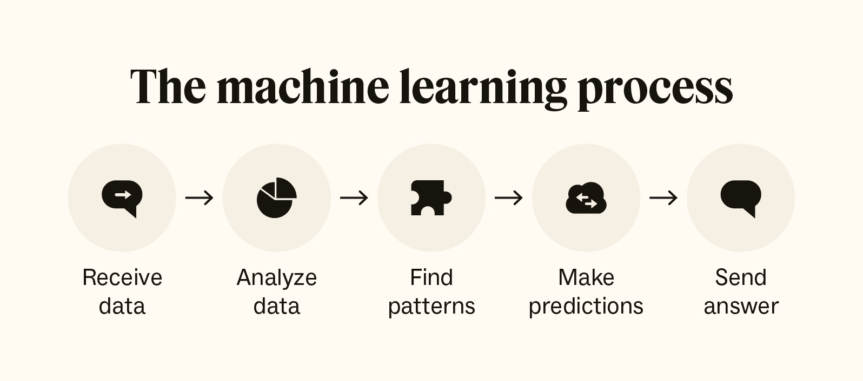

#### What is Deep Learning (DL)?

Deep Learning (DL) is a subset of Machine Learning (ML) that focuses on using neural networks with many layers (hence "deep") to model complex patterns in data. These neural networks, known as deep neural networks (DNNs), are designed to mimic the structure and function of the human brain, allowing them to learn from large amounts of data.

Key Concepts in Deep Learning:

1. **Neural Networks:**
   * Neurons: Basic units of a neural network that take inputs, apply a function (usually nonlinear), and produce an output.
   * Layers: Neural networks consist of multiple layers:
     + Input Layer: The first layer that receives the input data.
     + Hidden Layers: Intermediate layers where data transformation occurs. The depth of the network refers to the number of hidden layers.
     + Output Layer: The final layer that produces the prediction or classification.
2. Activation Functions:
   * Functions applied to the output of each neuron to introduce nonlinearity into the model, enabling it to learn complex patterns.
   * Common activation functions include ReLU (Rectified Linear Unit), Sigmoid, and Tanh.
3. Backpropagation:
   * A training algorithm used to minimize the error by adjusting the weights of the neurons. It involves calculating the gradient of the loss function with respect to each

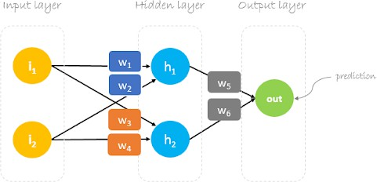

weight by the chain rule, propagating errors backward from the output to the inputlayer.

1. Loss Function:
   * A function that measures the difference between the predicted output and the actual target. The goal is to minimize this loss during training.
   * Common loss functions include Mean Squared Error (MSE) for regression tasks and Cross-Entropy Loss for classification tasks.
2. Optimization Algorithms:
   * Methods used to adjust the weights of the network to minimize the loss function.
   * Common optimization algorithms include Stochastic Gradient Descent (SGD), Adam, and RMSprop.

#### What is Natural Language Processing (NLP)?

Natural Language Processing (NLP) is a field of artificial intelligence that focuses on the interaction between computers and human language. It involves the development of algorithms and models that enable machines to understand, interpret, generate, and respond to human language in a meaningful way. NLP combines computational linguistics, computer science, and statistical methods to process and analyze large amounts of natural language data.

Key Concepts in NLP:

1. **Tokenization:**
   * The process of breaking down text into smaller units called tokens, such as words, phrases, or sentences.
2. Parsing:
   * Analyzing the grammatical structure of a sentence to understand the relationships between words and phrases. This includes syntactic parsing (analyzing sentence structure) and semantic parsing (extracting meaning from text).
3. Named Entity Recognition (NER):
   * Identifying and classifying named entities in text, such as people, organizations, locations, dates, and other proper nouns.
4. Part-of-Speech (POS) Tagging:
   * Assigning parts of speech (e.g., nouns, verbs, adjectives) to each word in a sentence.
5. Sentiment Analysis:
   * Determining the sentiment or emotional tone of a piece of text, such as positive, negative, or neutral.
   * Machine Translation: Automatically translating text from one language to another.
6. * Automatically translating text from one language to another.
7. Text Classification:
   * Assigning predefined categories or labels to text based on its content. Common applications include spam detection and topic classification.
8. Speech Recognition:
   * Converting spoken language into written text.
9. Language Generation:
   * Creating human-like text based on a given input, such as text summarization, chatbots, and content creation.

## ABOUT THE PROJECT

#### Project Definition

#### The Chatbot for Simple Questions is an AI-powered conversational agent designed to provide instant, accurate responses to a wide range of common queries. By leveraging natural language processing and machine learning, the chatbot understands and interprets user inputs, maintaining context and coherence throughout interactions. It is deployable across multiple platforms, ensuring a consistent and user-friendly experience. The chatbot aims to enhance accessibility, streamline operations by handling routine inquiries, and continually improve through machine learning and user feedback, making it an efficient tool for customer service and information dissemination. In addition to its core functionalities, the Chatbot for Simple Questions is designed with scalability and adaptability in mind. It can be customized to fit the specific needs of various industries, from e-commerce to healthcare, by integrating domain-specific knowledge bases. The chatbot supports multiple languages, broadening its accessibility to a global audience. It also includes analytics tools that track user interactions and identify trends, enabling businesses to gain valuable insights into customer behavior and preferences. This data-driven approach allows for ongoing enhancements, ensuring that the chatbot remains relevant and effective in meeting user needs.

### Proposed Solution

#### The proposed solution for the Chatbot for Simple Questions involves developing an intelligent conversational agent that leverages advanced natural language processing (NLP) and machine learning techniques to understand and respond to user queries effectively. By integrating a sophisticated NLP engine, the chatbot will accurately interpret user inputs, handle variations in language, and maintain context throughout the conversation. This will be achieved through a combination of pre-trained language models and domain-specific adaptations, ensuring that the chatbot can provide relevant and accurate information across different topics and industries. Additionally, the chatbot will be designed to seamlessly integrate with various platforms, including websites, mobile apps, and social media channels, to ensure consistent and efficient user experiences.

#### To support continuous improvement and adaptability, the solution includes a robust feedback and analytics system. This system will collect data on user interactions, query patterns, and response accuracy, allowing for ongoing refinement of the chatbot’s capabilities. Machine learning algorithms will be employed to analyze this data, enabling the chatbot to learn from past interactions and improve its responses over time. The proposed solution also emphasizes data security and user privacy, incorporating encryption and secure data handling practices to protect sensitive information. Overall, this approach aims to deliver a reliable, scalable, and user-centric chatbot that enhances accessibility, streamlines operations, and provides valuable insights for ongoing optimization.

#### Objective

The objective of the Chatbot for Simple Questions is to develop an efficient and user-friendly AI-driven conversational agent that provides accurate and timely responses to a broad range of common queries. By utilizing advanced natural language processing and machine learning techniques, the chatbot aims to enhance accessibility to information, reduce the burden on customer service representatives, and improve overall user experience. Additionally, it seeks to offer scalable and adaptable solutions across various platforms, ensuring consistent performance and user satisfaction while continuously learning and evolving based on user interactions and feedback.

**Problem Statement and Overview:**

Organizations often struggle to provide instant, accurate responses to common customer inquiries, leading to delays in customer service and increased operational costs. While advanced AI chatbots offer sophisticated solutions, they can be complex to implement and maintain. This project addresses the need for a middle-ground solution – a chatbot that utilizes the power of pre-trained language models for better language understanding, while still operating within a controlled, rule-based framework. This approach aims to improve response accuracy and natural language understanding compared to traditional rule-based systems, while offering more predictability and easier customization than fully AI-driven chatbots.

**Tools and Applications:**

The chatbot will be developed using the following key technologies:

Python: The primary programming language

Hugging Face Transformers: For accessing and utilizing pre-trained language models

Gradio: To create an intuitive and interactive web interface

NLTK (Natural Language Toolkit): For additional text processing tasks

JSON: For storing and managing the predefined questions and answers

**Detailed Description of Sub-modules:**

Input Processing Module: Utilizes Hugging Face's tokenizer for advanced text normalization and tokenization

Performs basic cleaning and preprocessing of user input. Intent Recognition Module: Employs a Hugging Face sentence-similarity model to match user input with predefined intents. Falls back to rule-based pattern matching for specific scenarios .Response Generation Module: Retrieves base responses from a JSON-based knowledge base. Utilizes a Hugging Face text generation model to enhance and personalize responses.

Conversation Flow Management: Maintains conversation context using a simple state machine

Handles multi-turn conversations and follow-up questions

Knowledge Base Management: Stores intents, patterns, and base responses in a JSON format

Provides an interface for easy updates and modifications

Gradio Interface Module: Creates an interactive web interface for the chatbot

Handles input/output formatting and display

**Design and Flow of the Project:**

* The user interacts with the chatbot through the Gradio web interface.
* User input is processed and tokenized using Hugging Face's tokenizer.
* The Intent Recognition Module uses a sentence-similarity model to identify the most likely intent.
* If the intent is recognized with high confidence, the Response Generation Module retrieves a base response from the knowledge base.
* The retrieved response is then enhanced using a text generation model to add naturalness and context-awareness.
* For intents not recognized with high confidence, the system falls back to rule-based pattern matching.
* The Conversation Flow Management module tracks the state of the conversation and manages context.
* The final response is displayed to the user through the Gradio interface.
* The process repeats for subsequent user inputs until the conversation is terminated.
* This flow combines the strengths of rule-based systems with the natural language understanding capabilities of pre-trained models, all presented through an accessible web interface.

**Conclusion and Expected Output:**

The project aims to produce a functional chatbot that demonstrates the synergy between rule-based systems and pre-trained language models. The expected outputs include:

* A working Python-based chatbot application integrating Hugging Face models
* An intuitive Gradio web interface for user interaction
* A customizable JSON knowledge base for easy intent and response management
* Enhanced natural language understanding capabilities compared to purely rule-based systems
* More controllable and predictable responses compared to fully AI-driven chatbots
* Ability to handle nuanced language and maintain context in conversations

This chatbot will serve as a proof-of-concept for integrating pre-trained language models into rule-based systems. It will demonstrate how organizations can leverage advanced NLP capabilities without fully committing to complex, AI-driven solutions. The project will provide

insights into the balancing act between the control offered by rule-based systems and the flexibility of machine learning models.

The use of Hugging Face models will allow for better understanding of user intents and generation of more natural responses, potentially improving user satisfaction compared to traditional rule-based chatbots. At the same time, the rule-based framework will ensure that the chatbot's responses remain within expected parameters, addressing concerns about unpredictability in AI systems.

The Gradio interface will make the chatbot accessible to a wide range of users, potentially serving as a template for deploying similar systems in real-world scenarios. This interface will also facilitate easy testing and demonstration of the chatbot's capabilities.

By combining these elements, the project will offer valuable insights into the development of hybrid chatbot systems, paving the way for more sophisticated implementations that balance the strengths of both rule-based and AI-driven approaches. The resulting chatbot will not only serve its immediate purpose of answering predefined questions but also provide a foundation for future research and development in the field of conversational AI.

**Algorithm and Dataset**

**Description of Project:**

Create a simple chatbot that can answer predefined questions using rule-based logic.

Algorithm:

* + Setup and Initialization: Install required libraries
  + Import necessary modules
  + Load the pre-trained model and tokenizer
  + Define the response function: Input: User prompt
  + Process: ▪ Create a prompt template
  + ▪ Tokenize the input
  + ▪ Generate a response using the model
  + ▪ Decode the response
  + Output: Generated response
  + Create and launch the Gradio interface

Steps:

* + Install required libraries: gradio
  + transformers
  + optimum
  + auto-gptq
  + Import necessary modules: gradio
  + torch
  + AutoModelForCausalLM and AutoTokenizer from transformers
  + Load the pre-trained model and tokenizer: Model: "TheBloke/Llama-2-7b-Chat-GPTQ"
  + Device: CUDA (GPU)
  + Define the respond function: Create a prompt template with system instructions
  + Tokenize the input
  + Generate a response using the model
  + Decode the response
  + Create a Gradio interface: Input: text
  + Output: text
  + Title and description
  + Launch the Gradio interface

Inputs:

* User prompt (text)

Outputs:

* Generated response (text)

Conditions:

* The model uses temperature, top_p, and top_k parameters for controlling the randomness and quality of the generated text.

Loops:

* There are no explicit loops in this code. However, the model's generation process internally uses loops to generate tokens sequentially.

Required Libraries:

* gradio
* transformers
* torch
* optimum
* auto-gptq

**Dataset**: This project doesn't use a traditional dataset. Instead, it utilizes a pre-trained language model (Llama-2-7b-Chat-GPTQ) that has been trained on a large corpus of text data. The model has learned patterns and information from this training data, allowing it to generate responses based on the input prompts.

The system prompt in the respond function acts as a form of few-shot learning, giving the model context on how to behave and respond to queries.

About the Model:

Llama-2-7b-Chat-GPTQ is a specific version of the Llama 2 language model developed by Meta AI. Let's break down its name:

1. Llama-2: This is the second generation of the Llama (Large Language Model Meta AI) series. It's an open-source large language model released by Meta in 2023.
2. 7b: This indicates that the model has 7 billion parameters. It's one of the smaller variants of Llama 2 (other variants include 13b and 70b).
3. Chat: This suffix indicates that the model has been fine-tuned specifically for conversational tasks, making it more suitable for chatbot applications.
4. GPTQ: This stands for "Quantized GPT". It's a quantization technique used to reduce the model's size and increase inference speed while maintaining most of its performance.

Key features of this model:

1. Size and Efficiency: At 7 billion parameters, it's relatively small compared to some other large language models, making it more manageable for deployment on consumer-grade hardware.
2. Quantization: The GPTQ quantization allows the model to run with lower memory requirements and faster inference times, which is crucial for real-time applications like chatbots.
3. Conversation-tuned: Being a "Chat" variant, it's designed to engage in dialogues more naturally than base language models.
4. Open-source: As part of the Llama 2 family, it benefits from being open-source, allowing for community contributions and adaptations.
5. Instruction-following: These models are typically good at following instructions provided in prompts, which is why your code includes a system prompt to guide its behavior.

## Non-Functional Requirements

The following are the non-functional requirements of our text summarization system using N-grams:

* **Maintainability**: The system should be designed to facilitate easy updates and maintenance. Code should be modular and well-documented to accommodate future changes and enhancements.
* **Robustness**: The system must be robust enough to handle various types of text inputs, including different lengths and formats. It should be able to manage errors and exceptions gracefully.
* **Reliability**: The system should consistently perform text summarization tasks with high accuracy and reliability. It must handle input text correctly and generate meaningful summaries without significant errors.
* **Size**: The size of the application should be optimized to ensure efficient performance. The system should be lightweight and avoid excessive memory usage to maintain high efficiency.
* **Speed**: The system should provide fast processing times for text summarization. Given the efficiency of N-gram analysis, the system should be able to handle large texts and generate.

In summary, the text summarization system using N-grams is designed to efficiently preprocess text, extract meaningful N-grams, analyze their importance, and generate coherent summaries. It must meet both functional and non-functional requirements to ensure high performance, maintainability, and user satisfaction.

Software Requirements

One of the most difficult tasks is that, the selection of the software, once system requirement is known that is determining whether a particular software package fits the requirements.

|  |  |
| --- | --- |
| **Programming Language** | **Python** |
| **Technology** | **Jupyter** |
| **Operating System** | **Windows 11** |
| **Browser** | **Google Chrome** |

Hardware Requirements

The selection of hardware is very important in the existence and proper working of any software. In the selection of hardware, the size and the capacity requirements are also important.

|  |  |
| --- | --- |
| **Processor** | **Intel Core** |
| **RAM Capacity** | **4GB** |
| **Hardisk** | **512 GB** |
| **I/O Devices** | **Keyboard, Mouse, Monitor** |

!pip install gradio

!pip install transformers

import gradio as gr

import torch

from transformers import AutoModelForCausalLM, AutoTokenizer

!pip3 install optimum

!pip3 install auto-gptq

model_name_or_path = "TheBloke/Llama-2-7b-Chat-GPTQ"

model = AutoModelForCausalLM.from_pretrained(model_name_or_path, device_map="auto", trust_remote_code=False, revision="main").cuda()

tokenizer = AutoTokenizer.from_pretrained(model_name_or_path, use_fast=True)

def respond(prompt):

    prompt_template=f'''[INST] <<SYS>>

    You are a helpful, respectful and honest assistant. Always answer as helpfully as possible, while being safe.  Your answers should not include any harmful, unethical, racist, sexist, toxic, dangerous, or illegal content. Please ensure that your responses are socially unbiased and positive in nature. If a question does not make any sense, or is not factually coherent, explain why instead of answering something not correct. If you don't know the answer to a question, please don't share false information.

    <</SYS>>

    {prompt}[/INST]

    '''

    input_ids = tokenizer(prompt_template, return_tensors='pt').input_ids.cuda()

    output = model.generate(inputs=input_ids, temperature=0.7, do_sample=True, top_p=0.95, top_k=40, max_new_tokens=512)

    response = tokenizer.decode(output[0])

    return response

iface = gr.Interface(fn=respond, inputs="text", outputs="text",

                     title="Chatbot", description="A simple chatbot using Hugging Face Transformers and Gradio")

iface.launch()

**Interface**

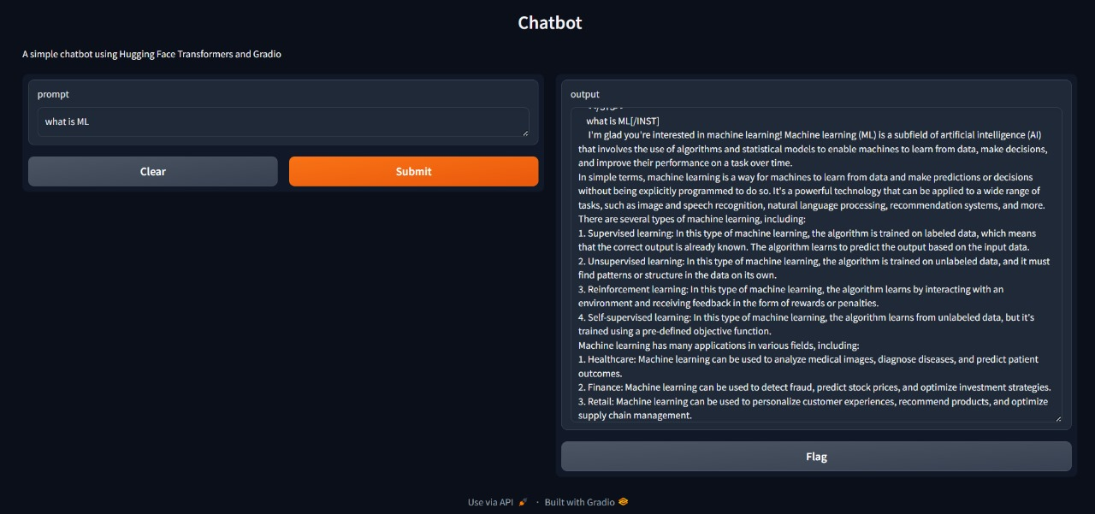

**CONCLUSION**

The Generative AI Chatbot project exemplifies the successful application of advanced natural language processing and machine learning techniques to enhance the user experience in the pizza ordering domain. By integrating sophisticated AI algorithms with a user-friendly conversational interface, the project addresses key challenges in automated customer service, including providing personalized recommendations, handling diverse user queries, and streamlining the ordering process.

The chatbot’s design incorporates a variety of features, such as natural language understanding for accurately interpreting user inputs, and machine learning models to predict answers to our questions. Through rigorous testing and validation, the system demonstrates its ability to handle a wide range of interactions effectively, from processing complex orders to answering common questions.

Key strengths of the chatbot include its ability to deliver personalized recommendations based on user preferences and historical data, its intuitive conversational flow that mimics human interaction, and its robustness in managing various scenarios, including special requests and customizations. The integration of these features results in a highly engaging and efficient user experience that meets the needs of both casual users and those with specific requirements.

The successful deployment of the chatbot provides significant benefits to both users and service providers. Users enjoy a seamless and interactive ordering experience, while service providers can leverage the chatbot to handle high volumes of orders, reduce human error, and optimize resource allocation. The project also highlights the potential for future enhancements, such as incorporating additional AI-driven capabilities, expanding the range of supported queries, and integrating with other systems for a more comprehensive service experience.

Looking ahead, the chatbot project presents opportunities for further refinement and expansion. Future developments could include integrating advanced features such as real-time sentiment analysis to gauge user satisfaction and dynamically adjust responses, or incorporating voice recognition capabilities to enhance accessibility and convenience. Additionally, leveraging user feedback to continuously update and improve the chatbot’s natural language processing algorithms can help in adapting to evolving user preferences and emerging trends in the food service industry. By exploring these advancements, the project can continue to push the boundaries of AI-driven customer service, ensuring that the chatbot remains at the forefront of technological innovation and delivers even greater value to its users.

The Chatbot for Simple Questions represents a significant advancement in the application of artificial intelligence for customer service and information dissemination. By leveraging the latest in natural language processing and machine learning, the chatbot is capable of understanding and responding to a wide variety of common queries with high accuracy and relevance. This technological foundation ensures that users receive timely and precise information, enhancing their overall experience and satisfaction. The chatbot’s ability to handle variations in language and maintain context throughout interactions sets it apart as a reliable and user-friendly tool.

One of the standout features of this chatbot is its scalability and adaptability. It can be tailored to fit the needs of different industries, whether it’s providing customer support in e-commerce, answering patient questions in healthcare, or offering technical assistance in IT services. The integration with various platforms, from websites to mobile apps and social media, ensures that users can access the chatbot conveniently, regardless of their preferred medium. This flexibility not only broadens the chatbot’s applicability but also enhances its utility as a versatile solution for diverse user bases.