KAFKA COMPOSER

When the order gets shipped from amazon, it happens in real time.

If you ordered from uber eats also, from the time of order placing to order receiving into your hand everything is done in real time.

KAKFA-

Kafka is a distributed event store and stream processing platform.

🡪Distributed event store – means all of the events are distributed and come to you

🡪Stream processing – a continuos source of data.Like open Instagram ,you watch reels swipe,swipe these all stuff is stream data.

Let’s say if you use UPI like Gpay, if you did transaction you will be panicked after 1min , coz your money is cutted but gone where, this is where we use the Real time event.

🡪One of the component – PRODUCER

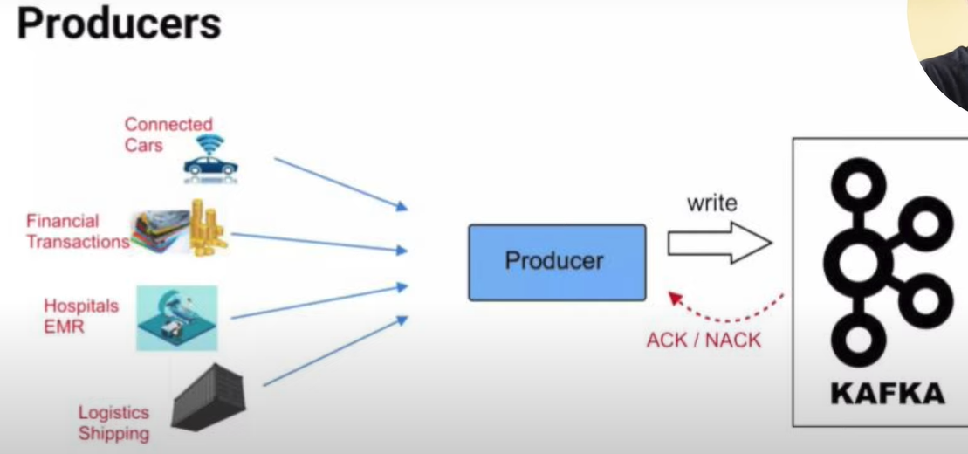

In kafka, each service is called a broker.

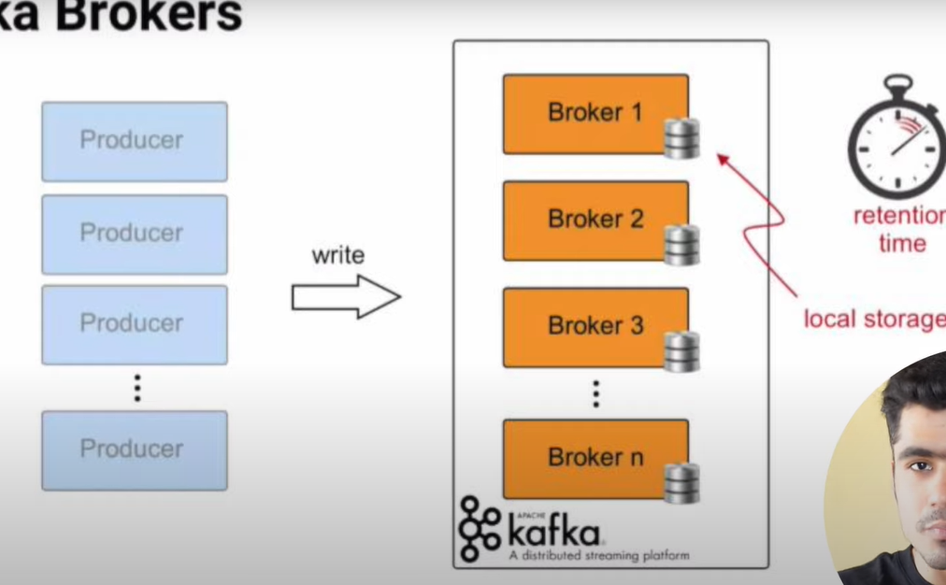

Architecture-

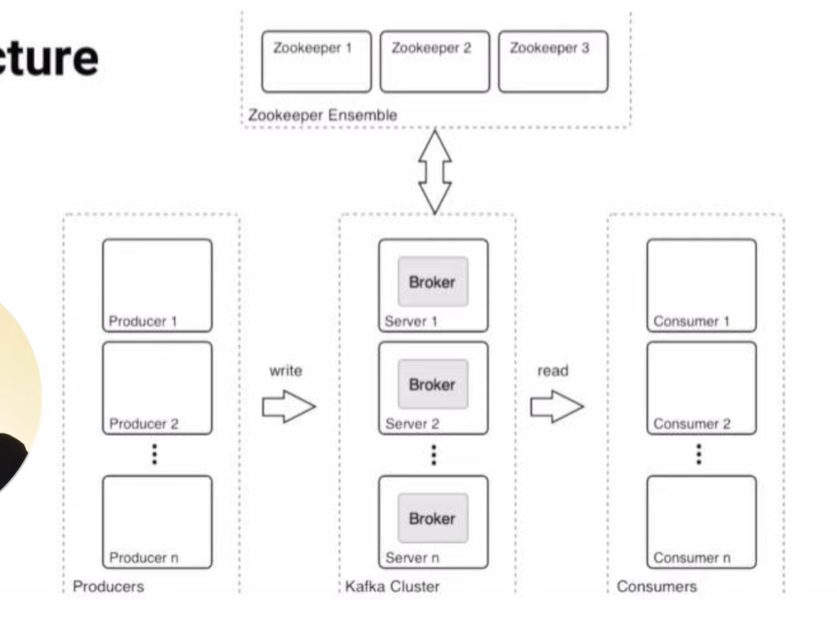

Here we have multiple producers and multiple servers connected.

Producer is something that generates and sends data to another device for processing or storage.

And receivers are here consumers.

So Brokers(servers) here store those messages in something called topics and manage partitions.

Zookeeper make sure all are running properly.

Zookeeper Basics-

Here data is stored in Key value pairs,this maintains the configurations

This also stores the Access control lists, and secrets

Toppics-

These are the logical buckets inside the kafka program.

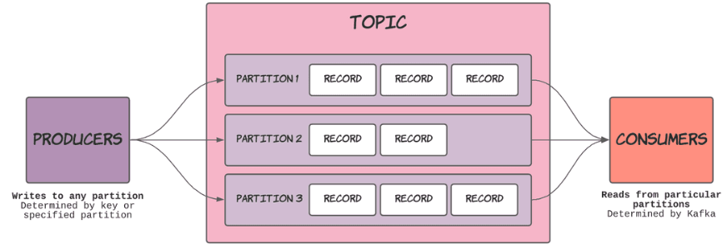

Topics are basically logical representation of kafka program.

Partition is a log file container that provides data activity related stuff.

So these topics are in brokers.

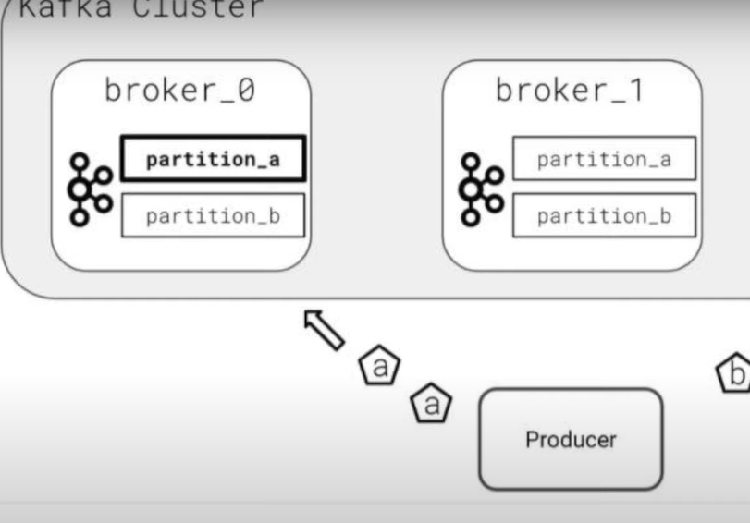

Log file – files in which incoming events are written until the end of the files until they receive.