REVIEW RESPONSE EVIDENCE PACK

MetricGAN+ Teacher-Student
Speech Enhancement
  - Audited data, proposed reviewer responses, and article-ready replacement text
Document purpose: A standalone working document for preparing the reviewer response and manually revising the manuscript. It is not an edited article.
Evidence cutoff: 1 August 2026
Campaign state: New training closed; review experiment matrix, paired uncertainty, lookahead, and analytical complexity audited.
Evaluation support: 824 paired VoiceBank+DEMAND test utterances per system, with bandwidth-matched clean references and PESQ modes.
Important use note
The concern titles in this pack are faithful paraphrases from the canonical review ledger, not verbatim reviewer quotations. Paste the official reviewer wording above each proposed response if the journal requires quotation-level correspondence. All proposed numerical statements below are tied to audited evidence.

1. Executive readiness
Scientific readiness
All requested new training in the approved scope is complete. No additional training is required to prepare the response. The remaining work is editorial: selecting the material below, adapting it to the journal response format, and applying the changes manually to the article.

- WB loss-component ablations are complete for clean-only, teacher-waveform-only, ERB-mask-only, teacher-waveform plus mask, and the reused complete objective.
- NB references are complete for noisy input, matched-input teacher, clean-only student, and reused complete student.
- All systems were evaluated on 824 utterances; sample-level aggregates and 48 paired bootstrap rows were independently reconciled.
- The 10-ms future-signal dependency was validated numerically for both canonical student profiles.
- Teacher and student parameter, weight-storage, recurrent-state, and neural-core MAC/s figures were reconciled analytically.
- The full validation suite passed 114/114 tests; campaign validation, research-plan validation, architecture hashes, diff checks, and project guard passed.
Retained limitations: One training seed; no listening test; no stateful streaming implementation; no measured end-to-end latency, peak memory, runtime, power, or energy on target hardware; no duration-matched FFT ablation.

2. Response status matrix
# | Concern (paraphrased) | Resolution | Status
1 | Distillation benefit not isolated | Addressed with WB ablation matrix and paired CIs | Ready
2 | NB teacher privileged information | Addressed with matched-input teacher and N-CLEAN | Ready with caveat
3 | Incorrect 16-ms lookahead | Corrected and numerically validated as 10 ms | Ready
4 | NB baselines missing | Noisy, matched teacher, clean-only, and complete NB rows | Ready
5 | Only one seed | Cannot be removed; report as explicit limitation | Open limitation
6 | Reproducibility identifiers missing | Stable code, checkpoint, config, manifest, and split IDs | Ready
7 | Foundational references missing | Reference package supplied | Ready
8 | Same FFT sizes at 16/8 kHz | Time-support asymmetry stated explicitly | Ready with caveat
9 | Energy terminology in Eq. (2) | Rename to ERB-band weighted magnitude | Ready
10 | Complexity analysis incomplete | Teacher/student analytical table plus exclusions | Ready
11 | No subjective/artifact evaluation | Cannot be claimed; state limitation and future work | Open limitation
12 | Figure and visual density | Training/inference diagram and audited comparison plots supplied | Ready
13 | Historical/refinement discussion too long | Short replacement paragraph supplied | Ready
14 | Historical SI-SDR discrepancy | Protocols must remain separate; no pooled comparison | Ready with caveat

3. Point-by-point response material
Each item below separates the response to the reviewer from the text recommended for manual insertion into the manuscript. Numerical wording intentionally distinguishes fixed-checkpoint utterance uncertainty from training-seed variability.

3.1 Distillation benefit was not isolated
Proposed response to the reviewer: We agree that the original comparison did not isolate the contribution of the distillation targets. We therefore trained a controlled wideband seed-0 ablation matrix using the same causal-max architecture, data splits, optimizer, checkpoint-selection rule, and 824-pair test protocol. Teacher-waveform-only, ERB-mask-only, teacher-waveform-plus-mask, clean-only, and complete-objective systems are now reported. Paired utterance bootstrap intervals show that each teacher-target configuration improves PESQ-WB by approximately 0.49-0.50 over clean-only training, while STOI and SI-SDR decrease. The teacher-waveform-plus-mask configuration differs only slightly from mask-only in PESQ-WB, and its interval includes zero. We have revised the interpretation from an unqualified distillation benefit to a perceptual-quality versus signal-fidelity trade-off.
Audited evidence: Table 1, Figure 2, and Appendix A. Key contrast: A-TWAVE-MASK minus A-CLEAN PESQ-WB = +0.5048 [0.4852, 0.5240]; SI-SDR = -9.2785 dB [-9.5076, -9.0506]. A-TWAVE-MASK minus A-MASK PESQ-WB = +0.0036 [-0.0019, 0.0095].
Recommended manuscript wording/action: Controlled loss-component ablations show that teacher-derived supervision primarily changes the quality-fidelity operating point. Relative to clean-only training, the teacher-waveform-plus-mask objective increased PESQ-WB by 0.5048 (paired 95% utterance bootstrap CI [0.4852, 0.5240]) but reduced SI-SDR by 9.2785 dB (CI [-9.5076, -9.0506]). Mask-only and teacher-waveform-plus-mask training produced similar PESQ-WB; their paired difference was 0.0036 (CI [-0.0019, 0.0095]). These fixed-seed results support a perceptual-score trade-off, not a claim of universal improvement across metrics or training initializations.

3.2 Narrowband teacher targets may contain privileged wideband information
Proposed response to the reviewer: We agree. Resampling a wideband teacher output to 8 kHz aligns the target representation but does not remove the fact that the teacher decision may have used frequencies above 4 kHz. We added a matched-input reference in which the teacher receives bandwidth-limited input and is evaluated at 8 kHz, together with a clean-only NB student. This separates representation alignment from information access. The fixed wideband teacher remains a reference rather than a dedicated NB teacher.
Audited evidence: On 824 NB pairs, the matched-input teacher obtained PESQ-NB 3.6058, STOI 0.9283, and SI-SDR 9.2583 dB. N-CLEAN obtained 3.3445, 0.9347, and 18.0940 dB; N-COMPLETE obtained 3.6151, 0.9294, and 9.0709 dB.
Recommended manuscript wording/action: For the narrowband student, teacher outputs are resampled to the 8-kHz representation, but the original teacher decision may still be conditioned on wideband input information. We therefore report a matched-input teacher reference that receives bandwidth-limited input. This reference reduces the information mismatch at evaluation but does not constitute a separately trained narrowband teacher. The remaining teacher-information asymmetry is retained as a limitation.

3.3 The reported 16-ms lookahead was incorrect
Proposed response to the reviewer: We corrected the lookahead calculation. The recurrent mapping is frame-causal, and the nonzero Hamming window is 20 ms in both profiles. The larger FFT buffer is zero padding and does not add nonzero future-signal support. A deterministic future-perturbation regression verified that outputs remain bit-identical before cutoff minus 160 samples at 16 kHz and cutoff minus 80 samples at 8 kHz; the following boundary region changes. Both bounds equal 10 ms.
Audited evidence: Focused 14/14 model and I/O tests and full 114/114 suite passed. The test establishes the offline operator's future-dependency bound, not a stateful chunk implementation or device latency.
Recommended manuscript wording/action: The recurrent mapping is frame-causal. Each student uses a centered 20-ms Hamming analysis window, so the mathematical future-signal dependency is 10 ms (160 samples at 16 kHz or 80 samples at 8 kHz). The larger n_fft/2 padding used by the library is not additional nonzero signal support because the analysis window is zero-padded inside the FFT buffer. This is algorithmic lookahead rather than measured end-to-end latency; buffering, feature computation, recurrent execution, synthesis, and device I/O remain to be benchmarked.

3.4 Narrowband baselines were missing
Proposed response to the reviewer: We added current-protocol NB references evaluated with the same 8-kHz clean signals and PESQ-NB mode: noisy input, matched-input teacher, clean-only student, and complete student. All rows use the same 824 utterance identities. WB/PESQ-WB and NB/PESQ-NB results remain in separate tables and are not ranked across modes.
Audited evidence: Table 3 and Figure 3. N-CLEAN minus NOISY-NB PESQ-NB = +0.3964 [0.3773, 0.4157]. N-COMPLETE minus N-CLEAN PESQ-NB = +0.2706 [0.2576, 0.2836], with SI-SDR = -9.0231 dB [-9.2528, -8.7927].
Recommended manuscript wording/action: Within the matched 8-kHz protocol, the complete student improves PESQ-NB relative to clean-only training but operates at substantially lower SI-SDR. Because PESQ-WB and PESQ-NB are different modes and bandwidth conditions, cross-band PESQ comparisons are not used to rank systems.

3.5 Only one training seed was used
Proposed response to the reviewer: We agree and retain this as a limitation. Additional complete-model seeds were removed from the approved experimental scope. We therefore do not report across-seed means, standard deviations, or training-variability confidence intervals. The paired bootstrap intervals quantify utterance-level uncertainty for fixed seed-0 checkpoints only.
Audited evidence: Seven student rows use seed 0. Bootstrap: 10,000 paired utterance draws, seed 20260730, support 824, no cross-band comparisons.
Recommended manuscript wording/action: All student comparisons use one training seed. The paired 95% bootstrap intervals quantify uncertainty over the 824 test utterances for the fixed checkpoints and must not be interpreted as training-seed variability. Replicated training remains necessary to establish the robustness of the observed differences to initialization and optimization stochasticity.

3.6 Reproducibility identifiers were absent
Proposed response to the reviewer: We added stable code, model, configuration, manifest, split, and implementation identifiers. Test evaluation was performed only after checkpoint selection. Machine-specific paths and mount details are intentionally excluded from publication-facing material.
Audited evidence: See Table 5. Manifest row counts: train_fit 9,754; val_rank 128; val_select 1,690; test 824. Validation speakers excluded from optimization: p239, p244, p270, and p286.
Recommended manuscript wording/action: Reproducibility identifiers are reported for the canonical code snapshot, teacher source revision and checkpoints, student checkpoints, resolved configuration, and all four data manifests. The test split was not used for model selection.

3.7 Foundational references were absent
Proposed response to the reviewer: We agree and remove the artificial recent-year restriction. The revised background should cite the original MetricGAN and MetricGAN+ methods, VoiceBank+DEMAND protocol source, PESQ, STOI, SI-SDR, and the foundational knowledge-distillation reference.
Audited evidence: A verified foundational-reference list with DOI identifiers is provided in Section 10.
Recommended manuscript wording/action: Use the reference package in Section 10 and connect each citation to the corresponding method, dataset, metric, or distillation claim. Recent compact-enhancement work may remain, but it should not replace the foundational sources.

3.8 Equal FFT-bin choices at 16 and 8 kHz do not imply equal time support
Proposed response to the reviewer: We agree. The multi-resolution spectral losses use the same sample-domain FFT sizes at both sample rates, which doubles their time durations in the NB condition. We now state the exact supports rather than claiming temporal equivalence. No duration-matched NB retraining was performed.
Audited evidence: FFT sizes {256, 512, 1024} correspond to {16, 32, 64} ms at 16 kHz and {32, 64, 128} ms at 8 kHz.
Recommended manuscript wording/action: The same sample-domain FFT sizes produce different temporal supports across bandwidths: 16/32/64 ms at 16 kHz and 32/64/128 ms at 8 kHz. This design asymmetry is a limitation; a duration-matched narrowband loss configuration would define a separate ablation requiring retraining.

3.9 Equation (2) uses magnitude, not energy
Proposed response to the reviewer: We agree. The implemented ERB target sums weighted spectral magnitudes. Calling it energy is incorrect. We recommend a terminology-only correction that preserves the trained method. Squaring the quantity would change the objective and would require new training.
Audited evidence: The implementation and completed checkpoints use weighted magnitude aggregation.
Recommended manuscript wording/action: Replace 'ERB-band energy' with 'ERB-band weighted magnitude' in the equation, variable definition, figure labels, and surrounding text. Do not change the numerical definition in the revised description.

3.10 Complexity reporting was incomplete
Proposed response to the reviewer: We expanded the analytical comparison to include the fixed teacher and both students, together with FP32 weight storage, theoretical INT8 weight-only lower bounds, neural-core MAC/s, and recurrent-state-only counts. We explicitly separate these architecture indicators from unmeasured processor costs.
Audited evidence: Table 4. Teacher: 1,895,514 parameters and 118.02M neural-core MAC/s. WB student: 604,386 and 60.22M. NB student: 514,018 and 51.21M.
Recommended manuscript wording/action: The reported operation counts cover recurrent and linear MACs only. The current whole-waveform implementation materializes centered STFT/iSTFT tensors and intermediate activations whose peak memory depends on batch size and utterance length. No stateful streaming kernel, fixed backend buffer plan, FFT workspace, memory traffic, worst-case hop runtime, end-to-end latency, power, or energy has been measured. These values are analytical architecture indicators, not deployment benchmarks.

3.11 No subjective or artifact-focused evaluation was performed
Proposed response to the reviewer: We agree that objective metrics cannot replace listening evidence. No formal listening test, artifact taxonomy, or sanitized listening package is available in the audited scope. We therefore keep this as an explicit limitation and do not infer perceptual artifact absence from PESQ or STOI.
Audited evidence: No subjective scores or formal artifact labels exist in the validated run packages.
Recommended manuscript wording/action: The evaluation is objective only. No formal listener study or artifact-specific analysis was performed, so the results cannot establish subjective preference or the absence of musical-noise and speech-distortion artifacts. Listening evaluation remains future work.

3.12 Figures and visual presentation were insufficient
Proposed response to the reviewer: We prepared a clear training-versus-inference diagram and separate WB and NB comparison plots based only on audited aggregates. They emphasize that the teacher is absent at inference and that WB and NB protocols remain separate.
Audited evidence: Figures 1-3 in this pack. Source values reproduce the historical aggregates within 1e-6.
Recommended manuscript wording/action: Use Figure 1 to replace the generic architecture sketch. Use Figures 2 and 3, or their journal-formatted equivalents, to present the quality-fidelity trade-offs. Do not merge the WB and NB PESQ axes.

3.13 Historical teacher-refinement discussion was too long
Proposed response to the reviewer: We agree. The long internal optimization chronology is not central to the student evidence. It should be replaced by one concise, traceable negative-result statement.
Audited evidence: The closed T1-T16 search retained the fixed T0 teacher. The best safe validation PESQ increase was +0.009619, below the predeclared +0.01 gate.
Recommended manuscript wording/action: A bounded sequence of teacher-refinement attempts did not meet the predeclared promotion gate; the best safe validation PESQ increase was +0.009619, below the required +0.01. We therefore retained the fixed official teacher for all reported student experiments. Detailed internal optimization chronology is omitted because it did not alter the selected teacher.

3.14 Historical and current SI-SDR values should not be pooled
Proposed response to the reviewer: We agree. Historical and current experiments differ in teacher, architecture, segmentation, true-length evaluation, and bandwidth protocol. The current article should either remove the historical comparison table or label it as non-comparable context.
Audited evidence: Current values use the corrected true-length VoiceBank+DEMAND evaluation and bandwidth-matched references. Historical values do not share the complete protocol.
Recommended manuscript wording/action: Historical results are retained only as qualitative context. They are not pooled with the current tables because model architecture, training data handling, segmentation, teacher definition, and evaluation protocol differ. No causal explanation is assigned to any single difference without a controlled experiment.

4. Audited result tables

4.1 Wideband loss-component ablation
Cell | Mask / teacher / clean | Selected / stop | n | PESQ-WB | STOI | SI-SDR | Delta SNR
A-CLEAN | 0 / 0 / 1 | 45 / 50 | 824 | 2.5517 | 0.9350 | 17.9958 | 9.6458
A-TWAVE | 0 / 1 / 0 | 32 / 40 | 824 | 3.0389 | 0.9278 | 8.7718 | -0.4849
A-MASK | 1 / 0 / 0 | 31 / 39 | 824 | 3.0529 | 0.9288 | 8.6783 | -0.4990
A-TWAVE-MASK | 12/17 / 5/17 / 0 | 34 / 42 | 824 | 3.0565 | 0.9292 | 8.7173 | -0.4631
A-COMPLETE | 0.60 / 0.25 / 0.15 | 34 / 42 | 824 | 3.0519 | 0.9296 | 9.0499 | -0.1566

Interpretation: Teacher-derived targets produce a large PESQ-WB gain relative to clean-only training but trade away STOI and approximately 9 dB SI-SDR. A-TWAVE-MASK and A-MASK are very close in PESQ-WB.

4.2 Canonical wideband teacher/reference comparison
System | n | PESQ-WB | STOI | SI-SDR | Delta SNR
T0-WB-OFFICIAL | 824 | 3.1309 | 0.9319 | 8.5791 | -0.7974
A-COMPLETE/S0-WB | 824 | 3.0519 | 0.9296 | 9.0499 | -0.1566
NOISY-WB | 824 | 1.9701 | 0.9210 | 8.4454 | 0.0000

Protocol rule: All rows use the canonical 16-kHz wideband test protocol and PESQ-WB on the same 824 utterances. This reference table is separate from all 8-kHz PESQ-NB results.

4.3 Narrowband matched-protocol references
System | n | PESQ-NB | STOI | SI-SDR | Delta SNR
NOISY-NB | 824 | 2.9481 | 0.9212 | 8.4318 | 0.0000
MATCHED TEACHER | 824 | 3.6058 | 0.9283 | 9.2583 | -0.2775
N-CLEAN | 824 | 3.3445 | 0.9347 | 18.0940 | 9.7529
N-COMPLETE | 824 | 3.6151 | 0.9294 | 9.0709 | -0.1419

Protocol rule: Every NB row uses 8-kHz clean references and PESQ-NB. No PESQ value in this table should be compared numerically with PESQ-WB values.

4.4 Key paired utterance contrasts
Contrast (left - right) | Metric | Mean delta | Paired 95% CI | n
A-TWAVE-MASK - A-CLEAN | PESQ-WB | +0.5048 | [+0.4852, +0.5240] | 824
A-TWAVE-MASK - A-CLEAN | SI-SDR (dB) | -9.2785 | [-9.5076, -9.0506] | 824
A-TWAVE-MASK - A-MASK | PESQ-WB | +0.0036 | [-0.0019, +0.0095] | 824
A-COMPLETE - A-TWAVE-MASK | PESQ-WB | -0.0045 | [-0.0083, -0.0008] | 824
N-CLEAN - NOISY-NB | PESQ-NB | +0.3964 | [+0.3773, +0.4157] | 824
N-COMPLETE - N-CLEAN | PESQ-NB | +0.2706 | [+0.2576, +0.2836] | 824
N-COMPLETE - N-CLEAN | SI-SDR (dB) | -9.0231 | [-9.2528, -8.7927] | 824
N-COMPLETE - MATCHED TEACHER | PESQ-NB | +0.0094 | [+0.0003, +0.0183] | 824

Uncertainty scope: 10,000 percentile-bootstrap draws over paired utterances, seed 20260730. Positive values favor the left system. These intervals do not estimate training-seed variability.

5. Figures available for the revision
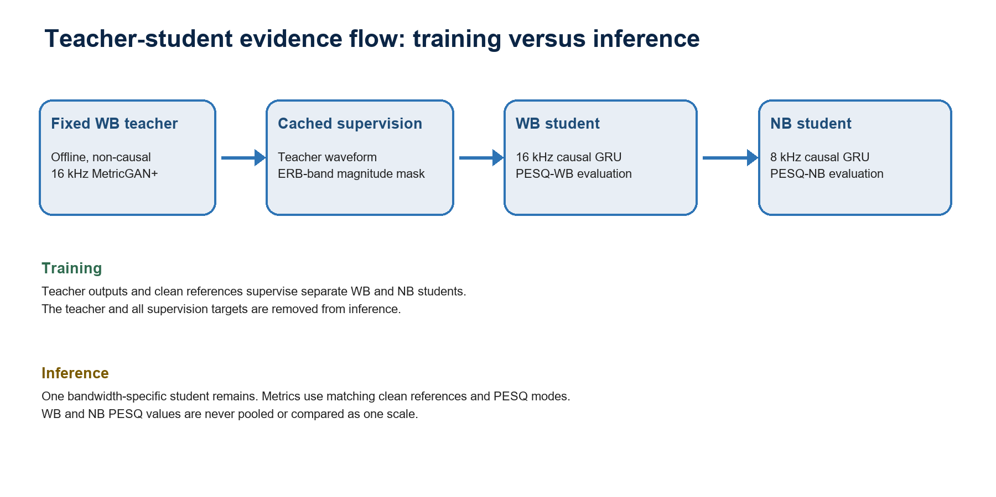
Figure 1. Teacher-student supervision flow and the bandwidth-specific inference boundary.
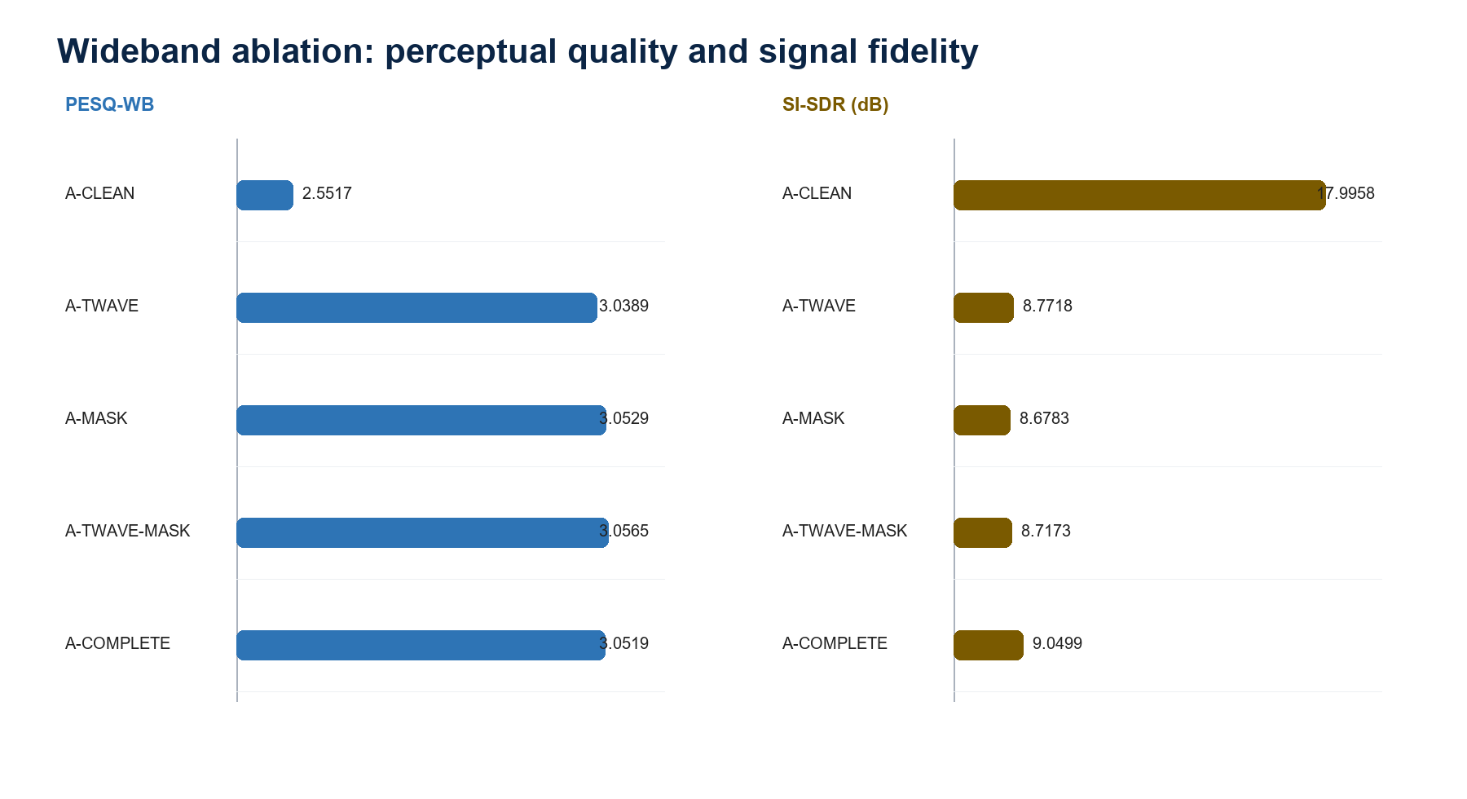
Figure 2. WB ablation aggregates on 824 PESQ-WB-matched test pairs.
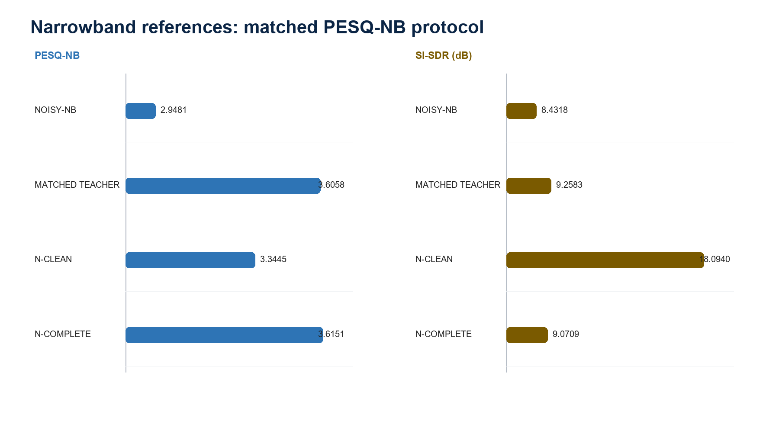
Figure 3. NB references on 824 PESQ-NB-matched test pairs.

6. Corrected lookahead and streaming wording
Validated claim
Algorithmic future-signal dependency is 10 ms for both students. This is not a measured end-to-end latency result.

Numerical check: Future-only perturbations leave all output samples before cutoff - win_length/2 bit-identical. The boundary region changes for both profiles, showing that the bound is meaningful: 160 samples at 16 kHz and 80 samples at 8 kHz.
Do not claim: stateful chunk-by-chunk inference, hop-by-hop equivalence, fixed peak memory, real-time factor, worst-case execution time, measured device latency, or energy.
Locations to correct manually: Abstract; Section III-C; Section VI-A; Table V; conclusion; any figure or caption that still reports 16 ms.

7. Analytical complexity package
Model | Parameters | FP32 weights | INT8 lower bound | Frames/s | Neural-core MAC/s | Reduction
Fixed MetricGAN+ teacher | 1,895,514 | 7.582 MB | 1.896 MB | 62.5 | 118.02M | -
WB student | 604,386 | 2.418 MB | 0.604 MB | 100 | 60.22M | 49.0%
NB student | 514,018 | 2.056 MB | 0.514 MB | 100 | 51.21M | 56.6%

Recurrent-state-only accounting: Either student: 3 GRU layers x 160 hidden values x 4 bytes = 1.920 kB FP32. Teacher LSTM state alone: 2 layers x 2 directions x (hidden + cell) x 200 x 4 bytes = 6.400 kB.
Required caveat: Weight storage is reported in decimal MB. The INT8 column is a theoretical one-byte-per-weight lower bound, not a converted or accuracy-tested integer model. STFT/iSTFT tensors, activations, backend workspace, runtime, peak memory, latency, power, and energy are excluded.

8. Reproducibility and provenance
Artifact | Stable identifier
Canonical seed-0 package code commit | 1770aa636f80042274e3181ae35f3e95f6aeb838
NB loader correction commit | f69da475d4ce8a275bb1ea537956105a37073661
SpeechBrain generator revision | a196ce26b3bdace6fa1d819017584bdbcce462a8
Raw official generator checkpoint SHA-256 | 147bfb866bac8264603546e035bf283370e716ed2f4b7412d308d2bcee88304f
Portable T0 checkpoint SHA-256 | 5ece6fbd1ac16cca6df11ea724fb5e3710d6611049f54bbc8d126c79dbbc65d8
Seed-0 WB complete student SHA-256 | dc1d2d2171876fb5665bd447506e3371492a4619cc8f2749cbfca7292f1ca335
Seed-0 NB complete student SHA-256 | 1b89e6b5931eb3a4bb63db7844ffe5e74486e9bf75b835342926776336d11491
N-CLEAN selected checkpoint SHA-256 | 6e0c69c2f484e5e7ab6a90779e98ae3bf77ab0fad4d40dcb70a2fb1da921cf7d
Resolved canonical config SHA-256 | d6989c259c51a43b75f66602e94964657405c21520f34c3a8b5dcc3d28ec9690
train_fit manifest: 9,754 rows | 5715037a664ecb6a7302393a8b973e8744261d95e9487af17c397cdd65642bf6
val_rank manifest: 128 rows | 5d3df5fa11ca64186117620d07f0beeeac0563ba93cffc85bcba48f38ad62a9e
val_select manifest: 1,690 rows | 328e86032d166dc68d01482658b4073f25624ba0d88071c1862c3e0e1ea68d23
test manifest: 824 rows | b74a2d9002d1a97a0c7f92d483d9c8840e2898d894222323d47f0aa630684e1d
Matrix summary SHA-256 | f0874cfbaf1f5a7f8e1d4b155c2872dc36649e9350f30b67a75d3f9af79a898b
Paired-bootstrap CSV SHA-256 | 593211d0360d4ad8a60a448874d7d03489a41e9b83a805b950054708ff3e0f39

Split rule: Validation speakers excluded from optimization: p239, p244, p270, and p286. Test was not used for checkpoint selection.
Publication hygiene: Do not publish usernames, personal paths, hostnames, IP addresses, mount names, external-drive logic, or credentials.

9. Manual article-editing checklist
- Replace every 16-ms lookahead statement with the validated 10-ms algorithmic dependency and preserve the latency caveat.
- Insert the WB ablation table and the key paired intervals; describe the PESQ versus STOI/SI-SDR trade-off.
- Insert a separate NB table with noisy input, matched-input teacher, N-CLEAN, and N-COMPLETE; keep PESQ-NB separate from PESQ-WB.
- Add the one-seed limitation and state that utterance bootstrap does not measure training variability.
- Correct Eq. (2) terminology from energy to ERB-band weighted magnitude without changing the trained objective.
- State the 16/32/64-ms WB and 32/64/128-ms NB multi-resolution supports.
- Replace Table V with the teacher/student analytical complexity table and all exclusions.
- Add the reproducibility identifiers and test-isolation statement.
- Add the foundational references in Section 10.
- Replace the long teacher-refinement chronology with the concise negative-result paragraph.
- Remove or explicitly label historical SI-SDR values as protocol-incomparable context.
- Add the objective-only, no-listening-test limitation.
- Use the supplied diagram and separate WB/NB plots, or redraw them in the journal's final style without changing the data.
- Recheck abstract, methods, results, Table V, limitations, conclusion, captions, and supplementary text for consistency.

10. Foundational references to add
- S.-W. Fu, C.-F. Liao, Y. Tsao, and S.-D. Lin, 'MetricGAN: Generative Adversarial Networks based Black-box Metric Scores Optimization for Speech Enhancement,' Proceedings of Machine Learning Research, vol. 97, pp. 2031-2041, 2019.
- S.-W. Fu et al., 'MetricGAN+: An Improved Version of MetricGAN for Speech Enhancement,' Interspeech, 2021, doi: 10.21437/Interspeech.2021-599.
- C. Valentini-Botinhao et al., 'Investigating RNN-based Speech Enhancement Methods for Noise-Robust Text-to-Speech,' SSW, 2016, doi: 10.21437/SSW.2016-24. Cite together with the exact VoiceBank+DEMAND release used by the experiment.
- A. W. Rix, J. G. Beerends, M. P. Hollier, and A. P. Hekstra, 'Perceptual Evaluation of Speech Quality (PESQ),' ICASSP, 2001, doi: 10.1109/ICASSP.2001.941023; and ITU-T Recommendation P.862.
- C. H. Taal, R. C. Hendriks, R. Heusdens, and J. Jensen, 'An Algorithm for Intelligibility Prediction of Time-Frequency Weighted Noisy Speech,' IEEE/ACM Transactions on Audio, Speech, and Language Processing, 2011, doi: 10.1109/TASL.2011.2114881.
- J. Le Roux, S. Wisdom, H. Erdogan, and J. R. Hershey, 'SDR - Half-baked or Well Done?' ICASSP, 2019, doi: 10.1109/ICASSP.2019.8683855.
- G. Hinton, O. Vinyals, and J. Dean, 'Distilling the Knowledge in a Neural Network,' arXiv:1503.02531, 2015.

Appendix A. Complete paired-bootstrap ledger
Reading rule
All rows are left minus right. Positive favors the left system for the displayed metric. Each interval uses 10,000 paired utterance draws over 824 identities. WB and NB are never mixed. These intervals do not estimate across-seed training variability.

Contrast (left - right) | Band | Metric | Mean delta | Paired 95% CI
A-TWAVE - A-CLEAN | WB | PESQ-WB | +0.4872 | [+0.4673, +0.5072]
A-TWAVE - A-CLEAN | WB | STOI | -0.0072 | [-0.0080, -0.0064]
A-TWAVE - A-CLEAN | WB | SI-SDR (dB) | -9.2240 | [-9.4557, -8.9914]
A-TWAVE - A-CLEAN | WB | Delta SNR (dB) | -10.1307 | [-10.3400, -9.9196]
A-MASK - A-CLEAN | WB | PESQ-WB | +0.5012 | [+0.4813, +0.5208]
A-MASK - A-CLEAN | WB | STOI | -0.0062 | [-0.0071, -0.0053]
A-MASK - A-CLEAN | WB | SI-SDR (dB) | -9.3174 | [-9.5518, -9.0825]
A-MASK - A-CLEAN | WB | Delta SNR (dB) | -10.1448 | [-10.3511, -9.9374]
A-TWAVE-MASK - A-CLEAN | WB | PESQ-WB | +0.5048 | [+0.4852, +0.5240]
A-TWAVE-MASK - A-CLEAN | WB | STOI | -0.0058 | [-0.0067, -0.0049]
A-TWAVE-MASK - A-CLEAN | WB | SI-SDR (dB) | -9.2785 | [-9.5076, -9.0506]
A-TWAVE-MASK - A-CLEAN | WB | Delta SNR (dB) | -10.1089 | [-10.3166, -9.8997]
A-COMPLETE - A-CLEAN | WB | PESQ-WB | +0.5002 | [+0.4808, +0.5194]
A-COMPLETE - A-CLEAN | WB | STOI | -0.0054 | [-0.0062, -0.0044]
A-COMPLETE - A-CLEAN | WB | SI-SDR (dB) | -8.9459 | [-9.1720, -8.7210]
A-COMPLETE - A-CLEAN | WB | Delta SNR (dB) | -9.8024 | [-10.0072, -9.5957]
A-TWAVE-MASK - A-TWAVE | WB | PESQ-WB | +0.0176 | [+0.0115, +0.0239]
A-TWAVE-MASK - A-TWAVE | WB | STOI | +0.0014 | [+0.0010, +0.0018]
A-TWAVE-MASK - A-TWAVE | WB | SI-SDR (dB) | -0.0545 | [-0.0998, -0.0112]
A-TWAVE-MASK - A-TWAVE | WB | Delta SNR (dB) | +0.0218 | [+0.0035, +0.0399]
A-TWAVE-MASK - A-MASK | WB | PESQ-WB | +0.0036 | [-0.0019, +0.0095]
A-TWAVE-MASK - A-MASK | WB | STOI | +0.0004 | [+0.0000, +0.0007]
A-TWAVE-MASK - A-MASK | WB | SI-SDR (dB) | +0.0390 | [+0.0112, +0.0660]
A-TWAVE-MASK - A-MASK | WB | Delta SNR (dB) | +0.0359 | [+0.0225, +0.0494]
A-COMPLETE - A-TWAVE-MASK | WB | PESQ-WB | -0.0045 | [-0.0083, -0.0008]
A-COMPLETE - A-TWAVE-MASK | WB | STOI | +0.0004 | [+0.0001, +0.0008]
A-COMPLETE - A-TWAVE-MASK | WB | SI-SDR (dB) | +0.3326 | [+0.3051, +0.3610]
A-COMPLETE - A-TWAVE-MASK | WB | Delta SNR (dB) | +0.3065 | [+0.2915, +0.3218]
N-CLEAN - NOISY-NB | NB | PESQ-NB | +0.3964 | [+0.3773, +0.4157]
N-CLEAN - NOISY-NB | NB | STOI | +0.0135 | [+0.0122, +0.0149]
N-CLEAN - NOISY-NB | NB | SI-SDR (dB) | +9.6622 | [+9.3756, +9.9480]
N-CLEAN - NOISY-NB | NB | Delta SNR (dB) | +9.7529 | [+9.4654, +10.0372]
N-COMPLETE - NOISY-NB | NB | PESQ-NB | +0.6670 | [+0.6470, +0.6871]
N-COMPLETE - NOISY-NB | NB | STOI | +0.0082 | [+0.0070, +0.0094]
N-COMPLETE - NOISY-NB | NB | SI-SDR (dB) | +0.6391 | [+0.2927, +0.9804]
N-COMPLETE - NOISY-NB | NB | Delta SNR (dB) | -0.1419 | [-0.4812, +0.1915]
N-COMPLETE - N-CLEAN | NB | PESQ-NB | +0.2706 | [+0.2576, +0.2836]
N-COMPLETE - N-CLEAN | NB | STOI | -0.0053 | [-0.0062, -0.0045]
N-COMPLETE - N-CLEAN | NB | SI-SDR (dB) | -9.0231 | [-9.2528, -8.7927]
N-COMPLETE - N-CLEAN | NB | Delta SNR (dB) | -9.8947 | [-10.0983, -9.6924]
N-CLEAN - MATCHED TEACHER | NB | PESQ-NB | -0.2613 | [-0.2766, -0.2461]
N-CLEAN - MATCHED TEACHER | NB | STOI | +0.0064 | [+0.0053, +0.0076]
N-CLEAN - MATCHED TEACHER | NB | SI-SDR (dB) | +8.8358 | [+8.5990, +9.0707]
N-CLEAN - MATCHED TEACHER | NB | Delta SNR (dB) | +10.0303 | [+9.7992, +10.2601]
N-COMPLETE - MATCHED TEACHER | NB | PESQ-NB | +0.0094 | [+0.0003, +0.0183]
N-COMPLETE - MATCHED TEACHER | NB | STOI | +0.0011 | [+0.0002, +0.0020]
N-COMPLETE - MATCHED TEACHER | NB | SI-SDR (dB) | -0.1873 | [-0.2632, -0.1130]
N-COMPLETE - MATCHED TEACHER | NB | Delta SNR (dB) | +0.1356 | [+0.0704, +0.1997]

Appendix B. Run and audit inventory
Evidence block | Run ID | Audit outcome
Current baselines | 20260730-review-baselines-test-s0-a1 | 3 systems x 824; audited
A-CLEAN | 20260730-review-clean-wb-s0-a1 | selected 45; completed 50
A-TWAVE | 20260731-review-twave-wb-s0-a1 | selected 32; stopped 40
A-MASK | 20260731-review-mask-wb-s0-a3 | selected 31; stopped 39
A-TWAVE-MASK | 20260801-review-twave-mask-wb-s0-a1 | selected 34; stopped 42
A-COMPLETE | 20260727-converged-s0-baseline-v2 | promoted seed-0 reuse; selected 34; stopped 42
N-CLEAN | 20260801-review-clean-nb-s0-a2 | selected 35; stopped 43
N-COMPLETE | 20260727-converged-s0-baseline-v2 | promoted seed-0 reuse; selected 41; stopped 49
Matrix uncertainty | 20260801-review-matrix-uncertainty-s0-a1 | 10 systems x 824; 48 bootstrap rows

Failed attempts: A-MASK a1/a2, N-CLEAN a1, and the first bounded N-CLEAN smoke remain infrastructure/orchestration or implementation failure records. They contain no promoted scientific result and are not used in any table above.

Appendix C. Final claim-safety checklist
- Use 'observed for the fixed seed-0 checkpoints' for experiment differences.
- Use 'paired utterance bootstrap interval' rather than 'training confidence interval'.
- Do not claim statistical significance across training seeds.
- Do not compare PESQ-WB and PESQ-NB as one metric scale.
- Do not call the matched-input teacher a dedicated NB teacher.
- Do not equate 10-ms algorithmic lookahead with end-to-end latency.
- Do not call INT8 storage a validated quantized deployment.
- Do not imply listening preference or artifact absence from objective metrics.
- Do not turn failed or interrupted runs into experimental rows.
- Do not publish machine-local paths or server details.

