VoiceBank PESQ-First Campaign Report
Raport generat automat pentru campania end-to-end pe VoiceBank-DEMAND. Metrica primară de selecție este PESQ, cu guardrails pe STOI și SI-SDR.

Executive Summary
Modelul final selectat: repo_baseline, stage=base, val PESQ=1.2037, test PESQ=1.1904.
Dataset validation: train=256, val=256, val_quick=256, test=824, speaker_disjoint=False.
Hardware/stack: device=cuda, VRAM=11.99 GB, torch=2.2.1+cu121.

Architecture
Arhitectura folosită este un denoiser aTENNuate-like pe waveform brut, mono 16 kHz, cu encoder-decoder pe blocuri SSM și inferență offline.

Architecture Details
Field | Value
Canale encoder | 16, 32, 64, 96, 128, 256
Factori resampling | 4, 4, 2, 2, 2, 2
Num coeffs / repeat | 16 / 16
Parametri | 844,864
Padding multiplu | 256
Pre-conv | True
Mod de lucru | offline waveform denoiser

Campaign Results

Per-Direction Leaderboard
Direction | Base Val PESQ | Refined Val PESQ | Best Val PESQ | Best Test PESQ | Rule | Selected Stage
repo_baseline | 1.2037 | - | 1.2037 | 1.1904 | none | base
protocol_longctx | 1.1165 | - | 1.1165 | 1.0920 | none | base

repo_baseline
Ipoteză/refinement: rule=none; rationale=control_or_no_actionable_issue; issues=control_experiment.
Base val: PESQ=1.2037, STOI=0.5819, SI-SDR=-22.0417.
Best selected (base): val PESQ=1.2037, test PESQ=1.1904. Checkpoint=runs/pesq_campaign_smoke/base/repo_baseline/best.pt.
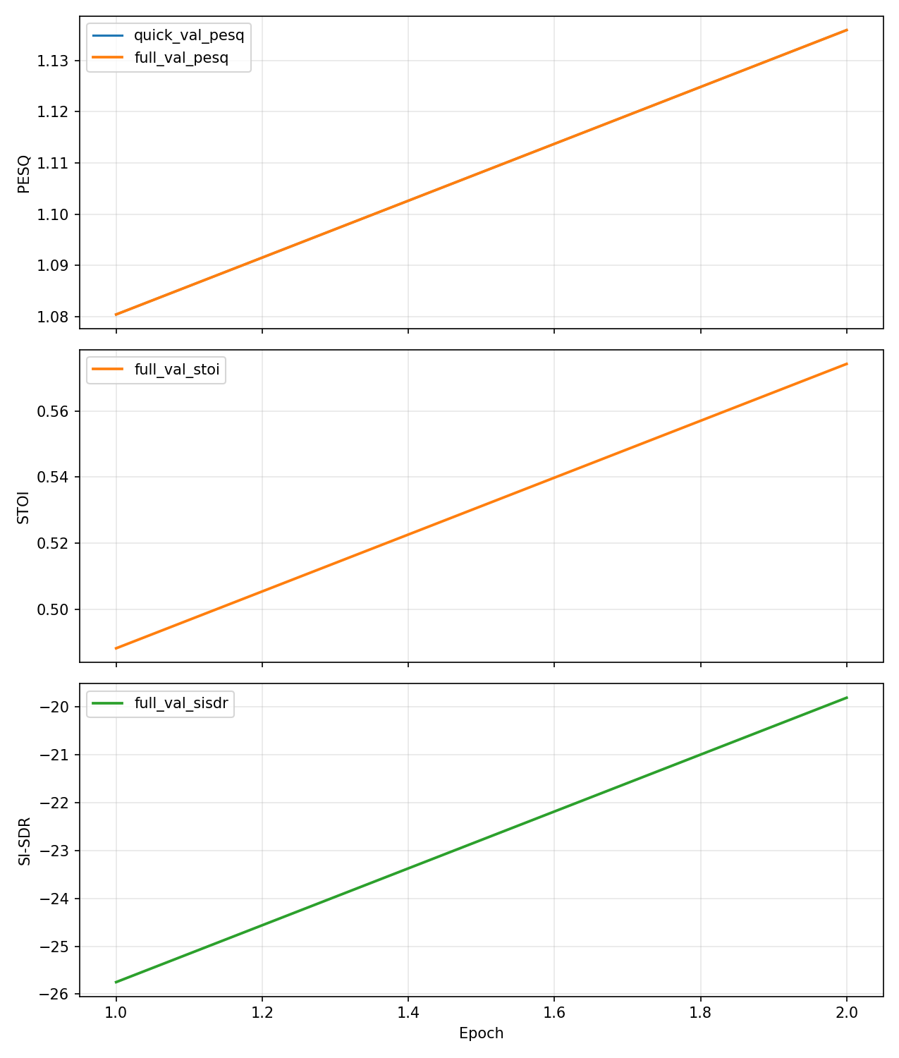

protocol_longctx
Ipoteză/refinement: rule=none; rationale=control_or_no_actionable_issue; issues=control_experiment.
Base val: PESQ=1.1165, STOI=0.5149, SI-SDR=-45.7782.
Best selected (base): val PESQ=1.1165, test PESQ=1.0920. Checkpoint=runs/pesq_campaign_smoke/base/protocol_longctx/best.pt.
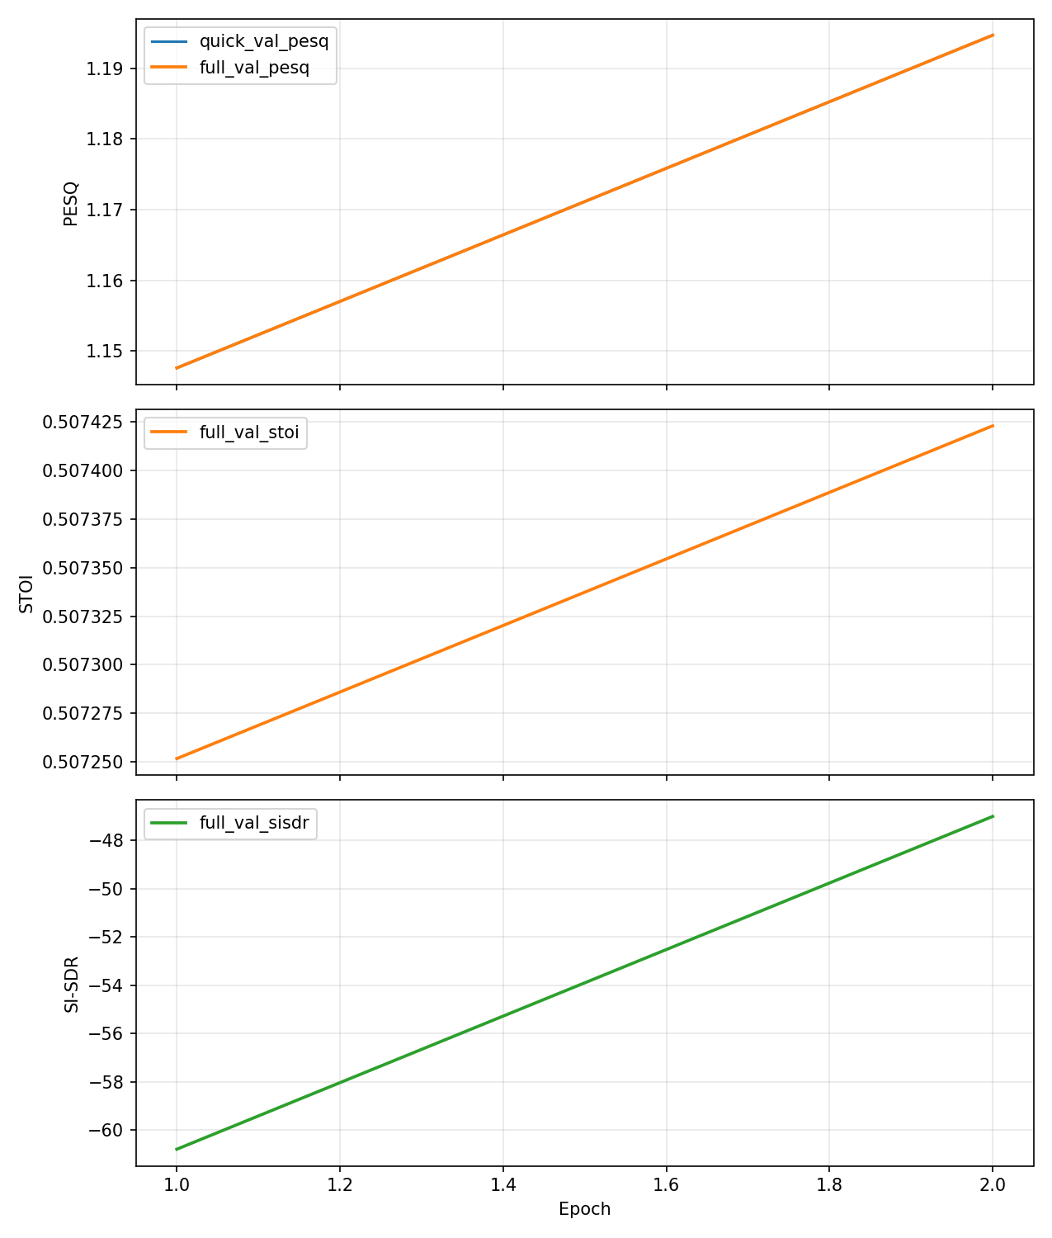

Final Model
Winner direction: repo_baseline. Final checkpoint: runs/pesq_campaign_smoke/base/repo_baseline/best.pt. Stage2 applied=False; stable_direction=False.
Final validation metrics: PESQ=1.2037, STOI=0.5819, SI-SDR=-22.0417.
Final test metrics: PESQ=1.1904, STOI=0.6356, SI-SDR=-26.0903, Delta-SNR=-9.8215.

Exports

Export Status
Format | Success | Artifact | Notes
TorchScript | True | runs/pesq_campaign_smoke/exports/final_model.ts | orrect. We can't record the data flow of Python values, so this value will be treated as a constant in the future. This means that the trace might not generalize to other inputs!  if coeffs <= c_in:
ONNX | False | runs/pesq_campaign_smoke/exports/final_model.onnx | e legacy exporter in this PyTorch build does not support FFT operators used by aTENNuate (for example aten::fft_rfft). Use TorchScript export or install a newer ONNX exporter stack with FFT coverage.

Reproducibility
Config source: experiments/pesq_campaign_smoke.toml. Outputs are aggregated in campaign_summary.json and leaderboard.csv/json under the run directory.
Seed principal: 1337. Seed confirmare: 2337. Fiecare direcție a fost antrenată end-to-end; smoke testele nu intră în raportul de performanță.

