TestCase description:

for Testcase sequence digrams, they are decribed in the “Lab2 Design-Report.pdf” file.

run-part1.sh & run-part2.sh : This Script files corresponds to the automation of the “For manual Test cases entered as Input by user” case discussed above. This script is executable and has all permissions. User Just need to run this script and Terminals Pop up and the user need to enter various values depending on the statements in the terminal and the Application can be tested. User Input Needed. The first or second line output in terminal will convey the operation performed by that process. See Appendix: 1 and Appendix 2

lab2-run-test-case.sh: This Script file corresponds to the automation of the “For Test cases file as Input” case discussed above. This script is executable and has all permissions. The script will execute in different Terminals and an output file “event-log1.csv”and/or “event-log2.csv” database file is created by the Gateway with the tuples containing time stamp values, deviceId, deviceType, currentState, event and inferredActivity from sensors and devices. No Need of User Input. Please wait till all the execution completes in 3 terminals and the output from the programs stop (Doesn’t move). See Appendix: 2

Appendix 1: part1 Ring Algorithm
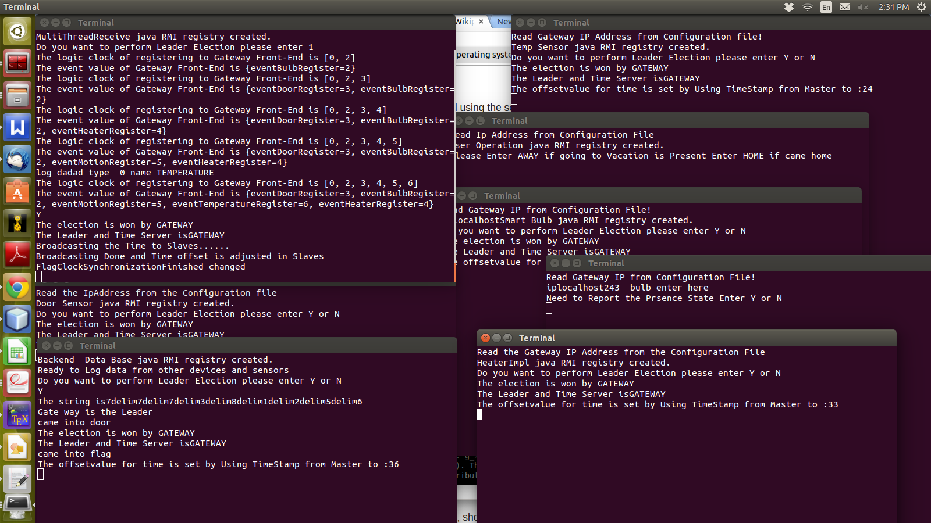
Appendix 2: part2 Logical clock
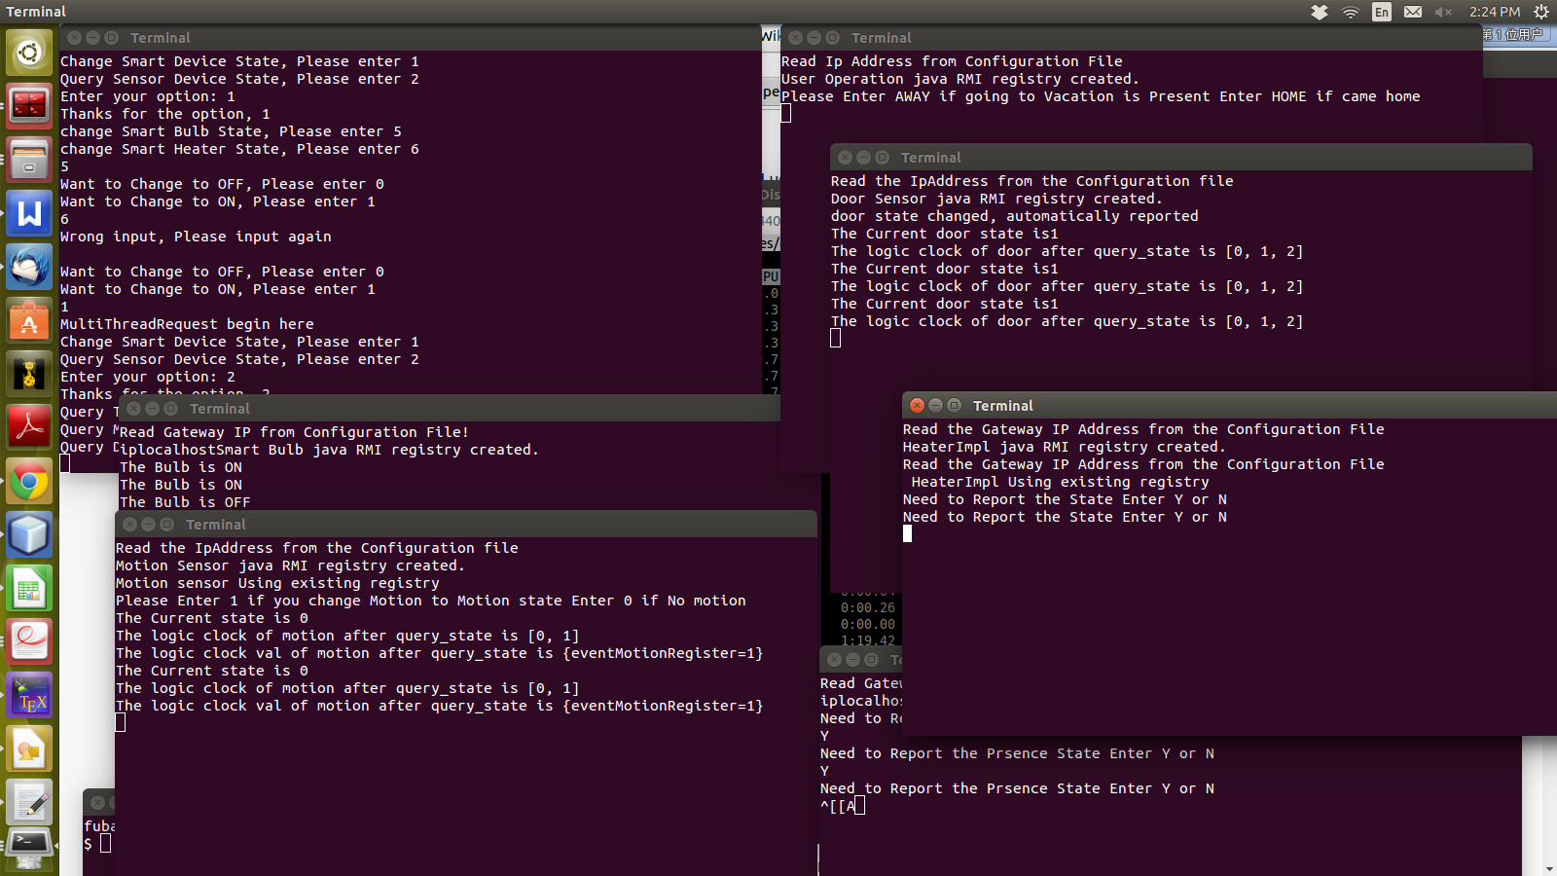

Appendix 3: test-cases , event ordering and automated part3

input file:lab2-test-input
output file: event-log1.csv and event-log2.csv

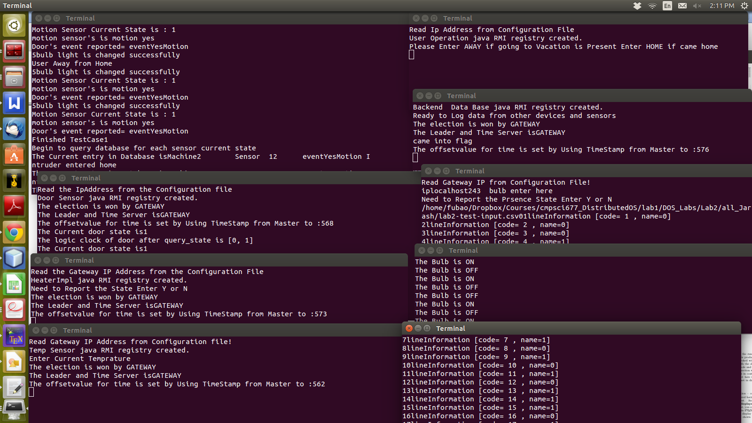

Note:

we run our test part1, part2 and part3 successfully in our ubuntu platform , without too much memory used, and we can get the right output result.
But when we run in the edlab, we have small problem sometimes, which is out of memor. Is it restricted by memory using in the edlab?

