**Mi primer Rmarkdown**

**Valme del Río García**

**2022/07/20**

Tabla de Contenidos

R Markdown 1

**Mi primer gráfico** 1

**Mi primera tabla incluyendo test de hipótesis** 2

Gráfico diagrama de cajas 3

Gráfico de Supervivencia 3

Gráfico Tasa Andalucía (Datos Aleatorios) 4

Bibliografía 5

## R Markdown

### **Mi primer gráfico**

Mi primera citación (1)

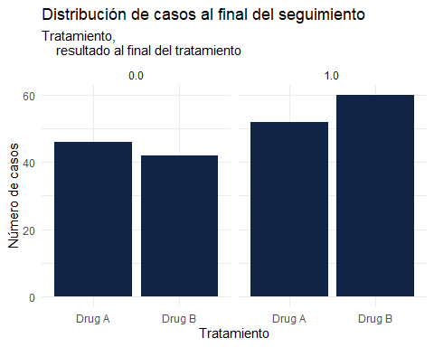

### **Mi primera tabla incluyendo test de hipótesis**

## Table printed with `knitr::kable()`, not {gt}. Learn why at  
## https://www.danieldsjoberg.com/gtsummary/articles/rmarkdown.html  
## To suppress this message, include `message = FALSE` in the code chunk header.

| **Characteristic** | **N** | **Drug A**, N = 98 | **Drug B**, N = 102 | **p-value** |
| --- | --- | --- | --- | --- |
| Edad | 189 | 46 (37, 59) | 48 (39, 56) | 0.7 |
| Unknown |  | 7 | 4 |  |
| Marcadores Tumorales ng/mL | 190 | 0.84 (0.24, 1.57) | 0.52 (0.19, 1.20) | 0.085 |
| Unknown |  | 6 | 4 |  |
| Estadio | 200 |  |  | 0.9 |
| T1 |  | 28 (29%) | 25 (25%) |  |
| T2 |  | 25 (26%) | 29 (28%) |  |
| T3 |  | 22 (22%) | 21 (21%) |  |
| T4 |  | 23 (23%) | 27 (26%) |  |
| Grado | 200 |  |  | 0.9 |
| I |  | 35 (36%) | 33 (32%) |  |
| II |  | 32 (33%) | 36 (35%) |  |
| III |  | 31 (32%) | 33 (32%) |  |
| Respuesta Tumoral | 193 |  |  | 0.5 |
| Negativa |  | 67 (71%) | 65 (66%) |  |
| Positiva |  | 28 (29%) | 33 (34%) |  |
| Unknown |  | 3 | 4 |  |
| Resultado al final del Seguimiento | 200 |  |  | 0.4 |
| Fallecido |  | 52 (53%) | 60 (59%) |  |
| Vivo |  | 46 (47%) | 42 (41%) |  |
| Tiempo de seguimiento en meses | 200 | 23.5 (17.4, 24.0) | 21.2 (14.6, 24.0) | 0.14 |

### Gráfico diagrama de cajas

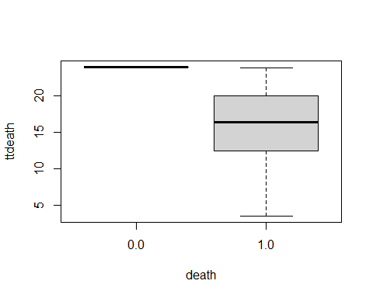

### Gráfico de Supervivencia

Mi segunda citación (2)

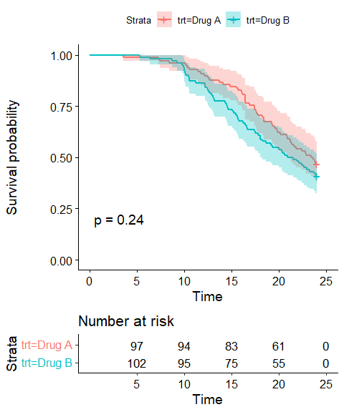

### Gráfico Tasa Andalucía (Datos Aleatorios)

Mi tercera citación(3)

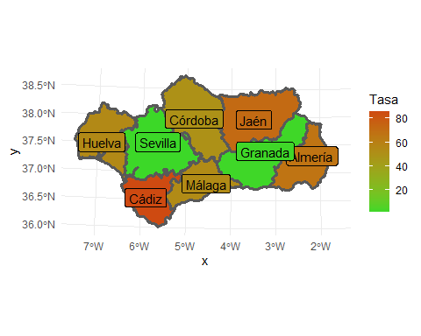

Paquetes usados con R [(4)](5)[(6)](7)[(8)](9)[(10)](11)

### Bibliografía

1. Chen P, Li T, Sun T, Willis VC, Roebuck MC, Bravata DM, et al. Clinical Decision Support for High-Risk Stage II Colon Cancer: A Real-World Study of Treatment Concordance and Survival. Diseases of the Colon & Rectum [Internet]. 2020 Sep 16;63(10):1383–92. Available from: <http://dx.doi.org/10.1097/DCR.0000000000001690>

2. Geribaldi-Doldán N, Carrasco M, Murillo-Carretero M, Domínguez-García S, García-Cózar FJ, Muñoz-Miranda JP, et al. Specific inhibition of ADAM17/TACE promotes neurogenesis in the injured motor cortex. Cell Death & Disease [Internet]. 2018 Aug 28;9(9). Available from: <http://dx.doi.org/10.1038/s41419-018-0913-2>

3. Carmona-Jiménez Y, Palma M, Guillén-Sánchez DA, García-Moreno MV. Study of the Cluster Thinning Grape as a Source of Phenolic Compounds and Evaluation of Its Antioxidant Potential. Biomolecules [Internet]. 2021 Feb 5;11(2):227. Available from: <http://dx.doi.org/10.3390/biom11020227>

4. Sjoberg DD, Whiting K, Curry M, Lavery JA, Larmarange J. Reproducible summary tables with the gtsummary package. 2021;13:570–80. Available from: <https://doi.org/10.32614/RJ-2021-053>

5. Wickham H. ggplot2: Elegant graphics for data analysis. 2016; Available from: <https://ggplot2.tidyverse.org>

6. Wickham H, François R, Henry L, Müller K. Dplyr: A grammar of data manipulation. 2022; Available from: <https://CRAN.R-project.org/package=dplyr>

7. Wickham H, Bryan J. Readxl: Read excel files. 2022; Available from: <https://CRAN.R-project.org/package=readxl>

8. R Core Team. R: A language and environment for statistical computing. 2022; Available from: <https://www.R-project.org/>

9. Therneau TM. A package for survival analysis in r. 2021; Available from: <https://CRAN.R-project.org/package=survival>

10. Kassambara A, Kosinski M, Biecek P. Survminer: Drawing survival curves using ’ggplot2’. 2021; Available from: <https://CRAN.R-project.org/package=survminer>

11. Pebesma E. Simple features for r: Standardized support for spatial vector data. 2018;10. Available from: <https://doi.org/10.32614/RJ-2018-009>