
Shri Vile Parle Kelavani Mandal's
INSTITUTE OF TECHNOLOGY
DHULE (M.S.)
DEPARMENT OF COMPUTER ENGINEERING
Subject: Artificial Intelligence Lab |  |  | Remark
Name : Valmik Vakilal Patil |  | Roll No. : 54 | Remark
Class : B.tech Computer | Batch : B3 | Division: | Remark
Expt. No. :02 | Date : / /2025 |  | Signature
Title : write a program to slolve 8 queen problem |  |  | Signature

Aim:- write a program to slolve 8 queen problem
Software required: SWI PROLOG

Code:
:- use_module(library(clpfd)).

% Main predicate: Solution is a list of 8 numbers representing queen rows for columns 1..8
eight_queens(Solution) :-
length(Solution, 8),
Solution ins 1..8, % Each queen in row 1 to 8
safe_queens(Solution),
labeling([], Solution).

% Check all queens are safe from attacks
safe_queens([]).
safe_queens([Q|Qs]) :-
safe_queens(Qs),
no_attack(Q, Qs, 1).

% No two queens attack each other diagonally
no_attack(_, [], _).
no_attack(Q, [Q1|Qs], D) :-
Q #\= Q1, % Not in the same row
abs(Q - Q1) #\= D, % Not in the same diagonal
D1 #= D + 1,
no_attack(Q, Qs, D1).

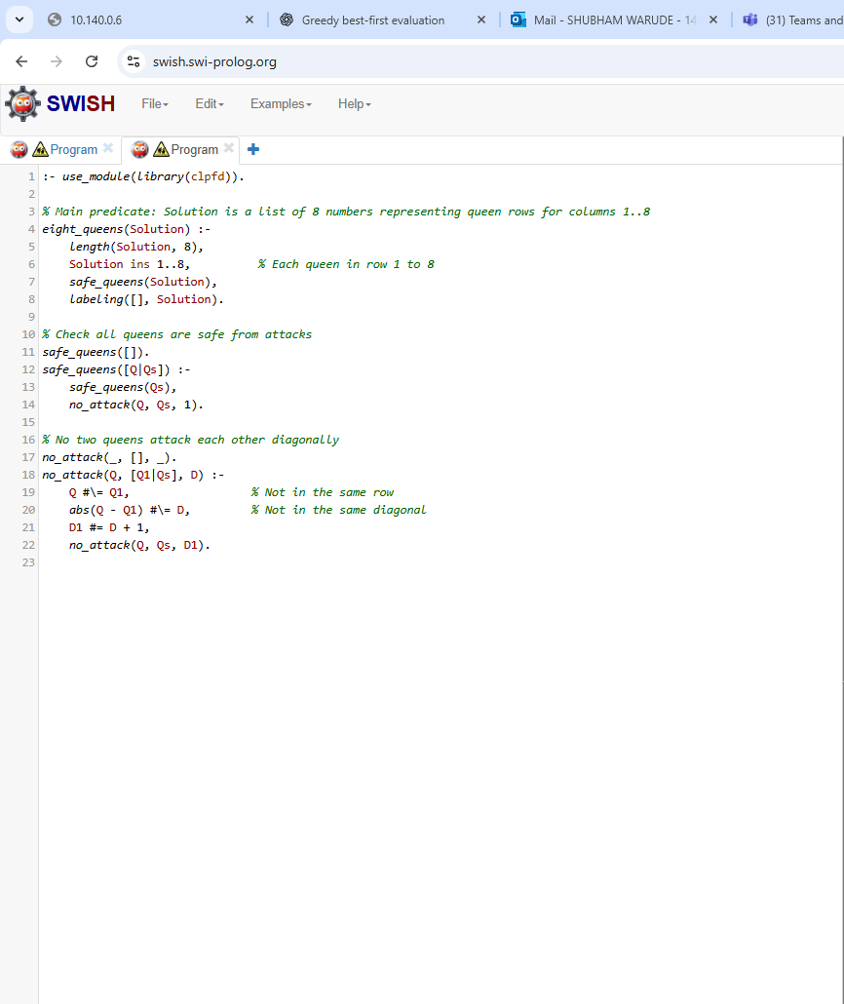
Output:
