
Shri. Vile Parle Kelavani Mandal's
Institute of Technology, Dhule
Survey No. 499, Plot No.2, Behind Gurudwara, Mumbai Agra Highway, Dhule (MS)
Name:- Valmik Vakilal Patil  Rollno:- 54 Date :- / /2025  Branch :-Final Year B.Tech (Computer Department)  Exp. No:- 4  Subject:- AI Lab | Sign :-
 | Remark :-
Aim:- solve any problem using Best first search swish code

Code:-

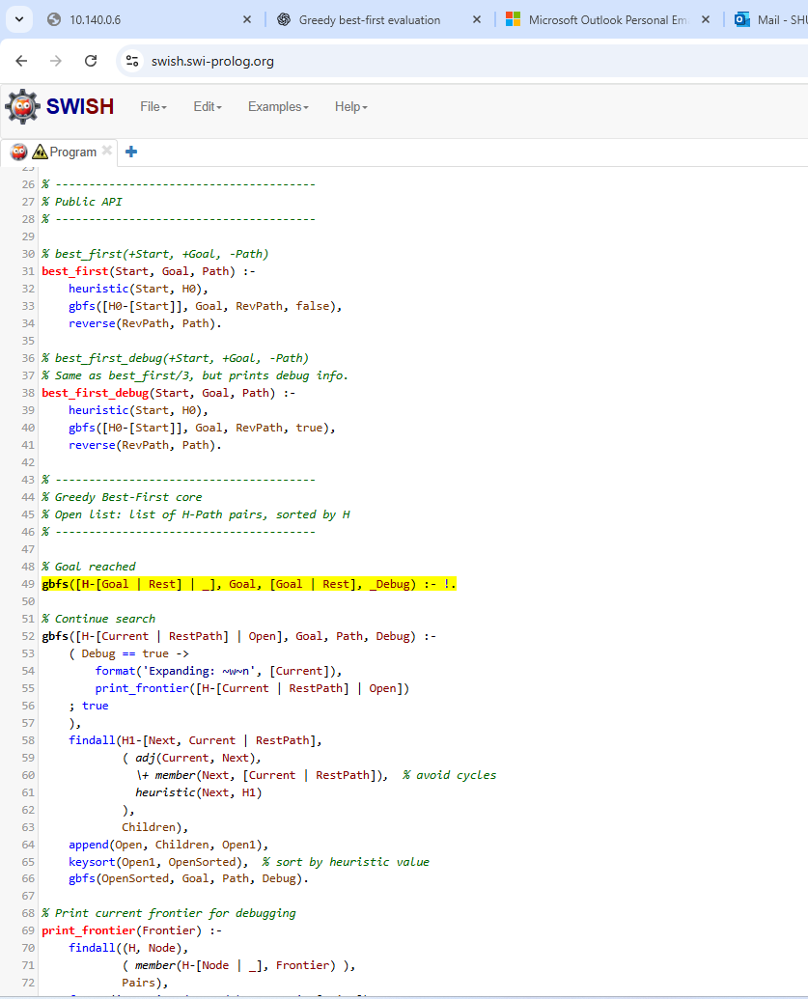

Output:-

