
Shri. Vile Parle Kelavani Mandal's
Institute of Technology, Dhule
Survey No. 499, Plot No.2, Behind Gurudwara, Mumbai Agra Highway, Dhule (MS)
Name:- Valmik Vakilal Patil  Rollno:- 54 Date :- / /2025  Branch :-Final Year B.Tech (Computer Department)  Exp. No:- 07  Subject:- AI Lab | Sign :-
 | Remark :-
Aim:- Solve Travelling Salesman Problem.

Code:-
/* -------- Traveling Salesman Problem in Prolog --------

Approach: Generate all possible tours (permutations), calculate their cost, and select the minimal one.

-------------------------------------------------------- */

:- use_module(library(clpfd)). % For utilities like min_list/2 if needed

% ----------------------------
% Distance facts: dist(City1, City2, Cost)
% ----------------------------
dist(a, b, 10).
dist(a, c, 15).
dist(a, d, 20).
dist(b, c, 35).
dist(b, d, 25).
dist(c, d, 30).

% Make distance symmetric
distance(X, Y, D) :- dist(X, Y, D) ; dist(Y, X, D).

% Compute cost of a given tour (list of cities, starting point repeated at end)
tour_cost([_], 0).
tour_cost([C1, C2 | Rest], Cost) :-
distance(C1, C2, D),
tour_cost([C2 | Rest], SubCost),
Cost is D + SubCost.

% Solve TSP from Start City
tsp(Start, BestPath, MinCost) :-
% Get all unique cities
findall(C, (dist(C, _, _) ; dist(_, C, _)), CitiesDup),
sort(CitiesDup, Cities),
delete(Cities, Start, OtherCities),
% generate all permutations of other cities
findall(Perm, permutation(OtherCities, Perm), PermPaths),
% prepend Start and append Start to form complete tours
findall([Start | P], member(P, PermPaths), PathsWithStart),
findall(Path, (member(P, PathsWithStart), append(P, [Start], Path)), AllTours),
% compute cost for each tour
findall(Cost-Path, (member(Path, AllTours), tour_cost(Path, Cost)), CostedTours),
% sort by cost and pick the best one
keysort(CostedTours, [MinCost-BestPath | _]).

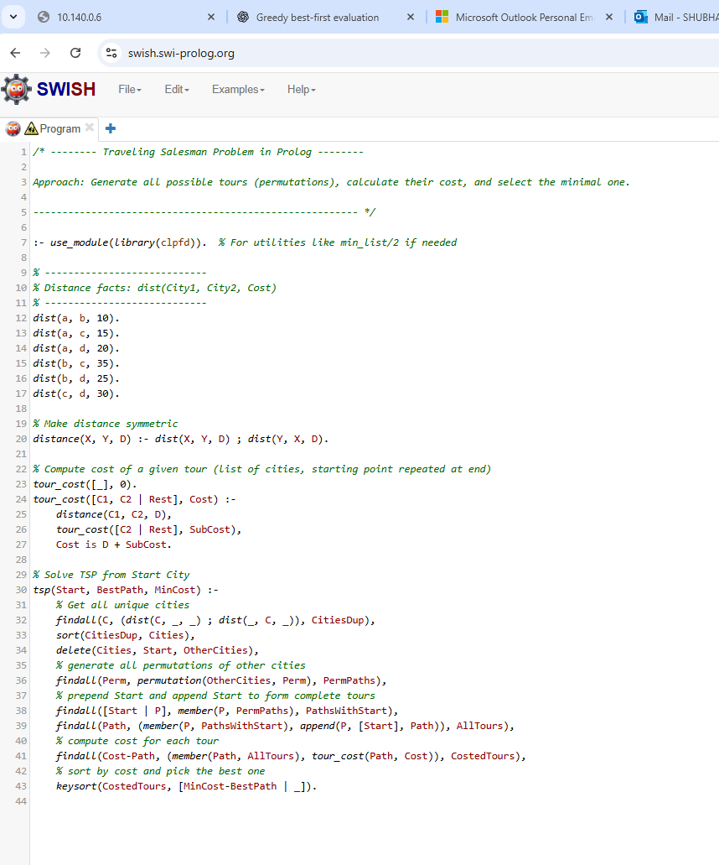

Output:-
