
Shri Vile Parle Kelavani Mandal's
INSTITUTE OF TECHNOLOGY
DHULE (M.S.)
DEPARMENT OF COMPUTER ENGINEERING
Subject: Artificial Intelligence Lab |  |  | Remark
Name : Valmik Vakilal Patil |  | Roll No. : 54 | Remark
Class : B.tech Computer | Batch : B3 | Division: | Remark
Expt. No. :08 | Date : 17-10-2025 |  | Signature
Title : Medical Diagnosis: ai systems assisting in Dignosing diseases from medical imaging data. |  |  | Signature

Aim: Medical Diagnosis: ai systems assisting in dignosing diseases from medical imaging data.
Software required: SWI PROLOG

Code:
% rule_based_diag.pl
% Simple rule-based diagnosis with certainty factors (CF)
% Usage: load file in SWI-Prolog: ?- [rule_based_diag].
% Add image facts for a case (see examples below) then call diagnose/2.

:- module(rule_based_diag, [diagnose/2, reset_case/0, add_feat/1]).

:- dynamic feat/1.

%% add_feat(+Feature) - assert a feature for current case
add_feat(F) :-
assertz(feat(F)).

%% reset_case - clear all asserted features for a new case
reset_case :-
retractall(feat(_)).

%% base rules: rule(Diagnosis, [(Feature,CF), ...])
% CF range: -1.0 .. 1.0 where positive supports, negative refutes.
rule(pneumonia, [(consolidation, 0.7), (air_bronchogram, 0.4), (pleural_effusion, 0.2)]).
rule(tuberculosis, [(cavity, 0.8), (upper_lobe_opacity, 0.5), (nodular_pattern, 0.3)]).
rule(normal, [(no_abnormality, 0.9)]).
rule(atelectasis, [(volume_loss, 0.7), (linear_opacity, 0.4)]).
rule(pleural_effusion, [(pleural_effusion, 0.9), (blunted_costophrenic, 0.6)]).

%% compute CF for a given diagnosis by summing supporting CFs for present features
diagnosis_cf(Diagnosis, CF) :-
rule(Diagnosis, Features),
findall(CFf, (
member((Feat,CFval), Features),
( feat(Feat) -> CFf = CFval ; CFf = 0 )
), CFs),
sum_list(CFs, Sum),
% clamp to [0,1]
( Sum > 1.0 -> CF = 1.0 ; CF = Sum ).

%% diagnose(+K, -Results) - returns top K diagnoses with CFs sorted desc
diagnose(K, Results) :-
findall((D,CF), (rule(D,_), diagnosis_cf(D,CF), CF>0.0), Pairs),
sort(2, @>=, Pairs, Sorted), % sort by CF descending
take(K, Sorted, Results).

%% helper: take first N elements
take(0, _, []) :- !.
take(_, [], []) :- !.
take(N, [H|T], [H|R]) :-
N1 is N-1,
take(N1, T, R).
Output:
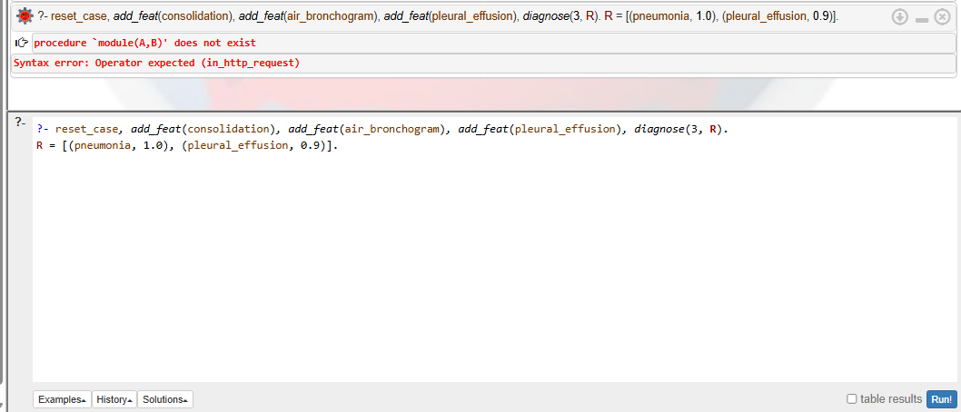

Conclusion:
The Prolog-based medical diagnosis system demonstrates how artificial intelligence can assist in identifying diseases using rule-based and case-based reasoning. By analyzing image-derived features, the system infers possible conditions and provides explainable results. Such AI models can support radiologists in faster and more consistent decision-making. Although simplified, this approach highlights the potential of intelligent diagnostic systems in improving healthcare accuracy and efficiency.

