
Shri Vile Parle Kelavani Mandal's
INSTITUTE OF TECHNOLOGY
DHULE (M.S.)
DEPARMENT OF COMPUTER ENGINEERING
Subject: Artificial Intelligence Lab |  |  | Remark
Name : Valmik Vakilal Patil |  | Roll No. : 54 | Remark
Class : Final Year Computer | Batch : B3 | Division: | Remark
Expt. No. :01 | Date : / / |  | Signature
Title : Study of PROLOG. Write the following programs using PROLOG. |  |  | Signature

Aim: Study of PROLOG. Write the following programs using PROLOG.
Software required: SWI PROLOG

Code:
likes(ram, mango).
girl(seema).
like(bill,cindy).
red(rose).
own(john).
Program Code and Output :

?- likes(ram, mango).
true.

?- likes(ram, apple).
false.

?- likes(bill, X).
X = cindy.

?- girl(seema).
true.

?- red(X).
X = rose.

?- own(john).
true.

?- likes(X, mango).
X = ram.

?- likes(X, Y).
X = ram, Y = mango ;
X = bill, Y = cindy.
------------------------------------------------------------
%facts male(john). female(lisa). parent(lisa,john).
%rules father(x,y) :- male(x), parent(x,y). mother(x,y) :- female(x), parent(x,y).
c_to_f(C,F) :- F is C * 9 / 5 + 32. freezing(F) :- F =< 32.

Output:

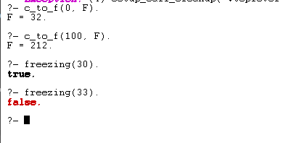

Conclusion:
This Prolog program converts temperatures from Celsius to Fahrenheit and checks if a given Fahrenheit temperature is at or below the freezing point. It demonstrates basic arithmetic operations and conditional checks in Prolog.

