
Shri. Vile Parle Kelavani Mandal's

Institute of Technology, Dhule
Survey No. 499, Plot No.2, Behind Gurudwara, Mumbai Agra Highway, Dhule (MS)

Subject: - Cloud Computing Lab  Name:- Valmik Vakilal Patil Roll No:- 54  Branch: - Final Year B.Tech (Computer Department) Exp. No:- 02  Aim: Create a scenario in WordPress for Social Marketing , Search engine and Sharing Tools | Sign: -
 | Remark: -
Theory:

What is XAMPP?
  - XAMPP stands for cross-platform, Apache, MySQL, PHP and Perl. It’s a simple and lightweight
solution that allows you to create a local web server for testing purposes.
  - Since XAMPP is cross-platform, it also works on Mac and Linux, but today we’re going to focus
on how to set up XAMPP on Windows 10.
  - WordPress isn’t a stand-alone application and requires server software in order to run. XAMPP provides the necessary environment needed to run WordPress on a local machine.
- Install Xampp

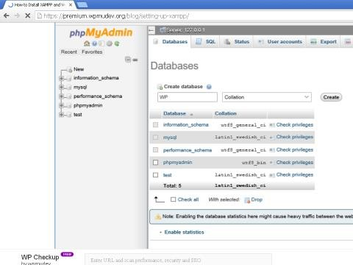

Download and Install WordPress:

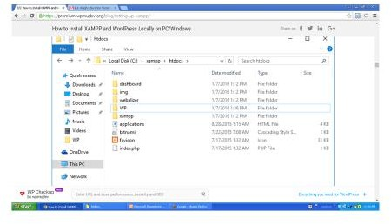

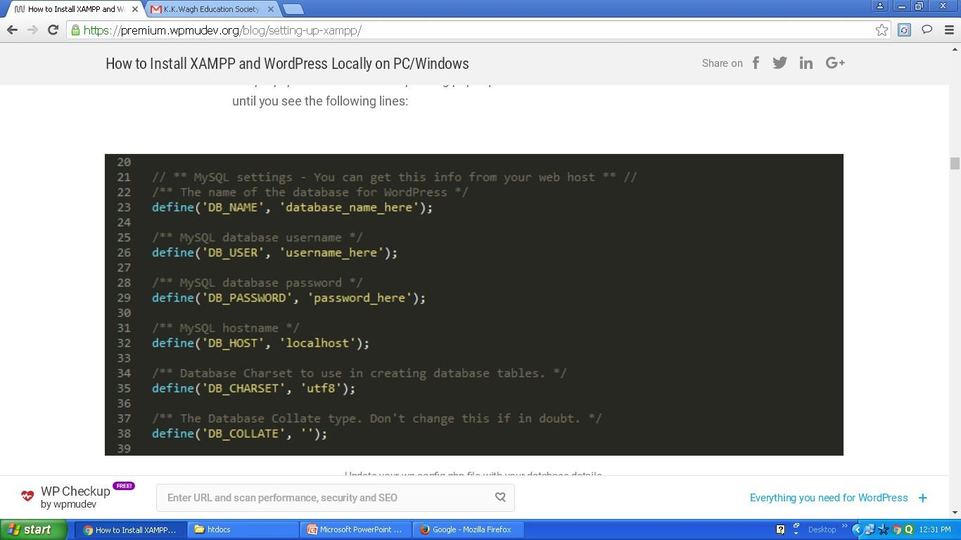
- Open your browser:
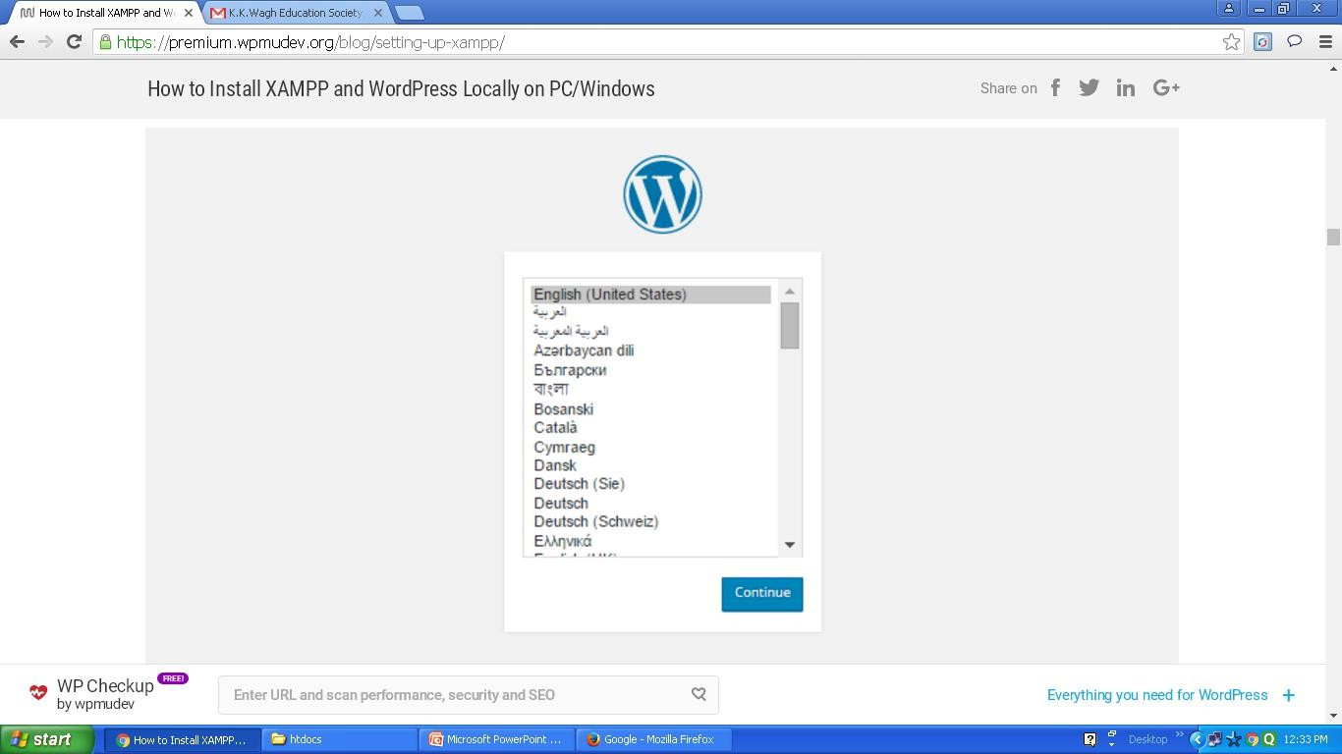

- Create the Login Page & Registration form for any Application using wordpress

