chmod 400 key.pem

ssh -i key.pem ubuntu@<<yourPublicIpAddress>>

*-- ssh -i* key*.pem ubuntu@*34.227.117.52

sudo apt-get update

sudo apt-get -y upgrade

*-- select "ok", select "keep local version currently installed"*

sudo apt-get install mysql-server

*-- select "ok", just set password to "root"*

mysql -u root -p

*-- login with "root"*

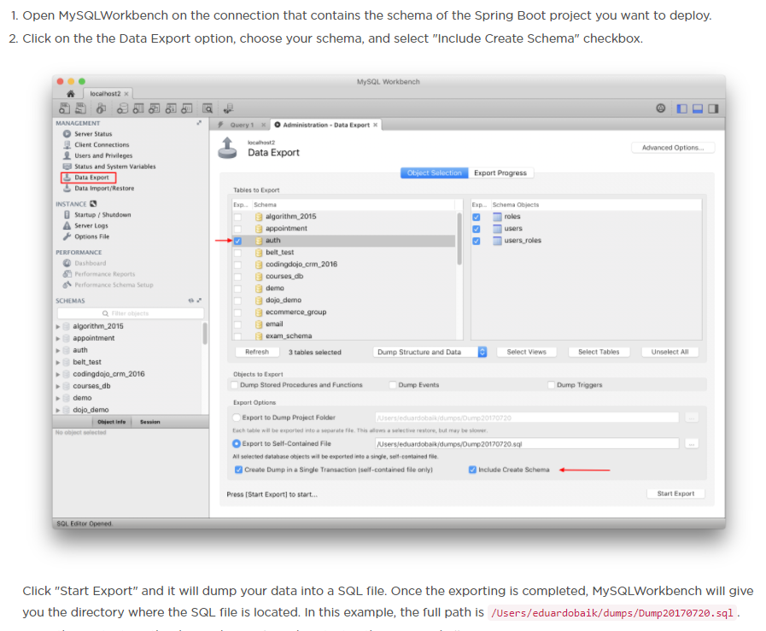

*-- Export, then open the exported MySQL script in workbench then PASTA EVERYTHING into your console*

show databases;   
use <<yourSchema>>;  
show tables;

quit

sudo apt-get install apache2

--Go to public IP to test if apache done works

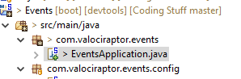

@Bean

public EmbeddedServletContainerFactory servletContainer() {

TomcatEmbeddedServletContainerFactory tomcat = new TomcatEmbeddedServletContainerFactory();

Connector ajpConnector = new Connector("AJP/1.3");

ajpConnector.setPort(9090);

ajpConnector.setSecure(false);

ajpConnector.setAllowTrace(false);

ajpConnector.setScheme("http");

tomcat.addAdditionalTomcatConnectors(ajpConnector);

return tomcat;

}

*--go to platform “Spring Boot Up” for maven instructions. Open POM.XML and change any references to the project name you are copying and pasting from\*\*\*\*\*\*\**

*--https://stackoverflow.com/questions/28192761/spring-maven-clean-error-the-requested-profile-pom-xml-could-not-be-activate*

*--RENAME THAT:*

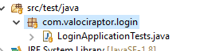

*--* [*https://stackoverflow.com/questions/19655184/no-compiler-is-provided-in-this-environment-perhaps-you-are-running-on-a-jre-ra*](https://stackoverflow.com/questions/19655184/no-compiler-is-provided-in-this-environment-perhaps-you-are-running-on-a-jre-ra)

*-- Ct;-c to get out of Ubuntu, navigate to Users\giordv\.m2\cd 0 \0.0.1-SNAPSHOT\Login-0.0.1-SNAPSHOT.war etc:*

*-- cd .m2/repository/com/valociraptor/login/Login/0.0.1-SNAPSHOT/*

scp -i ~/Desktop/KEYS/key.pem <<FILE_NAME>>.war ubuntu@<<SERVER_IP>>:~/

*scp -i ~/Desktop/KEYS/key.pem Login-0.0.1-SNAPSHOT.war* [*ubuntu@*34.227.117.52](mailto:ubuntu@54.157.51.202):~/

chmod 400 key.pem

ssh -i key.pem ubuntu@<<yourPublicIpAddress>>

*-- ssh -i* key*.pem ubuntu@34.227.117.52*

sudo mkdir /var/springApp

sudo mv ~/ <<FILENAME>>.war /var/springApp/

*sudo mv ~/ Login-0.0.1-SNAPSHOT.war /var/springApp/*

sudo a2enmod proxy

sudo a2enmod proxy_ajp

cd /etc/apache2/sites-available

sudo vim 000-default.conf

ProxyPass / ajp://localhost:9090/

ProxyPassReverse / ajp://localhost:9090/

sudo service apache2 restart

sudo apt-get install default-jdk

back to main directory

cd /var/springApp

java -jar <<FILENAME>>.war

java -jar *Login-0.0.1-SNAPSHOT.war*

*Back to main directory*

cd /etc/systemd/system

sudo touch auth.service

sudo vim auth.service

[Unit]

Description=<<APPNAME>> application using Spring Boot

After=syslog.target

[Service]

User=ubuntu

ExecStart=/usr/bin/java -jar /var/springApp/<<FILENAME>>.war

SuccessExitStatus=143

[Install]

WantedBy=multi-user.target

*[Unit]*

*Description=* Demo project for Spring Boot

*After=syslog.target*

*[Service]*

*User=ubuntu*

*ExecStart=/usr/bin/java -jar /var/springApp/Login-0.0.1-SNAPSHOT.war*

*SuccessExitStatus=143*

*[Install]*

*WantedBy=multi-user.target*

sudo systemctl daemon-reload

sudo systemctl enable login.service

sudo systemctl start login