Payload – Maxwell Ely

Purpose of subsystem: to create a code and holder so we can take a picture with out touching the camera.

Key Specifications and requirements: to create a code to make the servo push a button on the camera and to create a holder for the servo to take a picture with out touching or holding the servo or the button.

Note Key Features: A balsa wood cage that holds the servo in a position that allows it to push the camera’s button. A code that allows us to change the angel of the servo so it can reach the button from its cage. The code also used the built in alarm to delay how fast to push the button and when to start to push the button.

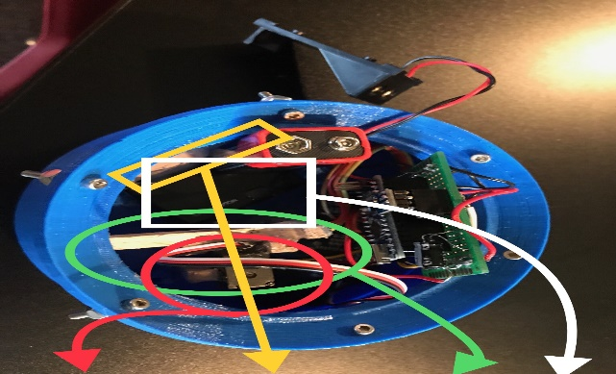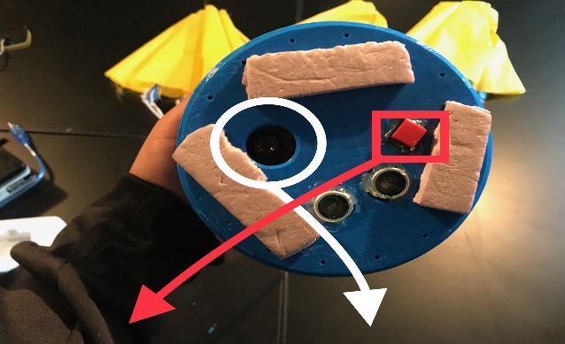Photograph if available:  
Switch that activated code | Camera Cutout | Servo | Camera Bar| Basal Wood Cage |Camera

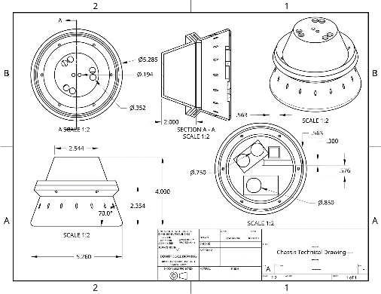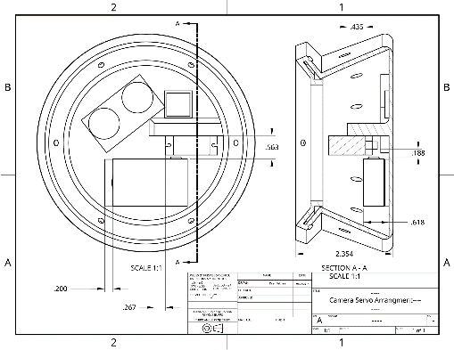Technical drawing with dimensions:

Summary of failed attempts with sketches or pictures of failed prototypes

Payload had two different failed attempts the first was way to boxy and cumbersome. It wouldn’t fit the requirements we needed. The second was a 3D Printed Bar that in theory would hold the servo, however when calibrating the servo the arm would hit the bar and from the force the servo would come lose. So we ripped it out and put in the basal wood cage to hold the camera.