# Лабораторна робота № 3

**Синтаксис:**

#include <iostream>

#define _USE_MATH_DEFINES

#include <math.h>

using namespace std;

int main()

{

double result;

int switch_on;

cout << "Input variable: ";

cin >> switch_on;

switch (switch_on) {

case 1: {

double a = -0.7, b = -1.1, x = -3.5, z;

while (x <= 1) {

z = exp(a);

if (x <= (5 * a))

{

result = 2.5 * pow(b, 2) + a * x - 4.5 * cos(x * z);

cout << "X: " << x << ", If: 1, Result: " << result << endl;

}

else if (x > b)

{

result = pow((pow(a, 2) - 5.4 * x), 3) + log(x * z);

cout << "X: " << x << ", If: 2, Result: " << result << endl;

}

else if ((5 * a < x) && (x <= b))

{

result = sqrt(6.5 * pow(b, 2) + (a - pow(x, 3) * z));

cout << "X: " << x << ", If: 3, Result: " << result << endl;

}

x += 1.5;

}

break;

}

case 2: {

double a = -2.1, b = 11.1, z, x = -15;

do {

z = exp(b);

if (x <= (5 * a))

{

result = 2.5 * pow(b, 2) + a * x - 4.5 * cos(x * z);

cout << "X: " << x << ", If: 1, Result: " << result << endl;

}

else if (x > b)

{

result = pow((pow(a, 2) - 5.4 * x), 3) + log(x * z);

cout << "X: " << x << ", If: 2, Result: " << result << endl;

}

else if ((5 * a < x) && (x <= b))

{

result = sqrt(6.5 * pow(b, 2) + (a - pow(x, 3) * z));

cout << "X: " << x << ", If: 3, Result: " << result << endl;

}

x += 5;

} while (x <= 15);

break;

}

case 3: {

double a = 2.2, b = 23.75, z, x;

for (x = 10; x <= 25; x += 2.5) {

z = exp(a * b);

if (x <= (5 * a))

{

result = 2.5 * pow(b, 2) + a * x - 4.5 * cos(x * z);

cout << "X: " << x << ", If: 1, Result: " << result << endl;

}

else if (x > b)

{

result = pow((pow(a, 2) - 5.4 * x), 3) + log(x * z);

cout << "X: " << x << ", If: 2, Result: " << result << endl;

}

else if ((5 * a < x) && (x <= b))

{

result = sqrt(abs(6.5 * pow(b, 2) + (a - pow(x, 3) * z)));

cout << "X: " << x << ", If: 3, Result: " << result << endl;

}

}

break;

}

default: {

cout << "Not supported variable, try more.";

break;

}

}

return 0;

}

**Виконання, перевірка в Excel:**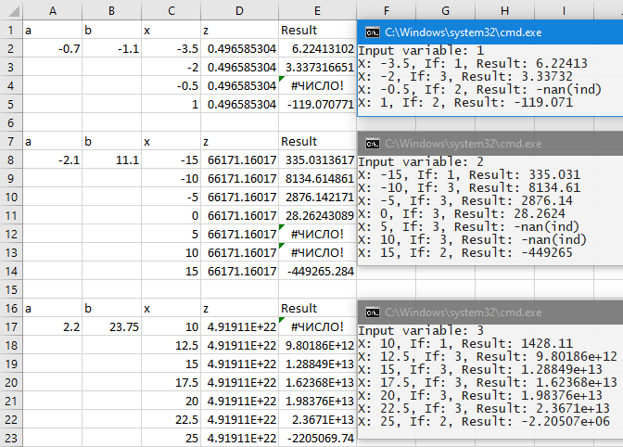

[**GitHub**](github)