«LinhaDeSaudação»

- Material utilizado –
2 LED
3 jumpers macho/macho
1 protoboard
1 placa Arduino
2 Resistores

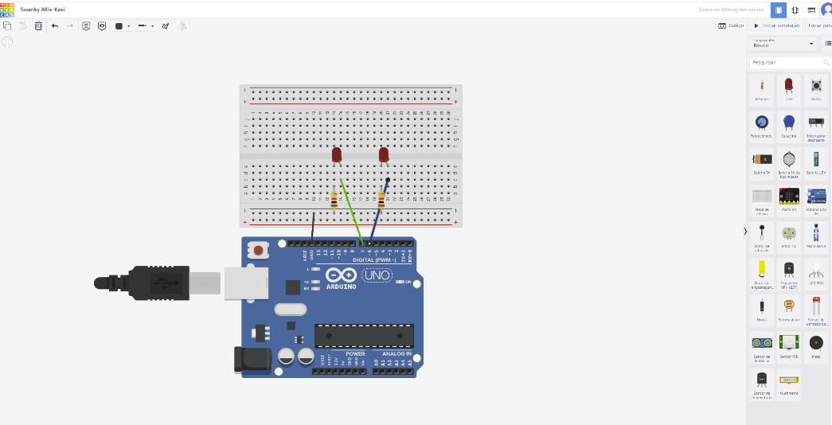
2)

3)

void setup()
{
pinMode(6, OUTPUT);
pinMode(7, OUTPUT);

}

void loop()
{
digitalWrite(7, HIGH);
delay(1000); // Wait for 1000 millisecond(s)

digitalWrite(7, LOW);
delay(1000); // Wait for 1000 millisecond(s)

digitalWrite(6, HIGH);
delay(1000); // Wait for 1000 millisecond(s)

digitalWrite(6, LOW);
delay(1000); // Wait for 1000 millisecond(s)
}
4) 