10/1/2017

KN

TAMK

IoT devices and data collection

Project requirements ver. 0.9

# Version history

Created 9.1.2017 KN

Version 0.91 10.1.2017 KN

Version 0.92 13.1.2017 EK

Contents

1 Version history 1

2 Tutorial 4

2.1 Available components: 5

2.2 Available measuring equipment’s 5

2.3 Available voltages on board 6

3 Common requirements for all teams (HW and SW teams) 7

3.1 Requirements for verifying measured data: 7

4 Database web addresses 7

5 Requirements for application circuit input (UIN) output (UOUT) signals: 8

5.1 Common for all signals 8

5.2 Digital signal levels ”0” ja ”1”: 8

6 Wind speed 9

6.1 General info 9

6.2 Reference circuit waveforms 11

7 Rain level 12

7.1 General info 12

7.2 Reference circuit waveforms 13

8 Humidity in and out 14

8.1 General info 14

8.2 Reference circuit waveforms / Humidity IN 16

8.3 Reference circuit waveforms / Humidity OUT 16

9 Temperature 17

9.1 General info 17

10 Light level 18

10.1 General info 18

11 Wind direction 19

11.1 General info 19

11.2 Reference circuit waveforms 20

12 Air pressure 21

12.1 Tutorial 21

12.2 Message format that is used to send data to Raspberry 21

12.3 Local display for air pressure 22

12.4 Showing time in display 22

12.5 Used sensor and reading sensor 22

12.6 Available code 23

# Tutorial

This document descripts the requirements that each project team application circuit has to full fill. All requirements that is related your application circuit have to be verified by your team.

**UsgbOUT**

Nano/  
 Mega  
 (Arduino)

Signal   
 box

**A4/  
D2**

Application  
circuit

**UIN**

**UOUT**

Your project team is responsible to design the application circuit and implement it. One team is responsible of one signal. Verification against the requirements is required. Team is responsible to produce all relevant documentation during the project life time.

Application circuit is converting the signal from signal box to be suitable for Arduino input. The required functionality of application circuit is descripted in this document. Each signal has signal specific requirements and common requirements of signal type (analog/ digital).

For Arduino Analog signal is fed to A4 pin and digital signal is fed to D2 pin.

A4 is used as analog input pin and D2 as digital input pin.

Air pressure sensor is using A4,A5 pins in Arduino.

Digital input signal has logical one “1” level (4.0V - 5.0V) and logical zero “0” level (0.0V - 0.5V).

Analog input signal level can be from 0.0V to 5.0V. Analog input signal is converted to numeric form by 10bit A/D converter. 0.0V equal number 0 and 5.0V equal number 1023.

All needed modules (Arduino Nano/Mega, LCD-display, Ethernet module, Keyboard, Regulator) are installed to board. Module wiring instructions is given by teacher. All needed software (SW) to Arduino is given by teacher.

## Available components:

For application circuit the next components are available:

Operational amplifier LM358/LMC662A

Resistor E24 series (1R – 4.7M)

Capacitor ( 200pF – 1000uF)

Transistor BC547 / BC557

Diode 1N4007 and zenerdiode 5.1V

Breadboard + wires

(if other components are needed that has to be agreed with teacher )

## Available measuring equipment

(for module testing)

Multimeter Fluke 75 ja 79

Digital oscilloscope

Signal generator

Power supplies 2 pcs

Test wires for measuring

Potentiometer on board (can be used to generate 0-5V test voltage)

## Available voltages on board

Unregulated 8V

Regulated 5V

Regulated 3.3V

# Common requirements for all teams (HW and SW teams)

## Requirements for verifying measured data:

Measured data visibility and handling

1. Measured data must be readable in Arduino’s LCD display.
2. Measured data must be readable from Raspberry’s display.
3. Measured data must available in DataBase
4. Database data must be available to Web UI
5. Measured data can be seen by web UI (web UI course)

## Database web addresses

Next web addresses are used to verify that that data is send from Raspberry to DB

Test url:

( <http://koti.tamk.fi/~poypek/ict_saa_tulosta.php> )

Final url: Not used 2016

A-class

a1-a6

<http://home.tamk.fi/~poypek/a1_ict_saa_tulosta.php>

B-class

b1-b6

<http://home.tamk.fi/~poypek/b1_ict_saa_tulosta.php>

# Requirements for application circuit input (UIN) output (UOUT) signals, ( relevant for HW teams ):

## Common for all signals

1. Arduino input signal must be < 5V (5.7V)
2. Arduino input signal must be >0V (-0.7V)
3. Application circuit load to signal box must be (+/-) <50uA
4. In case of malfunction or short circuit (5V) the arduino input signal can’t cause more than 2mA short circuit current.
5. In case of mall function or short circuit (5V) the application circuit input signal can’t cause more than 0.1mA short circuit current.

## Digital signal levels ”0” ja ”1”:

Arduino digital input pin is D2

1. ”0” must be < 0.5V
2. ”1” must be > 4.0V
3. No signal vibration allowed during state transition
4. Signal rice and fall down times must be < 1.0ms

Digital signals are:

1. Wind speed
2. Rain
3. Humidity in
4. Humidity out

## Analog signal levels

For analog signal Arduino pin A4 is used.

Input signal to Arduino A4 pin must be 0V < 5V

Analog signals are:

1. Wind direction
2. Temperature
3. Light

# Wind speed

## General info

Application circuit UOUT signal should not stay in state”1” no longer than 4ms. Signal can be in state “1” 2ms – 6ms. Signal voltage 0V and 5V.

|  |  |
| --- | --- |
| Wind speed m/s | =pulses/sec |
| 16.0 | 25.0 |
| 13.9 | 22.2 |
| 10.9 | 16.7 |
| 8.8 | 12.5 |
| 7.10 | 10.0 |
| 4.8 | 6.7 |
| 2.7 | 5 |
|  |  |

Wind speed versus pulses from sensor

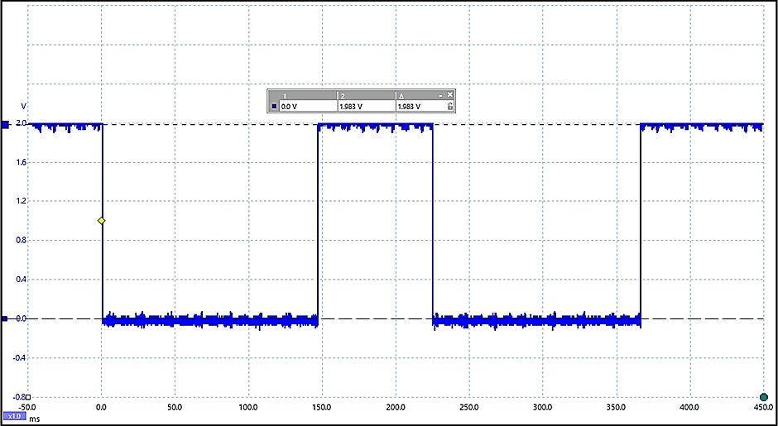

**0.0 V**

**2.0 V**

Wind speed signal waveform from signal box ( UsgbOUT )

Low level “0” = 0.0V

High level “1” = 2.0V

## Reference circuit waveforms

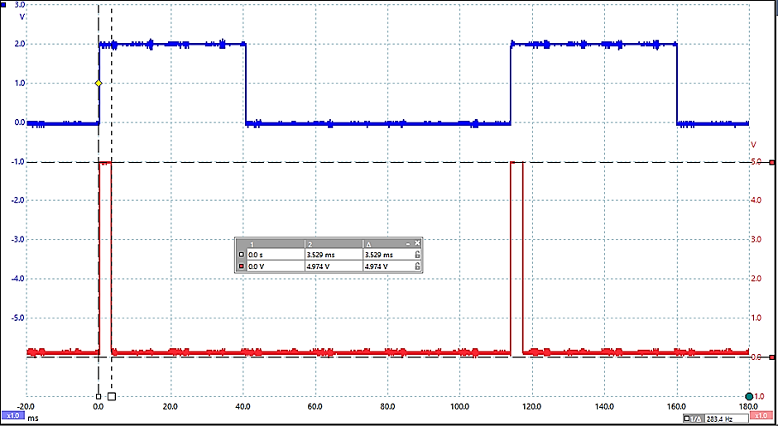

**UOUT**

**UIN**

Wind speed reference circuit UIN and UOUT waveforms

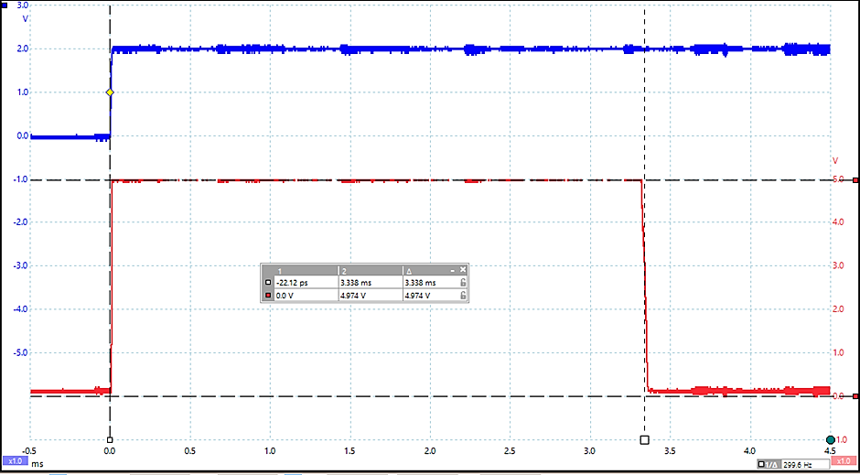

**UOUT**

**UIN**

Wind speed reference circuit UIN and UOUT waveforms

# Rain level

## General info

One sensor tip over gives one pulse.

For on tip over water is needed 3 ml. Collecting area is 55 cm2 .

One pulse equal 3ml rain.

Application circuit UOUT signal should not stay in state”1” no longer than 50ms.

Signal can be in state “1” 3ms – 50ms

Voltage level 0V and 5V

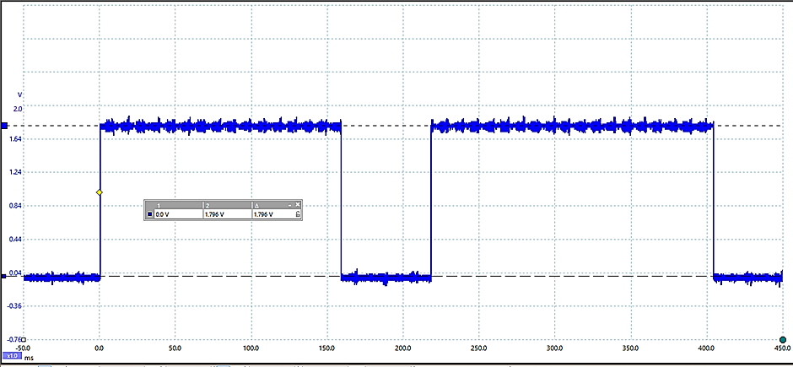

**1.8 V**

**0.0 V**

Rain level signal waveform from signal box( UsgbOUT )

Low level “0” = 0.0V

High level “1” = 1.8V

## Reference circuit waveforms

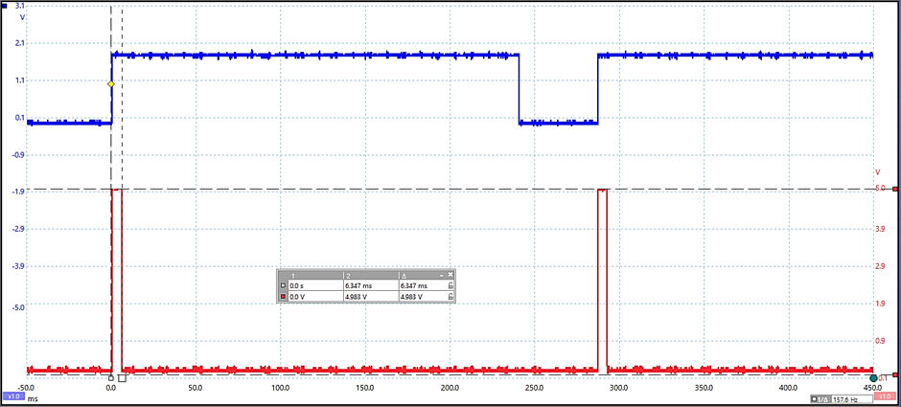

**UOUT**

**UIN**

Rain level reference circuit UIN and UOUT waveforms

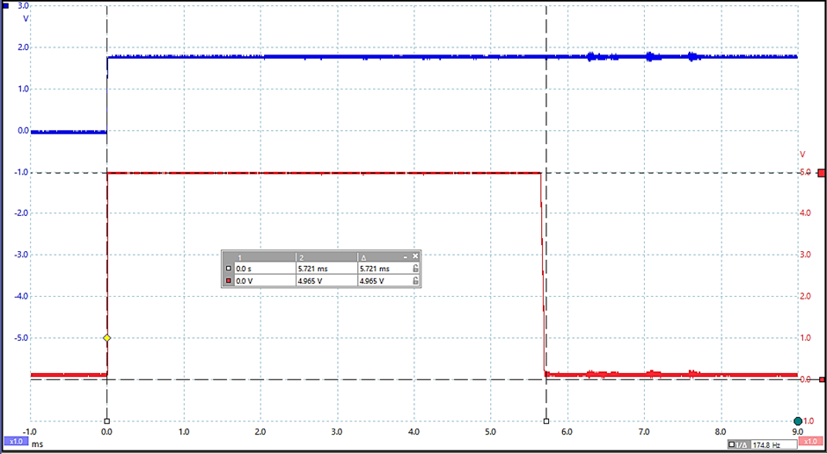

**UOUT**

**UIN**

Rain level reference circuit UIN and UOUT waveforms

# Humidity in and out

## General info

Relative humidity = 40% > frequency = 7.9 KHz

Relative humidity = 100% > frequency = 6.9 KHz

In laboratory A3-16 about = 7.4KHz

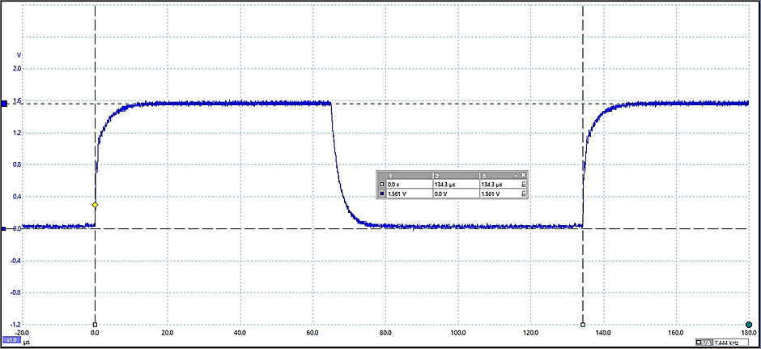

**130us**

**1.6 V**

**0.0 V**

Humidity In signal waveform from signal box( UsgbOUT )

Low level “0” = 0.0V

High level “1” = 1.6V

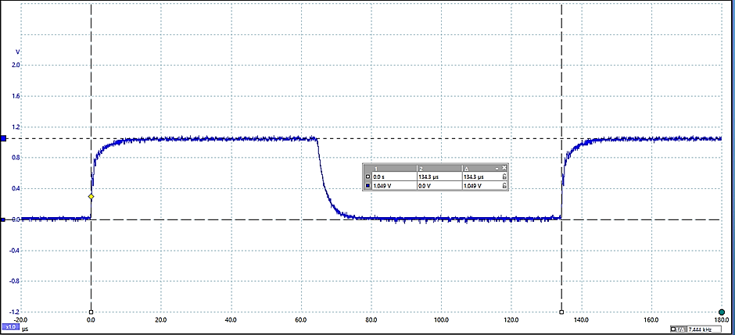

**130us**

**1.0 V**

**0.0 V**

Humidity Out signal waveform from signal box( UsgbOUT )

Low level “0” = 0.0V

High level “1” = 1.0V

## Reference circuit waveforms / Humidity IN

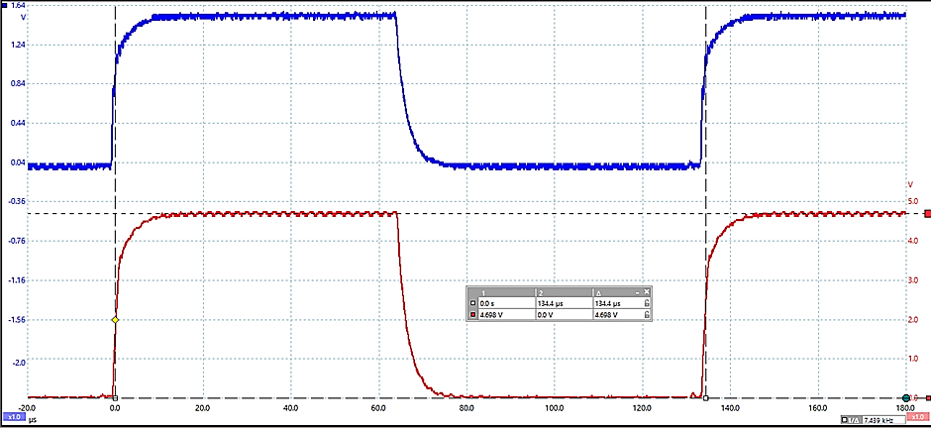

**UOUT**

**UIN**

Humidity IN reference circuit UIN and UOUT waveforms

## Reference circuit waveforms / Humidity OUT

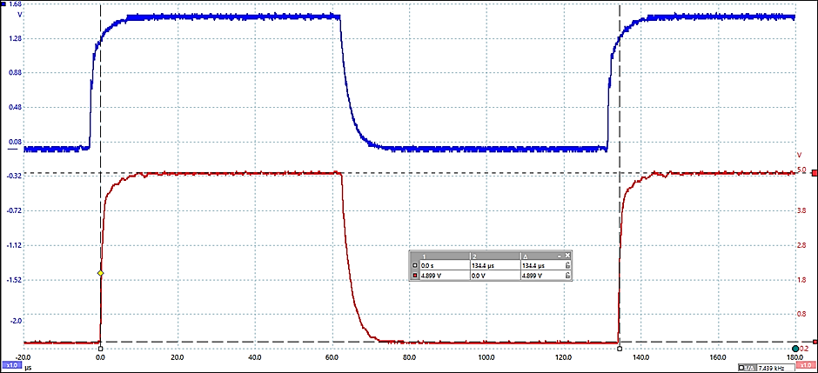

**UOUT**

**UIN**

Humidity OUT reference circuit UIN and UOUT waveforms

# Temperature

## General info

Voltage from signal box versus temperature

|  |  |
| --- | --- |
| Temperature / °C | Voltage / V |
| -10 | 0.50 |
| 0 | 0.83 |
| +10 | 1.7 |
| +20 | 1.5 |
| +30 | 1.8 |

Required application circuit functionality

|  |  |  |
| --- | --- | --- |
| Temp/ °C | Voltage UIN / V | Voltage UOUT / V |
| -10 | 0.50 | 1.5 |
| 0 | 0.83 | 2.5 |
| +10 | 1.7 | 3.5 |
| +20 | 1.5 | 4.5 |
| +30 | 1.8 | 5.5 |

# Light level

## General info

Voltage from signal box versus light level

|  |  |
| --- | --- |
| Light | Voltage / V |
| Dark | 0.62 |
| Bright sun light | 2.25 |
|  |  |
|  |  |
|  |  |

Required application circuit functionality

|  |  |  |
| --- | --- | --- |
| Light | Voltage UIN / V | Voltage UOUT / V |
| Dark | 0.62 | 1.23 |
| Bright | 2.25 | 4.5 |
|  |  |  |
|  |  |  |
|  |  |  |

# Wind direction

## General info

Voltage levels from signal box versus wind directions

|  |  |  |
| --- | --- | --- |
| Value | Wind direction | Voltage UIN /V |
| 1 | N | 2.17 |
| 2 | NE | 3.41 |
| 3 | E | 4.71 |
| 4 | SE | 4.49 |
| 5 | S | 4.03 |
| 6 | EW | 2.78 |
| 7 | W | 1.53 |
| 8 | NW | 1.82 |

Required application circuit functionality Selite taulukolle, 0.5V pudotus?

|  |  |  |  |
| --- | --- | --- | --- |
|  |  | Voltage | |
| Value | Dir | UIN /V | UOUT / V |
| 1 | N | 2.17 | 1.67 |
| 2 | NE | 3.41 | 2.90 |
| 3 | E | 4.71 | 4.19 |
| 4 | SE | 4.49 | 3.93 |
| 5 | S | 4.03 | 3.51 |
| 6 | EW | 2.78 | 2.26 |
| 7 | W | 1.53 | 1.03 |
| 8 | NW | 1.82 | 1.31 |

## Reference circuit waveforms

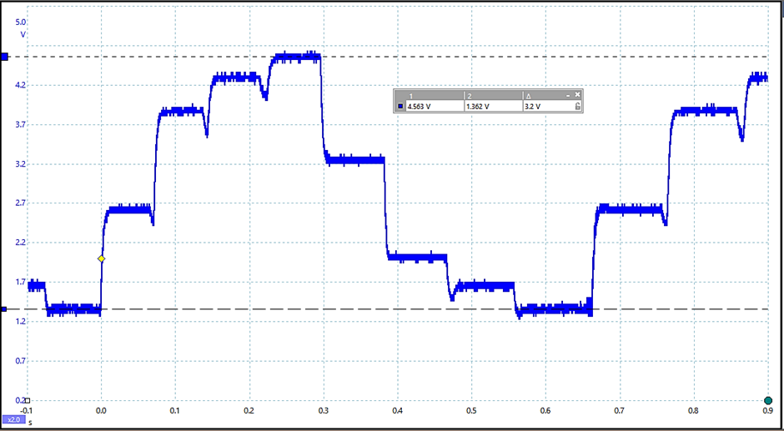

**4.6 V**

**1.4 V**

Wind direction signal waveform ( UsgbOUT ) from signal box when indicator sensor is rotating

# Air pressure

## Tutorial

Air pressure teams are SW teams, means that they will get all circuits and wiring diagrams as ready-made. Air pressure teams have to create software to Arduino, teams get Ethernet and MQTT functions as ready-made. Task for teams is to create main functionality of Arduino sw.

Teams need to implement all modules and wirings to board as like HW-teams.

## Message format that is used to send data to Raspberry

Data that is send to Raspberry must be in next format:

AA:BBBBCC

AA is channel number.

Channel number for air pressure teams

|  |  |  |
| --- | --- | --- |
|  | A-class | B-class |
| Air pressure 1 | 11 | 31 |
| Air pressure 2 | 12 | 32 |

BBBB is integer part of air pressure reading

CC is decimal part of reading.

A,B and C are in ASCII format .

Example: send message: **12:101250** means:

A-class; team airpressure 2

Air pressure 1012.50 mbar.

Message is send in each second. Sending time is synchronized to clock time.

## Local display for air pressure

Air pressure is shown in LCD-display according next example:

1012.50 mbar

Local LCD-display

Display readings are updated in period of one second.

## Showing time in display

Time is showing in display according next example:

13:50.45  
1012.50 mbar

Local LCD-display

## Used sensor and reading sensor

Type of sensor: BMP180,

Sensor can be read with next library functions.

<https://github.com/adafruit/Adafruit-BMP085-Library>

Sensor wiring diagram is available in in same place as all wiring diagram.

Air pressure 1 is outside air pressure, there is trough hole pipe to outside in lab A3-17 window side.

Air pressure 2 inside air pressure in laboratory.

## Available code

Source code for next functions are available to use:

Sending message to Raspberrylle:

* MQTT functions
* Ethernet functions:

Could asked from teacher:

Fetch time from internet time server