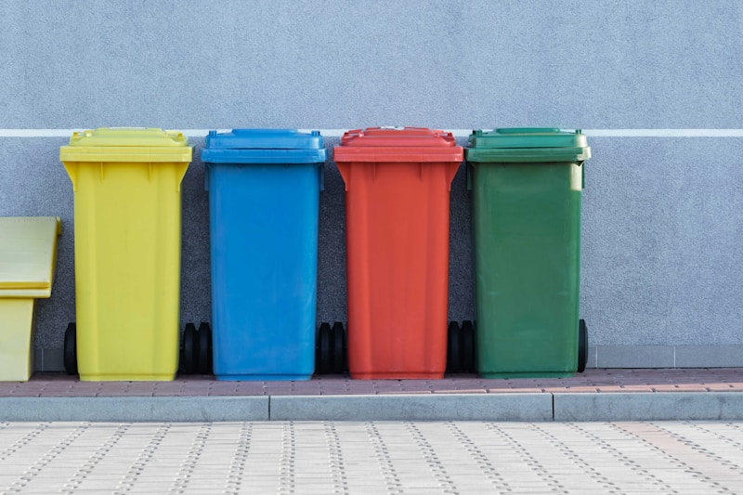
Circular economy packaging
55 companies just signed up for the UK Packaging Pact. Tesco, ASDA, Lidl, Arla, Biffa, SUEZ, Veolia. Pretty big names.
They’re volunteering to test out regulations that hit in 2026. Extended Producer Responsibility, Simpler Recycling, Deposit Return Schemes. All that stuff people have been talking about for years? It’s finally going to happen.
What they signed up for: - Design packaging better from the start - Scale up reuse and refill (not just those tiny test projects) - Actually invest in circular infrastructure - Fix the data mess so we can trace materials properly
That last bit is the real problem. Recycling data is a disaster right now. Every company does it their own way. Nobody knows where stuff ends up. Sure, you can print “recyclable” on your packaging, but do you know if it actually got recycled? Almost never.
Catherine David from WRAP: “Collaboration works and it’s delivering real change, but the scale of the challenge demands more.”
The UK Plastics Pact proved this approach works. Now they’re expanding it to all packaging. Not just plastic anymore. Food, cosmetics, pet food, cleaning stuff. The whole lot.
At Value Chain Hackers, this is what we’re trying to solve. How do you measure sustainability instead of just claiming it? How do you follow a milk carton through its whole life and prove it became something new?
Because without the data to back it up, circular economy stays stuck as a concept that sounds good but doesn’t really work.
Is anyone seeing similar things where you are? What’s actually moving forward versus what’s still just talk?
https://www.circularonline.co.uk/news/55-founding-organisations-join-uk-packaging-pact-ahead-of-april-2026-launch/
#CircularEconomy #Sustainability #SupplyChain #PackagingInnovation #ValueChainHackers #ExtendedProducerResponsibility #ZeroWaste #SupplyChainTransparency #UKPackagingPact #SustainablePackaging #ReuseRefill

