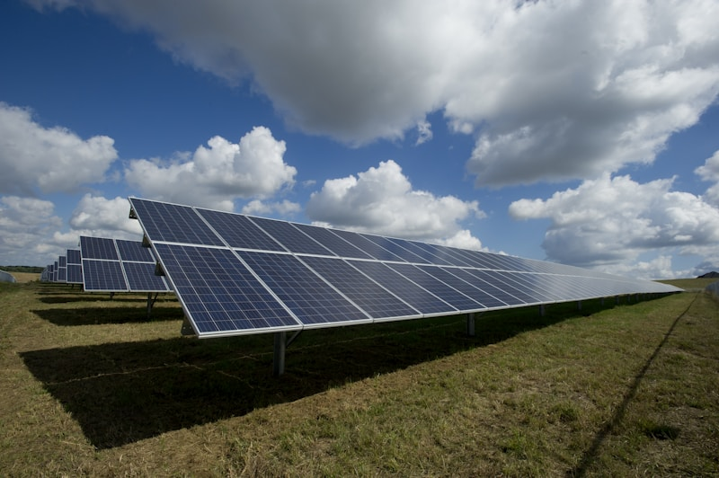
Green energy infrastructure
£68 million just went to 8 heat network projects across England. They’re using waste heat from places you wouldn’t expect.
Rivers. Data centres. Sewage works.
Most people think renewable energy means solar panels or wind turbines. But there’s heat everywhere that just gets wasted. Data centres pump out heat constantly. Sewage treatment generates heat. Even rivers can be heat sources.
These 8 projects are turning that into heating for buildings: - Milton Keynes got £17.6 million - Stockport got £14.65 million - Oldham got £8.8 million - Ipswich, Barking, Camden, Islington, and Birmingham all got chunks too
Together they’re supposed to cut 4.7 million tonnes of carbon.
But there’s a supply chain angle nobody talks about. To make this work, you need data centres willing to share their waste heat. You need sewage treatment plants connected to heating networks. You need local councils, energy companies, and property developers all coordinating.
That’s a supply chain problem. Who pays for what? Who owns the infrastructure? How do you verify the heat is actually renewable and not just marketing?
At Value Chain Hackers, we’re interested in how you build transparency into these systems. How do you track waste heat from source to end use? How do you prove a building is really heated by renewable sources and not just connected to a network that claims to be green?
Because the UK has already put £500 million into this fund. If we can’t measure what’s actually working, how do we know where to invest next?
What do you think about waste heat recovery? Is this the kind of circular thinking that scales, or just good for specific cases?
Sources: - 8 projects to receive £68 million from the Green Heat Network Fund
#CircularEconomy #RenewableEnergy #Sustainability #SupplyChain #ValueChainHackers #WasteHeat #GreenEnergy #SupplyChainTransparency #EnergyTransition #SustainableInfrastructure

