STUDY OF VARIOUS INVESTMENT AVENUES WITH SPECIAL REFERENCE TO MUTUAL FUNDS

ABSTRACT

This study delves into diverse investment avenues, focusing particularly on mutual funds, to analyze their distinctive characteristics, risks, and potential returns. The research centers on the performance assessment of open-ended equity schemes oriented towards growth, spanning from May 2019 to May 2024. Daily closing Net Asset Values (NAVs) of selected schemes serve as the basis for calculating returns. To benchmark these mutual funds, the study contrasts their performance against the NSE Nifty 50 index and bank fixed deposits, representing the market portfolio.

Key evaluation metrics employed include the Sharpe ratio, Treynor ratio, and Jensen's alpha. These measures offer comprehensive insights into risk-adjusted returns and fund manager performance over the specified period. Such rigorous analysis aims to empower investors with objective data, facilitating informed decision-making regarding their investment choices.

The findings from this study are expected to provide actionable insights for investors seeking optimal investment strategies. By comparing mutual fund performance against both market benchmarks and traditional fixed income options, the research aims to highlight the potential advantages and risks associated with each investment avenue. Ultimately, the study's outcomes are intended to assist investors in navigating the complexities of financial markets and optimizing their investment portfolios for better long-term outcomes.

INTRODUCTION

Overview of Investments
Investing is the act of allocating resources, usually money, with the expectation of generating an income or profit. The landscape of investment options is vast and varied, providing numerous opportunities for individuals to grow their wealth. Understanding the different types of investments, their risks, returns, and suitability is crucial for making informed financial decisions. Investment avenues can broadly be categorized into several types, each with unique characteristics.

Equity Shares (Stocks) :
Investing in equity shares, or stocks, involves purchasing ownership stakes in companies listed on stock exchanges. When you buy a share, you become a part-owner of the company. Equity investments are considered high-risk due to market volatility and the performance of the specific company. However, the potential returns on equity shares can be substantial, especially if the company performs well. Returns are in the form of capital gains and dividends. Stocks are highly liquid, meaning they can be easily bought and sold on the stock market. Equity shares are best suited for investors with a high-risk tolerance and a long-term investment horizon.

Bonds :
Bonds are debt securities issued by governments or corporations to raise capital. When you buy a bond, you are lending money to the issuer in exchange for periodic interest payments and the return of the bond’s face value at maturity. Bonds generally have lower risk compared to stocks, though the risk varies based on the issuer’s creditworthiness. Returns come from fixed interest payments and the return of principal at maturity. Government bonds are typically safer but offer lower returns, whereas corporate bonds may offer higher returns but come with higher risk. Bonds can be traded in the secondary market, but liquidity varies by bond type. They are suitable for conservative investors looking for steady income and lower risk.

Real Estate :
Investing in real estate involves purchasing residential, commercial, or industrial properties. Investors can earn returns through rental income and property appreciation. Real estate investments carry moderate to high risk, influenced by factors such as location, market conditions, and economic cycles. There is potential for significant returns through capital appreciation and rental income, though returns can be inconsistent and dependent on market conditions. Real estate is less liquid compared to stocks and bonds, as properties can take time to sell. This avenue is suitable for investors looking for tangible assets and willing to commit substantial capital over a longer term.

Gold and Precious Metals :
Investing in gold and other precious metals involves buying physical metals or financial instruments backed by these assets. Gold is often seen as a safe haven during economic uncertainty. The risk associated with precious metals is moderate, affected by global economic conditions, currency fluctuations, and market demand. Historically, gold has been a good hedge against inflation, though it does not generate income like dividends or interest. Gold and precious metals are highly liquid, as they can be easily bought and sold in various markets. This investment avenue is suitable for investors seeking to hedge against inflation and diversify their portfolios with a safe-haven asset.

Fixed Deposits :
Fixed deposits are savings instruments offered by banks that provide a fixed rate of interest over a specified period. Fixed deposits are considered very low-risk, especially when insured by government schemes. Returns are fixed and guaranteed but generally lower compared to other investment avenues. They offer lower liquidity, as premature withdrawal can result in penalties. Fixed deposits are ideal for risk-averse investors seeking capital protection and stable returns.

Focus on Mutual Funds :
Among these various investment avenues, mutual funds are a popular investment vehicle that pools money from many investors to purchase a diversified portfolio of stocks, bonds, or other securities. Managed by professional fund managers, mutual funds offer an accessible and versatile investment option suitable for a wide range of investors. Mutual funds can be categorized into types such as equity funds, debt funds, balanced funds, index funds, and sector funds, each catering to different investor needs and risk appetites. Equity funds, while offering potentially higher returns, come with higher risks, whereas debt funds provide more stability with lower returns. Balanced funds offer a mix of both equities and debts, aiming for moderate returns with controlled risk.

Advantages of Mutual Funds :
Mutual funds provide key benefits, including diversification, professional management, and ease of access. Diversification spreads investment across various securities to reduce risk, while professional management ensures that experienced managers make informed investment decisions. Mutual funds also offer high liquidity, as investors can easily buy and sell mutual fund units. They are suitable for both small and large investors, with various funds available to meet different investment needs. However, mutual funds also carry risks such as market fluctuations, credit risk for debt investments, and performance risk linked to the fund manager’s abilities. Additionally, expense ratios associated with managing the fund can impact net returns.

Importance of Mutual Funds in Modern Investing :
Mutual funds have become a cornerstone of modern investment portfolios due to their ability to offer diversified exposure to different asset classes with professional management. They are particularly attractive for individual investors who lack the time or expertise to manage their own portfolios. Mutual funds provide an efficient way to diversify investments, which is a key strategy for managing risk. By investing in a variety of securities, mutual funds help mitigate the impact of poor performance of any single investment. Access to professional fund managers allows individual investors to benefit from expert knowledge and investment strategies, which can enhance returns and reduce risks. For many investors, mutual funds are a cost-effective way to access a diversified portfolio, as the costs of buying and managing the securities are shared among all investors in the fund. With a wide range of mutual funds available, investors can choose funds that align with their specific financial goals, risk tolerance, and investment horizon.

OBJECTIVES OF STUDY
- Explore and analyze various investment avenues to understand their characteristics, risks, returns, and suitability.
- Evaluate the historical performance of selected equity diversified mutual fund schemes over a specified period.
- Compare the risk-adjusted returns of mutual funds with other investment options like equity shares, bonds, and potentially real estate.
- Provide data-driven insights to guide investors in making informed decisions and optimizing their investment portfolios.
- Assess the performance metrics such as volatility, Sharpe ratio, Treynor ratio, and Jensen's alpha to gauge mutual fund performance relative to benchmarks and peers.
- Highlight the advantages and disadvantages of each investment avenue to help investors understand trade-offs between risk and return.

NEED OF STUDY
Understanding the diverse landscape of investment avenues, particularly focusing on mutual funds, is essential in today's complex financial markets. Investors are confronted with numerous options, each presenting varying degrees of risk and potential returns. This study is crucial as it aims to provide a thorough analysis of mutual funds, specifically open-ended equity schemes geared towards growth, spanning from May 2019 to May 2024. By evaluating the performance of these mutual funds using metrics like the Sharpe ratio, Treynor ratio, and Jensen's alpha, the study offers a quantitative assessment of risk-adjusted returns and fund manager proficiency over the specified period. Furthermore, benchmarking these mutual funds against the NSE Nifty 50 index and bank fixed deposits provides a comparative perspective on their performance against broader market trends and traditional fixed income alternatives. Such rigorous analysis not only aims to equip investors with objective data for informed decision-making but also highlights the potential advantages and risks associated with investing in mutual funds compared to other investment avenues. Ultimately, the study seeks to guide investors in navigating financial complexities and optimizing their investment portfolios to achieve better long-term financial outcomes.

SCOPE OF STUDY

This study encompasses a focused exploration of various investment avenues, with a particular emphasis on mutual funds. The primary objective is to conduct a comprehensive analysis of open-ended equity schemes oriented towards growth, spanning the period from May 2019 to May 2024. Daily closing Net Asset Values (NAVs) of selected mutual fund schemes serve as the foundational data for calculating returns and assessing performance metrics such as the Sharpe ratio, Treynor ratio, and Jensen's alpha. Benchmarking these mutual funds against the NSE Nifty 50 index and bank fixed deposits provides context by contrasting their performance against broader market indices and traditional fixed income options. The study also aims to offer insights into the distinctive characteristics, risks, and potential returns associated with each investment avenue, guiding investors in making informed decisions aligned with their financial goals and risk tolerance. Practical implications include recommendations for portfolio diversification strategies and optimizing investment allocations based on empirical findings.
Key Points:
- Analysis of open-ended equity mutual fund schemes from May 2019 to May 2024.
- Evaluation of performance metrics like Sharpe ratio, Treynor ratio, and Jensen's alpha.
- Benchmarking against NSE Nifty 50 index and bank fixed deposits.
- Providing insights into characteristics, risks, and potential returns of mutual funds.

Review and literature
- Miss Singh Preeti, Investment Management: Security Analysis and Portfolio Management, 2000: Miss Singh Preeti's "Investment Management: Security Analysis and Portfolio Management," originally published in 2000, remains a foundational text in the field of investment management. This scholarly work emphasizes the detailed analysis of securities and the strategic management of investment portfolios. Singh Preeti covers topics such as fundamental and technical analysis, portfolio diversification strategies, risk assessment, and the evaluation of investment performance metrics. The book is known for its rigorous approach to security analysis and its practical insights into constructing balanced and efficient investment portfolios. It continues to be relevant for both academic study and professional practice, providing readers with timeless principles and methodologies in managing investments effectively.

- Mrs. Pandey Meena, Investment Analysis and Portfolio Management, 2016: Mrs. Pandey Meena's "Investment Analysis and Portfolio Management" provides a comprehensive exploration of the principles and practices involved in managing investment portfolios. Published in 2016 by Himalaya Publishing House Pvt. Ltd., the book covers essential topics such as security analysis, portfolio theory, asset allocation strategies, risk management techniques, and the application of modern portfolio theory. Meena's work is structured to cater to both academic study and practical application, offering readers a blend of theoretical insights and practical examples to understand investment decision-making processes. The book serves as a valuable resource for students, professionals, and anyone looking to deepen their understanding of portfolio management within the context of contemporary financial markets.

- Analysis of Various Investment Avenues in India by PS Panpaliya, 2020: PS Panpaliya's "Analysis of Various Investment Avenues in India," published in 2020, offers a detailed examination of different investment options available to investors in the Indian market. The study covers a wide range of investment avenues including stocks, bonds, mutual funds, real estate, and commodities. Panpaliya provides insights into the characteristics, risks, returns, and liquidity of each investment avenue, along with an analysis of market trends and economic factors influencing investment decisions. This work is valuable for investors, financial analysts, and policymakers seeking a comprehensive understanding of investment opportunities in India's dynamic financial landscape.

- Study of Investors Preferences Among Various Investment Avenues by Sunil Gupta, 2019: Sunil Gupta's study, "Study of Investors Preferences Among Various Investment Avenues," conducted in 2019, investigates the factors influencing investor preferences and decision-making regarding different investment options. Gupta explores how investors in India prioritize investment avenues based on factors such as risk tolerance, expected returns, investment horizon, and personal financial goals. The research provides insights into behavioral finance aspects, including investor biases and decision-making patterns. Gupta's study is beneficial for financial professionals, policymakers, and anyone interested in understanding the dynamics of investor behavior and its implications for investment strategies and financial markets.

- A Study of Risk and Return of Selected Mutual Funds in India by Dr. Nalla Bala Kalyan and Dr. S. Gautami, 2018: Dr. Nalla Bala Kalyan and Dr. S. Gautami's study focuses on the risk-return analysis of selected mutual fund schemes in India. This research employs quantitative methods to evaluate how effectively these mutual funds manage risk while generating returns for investors. The study includes the measurement of risk metrics such as standard deviation, beta, and Sharpe ratio, alongside the analysis of historical returns and benchmark comparisons. Kalyan and Gautami's work contributes valuable empirical insights into the performance dynamics of mutual fund investments in the Indian context, aiding investors and financial analysts in making informed investment decisions and optimizing portfolio allocations.

RESEARCH METHODOLOGY
“Research methodology is a systematic and objective process of identifying and formulating the problem by setting objectives and methods for collecting, editing, calculating, evaluating, analyzing, interpreting and presenting data in order to find justified solutions.”

Research Design:
- Quantitative Approach: The study utilizes a quantitative research design to objectively measure and analyze numerical data related to the risk and return of selected mutual fund schemes. This approach allows for statistical analysis of performance metrics and comparisons with benchmarks.

Sampling:
- Sample Selection: The researchers select a sample of mutual fund schemes based on predefined criteria such as asset size, fund type (equity, debt, balanced), and historical performance data availability. The sample is designed to be representative of the broader mutual fund universe in India.

Data Collection:
- Secondary Data: Historical data on Net Asset Values (NAVs), fund performance reports, and benchmark indices (such as NSE Nifty 50) are collected from reliable sources such as mutual fund fact sheets, financial databases, and market reports. The data cover a specific period, likely spanning several years to capture varying market conditions.

Variables and Measures:
- Dependent Variables: Risk-adjusted returns of selected mutual fund schemes, measured using metrics like Sharpe ratio, Treynor ratio, and Jensen's alpha.
- Independent Variables: Fund characteristics such as expense ratios, standard deviation (volatility), beta (systematic risk), and average returns.

Data Analysis:
- Statistical Techniques: The collected data are analyzed using statistical methods such as regression analysis to examine the relationship between risk (independent variables) and returns (dependent variables). This helps in understanding how effectively each mutual fund scheme manages risk to generate returns compared to market benchmarks.
Source of data
- NSE Nifty 50 Data: Obtain from www.nseindia.com.
- Bank Deposit Interest Rates: Retrieve from www.rbi.org.in.
- Mutual Fund Data (Mutual Fund India): Access from www.mutualfundindia.com.
- Mutual Fund Data (Moneycontrol): Obtain from www.moneycontrol.com.

Period of study
The period of study for the research on various investment avenues with a special reference to mutual funds spans from May 2019 to May 2024.

Ethical Considerations:
- The researchers adhere to ethical guidelines regarding data confidentiality, ensuring that all data used in the study are anonymized and used solely for research purposes.

Limitations:
- Sample Bias: Potential limitations include sample bias if the selected mutual fund schemes do not represent the entire market accurately.
- Data Reliability: Reliance on historical data assumes accuracy and reliability from sources accessed.
- Market Conditions: Findings may be influenced by specific market conditions during the study period.

Data analysis and interpretation

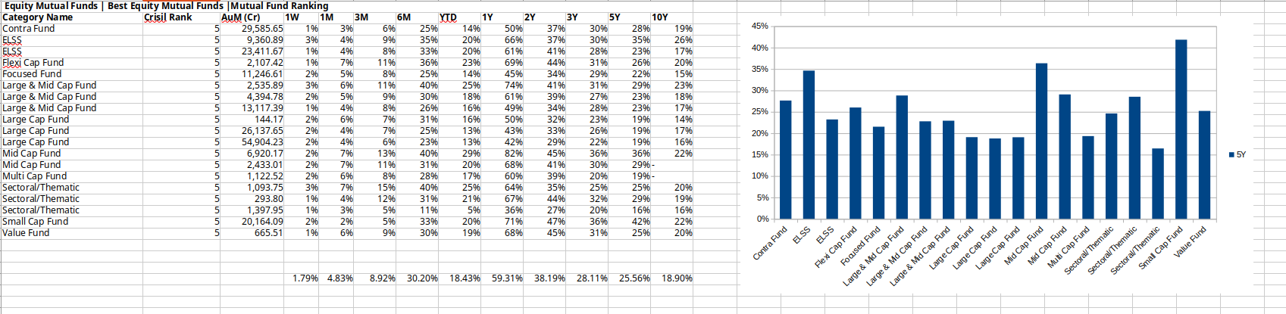
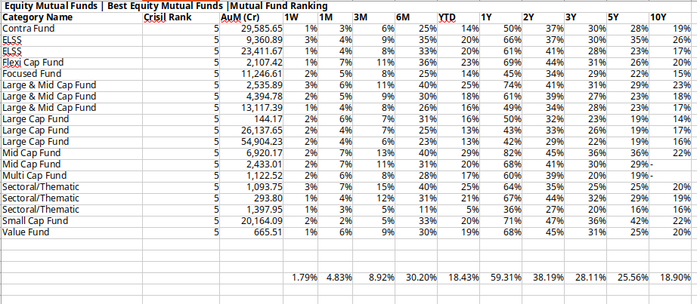
Mutual fund data

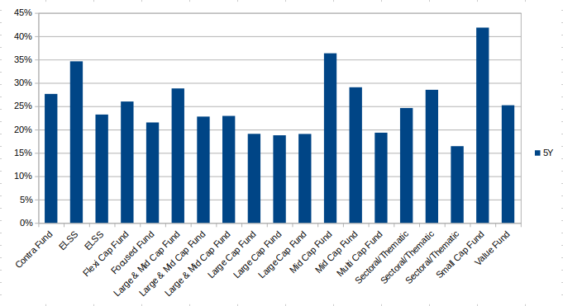
bar graph of mutual funds

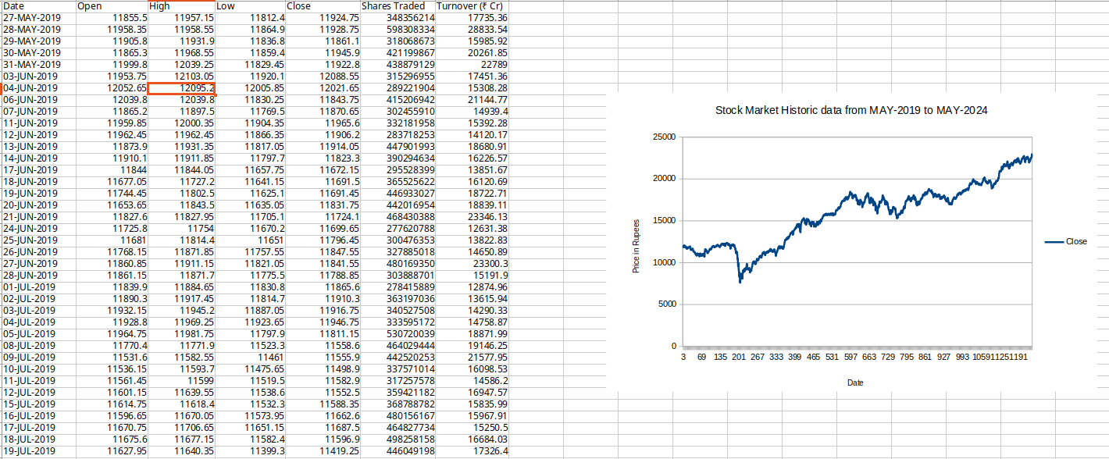
nifty 50 stock price
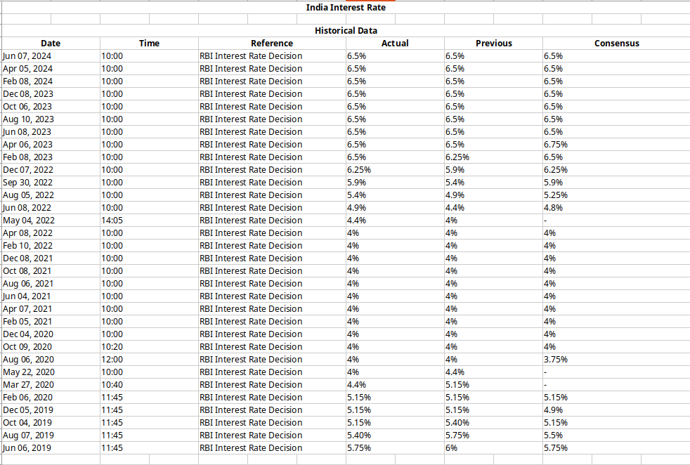
rbi interest rates

