DA Assignment-3

1.Define at least two sets based on specific criteria from your dataset (e.g., high-value customers, top-performing products).

* High-Value Customer Set:

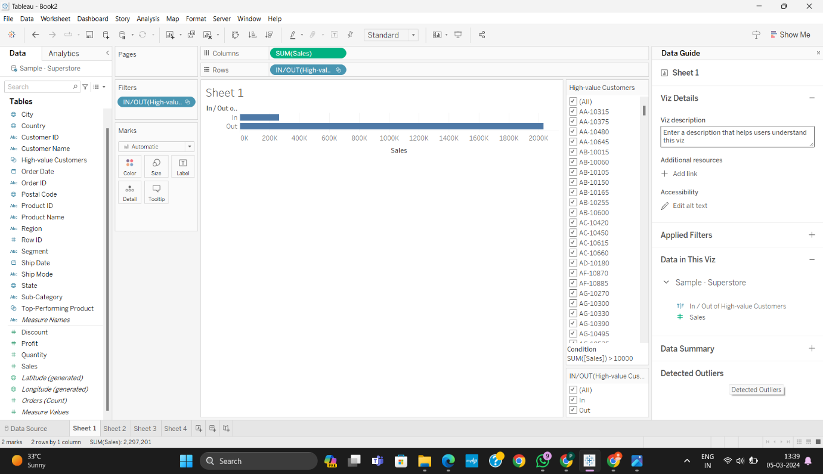

* Top-Performing products Set:

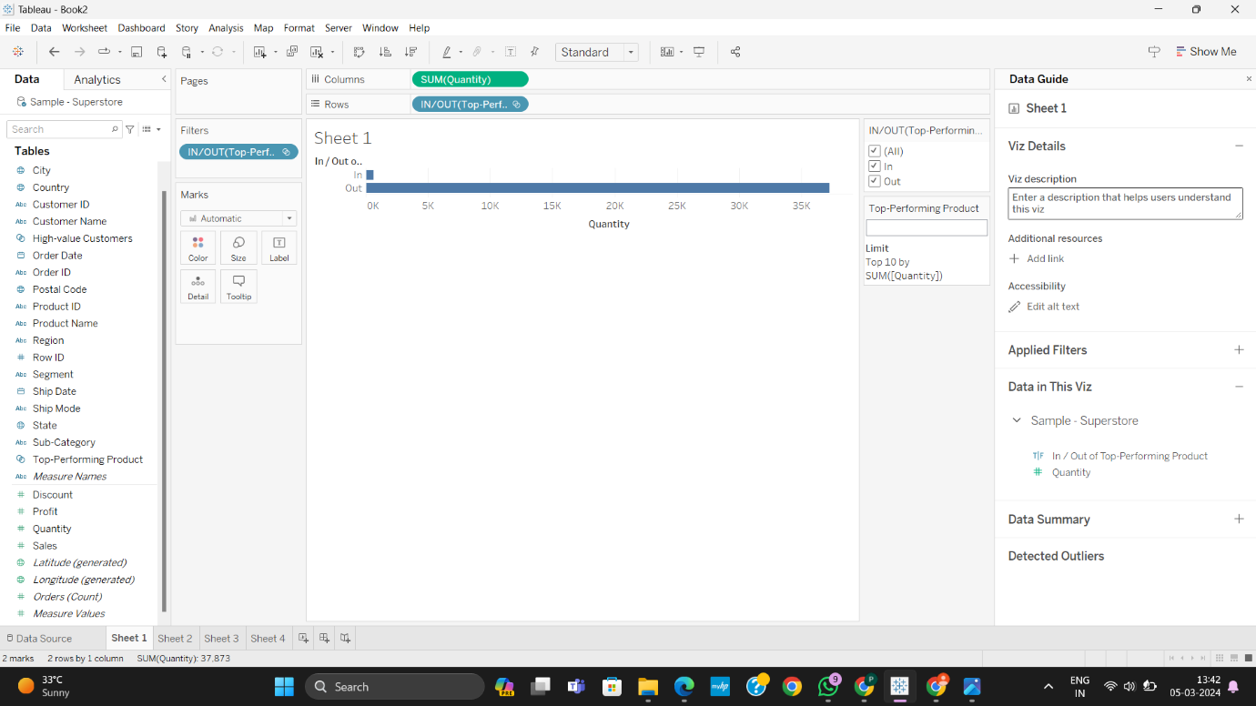

2.Experiment with combining sets using UNION, INTERSECT, and MINUS operations.

* UNION:

Union is a method for combining data by appending rows of one table onto another table.

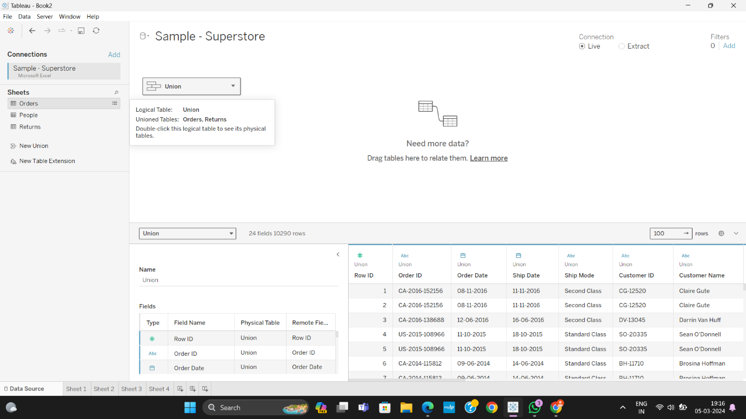

* INTERSECT:

 This function allows you to determine if two spatial objects overlap.

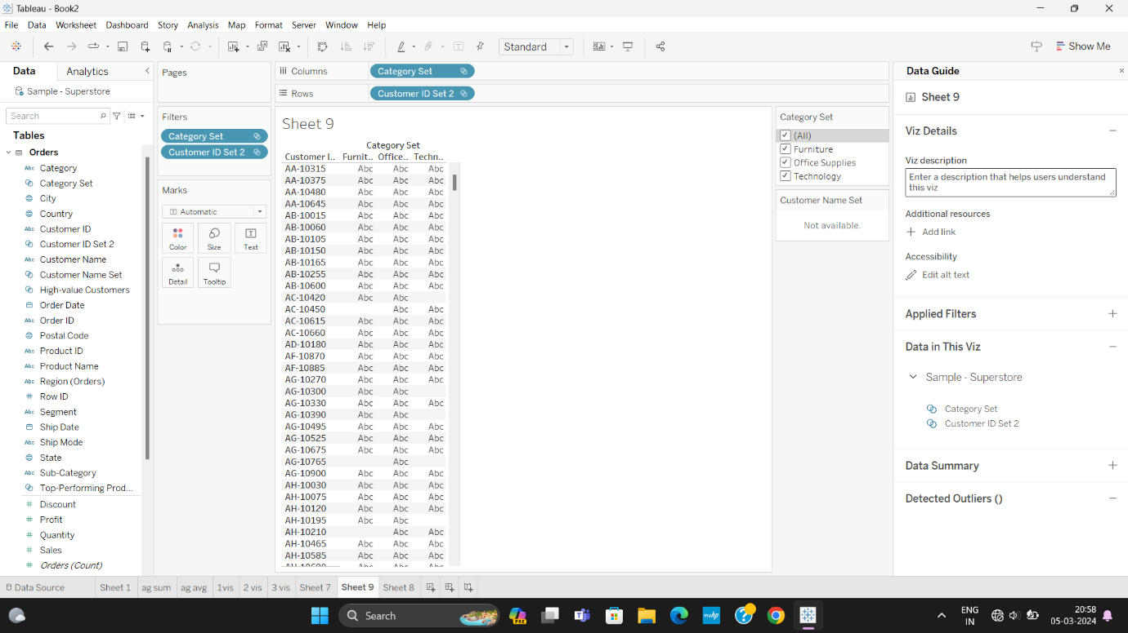

3.Create 2 Calculation field using any aggregate function:

* Total Sales:

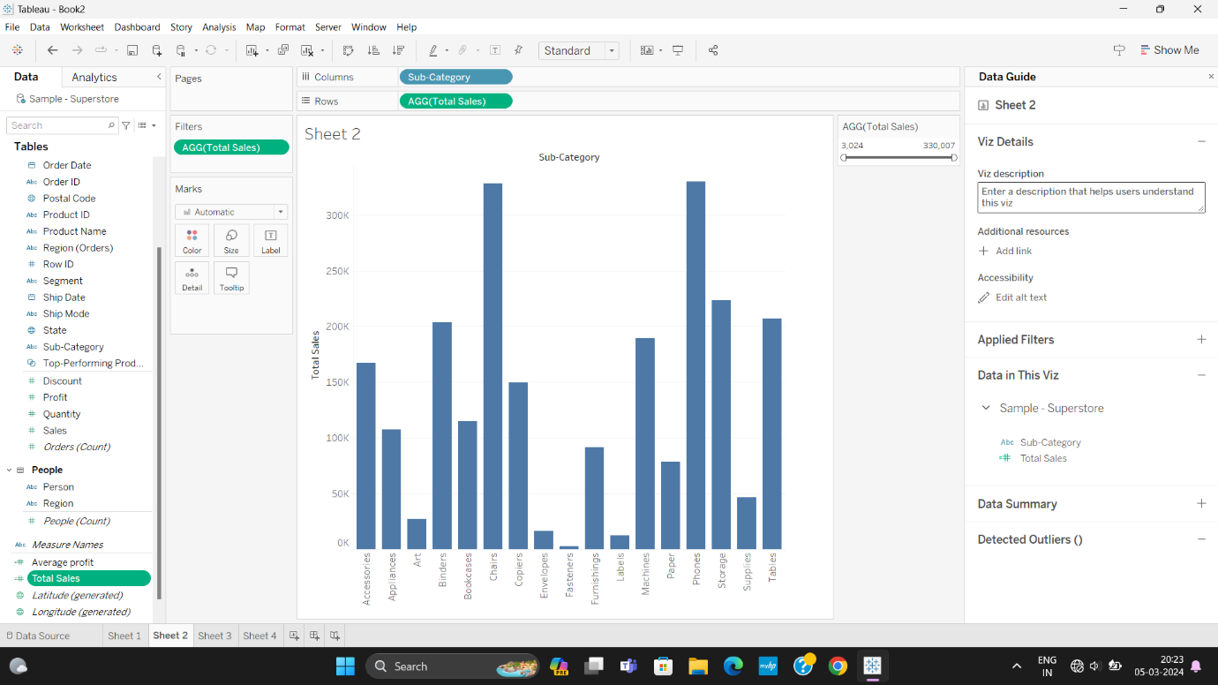

* Average Profit:

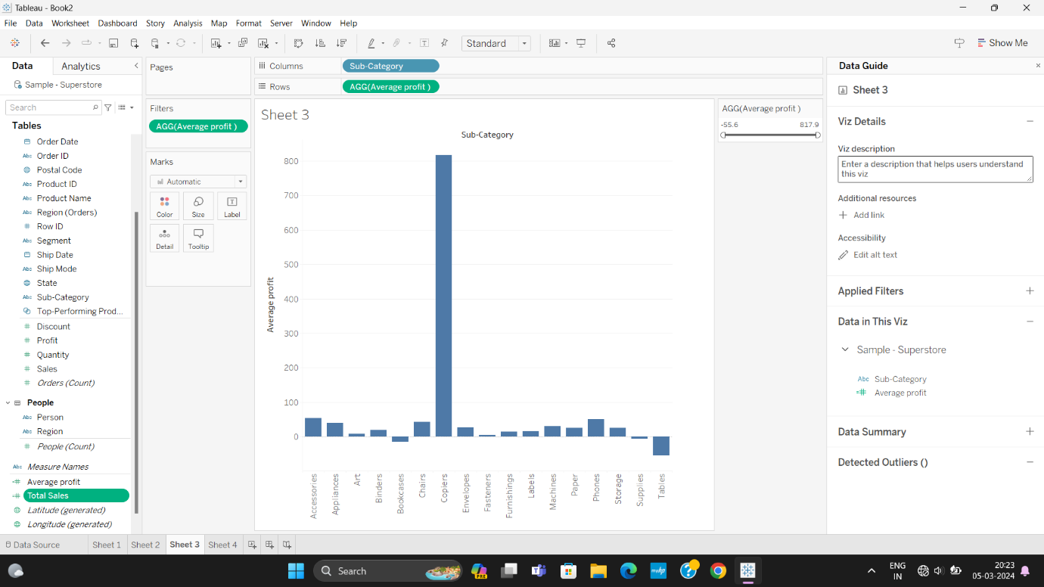

4.Create any 3 visualization using quick Table Calculations:

* Running Total of Sales Over Time:

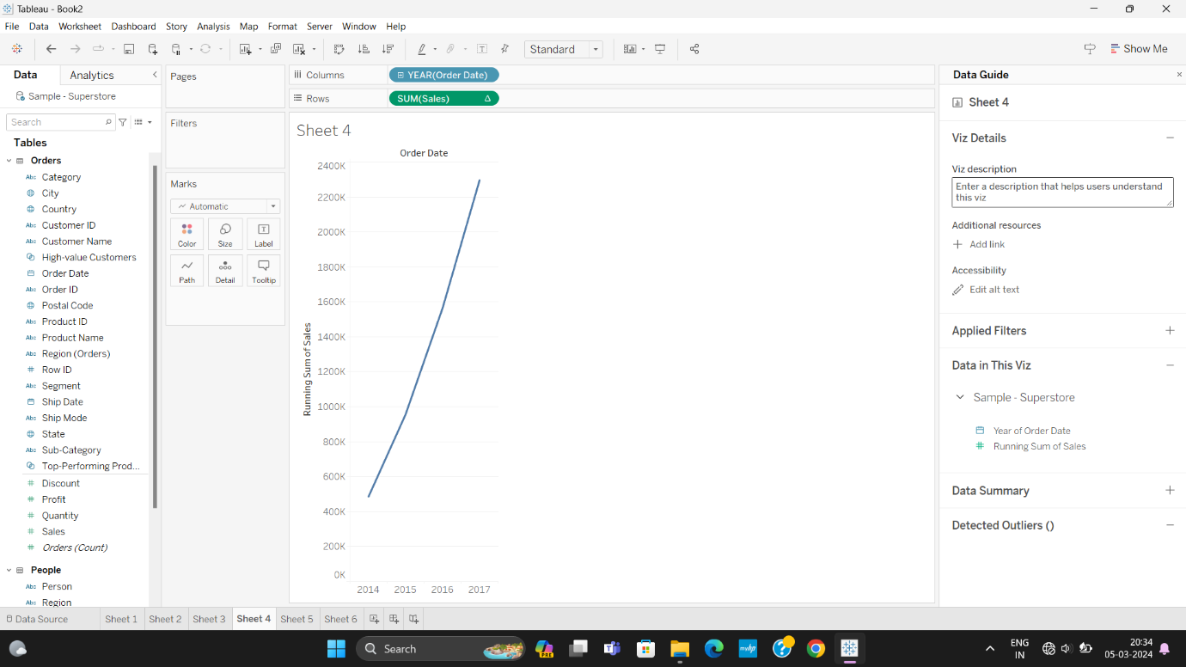

* Percentage of Total Sales by Category:

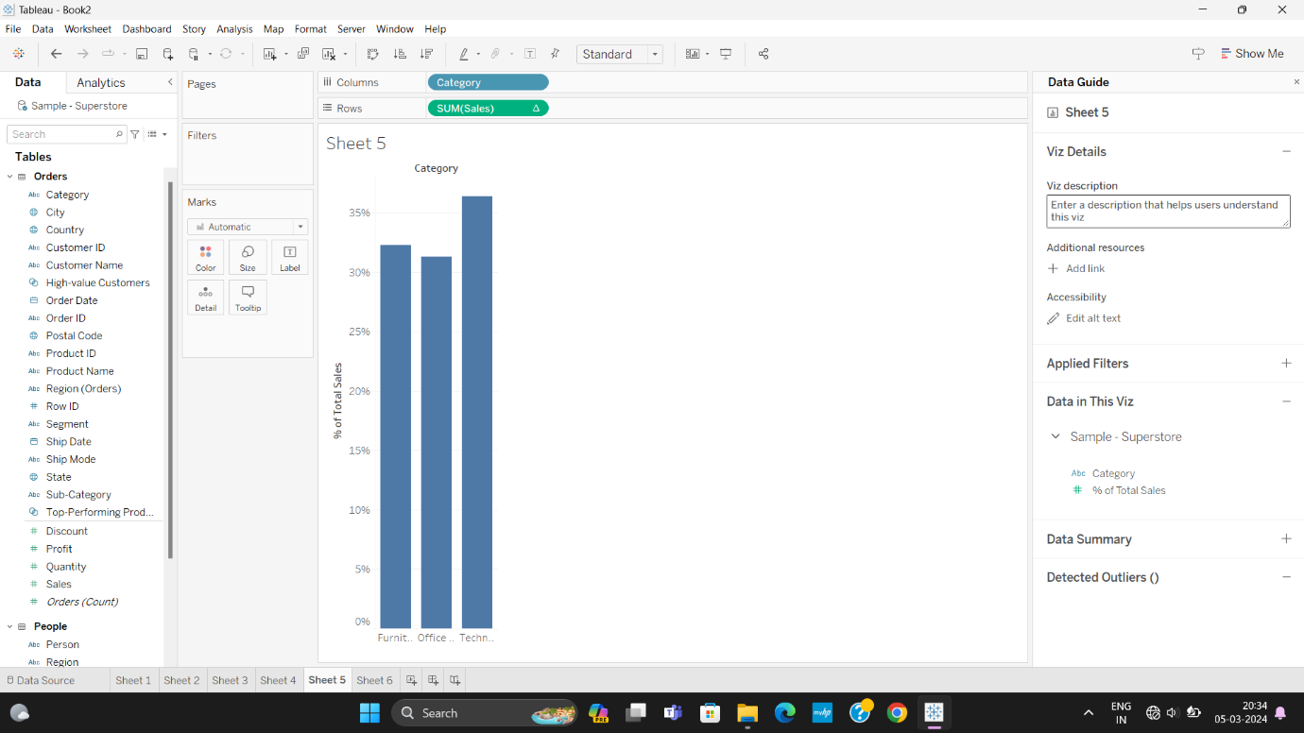

* Moving Average of Profit Over Time:

