Introduction to Prompt Engineering
Prompt engineering is the practice of designing clear and effective instructions for an AI model to get accurate, useful, and relevant responses.
Think of it as learning how to communicate with AI. The better your prompt, the better the output.
Lesson 1: Foundations of prompt engineering:

Why is Prompt Engineering Important?
A well-written prompt helps the AI:
- Understand your goal clearly.
- Produce more accurate and relevant answers.
- Reduce ambiguity and errors.
- Save time by requiring fewer follow-up questions.
For example:
Basic Prompt:
Explain machine learning.
Improved Prompt:
Explain machine learning to a high school student using simple language and real-world examples.
The second prompt provides context, audience, and style, resulting in a much better response.

Components of an Effective Prompt
A good prompt often includes:
- Task – What do you want the AI to do?
- Context – Background information.
- Constraints – Any limitations (length, format, tone).
- Output Format – How you want the response presented.
Example:
Summarize the following article in 150 words, using simple English, and present the key points as bullet points.

Prompt Engineering Techniques

1. Zero-shot Prompting
Ask the model to perform a task without providing examples.
Example:
Translate the following sentence into French: "Good morning."

2. One-shot Prompting
Provide one example before asking the model to perform the task.
Example:
English: Hello → Spanish: Hola
English: Thank you → Spanish: Gracias

3. Few-shot Prompting
Provide several examples to guide the model.
Example:
Positive: "I love this movie."
Negative: "This movie is boring."
Classify: "The acting was fantastic."

4. Chain-of-Thought Prompting
Encourage the model to reason through a problem step by step. For example:
Solve this math problem by explaining the reasoning clearly before giving the final answer.
(Note: For some tasks, simply asking for an explanation or solution is sufficient, as modern AI models often reason effectively without explicit prompting.)

5. Role Prompting
Assign the AI a specific role.
Example:
Act as a financial advisor and explain how to create a monthly budget.

Best Practices
- Be specific and clear.
- Provide sufficient context.
- Specify the desired output format.
- State any constraints (word limit, tone, audience).
- Refine your prompt based on the results.

Example
Poor Prompt
Write about climate change.
Better Prompt
Write a 300-word article explaining the causes and effects of climate change for college students. Include three major causes, three effects, and conclude with possible solutions.

Common Mistakes
- Using vague instructions.
- Omitting important context.
- Asking multiple unrelated questions in one prompt.
- Not specifying the desired output format.
- Expecting the AI to infer unstated requirements.

A Simple Prompt Template
You can use this template for many tasks:
Task: What should the AI do?
Context: Background information.
Audience: Who is the output for?
Constraints: Length, tone, style, or rules.
Output Format: Paragraph, table, list, JSON, code, etc.

Example
Task: Create a lesson plan.
Context: Introduction to Python programming.
Audience: Beginners with no coding experience.
Constraints: 60-minute lesson with practical exercises.
Output Format: Table with time, topic, activity, and learning outcomes.

Overview of Prompt Engineering and Its Significance in NLP and ML

Introduction
Prompt Engineering is the process of designing, structuring, and refining input instructions (called prompts) to guide Artificial Intelligence (AI) models, especially Large Language Models (LLMs), to produce accurate, relevant, and high-quality outputs. It is a crucial technique in modern AI because the quality of the response depends heavily on how the prompt is written.
Prompt engineering has become an essential skill in Natural Language Processing (NLP) and Machine Learning (ML), enabling users to interact with AI models effectively without modifying or retraining them.

What is a Prompt?
A prompt is any input given to an AI model that tells it what task to perform.

Task (a): Different Prompts for Definition of AI

Aim:
To analyze how different prompt styles affect the responses generated by AI tools like ChatGPT.

Prompt 1: (Simple Prompt)
What is Artificial Intelligence?

Output:
Artificial Intelligence (AI) is the ability of machines to perform tasks that normally require human intelligence, such as learning, reasoning, and decision-making.

Artificial Intelligence is the simulation of human intelligence by machines.

Prompt 2: (Detailed Prompt)
Explain Artificial Intelligence in detail with examples and applications.

Output:

Artificial Intelligence (AI) enables machines to perform tasks that normally require human intelligence, such as learning, reasoning, and decision-making. Examples: ChatGPT and Siri. Applications: Healthcare, finance, education, and self-driving cars.

Prompt 3 (Academic Prompt)
Define Artificial Intelligence for a B.Tech final year student including real-time applications and advantages.

Output:
Artificial Intelligence (AI) is the simulation of human intelligence in machines. It is used in applications like ChatGPT, self-driving cars, medical diagnosis, and recommendation systems. Advantages: automation, accuracy, and faster decision-making.

Comparison:
- Prompt 1 → Very basic answer
- Prompt 2 → More detailed
- Prompt 3 → Most detailed and structured

Task (b): Same Question, Different Prompt Styles

Question: What is Artificial Intelligence?

1. Direct Question
What is Artificial Intelligence?
Output:
Artificial Intelligence (AI) is the ability of machines to perform tasks that normally require human intelligence, such as learning, reasoning, and decision-making.

2. Instruction-Based Prompt
Explain Artificial Intelligence in 5 points with examples?
Output:
- AI enables machines to think and learn.
- It solves problems and makes decisions.
- It understands speech and images.
- Example: ChatGPT and Siri.
- Used in healthcare, education, and finance.

3. Role-Based Prompt
Act as a professor and explain Artificial Intelligence to engineering students with examples?
Output:
Artificial Intelligence (AI) is the technology that enables machines to perform human-like tasks such as learning and decision-making. Examples: ChatGPT, Siri, and self-driving cars. AI is widely used in healthcare, finance, and education.

Task (c): Interviewer Prompt (NLP Basics)

Prompt:
Act as an interviewer and ask me 5 questions about Natural Language Processing basics suitable for a B.Tech student.
Output:
- What is Natural Language Processing (NLP)?
- What is tokenization?
- What is stemming?
- What is lemmatization?
- Name two applications of NLP.

Task (d): Paragraph Generation & Summarization

Prompt 1: Generate Paragraph
Write a short paragraph about Artificial Intelligence and its applications?
Output:
Artificial Intelligence (AI) enables machines to perform tasks that require human intelligence. It is used in applications like chatbots, healthcare, self-driving cars, and recommendation systems. AI improves efficiency and decision-making.

Prompt 2: Summarize
Summarize the above paragraph in 2 lines?
OUT PUT:
Artificial Intelligence enables machines to perform human-like tasks.
It is widely used in healthcare, chatbots, and self-driving cars.

Prompt 3: generate a image using summarized paragraph for illustration purpose

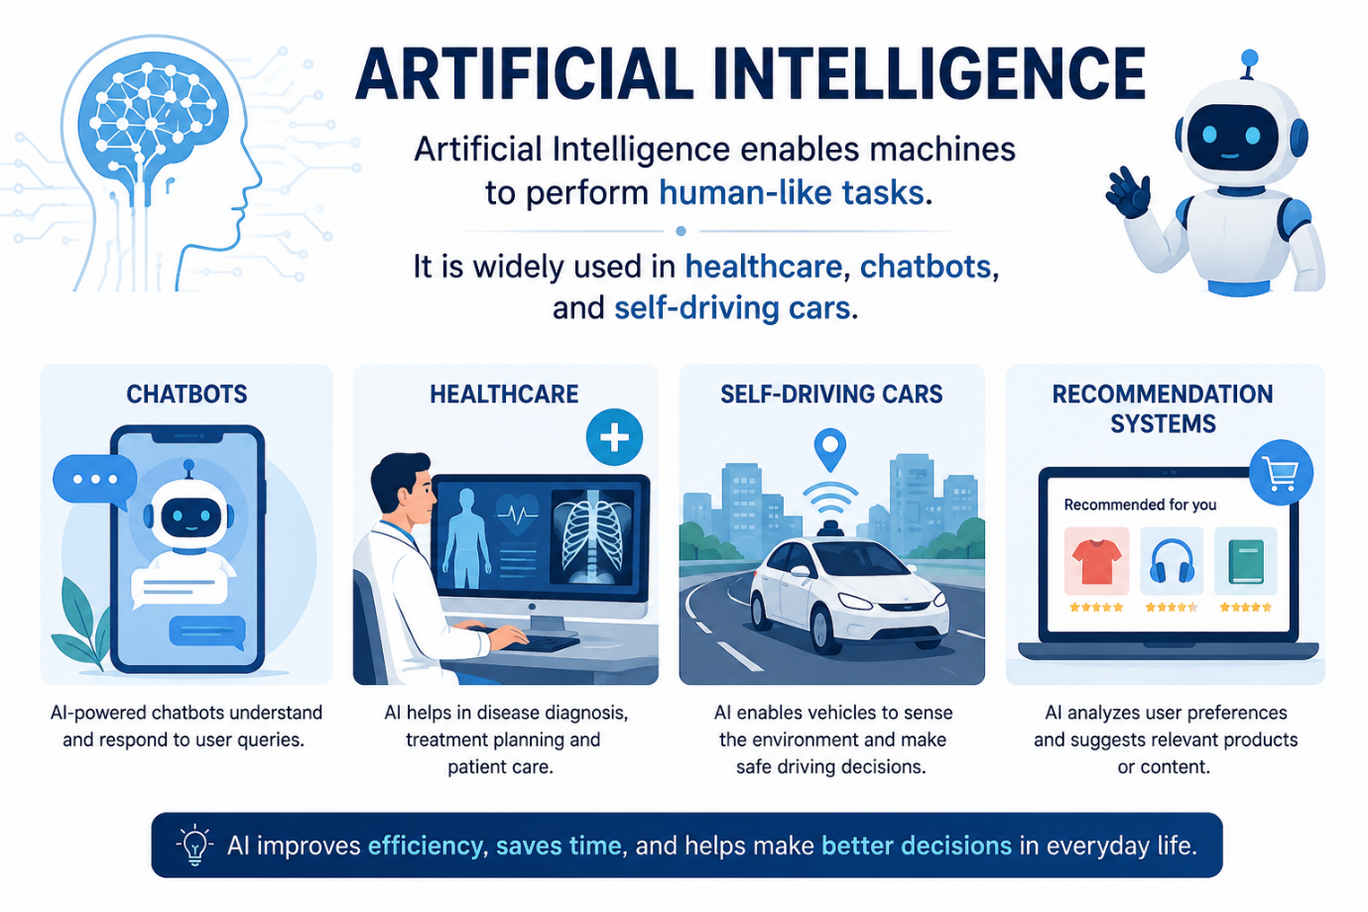

Prompt 4: generate a simple understanding image

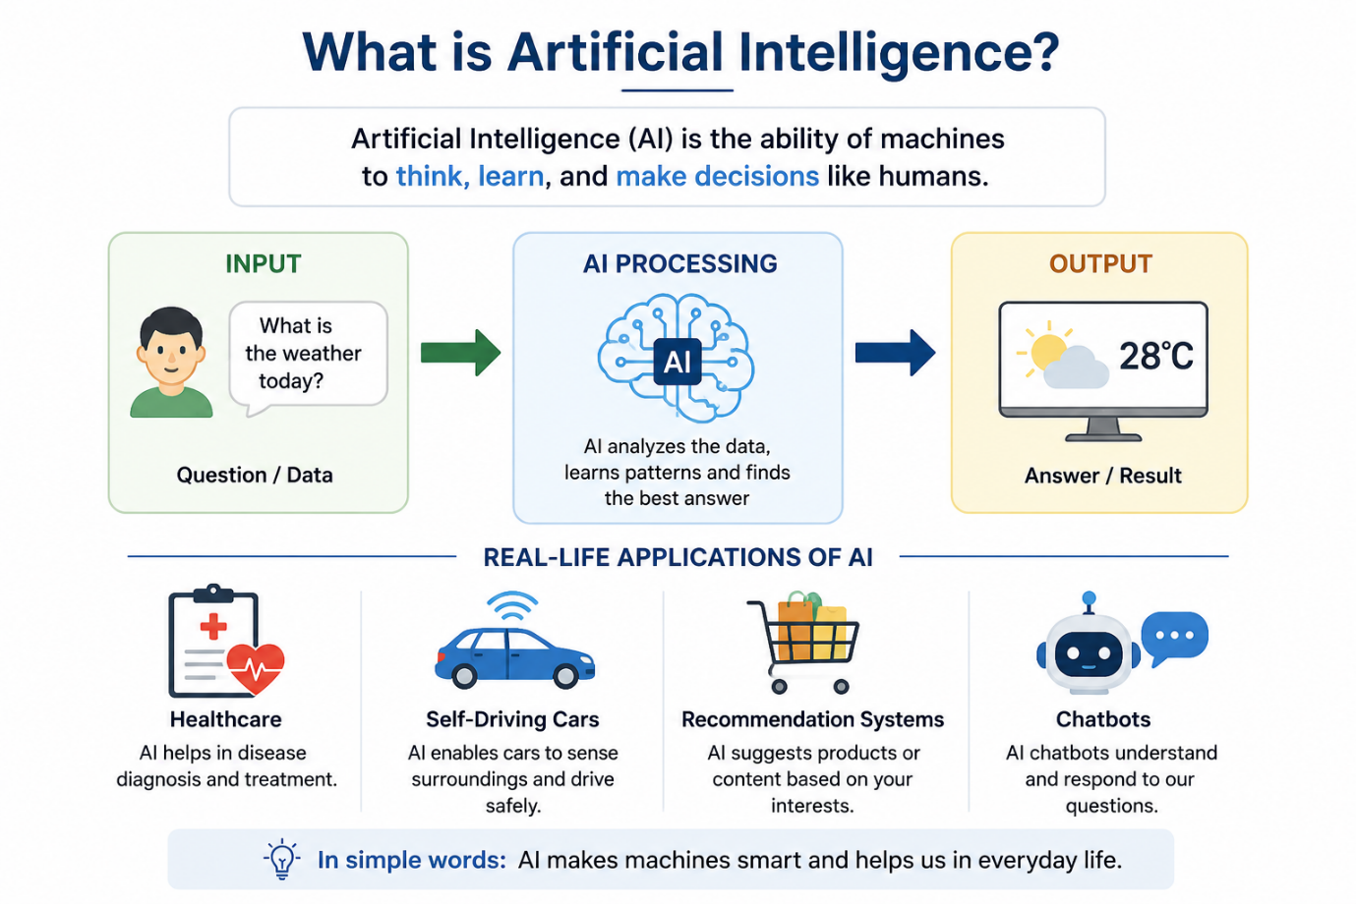

Historical Context and Evolution of Prompt-Based Approaches

Introduction
Prompt-based approaches have evolved alongside the development of Artificial Intelligence (AI) and Natural Language Processing (NLP). Initially, AI systems relied on manually written rules and commands. With advances in machine learning, deep learning, and large language models (LLMs), prompts have become a powerful way to interact with AI. Today, prompt engineering is a key skill for obtaining accurate, relevant, and high-quality outputs from AI systems such as ChatGPT.

Evolution of Prompt-Based Approaches

1. Rule-Based Systems (1950s–1980s)

Overview
The earliest AI systems were rule-based expert systems. Users had to provide precise commands, and the system followed predefined rules.

Characteristics
- Based on "if-then" rules
- No learning capability
- Required exact input formats
- Limited flexibility

Example
IF temperature > 38°C
THEN diagnose fever.

Advantages
- Easy to understand
- Predictable outputs

Limitations
- Could not handle ambiguity
- Difficult to scale
- No understanding of natural language

2. Statistical Machine Learning Era (1990s–2010)

Overview
AI shifted from handcrafted rules to learning from data using statistical methods.

Characteristics
- Used algorithms such as:
  - Decision Trees
  - Naïve Bayes
  - Support Vector Machines (SVM)
- Required feature engineering
- Prompts were still simple queries

Example
Classify this email as Spam or Not Spam.

Improvements
- Better accuracy
- Learned patterns from data
- Reduced manual rule creation

Limitations
- Depended heavily on handcrafted features
- Limited contextual understanding

3. Deep Learning Era (2013–2017)

Overview
Deep learning transformed NLP using neural networks such as RNNs, LSTMs, and GRUs.

Characteristics
- Learned features automatically
- Improved language understanding
- Enabled sequence-to-sequence learning

Example Applications
- Machine translation
- Speech recognition
- Text summarization

Limitations
- Struggled with long-range dependencies
- Training was computationally expensive

4. Transformer Era (2017)

Overview
The introduction of the Transformer architecture in the paper "Attention Is All You Need" revolutionized NLP.

Key Innovation
- Self-attention mechanism
- Parallel processing
- Better handling of long text

Impact
- Faster training
- Higher accuracy
- Better contextual understanding

Significance
Transformers became the foundation for modern Large Language Models.

5. Pre-trained Language Models (2018–2020)

Overview
Researchers introduced large pre-trained models that could be fine-tuned for many tasks.

Popular Models
- BERT
- GPT
- RoBERTa
- T5

Characteristics
- Trained on massive datasets
- Transfer learning
- Fine-tuning for downstream tasks

Example Prompt
Question:
Who invented the telephone?
Output:

6. Prompt Engineering Era (2020–Present)

Overview
Instead of retraining models, users guide AI behavior using carefully designed prompts.

Characteristics
- Natural language instructions
- No additional model training required
- Better flexibility
- Faster deployment

Common Prompting Techniques
- Zero-shot prompting
- One-shot prompting
- Few-shot prompting
- Chain-of-thought prompting
- Role prompting

Example
Act as a cyber-security expert.
Explain phishing attacks to first-year engineering students with real-life examples.

Benefits
- Easy to use
- Task-specific customization
- Improved output quality

7. Advanced Prompting and AI Agents (2023–Present)

Overview
Modern AI systems combine prompt engineering with external tools, memory, and reasoning to solve complex tasks.

New Developments
- Multi-step reasoning
- Retrieval-Augmented Generation (RAG)
- AI agents
- Tool use (search, code execution, databases)
- Multimodal prompting (text, images, audio)

Example
Analyze this dataset, create charts, summarize the findings, and suggest business recommendations.

Applications
- Research assistance
- Software development
- Healthcare
- Education
- Business analytics

