BUMP.TRADE
GAMEPLAY HUD & FEEDBACK PRD
Desktop 16:9 • MVP / Vertical Slice
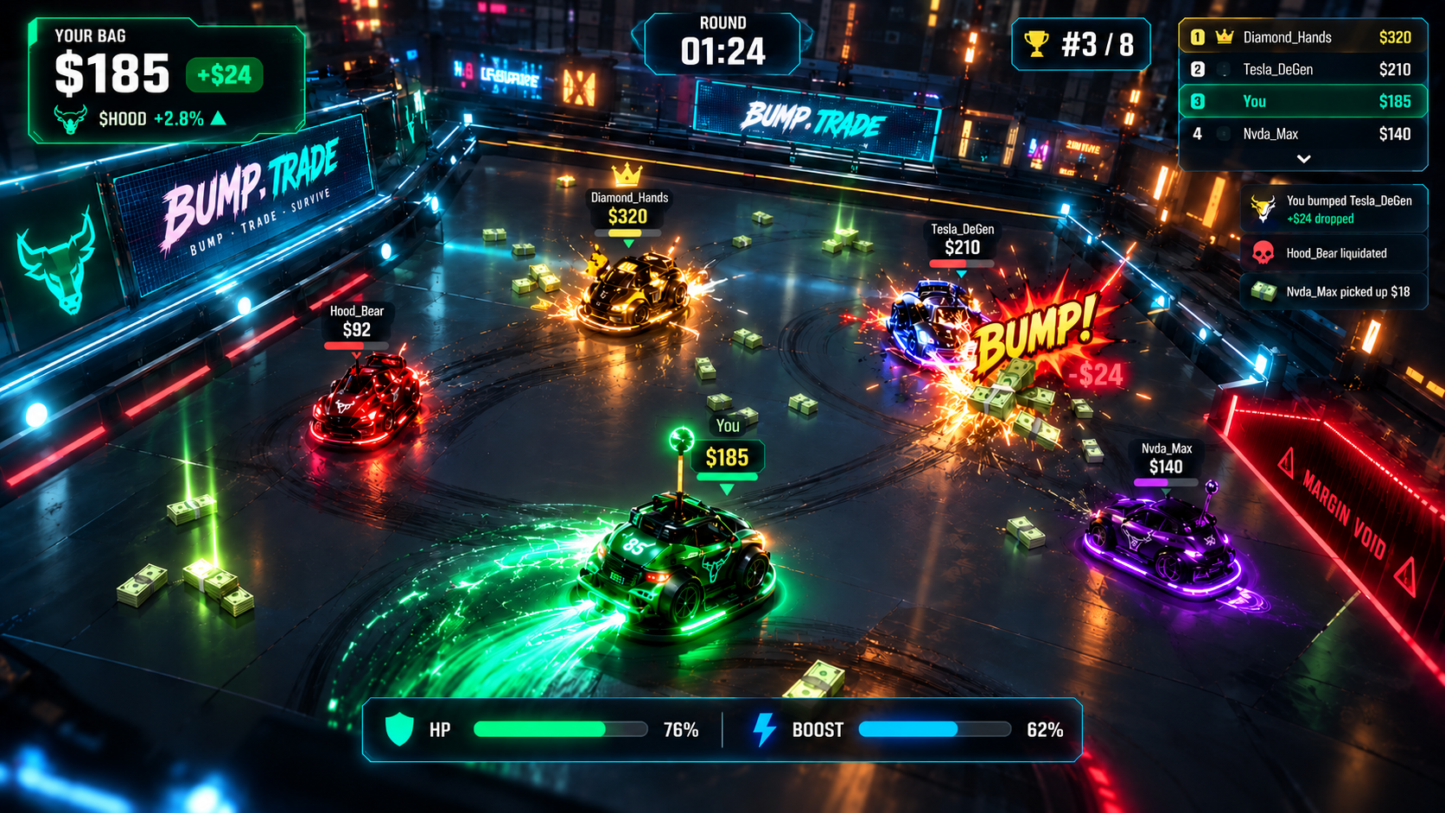
Visual reference: latest approved gameplay HUD direction. The production UI should preserve the same hierarchy while staying cleaner and less intrusive.

1. Overview
This PRD defines the desktop gameplay HUD, in-world labels, event notifications, and collision feedback system for BUMP.TRADE. The target experience is a clean, immersive arcade interface that communicates the player bag, round state, rank, health, boost, and important combat events without blocking the 3D arena.
The core design rule is: HUD quiet, impact loud. Normal play should keep the center of the screen visually open; major collisions, money drops, rank changes, and liquidations should create short, readable, event-driven feedback moments.

2. Goals & Non-Goals
Goals | Non-goals
Fast information at a glance | Debug telemetry
Strong collision feedback | Permanent controls overlay
Clear bag / money feedback | Large minimap
Readable player labels | Complex trading charts
Desktop 16:9 polish | Wallet/token UI
60 FPS target | Dense RPG-style stats

3. Final HUD Layout
The gameplay camera must remain dominant. Persistent UI should be concentrated around the perimeter of the screen, while event feedback is allowed to temporarily occupy the center.
Zone | Component | Purpose
Top-left | Player Bag | Current money, gain/loss, stock identity.
Top-center | Round Timer | Round time; stronger urgency during final 10 seconds.
Top-right | Mini Leaderboard | Top 3 + player; live bag values and rank.
World-space | Player Labels | Player name + bag value above each car.
Center-below timer | Event Notifications | Short impact/liquidation/rank messages.
Bottom-center | Player Status | HP and BOOST only.
Center arena | Gameplay | Keep mostly clear except event feedback.

4. Component Specifications

4.1 Player Bag
Top-left. Show YOUR BAG, large current value, animated +/- change, and compact stock identity such as $HOOD +2.8%. Bag change animation: scale + glow + value transition, approx. 300–450ms.

4.2 Round Timer
Top-center. Example: ROUND 01:24. Minimal at normal time; subtle red/pulse behavior in final 10 seconds and stronger urgency at 5 seconds.

4.3 Mini Leaderboard
Top-right. Show Top 3 plus the local player. Highlight the player row in green. Avoid a full scoreboard during normal play.

4.4 World Labels
Above every active vehicle. Primary value is bag amount; player name is secondary. High-value bags may receive a gold accent.

4.5 Player Status
Bottom-center. Only HP and BOOST. Keep as one centered glass strip. No minimap and no persistent control hints.

4.6 Event Notification
Center below the timer. Two or three short messages may stack briefly, then slide/fade away.

5. Event Feedback System
Every meaningful collision should produce a single normalized event that can drive physics, VFX, camera, audio, and UI. This keeps all feedback synchronized and avoids separate systems guessing what just happened.
Physics | Impact Tier | Knockback | VFX | Camera | Audio | UI
Collision detected | Light / Heavy / Critical | Impulse / recoil | Sparks / flash / money | Shake / hit-stop | Impact sound | BUMP / BAG DROPPED

6. Impact Tiers
Tier | Trigger | UI | Camera | VFX
Light | Low impact speed | Small BUMP text | Very small shake | Small sparks
Heavy | Above heavy threshold | BUMP! + dropped amount | Medium shake | Large sparks + flash
Critical | Above critical threshold | MASSIVE BUMP! + bag value | Strong shake + 80–120ms hit-stop | Major flash + money burst

7. Money Feedback
- Money drop: world pickups explode outward from the impacted vehicle; UI briefly shows “+$XX DROPPED”.
- Money pickup: floating “+$XX” appears near the player, then the bag value animates to the new total.
- Money loss: use “-$XX” with a short red pulse; update bag immediately after the event resolves.
- Large bags should be visually more attractive targets, using a subtle gold accent on the world-space value.

8. Liquidation & Margin Void
When a vehicle crosses a Margin Void trigger, the game should stage a clear but short liquidation sequence. Do not instantly delete the vehicle before the player sees the consequence.
- Vehicle starts falling and losing electrical energy.
- Red danger pulse appears in the HUD/edge treatment.
- Center event: “LIQUIDATED”.
- Show the lost bag value or the amount transferred when applicable.
- Disable gameplay collision after the fall animation completes.

9. Rank & Competition Feedback
- Rank up: short green “▲ #3” style notification; approx. 500–700ms.
- Rank down: short red “▼ #4” style notification.
- Mini leaderboard updates immediately after meaningful bag changes.
- Current player remains highlighted in the compact leaderboard.

10. HUD Animation Guidelines
Event | Animation | Timing
Normal HUD | Stable; subtle idle glow | Continuous / low amplitude
Bag change | Scale, glow, value interpolation | 300–450ms
Light bump | Small text pop + tiny shake | ~300ms
Heavy bump | Large text pop + shake + flash | ~500ms
Critical bump | Hit-stop + large text + money burst | ~600–800ms
Liquidation | Large center text + red pulse | ~600ms
Rank change | Slide/fade indicator | ~700ms

11. Color & Iconography
Semantic | Color Direction | Usage
Positive / Gain | Green / Teal | Bag gain, positive stock, rank up, player highlight
Danger / Loss | Red | Bag loss, liquidation, Margin Void, rank down
High Value | Gold / Yellow | Large bags, leader, critical reward moments
Boost / Electric | Blue / Cyan | Boost bar, electrical energy
Special | Purple | AI / special vehicle theme
Neutral | White / Gray | Normal text and passive UI

12. Removal / Production Cleanup
- Remove current debug panel with STATE, AI, physics, internal HP, and telemetry values from production.
- Remove permanent WASD / SPACE instruction panel after onboarding. Keep controls only in debug/onboarding state.
- Remove minimap for the MVP HUD unless arena testing proves it materially improves navigation.
- Remove large technical stat blocks from gameplay.
- Do not add trading charts, wallets, token data, or financial dashboards to the gameplay screen.

13. Implementation Guidance for Three.js
Treat UI as an event-driven layer over the 3D scene. Physics emits normalized gameplay events; the HUD, VFX, camera, and audio subscribe to those events. Avoid coupling DOM UI directly to physics collision callbacks.
System | Responsibility
CollisionSystem | Detect and classify impact; emit CollisionEvent.
GameplayEventBus | Dispatch typed events such as COLLISION, MONEY_DROPPED, PICKUP, LIQUIDATED, RANK_CHANGED.
HUDController | Subscribe to events and update persistent UI / transient notifications.
VFXManager | Play sparks, flash, money burst, void effects.
CameraController | Apply shake, hit-stop, FOV changes.
AudioManager | Play contextual impact / pickup / liquidation sounds.

14. Suggested Event Payloads
CollisionEvent should contain enough normalized data for every presentation system to respond consistently.
- attackerId
- victimId
- position
- normal
- relativeVelocity
- impactForce
- impactTier
- moneyDropped
- timestamp

15. Acceptance Criteria
- Player can read bag, timer, rank, HP, and boost within one glance.
- Center of arena remains unobstructed during normal play.
- Light / heavy / critical collisions feel visibly different.
- Every strong collision produces synchronized knockback, VFX, audio, camera, and UI feedback.
- Money drop is immediately understandable visually and numerically.
- Liquidation cannot be missed, but its notification is brief.
- Rank changes are obvious without requiring a full leaderboard.
- No debug telemetry appears in production.
- HUD works at 1920×1080 and 1440×900 without overlap.
- Gameplay target remains 60 FPS on a modern desktop.

16. Implementation Priority
Priority | Scope | Deliverable
P0 | HUD cleanup | Bag, timer, mini leaderboard, player labels, HP/BOOST, remove debug UI
P0 | Collision feedback | Impact tiers, camera shake, hit-stop, impact text, sparks
P0 | Money feedback | Drop, pickup, bag animation, world-space value
P1 | Liquidation | Margin Void warning, LIQUIDATED event, fall feedback
P1 | Rank feedback | Rank up/down notification and live mini leaderboard
P2 | Advanced juice | Combo, comeback, high-value target emphasis

17. Final UX Principle
NORMAL PLAY: quiet HUD, open arena, clear bag/boost.
IMPORTANT EVENT: short, dramatic, readable feedback.
DESIGN TEST: if the player can feel the collision before reading the UI, the feedback system is working.

Appendix A — Approved Visual References
Gameplay HUD reference used for this PRD.
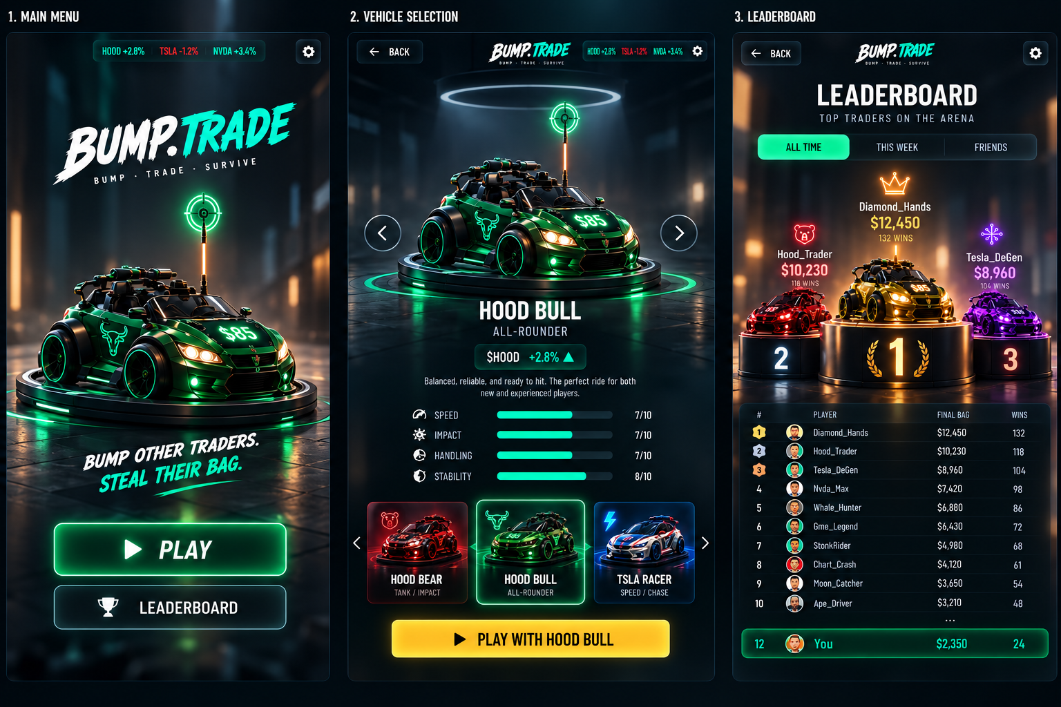
Desktop menu / vehicle selection / leaderboard reference.

