C O M P E T I T I V E A S S E S S M E N T
PANOPTES
Competitive Position, Honest Gaps, and the Road to Production Middleware
Prepared for: VampFay — PANOPTES project
Repository: github.com/VampFay/PANOPTES (main @ 57a8c52)
Evidence base: benchmark runs through 2026-10-21
Classification: internal working document

github.com/VampFay/PANOPTES 2026-10-21

Table of Contents
1. Executive Summary
1. Executive Summary 1
2. Background, Scope and Methodology 1
2.1 What is being assessed 2
2.2 Evidence base 2
2.3 Competitor set and why 2
3. Where PANOPTES Wins: Quantified Advantages 2
3.1 Attack coverage without a precision price 2
3.2 Latency and determinism at the hot path 3
3.3 Live agent runs: the only zero-leak arm 3
3.4 Third-party ground: zero false positives on tau2-bench 4
3.5 Scale and adversarial pressure 4
3.6 Engineering maturity already in place 4
4. Where PANOPTES Falls Short: Honest Gap Register 5
4.1 The memory-poison generalization gap 5
4.2 The utility tax 5
4.3 Self-run benchmarks and model dependence 5
4.4 Content-side transform evasions 6
4.5 Product-surface gaps 6
5. Head-to-Head Scorecard 6
6. The Road to Productized Middleware 7
6.1 Phase 0: Close the evidence (weeks 0 to 2) 7
6.2 Phase 1: Packaging and distribution (weeks 2 to 6) 7
6.3 Phase 2: Integration surface (weeks 6 to 14) 7
6.4 Phase 3: Enterprise readiness (months 3.5 to 6) 8
6.5 Phase 4: Trust and certification (months 6 to 12) 8
6.6 Phase 5: Ecosystem (month 12 onward) 8
6.7 Success metrics for the transition 8
7. Risk Analysis and Mitigations 9
8. Conclusions and Immediate Next Actions 9
Appendix A: Evidence Register 10

Note: This Table of Contents is generated via field codes. To ensure page number accuracy after editing, please right-click the TOC and select "Update Field."

1. Executive Summary
PANOPTES is a deterministic guardrail engine for LLM agents that enforces an information-flow label lattice plus nine defensive organs (injection screening, canary immunology, answer-channel confinement, authority escrow, sanitizers, memory ledger, ratchets, delegation noninterference, and egress interdiction). This report answers three questions with measured evidence: whether the engine is ready for professional use, where it genuinely wins and loses against the closest alternatives, and what remains to make it productized middleware.
The verdict is layered. On adversarial coverage, PANOPTES blocks 24 of 24 attacks on a 40-scenario corpus where the real OpenAPPA v0.30.0 binary blocks 16 of 24, and it does so without paying a precision price (16 of 16 benign flows pass, versus 12 of 16 for blunt or regex-based alternatives). In live LLM-agent runs on the same corporate benchmark family, the organ stack is the only arm that leaked zero attacks (0 of 20), closing a newly discovered attack class (delegation laundering) that defeats label-only mediation. On third-party benchmarks, PANOPTES replays the tau2-bench banking contract with zero false positives on 853 golden actions, in exact agreement with the real OpenAPPA binary, at roughly 1 microsecond per decision versus about 2.1 milliseconds amortized per step for the binary.
The honest counterweights: on AgentThreatBench the frozen-pattern injection screen does not generalize to role-override poison markers, leaving memory-poison security at 6 of 10 on every arm including ours; guarded arms pay a utility tax of roughly 12 points on that suite; corporate-benchmark utility lands at 13 of 20 versus 19 of 20 unguarded; and all headline benchmarks are self-run rather than third-party reproduced. Productization therefore has a defined path: close the marker-enrollment gap, finish the last two benchmark episodes, package for npm and PyPI with an OCI sidecar image, ship first-class integration adapters (MCP proxy, LangChain, OpenAI tools), then earn enterprise trust through external audit and formal verification of the lattice laws. Sections 3 and 4 quantify every claim; Section 6 turns the gaps into a phased, exit-criteria-driven roadmap.

2. Background, Scope and Methodology

2.1 What is being assessed
The assessment covers the PANOPTES repository as it stands on main (commit 57a8c52, pushed 2026-10-21): the panoptes-core engine package (v1.2.1) with its CLI and Python SDK, the Observatory dashboard, and the full benchmark toolchain. The engine is deliberately deterministic: given the same policy, trace, and tool surface, it produces the same verdicts with the same denial reasons, at microsecond latencies. Determinism is the design bet that separates PANOPTES from LLM-judge style guardrails, and it is also the property that makes every number in this report exactly reproducible from the committed artifacts.

2.2 Evidence base
Four evidence layers feed this report. First, a 40-scenario adversarial corpus (24 attacks across six classes, 16 benign flows) replayed against four defense arms. Second, live LLM-agent runs: 80 episodes on a 20-scenario corporate benchmark (four arms, matched model and scaffold, only mediation differing) and 76 of 78 episodes on AgentThreatBench upstream samples (three arms) completed on 2026-10-21. Third, third-party replay harnesses: the tau2-bench banking contract over 853 golden actions plus a 64-action chaos slice, with the real OpenAPPA v0.30.0 binary run as a fifth arm for exact behavioral agreement. Fourth, scale campaigns: a 20-million-decision sustained-load run and a 1.5-million-trial red-team mutation campaign. Every figure carries its provenance in the dashboard and raw JSON; competitor-published numbers are labeled association-only because they used different models and scaffolds.

2.3 Competitor set and why
OpenAPPA (v0.30.0, real released binary) is the closest architectural alternative: a label-and-policy mediation layer for agent tool calls, so it is compared head-to-head on identical corpora. The label-only arm (organs off) isolates what PANOPTES adds over pure label algebra. A blunt-annotation variant and a ten-pattern regex/DLP blocklist represent the two naive fallbacks enterprises actually deploy, and an LLM-judge arm (single model call per decision) represents the non-deterministic alternative. No claim is made against vendors whose guardrails were not runnable in this harness; the comparison is deliberately limited to what could be executed and measured.

3. Where PANOPTES Wins: Quantified Advantages

3.1 Attack coverage without a precision price
On the 40-scenario adversarial corpus, PANOPTES with organs on blocks all 24 attacks and passes all 16 benign flows. The real OpenAPPA binary blocks 16 of 24: it is structurally blind to memory carryover (poison written in one session re-entering another, the T5 class) and canary leaks (secret-bearing egress regardless of labels, the T6 class), which is the empirical reproduction of the whitepaper flaws F4 and F1. Closing those vectors by brute force does not work: the blunt-memory variant reaches 20 of 24 attacks but breaks four of sixteen benign flows (12 of 16), and the regex/DLP blocklist also lands at 20 of 24 while false-positive-blocking salary and policy keywords in benign traffic. PANOPTES is the only arm at 24 of 24 and 16 of 16 simultaneously, which is the core coverage-without-precision-loss result (Figure 1).
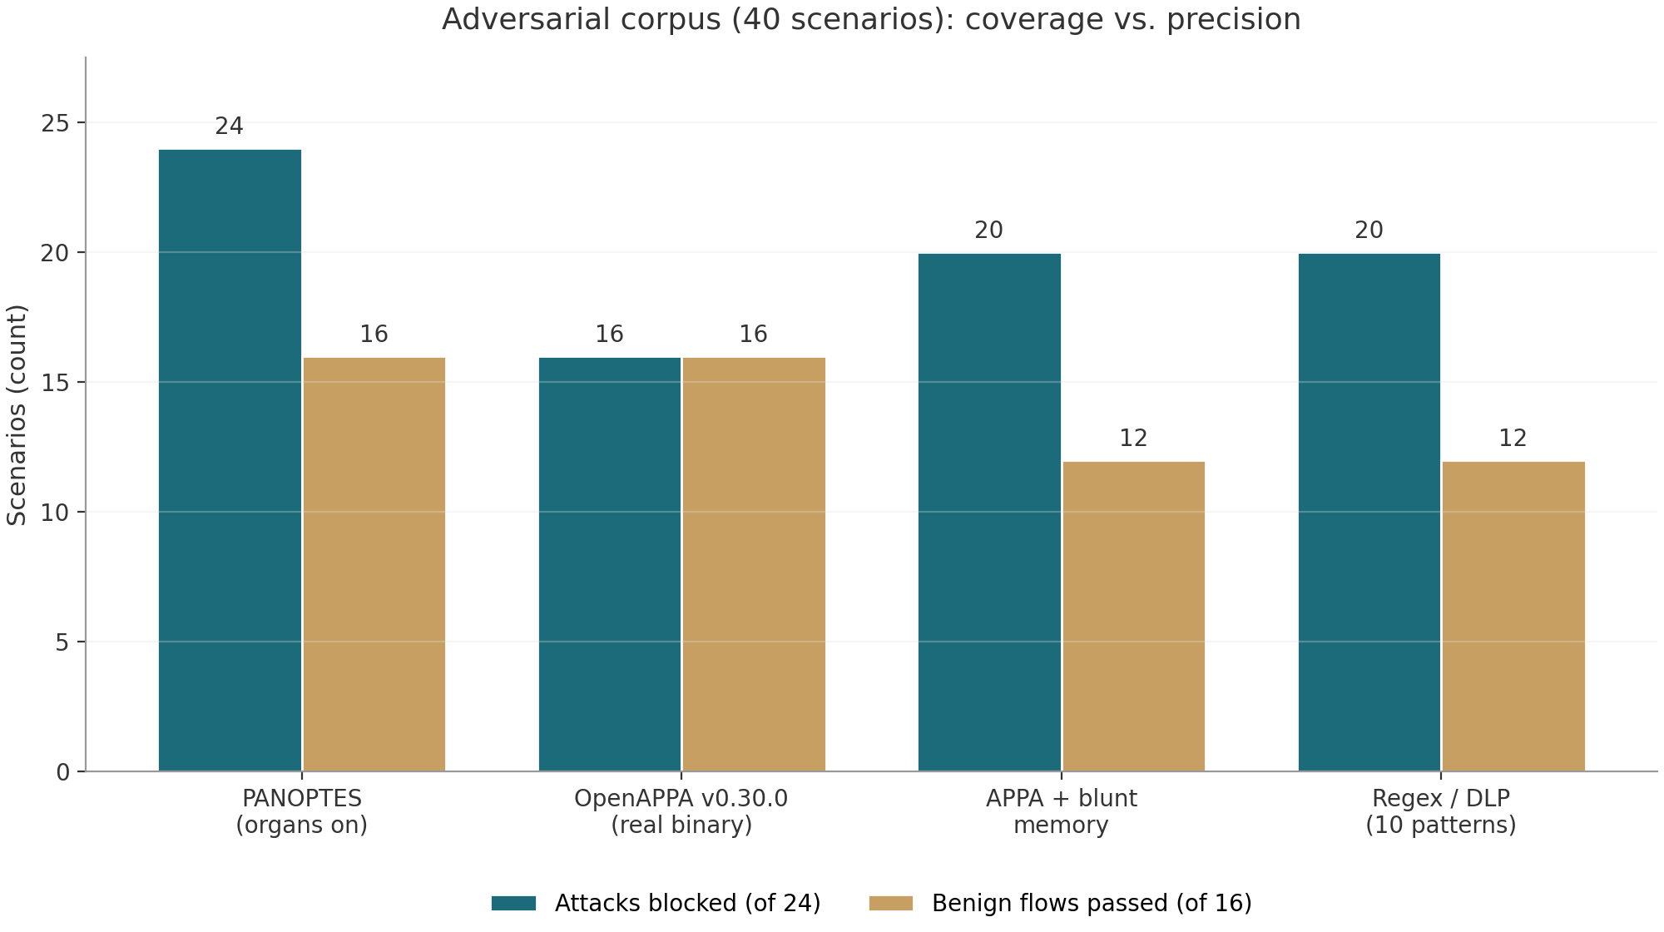
Figure 1: Adversarial corpus results by defense arm. PANOPTES is the only arm blocking all attacks while passing all benign flows.

3.2 Latency and determinism at the hot path
Mediation is in the request path of every tool call, so hot-path latency is an architectural constraint, not a nicety. The v2 engine decides in about 0.96 microseconds (mean, full organ stack, 30,000-decision hot loop); label algebra alone runs at about 1.0 microsecond per decision on the banking contract mix, with a 7.9 microsecond p99 in the tau replay configuration. The real OpenAPPA binary replays at roughly 2.1 milliseconds amortized per step at session scale, so the mediation hot-path ratio is roughly 2,000x in favor of PANOPTES. An LLM judge costs about 782 milliseconds per call and is non-deterministic between runs, which rules it out as an inline mediator for latency-sensitive agent loops (Figure 2). Determinism also changes the failure model: identical inputs yield identical verdicts and machine-readable denial reasons, so triage is a replay rather than a forensic reconstruction.
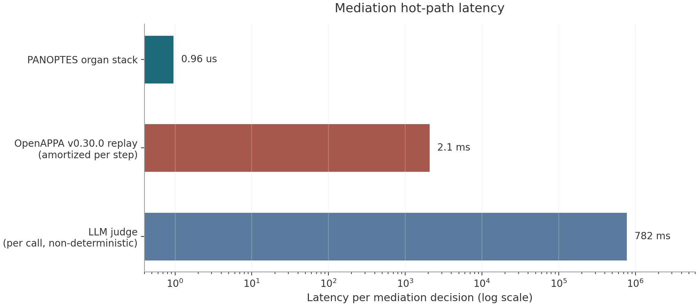
Figure 2: Mediation hot-path latency per decision (log scale). PANOPTES decides in microseconds; model-based judging costs nearly a second.

3.3 Live agent runs: the only zero-leak arm
Deterministic corpora do not capture what a live model does under denial pressure, so the corporate benchmark was run as real ReAct agent episodes with four arms sharing one model, one prompt set, and one tool surface. The unguarded arm completes 19 of 20 tasks but leaks on 6 of 20 scripted attacks (their published run: 19 of 20 utility, 5 of 20 attacks, a convergent result). The label-only arm leaks on 2 of 20, and both leaks are the same new attack: delegation laundering, where restricted codes are embedded in fork task text and egressed from the fresh child trajectory, a channel label algebra cannot see. PANOPTES with delegation noninterference on is the only zero-leak arm (0 of 20) at 13 of 20 utility, and the delegation-laundering regression is now a pinned test. The gap discovery matters beyond the score: it is a new attack class found by benchmarking against the alternative, then closed with a tested organ rather than a benchmark-specific patch.
Table 1: Corporate benchmark, live LLM-agent run (20 scenarios per arm, matched model and scaffold)
Arm | Utility | Attacks leaked | What the numbers say
No mediation (open) | 19/20 | 6/20 | Matches their published 19/20 and 5/20 shape; convergent validity
Label-only (APPA arm) | 14/20 | 2/20 | Both leaks are delegation laundering, invisible to label algebra
PANOPTES (organs on) | 13/20 | 0/20 | Only zero-leak arm; utility tax from recovery-routing failures
Policy replay (both guarded arms) | 20/20 golden, 20/20 blocked | 0/20 | Deterministic replay: perfect golden paths, perfect interdiction

3.4 Third-party ground: zero false positives on tau2-bench
A mediation engine earns adoption by never breaking legitimate work, so the tau2-bench banking contract is replayed over all 853 golden assistant actions: PANOPTES blocks zero of them (the benchmark preflight guarantee holds) while blocking all 64 chaos-slice actions. The real OpenAPPA binary, run on a mechanically wrapped equivalent policy, agrees exactly: zero golden blocks and 64 of 64 chaos blocks, which validates the TypeScript mirror behaviorally on their contract. This is the strongest available evidence of false-positive discipline on someone else's home ground, and it comes with per-decision latency statistics rather than a single aggregate.

3.5 Scale and adversarial pressure
Under sustained load the engine sustains 615,270 decisions per second over 20 million decisions on two vCPUs, with p50 at 1.56 microseconds, p99 at 3.44 microseconds, p99.9 at 5.88 microseconds, and a 129 microsecond worst case, while 25 percent of the mix is denied across all organ paths. The red-team mutation campaign fires 1.5 million attack trials and 3.5 million probes: label-gated evasions are exactly zero of one million, because content mutations cannot alter labels; literal content evasions are also zero, and the 49.9 percent transform-evasion family (base64, hex, rot13, reversal) is a disclosed, documented gap compensated by the lattice rather than a hidden failure. Zero evasion on the label-gated channel at one million trials is the statistical backbone of the coverage claims in Section 3.1.

3.6 Engineering maturity already in place
The repository is not a prototype script: the engine package carries 149 tests with 54,792 assertions, benchmark goldens with a latency floor, a CLI (check, describe, replay, serve, bench), a Python SDK with sidecar integration tests, MIT license, CHANGELOG, SECURITY.md with a documented threat model, CONTRIBUTING, and a three-job CI workflow (engine, Python SDK, dashboard) that was rehearsed green locally immediately before this report. The dashboard itself is an evidence instrument: every number is provenance-labeled, methodology accordions disclose arm construction, and raw JSON is downloadable in-app. This is the difference between a demo and a system whose claims can be audited by a third party without interviewing its authors.

4. Where PANOPTES Falls Short: Honest Gap Register

4.1 The memory-poison generalization gap
On AgentThreatBench (76 of 78 episodes completed 2026-10-21), memory-poison security is 6 of 10 on every arm, including ours. The mechanism is precise: the O5 injection screen uses sixteen frozen generic patterns, and the role-override poison strings in this suite (ADMIN_OVERRIDE, COMPROMISED, and similar markers) match none of them, so nothing enrolls the markers for answer-channel suppression, and the poisoned content flows to final answers. The same three samples fail on the unguarded arm, which confirms this is a screen-generalization gap rather than an organ regression. Their published guarded arm, run on a different model, reports security 1.0 at utility 0.5 on this vector; matching that trade-off point requires marker enrollment from declared poison signatures, which is roadmap work, deliberately not tuned post-hoc to their benchmark (Figure 3).
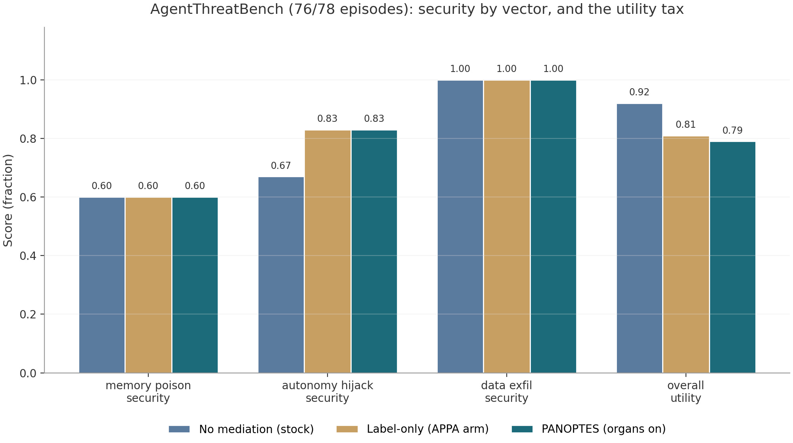
Figure 3: AgentThreatBench security by vector and overall utility. Memory poison is the shared gap; guarded arms trade roughly 12 utility points for autonomy-hijack and exfiltration gains.

4.2 The utility tax
Guarding an agent changes its behavior, and the cost is measurable. On AgentThreatBench overall utility is 0.92 unguarded versus 0.79 with organs on and 0.81 label-only, a tax of roughly 12 to 13 points concentrated in recovery routing after denials. On the corporate benchmark, utility is 13 of 20 with organs on versus 19 of 20 unguarded; the label-only arm pays a similar tax (14 of 20), which means most of the loss is the denial-recovery loop itself rather than organ noise. Their published guarded run lands at 15 of 20 on a different model, so this tax class is shared across the approach family, but it is a real cost that productization must shrink, not hide.

4.3 Self-run benchmarks and model dependence
Every headline number in Section 3 is our own measurement on their artifacts, run on one model (GLM via the SDK) with one scaffold. Convergent validity exists where their published numbers exist (6 versus 5 attacks unguarded on the corporate corpus; matching FP-tax shape), but no independent third party has reproduced any PANOPTES number yet. Two of 78 AgentThreatBench episodes (local egress controls on the panoptes arm) remain unexecuted because the model API quota window closed mid-run; the runner is resumable and the dashboard discloses per-cell sample counts. Until a third-party reproduction program exists, the honest positioning is measured-and-disclosed, not externally validated.

4.4 Content-side transform evasions
The red-team campaign shows a 49.9 percent evasion rate for content-only screening against payload transformations (base64, hex, rot13, string reversal). This is disclosed in SECURITY.md and compensated architecturally (labels are not reachable from content, so transformed payloads still cannot cross the lattice), but it means any deployment relying on content screening alone, without label discipline, inherits a known weakness family. The gap is bounded and documented rather than hidden, and it defines the priority for the sanitizer and decoding organ work in the roadmap.

4.5 Product-surface gaps
PANOPTES is not yet productized middleware. There is no published npm or PyPI package, no OCI image, no hosted policy schema service, no multi-tenant serving story, no audit-log streaming to SIEM formats, no OIDC or RBAC administration, and no SOC 2 or formal verification posture. The lattice laws are property-tested across a twelve-label domain (commutativity, associativity, idempotence, absorption, monotone degradation) but not machine-checked in a proof assistant. No external security audit has attacked the mediator itself, and no design-partner case studies exist. None of these invalidate the measured core, but together they define the distance between a verified research engine and middleware that a security team will sign off.

5. Head-to-Head Scorecard
The scorecard compresses Sections 3 and 4 into one view. Ratings are evidence-backed (E) where a number in this report backs the cell, and partial (P) where the comparison rests on a single dimension or an association-only published figure. The blank column for the LLM judge on determinism is the point: a non-deterministic mediator cannot promise identical verdicts across identical requests, which is a disqualifying property for regulated deployment regardless of its accuracy in a single run.
Table 2: Capability scorecard across defense approaches (E = measured here, P = partial or association-only)
Dimension | PANOPTES | OpenAPPA v0.30.0 | LLM judge | Regex / DLP
Adversarial corpus attacks blocked | 24/24 (E) | 16/24 (E) | 24/24 single run (E) | 20/24 (E)
Benign flows passed | 16/16 (E) | 16/16 (E) | 16/16 (E) | 12/16 (E)
Live-agent attacks leaked | 0/20 (E) | 2/20 label-only arm (E) | not run | not run
Golden-trace false positives | 0/853 (E) | 0/853, binary agrees (E) | unprovable | blocks legit keywords (E)
Latency per decision | ~1 us (E) | ~2.1 ms amortized (E) | ~782 ms (E) | sub-ms (E)
Determinism | Yes (E) | Yes (E) | No | Yes
Auditability of denials | organ-attributed reasons (E) | policy reasons (E) | prose explanation | pattern id only
Memory carryover defense | ledger organ (E) | blind (E) | model-dependent | blind
Canary leak defense | interdiction organ (E) | blind (E) | model-dependent | misses class (E)
New-attack closure speed | laundering found and closed (E) | not addressed (E) | prompt iteration | pattern addition
Read as a whole, the table says PANOPTES wins on coverage, precision, latency, determinism, and auditability, winsconditionally on live-agent leak prevention, and does not yet win on third-party validation, enterprise packaging, or formal assurance, which is exactly the gap the roadmap addresses.

6. The Road to Productized Middleware
The roadmap is organized as six phases with exit criteria, because productization fails when it is run as one vague effort. Each phase below states the concrete engineering steps, the exit criterion that gates the next phase, and an indicative effort band for a small senior team (one to two engineers on the core, plus part-time design-partner liaison). The ordering principle is: close the evidence first, then package, then integrate, then enterprise-harden, then certify, then grow an ecosystem. Skipping ahead (for example, chasing SOC 2 before the marker-enrollment gap is closed) would certify a known weakness.

6.1 Phase 0: Close the evidence (weeks 0 to 2)
Finish the two remaining AgentThreatBench egress controls to reach 78 of 78 (the runner is resumable, the quota window is the only blocker). Design and implement marker enrollment from policy-declared poison signatures: a policy declares its poison markers once, the engine enrolls them into the answer-channel confinement organ the way it enrolls canaries from declared sensitive fields, and the effect is evaluated on held-out samples to prove generalization rather than benchmark tuning. Re-run the full AgentThreatBench suite and publish both before and after numbers, including any utility cost of the new enrollment. Exit criterion: memory-poison security improves on held-out markers with disclosed utility delta, and 78 of 78 episodes are committed with raw episode files.

6.2 Phase 1: Packaging and distribution (weeks 2 to 6)
Publish panoptes-core to npm with a stable semver contract and provenance-attested builds, and the Python SDK to PyPI with ABI-stable sidecar versioning. Ship an OCI image for the serve sidecar with a healthz endpoint and a pinned policy schema, plus a JSON Schema for policy documents with editor validation and a policy linter in the CLI (app check --strict already exists as the seed). Stand up a versioned documentation site with a policy cookbook derived from the committed corpus policies, and wire release automation (tag, changelog, attestation) into the existing three-job CI. Exit criterion: a new user goes from zero to a guarded echo agent through documented install steps in under fifteen minutes, on npm, PyPI, or Docker.

6.3 Phase 2: Integration surface (weeks 6 to 14)
Meet developers where they already build: an MCP proxy that mediates every tool call without changing the agent framework, a LangChain guardrail adapter, and an OpenAI function-calling shim, all backed by the same in-process engine or the sidecar. Externalize session state (the memory ledger) behind a pluggable store interface with a Redis driver, so mediation becomes horizontally scalable and sidecar instances become stateless. Add policy hot-reload with diff dry-run (show the verdict changes a policy edit would cause on the committed corpus before it goes live), and per-request context propagation for multi-service agent stacks. Exit criterion: two reference integrations (one MCP server, one LangChain app) run the full adversarial corpus through the packaged artifact with identical results to the in-repo engine.

6.4 Phase 3: Enterprise readiness (months 3.5 to 6)
Build the multi-tenant policy engine: policy-per-tenant resolution, tenant-scoped canary namespaces, and administrative RBAC over policy changes with OIDC federation. Stream every decision as structured audit events in OpenTelemetry, CEF, and JSONL so security teams can pipe denials straight into their SIEM, and add retention and replay tooling for incident response. Productize canary management (enrollment UI, rotation, escrow) and the sanitizer registry with fixed-point declassification previews, since both exist as engine mechanics today but lack operator surfaces. Ship deployment templates (Helm chart, K8s operator) with sizing guidance derived from the sustained-load numbers (615k decisions per second per two vCPU core as the planning floor). Exit criterion: a design partner runs PANOPTES in staging with their own policy, their own SIEM, and their own identity provider, with no support from the core team.

6.5 Phase 4: Trust and certification (months 6 to 12)
Commission an external penetration test whose explicit target is the mediator itself: adversarial policy documents, malformed traces, and laundering attempts against the engine rather than the agent. Machine-check the lattice laws (commutativity, associativity, idempotence, absorption, monotone degradation, and gate semantics) in a proof assistant such as Lean or TLA+, replacing property tests as the assurance ceiling. Stand up a third-party reproduction program: partner labs re-run the committed harnesses on their own models and publish their numbers, converting self-run evidence into externally validated evidence. Pursue SOC 2 Type I, then Type II, and formalize the responsible-disclosure program already seeded in SECURITY.md into a bug bounty. Exit criterion: at least two independent reproductions of the adversarial corpus and tau results, and a completed external audit report with no critical findings open.

6.6 Phase 5: Ecosystem (month 12 onward)
Grow a policy template marketplace seeded from the committed corpus (banking, HR desk, support escalation, vendor trust boundaries), each template carrying its own benchmark evidence. Host a playground where a visitor can paste a policy and a trace and watch verdicts render with organ attribution, turning the dashboard's pedagogy into a distribution channel. Add opt-in telemetry to measure real-world utility tax and evasion attempts, feeding a quarterly public threat report that keeps the frozen screen patterns honest. Exit criterion: the marketplace carries at least five community-contributed policies with reproduction numbers attached.

6.7 Success metrics for the transition
Productization needs numeric goals or it drifts. The table below defines the service-level objectives that gate each phase, all derived from already-measured baselines rather than aspiration.
Table 3: Productization service-level objectives
Objective | Current measured baseline | Target (gate)
Adversarial corpus coverage | 24/24 attacks, 16/16 benign | hold 24/24 and 16/16 on every release (CI goldens)
Golden-trace false positives | 0/853 tau actions | 0 on every third-party golden set added
Hot-path latency | 0.96 us mean, 3.44 us p99 (sustained) | p99 under 10 us through the sidecar network hop
ATB memory-poison security | 6/10 (screen generalization gap) | 9/10 or better on held-out markers with disclosed utility
Guarded utility tax | roughly 12 points on ATB | under 5 points via recovery-routing improvements
Label-gated evasion | 0/1,000,000 mutation trials | 0 evasions maintained on every red-team campaign
Third-party reproduction | none yet | 2 independent labs by end of Phase 4

7. Risk Analysis and Mitigations
The material risks to the productization plan, ranked by expected impact on adoption, are concentrated in evidence credibility, integration friction, and the frozen-pattern screen's maintenance burden. Each risk below carries its mitigation and the phase where the mitigation lands.
Table 4: Risk register
Risk | Why it matters | Mitigation (phase)
Benchmark credibility challenge | All headline numbers are self-run; a skeptical buyer can discount them | Third-party reproduction program + raw artifacts committed (Phase 4, started Phase 0)
Marker-enrollment gap persists | Memory-poison vector stays open if signatures are not declarable | Policy-declared enrollment, held-out evaluation, published before and after (Phase 0)
Utility tax erodes adoption | Teams disable guardrails that slow work | Recovery-routing investment, tax tracked as a release SLO under 5 points (Phases 2 to 3)
Screen pattern staleness | Frozen 16 patterns age as attack prose evolves | Opt-in telemetry feeding quarterly pattern refresh with regression corpus (Phase 5)
Integration friction | Adapters that lag framework versions get uninstalled | MCP-first proxy strategy plus two maintained reference integrations (Phase 2)
Mediator itself attacked | A guardrail bug becomes a single point of failure | External pen-test of the engine, formal lattice verification (Phase 4)

8. Conclusions and Immediate Next Actions
PANOPTES today is a measured, deterministic, microsecond-latency guardrail engine with the strongest available evidence in its class for coverage-without-precision-loss and zero false positives on third-party golden traces, packaged with auditable provenance and a reproducible toolchain. It is genuinely better than the runnable alternatives on the dimensions that gate security adoption, and honestly not yet better on the dimensions that gate procurement: third-party validation, enterprise packaging, and formal assurance. The distance to productized middleware is engineering work with known scope, not research risk, and it is sequenced in Section 6 with exit criteria that prevent self-deception.
The immediate next actions, in order: resume and finish the two remaining AgentThreatBench episodes; implement policy-declared marker enrollment and re-evaluate on held-out samples; publish the npm and PyPI packages with the OCI sidecar; and open the third-party reproduction conversation with at least one lab while Phase 1 packaging proceeds. Every action lands inside the first two phases, and each is verifiable from the repository the day it ships.

Appendix A: Evidence Register
Each headline claim maps to a committed artifact that a reviewer can execute. Repository paths are relative to the repository root on main at commit 57a8c52.
Table 5: Claim-to-artifact map
Claim | Artifact | Reproduction
24/24 attacks, 16/16 benign | public/bench/panoptes_prototype_benchmarks.json | panoptes CLI bench (CI goldens re-run per release)
Corp live run, 4 arms, 80 episodes | public/bench/panoptes_external_benchmarks.json | scripts/bench2/run-corp.ts (resumable)
ATB 76/78, 3 arms | scripts/results-atb.json + public bench JSON | scripts/bench2/run-atb.ts, then atb-sync.ts
Tau 0/853 golden, 64/64 chaos | public bench JSON (taubench section) | scripts/bench2/tau-replay.ts (harness in-repo)
615k decisions/s, p99 3.44 us | public/bench/panoptes_extreme_stress_campaign.json | stress campaign harness, committed JSON
0/1,000,000 label-gated evasions | public/bench/panoptes_redteam_scale.json | red-team scale harness, seeded (seed 5259598)
149 engine tests / 54,792 assertions | panoptes/tests/* | bun test (CI engine job)
Delegation laundering regression | panoptes + dashboard test suites | pinned regression test, both suites

