Classic IIR order-2 filter
The classic IIR order-2 filter, also known as biquad, is an effective software implementation. It is morean effective to implement high-order IIR filters as cascades of biquad than implementing them directly. See https://en.wikipedia.org/wiki/Digital_biquad_filter for reference. However, this implementation is not well suited for high-speed FPGA implementation.

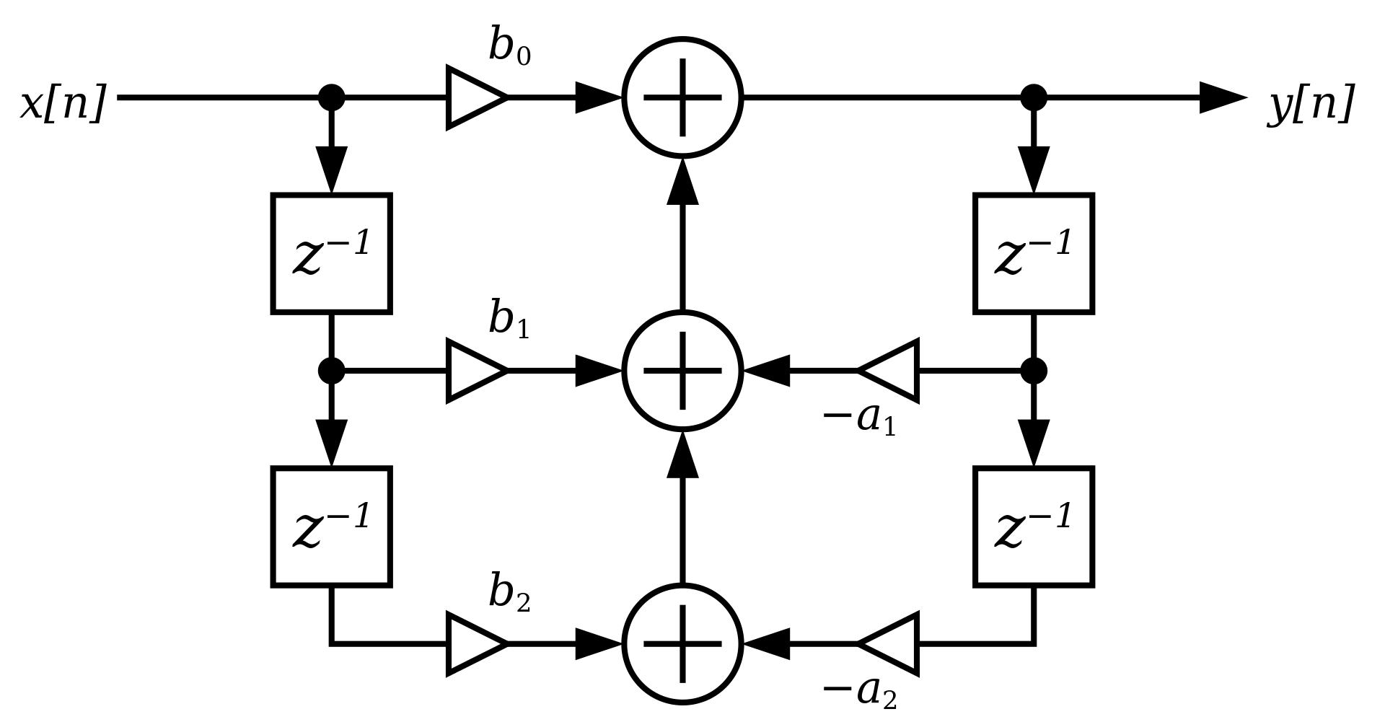

FPGA implementation problems

A fully-pipelined IIR filter running at 100 Msamples/s (100 Mhz ) would have trouble meeting timing closure as there are multiple combinational delays between y[n] and x[n]. Adding delays (flip-flops) in the FIR part is feasible, as it will only add a delay to the output, however adding a delay in the feedback chain (right-hand half) will change the transfer function and thus defeat the purpose as the new pipelined filter will not have the expected transfer function.

Scattered look-ahead pipelining
A technique exists to pipeline IIR filters. However, it requires to change the transfer function by increasing the order from 2, to 4 or 6 or 8. The schematic below shows a pipelined implementation where the order has been increased to 6.

