《并行程序设计》
实验报告

学号：201530613825
姓名：钟宇健
班级：卓越班

2018/07/10

华南理工大学本科实验报告
课程名称 并行程序设计 成绩评定
实验项目名称MPI+OpenMP实现PSRS排序实验 指导教师 汤德佑 实验地点 B7-233
学生姓名 钟宇健 学号 201530613825
学院 软件学院 系 软件工程 专业 软件工程
实验时间 2018 年 7 月 1 日 上 午～ 7 月 10 日 上 午
1、实验目标
（1）在天河超算上运行MPI+OpenMP实现的PSRS算法，并对80G的double数据进行排序；
2、串行程序代码
采用STL的sort进行排序
3、并行程序关键代码
（1）分段读取数据，并排好序
由于内存不足，不能一次将80G的数据加载如内存，采用分段读取数据的方法，每次读取80G / rounds的数据，使用MPI+OpenMP的PSRS排序算法进行排序，然后将结果保存到temp文件夹中，作为归并段。
（2）归并排序
将上述的各个归并段通过另一个程序进行归并排序，最终得出结果，但由于时间关系，没有实现该部分。
OpenMP:
void PSRS(double *numbers, size_t n, size_t p)
{
if (p <= 0)
{
return;
}
else if (p == 1)
{
sort(numbers, numbers + n);
return;
}
// 每段数据的长度，最后一段可能会不一样
size_t offset = n / p;
// 为正则采样分配空间
double *sample = new double[p * p];

#pragma omp parallel num_threads(p)
{
size_t thread_num = omp_get_thread_num();
// 计算出每个线程需要处理的段的起始和终点位置，以及处理的长度
size_t start_index = thread_num * offset;
size_t end_index = (thread_num + 1) * offset;
end_index = thread_num == p - 1 ? n : end_index;
size_t length = end_index - start_index;

sort(numbers + start_index, numbers + end_index);

// 计算出每个线程存放采样数据的起始位置和采样间隔，每个线程都能获取p个数据
size_t sample_start_index = thread_num * p;
size_t sample_offset = length / p;
for (size_t i = 0; i < p; i++)
{
sample[sample_start_index++] = numbers[start_index + i * sample_offset];
}
}
#pragma omp barrier

sort(sample, sample + p * p);

// 选择主元，存放在刚刚存放采样数据的前面，节省空间
for (size_t i = 0; i < p - 1; i++)
{
sample[i] = sample[(i + 1) * p];
}

// 暂时存放最终结果的数组
double *result_temp = new double[n];
// 存放主元划分后的分界，p组，每组p个，最后一个为段结束的index
size_t *slice_indices = new size_t[p * p];
// 记录每个段有多长，用于拷贝数据
size_t *segment_length = new size_t[p]();

#pragma omp parallel num_threads(p)
{
size_t thread_num = omp_get_thread_num();
size_t start_index = thread_num * offset;
size_t end_index = (thread_num + 1) * offset;
end_index = thread_num == p - 1 ? n : end_index;

size_t sample_index = 0;
const size_t slice_start_index = thread_num * p;

// 将每一段数据按照主元划分成小段，记录分界index
for (size_t i = start_index; i < end_index; i++)
{
if (numbers[i] > sample[sample_index])
{
do
{
slice_indices[slice_start_index + sample_index++] = i;
} while (numbers[i] > sample[sample_index] && sample_index < p - 1);

if (sample_index == p - 1)
break;
}
}
while (sample_index < p)
{
slice_indices[slice_start_index + sample_index++] = end_index;
}

#pragma omp barrier
#pragma omp master
{
for (size_t i = 0; i < p; i++)
{
for (size_t j = 0; j < p; j++)
{
if (i == 0 && j == 0)
segment_length[0] += slice_indices[0];
else
{
segment_length[i] += slice_indices[j*p + i] - slice_indices[j*p + i - 1];
}
}
}

for (size_t i = 1; i < p; i++)
{
segment_length[i] += segment_length[i - 1];
}
}

#pragma omp barrier

size_t result_start_index = thread_num == 0 ? 0 : segment_length[thread_num - 1];
size_t result_start_index_backup = result_start_index;
vector<size_t> segment_start_indices;

for (size_t i = 0; i < p; i++)
{
size_t copy_start_index = thread_num == 0 && i == 0 ? 0 : slice_indices[i * p + thread_num - 1];
size_t copy_end_index = slice_indices[i * p + thread_num];
size_t length = copy_end_index - copy_start_index;
if (length != 0)
{
segment_start_indices.push_back(result_start_index);
memcpy(result_temp + result_start_index, numbers + copy_start_index, length * sizeof(double));
result_start_index += length;
}
}
size_t result_end_index = result_start_index;
result_start_index = result_start_index_backup;
#pragma omp barrier

vector<size_t> points(segment_start_indices);
double min = INT_MAX;
size_t *min_index = NULL;
size_t count = 0;
size_t length = result_end_index - result_start_index;

while (count < length)
{
size_t i = 0;
for (; i < points.size() - 1; i++)
{
if (points[i] < segment_start_indices[i + 1] && result_temp[points[i]] < min)
{
min = result_temp[points[i]];
min_index = &points[i];
}
}
if (points[i] < result_end_index && result_temp[points[i]] < min)
{
min = result_temp[points[i]];
min_index = &points[i];
}

count++;
numbers[result_start_index++] = min;
(*min_index)++;
min = INT_MAX;
}
}

delete[] sample;
delete[] slice_indices;
delete[] segment_length;
delete[] result_temp;
}
MPI:
void PSRS(const char* dataFilePath, const size_t n, const size_t data_start_offset, const size_t process_num, const size_t process_count, const size_t thread_num, const size_t curr_round, const size_t total_round)
{
MPI_Request request;

/// 1. 均匀划分
size_t number_length_in_per_process = n / process_count;
size_t number_length_in_curr_process = process_num == process_count - 1 ? n - number_length_in_per_process * process_num : number_length_in_per_process;

// 每个进程读取属于自己的一段数据
MPI_File fh;
size_t ierr;
ierr = MPI_File_open(MPI_COMM_WORLD, dataFilePath, MPI_MODE_RDONLY, MPI_INFO_NULL, &fh);

if (ierr)
{
printf("Cannot Open file %s\n", dataFilePath);
MPI_Finalize();
exit(-1);
}

MPI_Status status;
double *numbers_in_curr_process = new double[number_length_in_curr_process];
MPI_File_seek(fh, data_start_offset + sizeof(double) * number_length_in_per_process * process_num, MPI_SEEK_SET);
MPI_File_read(fh, numbers_in_curr_process, number_length_in_curr_process, MPI_DOUBLE, &status);
MPI_File_close(&fh);
//DisplayArray(numbers_in_curr_process, number_length_in_curr_process);

//double start_time = MPI_Wtime();

/// 2. 局部排序
//sort(numbers_in_curr_process, numbers_in_curr_process + number_length_in_curr_process);
PSRS(numbers_in_curr_process, number_length_in_curr_process, thread_num);

//DisplayArray(numbers_in_curr_process, number_length_in_curr_process);

/// 3. 正则采样
double *sample = NULL;
double *temp = new double[process_count];

// 现在temp用于存放各个进程自己的采样，长度process_count
size_t sample_offset = number_length_in_curr_process / process_count;
for (size_t i = 0; i < process_count; i++)
{
temp[i] = numbers_in_curr_process[i * sample_offset];
}

if (process_num == 0)
{
// 主进程负责从各个进程中接收采样，存在sample中
sample = new double[process_count * process_count];
memcpy(sample, temp, process_count * sizeof(double));

for (size_t i = 1; i < process_count; i++)
{
MPI_Recv(sample + i * process_count, process_count, MPI_DOUBLE, i, 0, MPI_COMM_WORLD, MPI_STATUS_IGNORE);
}

/// 4. 采样排序
sort(sample, sample + process_count * process_count);
//DisplayArray(sample, process_count * process_count);

/// 5. 选择主元
// 现在temp用于存放主元数据，长度process_count - 1
for (size_t i = 0; i < process_count - 1; i++)
{
temp[i] = sample[(i + 1) * process_count];
}

// 主进程向各个进程发送主元
for (size_t i = 1; i < process_count; i++)
{
MPI_Isend(temp, process_count - 1, MPI_DOUBLE, i, 0, MPI_COMM_WORLD, &request);
}
}
else
{
// 非主进程先发送自己的采样，然后从主进程处接收主元信息

// 现在temp存放各个进程自己的采样，长度process_count
MPI_Send(temp, process_count, MPI_DOUBLE, 0, 0, MPI_COMM_WORLD);
// 现在temp存放主进程发送的主元，长度process_count - 1
MPI_Recv(temp, process_count - 1, MPI_DOUBLE, 0, 0, MPI_COMM_WORLD, MPI_STATUS_IGNORE);
}

DisplayArray(temp, process_count - 1);

/// 6. 主元划分
size_t flag_index = 0;
// 现在temp记录numbers_in_curr_process中第一个比主元大的数的下标，长度process_count
for (size_t i = 0; i < number_length_in_curr_process; i++)
{
if (numbers_in_curr_process[i] > temp[flag_index])
{
do
{
temp[flag_index++] = i;
} while (numbers_in_curr_process[i] > temp[flag_index] && flag_index < process_count - 1);

if (flag_index == process_count - 1)
break;
}
}
// 剩下的记为number_length_in_curr_process
while (flag_index < process_count)
{
temp[flag_index++] = number_length_in_curr_process;
}

//DisplayArray(temp, process_count);
// 现在temp记录每段的长度，长度process_count
for (size_t i = process_count - 1; i > 0; i--)
{
temp[i] -= temp[i - 1];
}
//DisplayArray(temp, process_count);

// 将对应段的长度发送给对应的进程，给自己的不发送
int *receive_data_length = new int[process_count]();
for (size_t i = 0; i < process_count; i++)
{
if (i != process_num)
{
MPI_Isend(temp + i, 1, MPI_DOUBLE, i, 0, MPI_COMM_WORLD, &request);
}
}

receive_data_length[process_num] = temp[process_num];
int *displs = new int[process_count]();
for (size_t i = 0; i < process_count; i++)
{
if (i != process_num)
{
double temp;
MPI_Recv(&temp, 1, MPI_DOUBLE, i, 0, MPI_COMM_WORLD, MPI_STATUS_IGNORE);
receive_data_length[i] = temp;
}
if (i < process_count - 1)
displs[i + 1] = displs[i] + (int)receive_data_length[i];
}

//DisplayArray(receive_data_length, process_count);
//DisplayArray(displs, process_count);

////DisplayArray(temp, process_count);
////DisplayArray(receive_data_length, process_count);

/// 7. 全局交换
size_t result_length = 0;
for (size_t i = 0; i < process_count; i++)
{
result_length += (size_t)receive_data_length[i];
}
double *result_temp = new double[result_length];

// 将数据发到对应进程
for (size_t i = 0; i < process_count; i++)
{
// 计算当前进程发送数据的offset
size_t offset = 0;
for (size_t j = 0; j < i; j++)
{
offset += temp[j];
}
// i进程收，其他进程发
MPI_Gatherv(numbers_in_curr_process + offset, (int)temp[i], MPI_DOUBLE, result_temp, receive_data_length, displs, MPI_DOUBLE, i, MPI_COMM_WORLD);
}

//DisplayArray(result_temp, result_length);

/// 8. 归并排序
vector<size_t> points(displs, displs + process_count);
double min = INT_MAX;
size_t *min_index = NULL;
size_t count = 0;
numbers_in_curr_process = new double[result_length];

while (count < result_length)
{
for (size_t i = 0; i < points.size(); i++)
{
int next_index = i == points.size() - 1 ? result_length : displs[i + 1];
if (points[i] < next_index && result_temp[points[i]] < min)
{
min = result_temp[points[i]];
min_index = &points[i];
}
}

numbers_in_curr_process[count++] = min;
(*min_index)++;
min = INT_MAX;
}

//DisplayArray(numbers_in_curr_process, result_length);

/// 通知各个进程自己的result长度
vector<size_t> result_length_in_each_process(process_count);
for (size_t i = 0; i < process_count; i++)
{
if (i != process_num)
{
MPI_Isend(&result_length, 1, MPI_INT, i, 0, MPI_COMM_WORLD, &request);
}
}

for (size_t i = 0; i < process_count; i++)
{
if (i == process_num)
{
result_length_in_each_process[i] = result_length;
}
else
{
MPI_Recv(&result_length_in_each_process[i], 1, MPI_INT, i, 0, MPI_COMM_WORLD, MPI_STATUS_IGNORE);
}
}

/// 各个进程将自己的结果写入临时文件
size_t start_index = 0;
for (size_t i = 0; i < process_num; i++)
{
start_index += result_length_in_each_process[i];
}
char temp_file_name[100];
sprintf(temp_file_name, "temp/data_%d", curr_round);
MPI_File_open(MPI_COMM_WORLD, temp_file_name, MPI_MODE_CREATE | MPI_MODE_WRONLY, MPI_INFO_NULL, &fh);
MPI_File_write_at_all(fh, start_index * sizeof(double), numbers_in_curr_process, result_length, MPI_DOUBLE, &status);
MPI_File_close(&fh);

delete[] sample;
delete[] temp;
delete[] receive_data_length;
delete[] result_temp;
delete[] displs;
delete[] numbers_in_curr_process;
}

4、性能分析（取进程运行时间最大值，运行时间包括读取文件和写入文件的时间）
由于运行程序时间过长会被强制kill掉，所以将整个过程分为了几个流程进行，而且要设置一定进程数。由于文件读写时间过长，下面只选择几类进程线程组合进行测试。由于时间关系，只做了MPI+OpenMP进行PSRS排序部分，归并部分暂时没有实现。
初始进程数：16
Round：8
初始线程数：1
排序结果可通过ReadData程序查看（ReadData 文件名 查看double的个数）
中间输出的数字是选择主元后的主元结果
（1）十六进程单线程（总时间：654.36s）
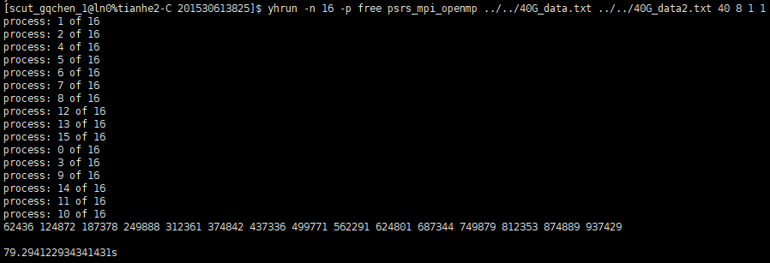
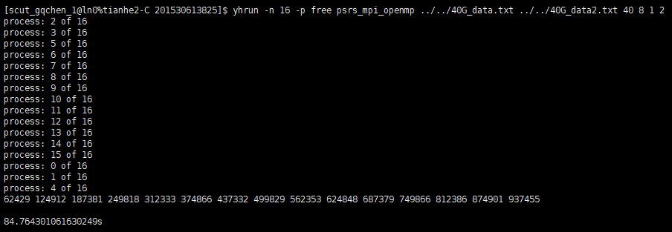
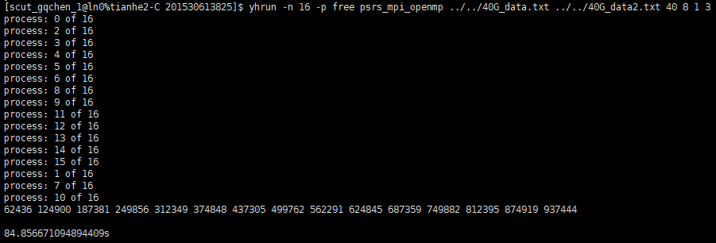
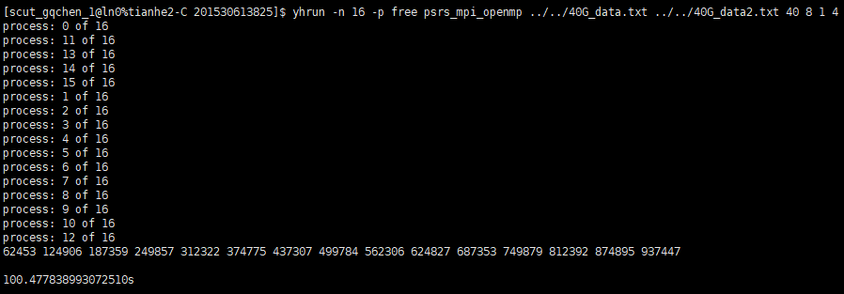
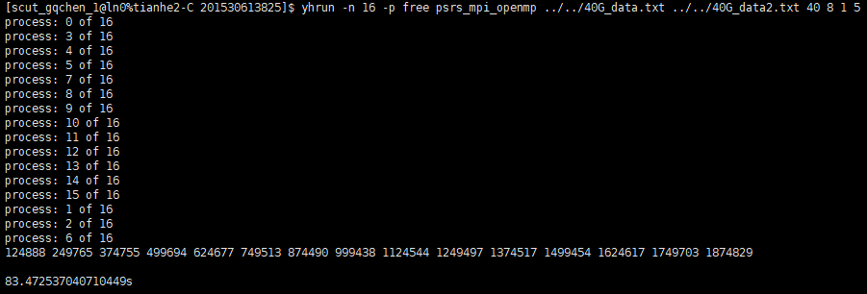
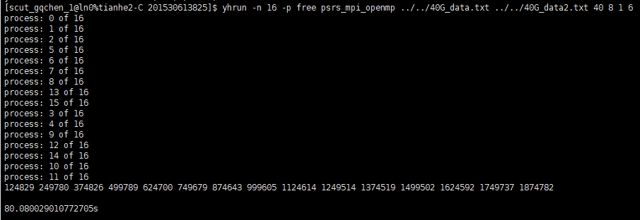
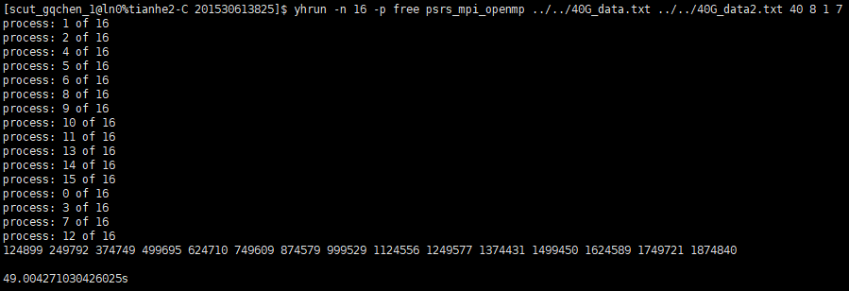
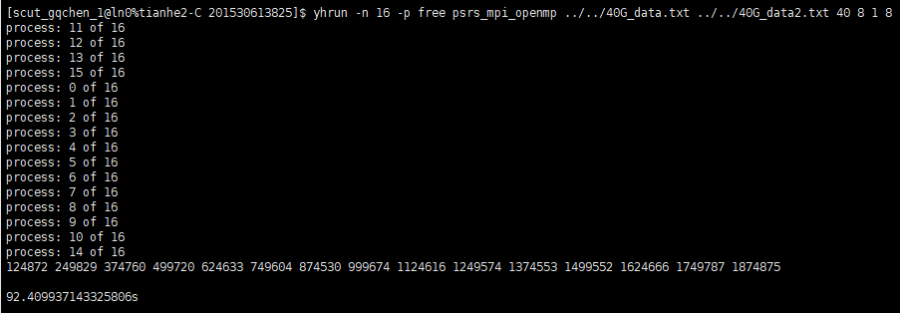
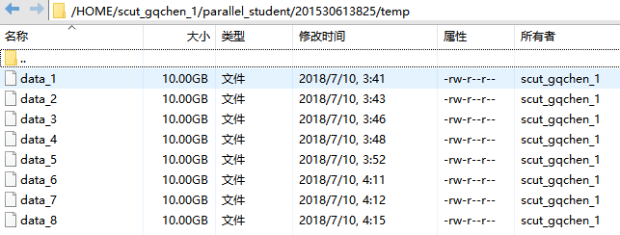
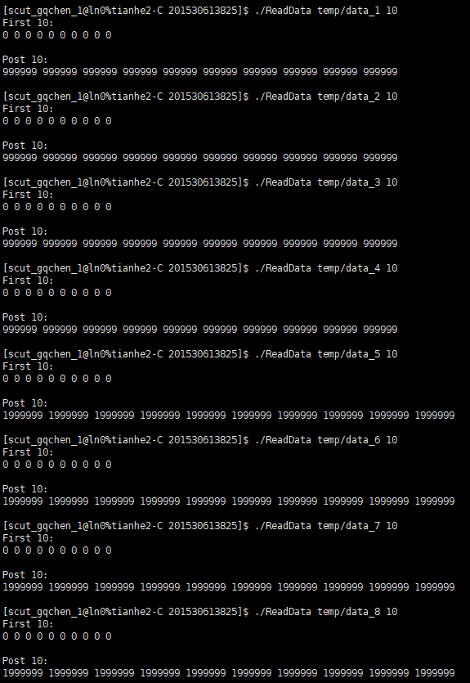
（2）三十二进程三十二线程（总时间：346.45s）
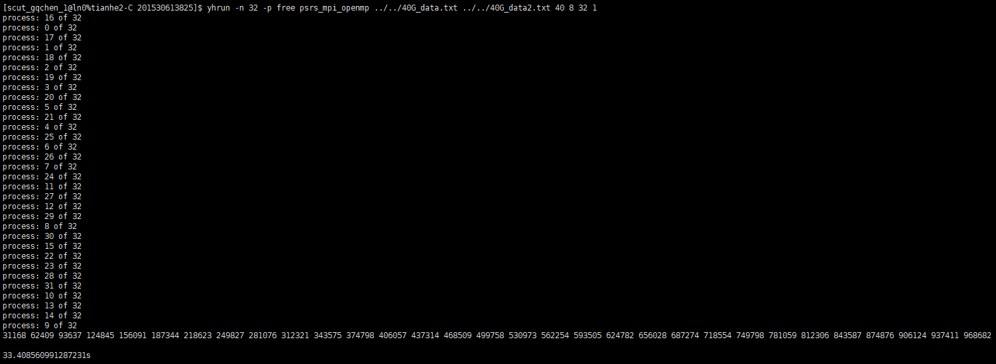
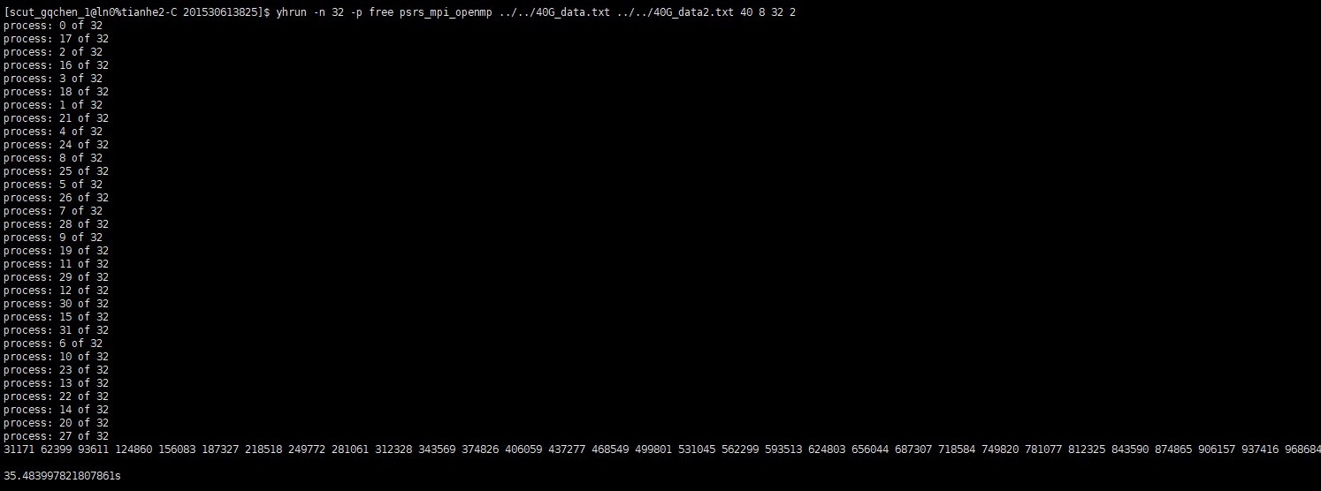
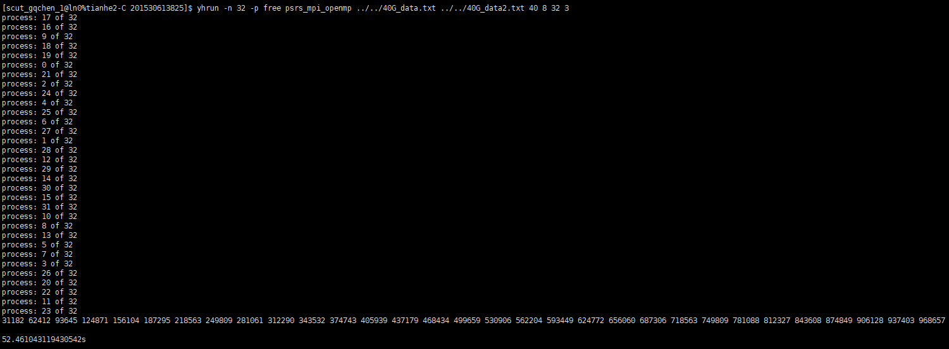
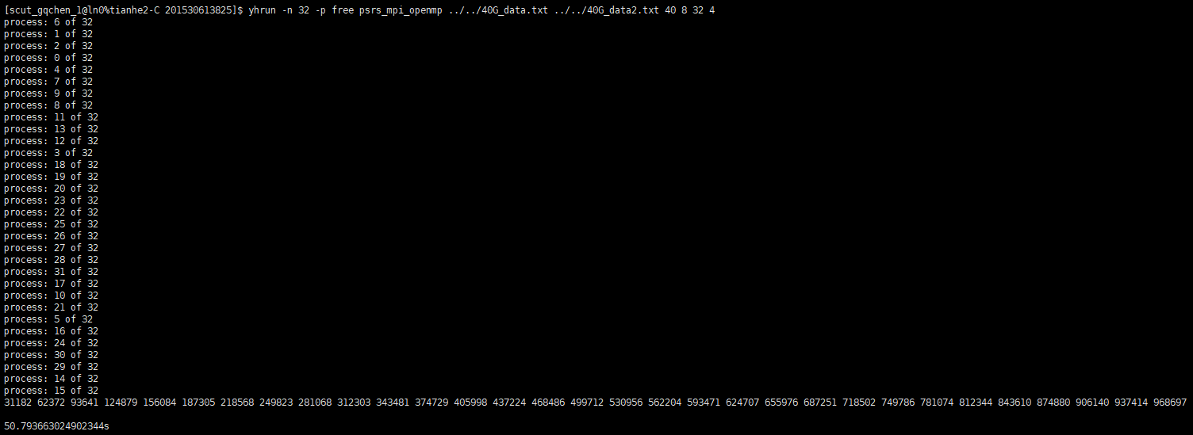
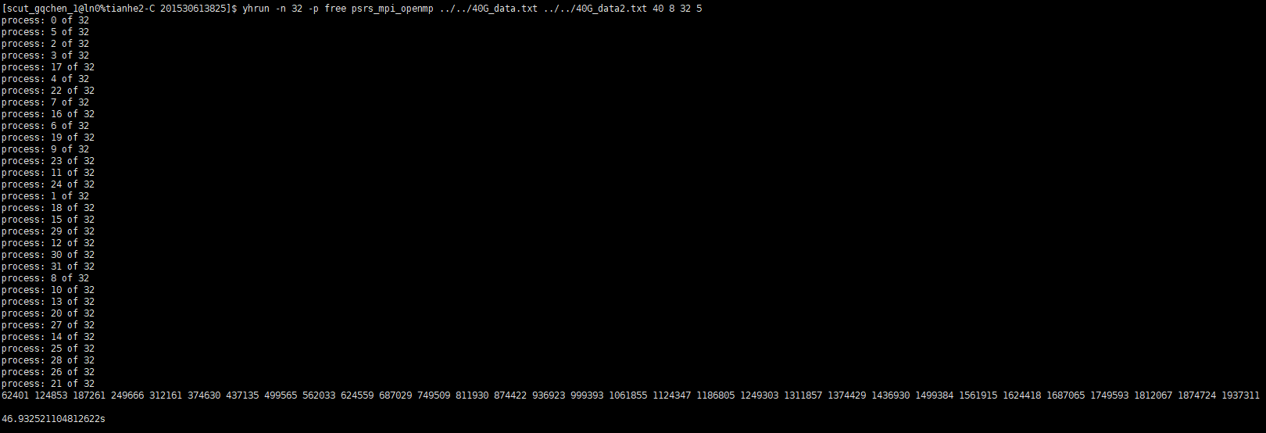
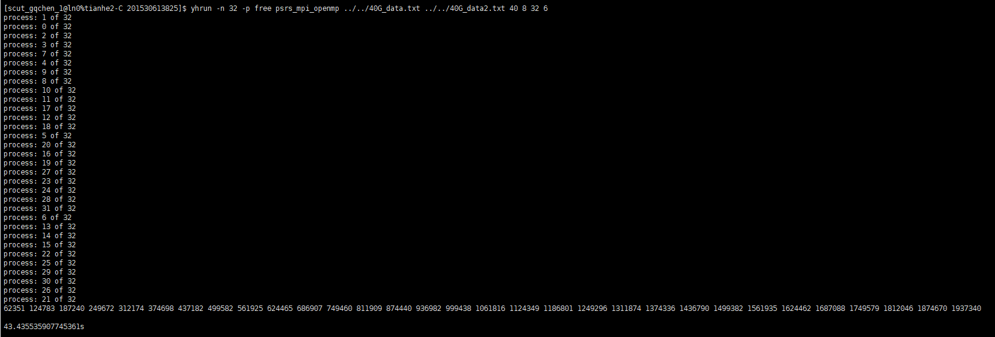
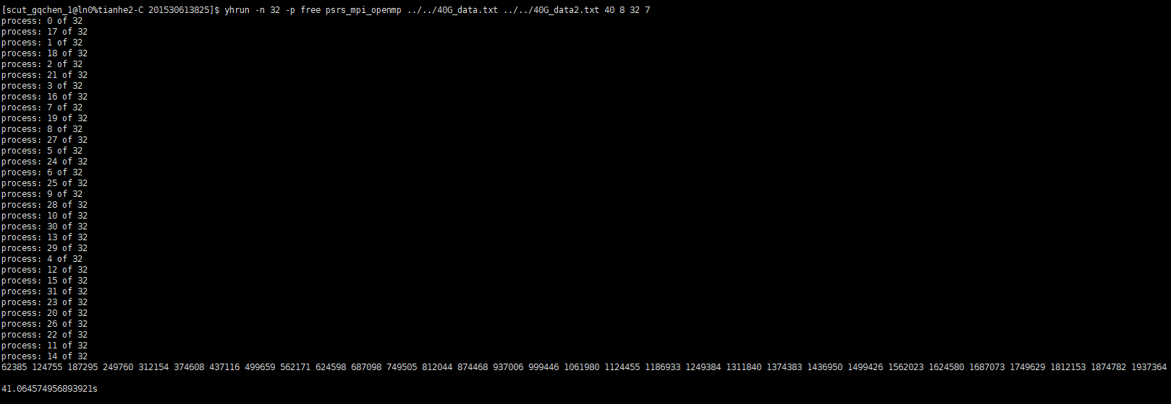
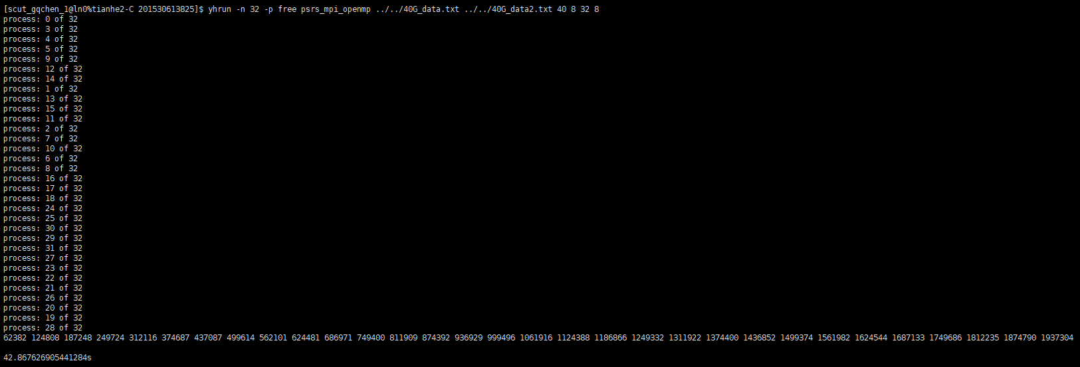
（3）六十四进程三十二线程
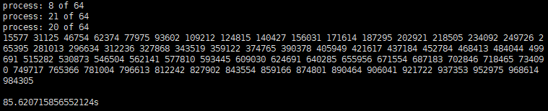
比之前都慢，下面的段就不进行测试了

5、总结
（1）增加进程比增加线程加速效果更明显
（2）当进程增加到一定数量时，程序运行时间基本没多大变化
（3）通过这次实验，我学会了如何使用MPI和OpenMP一起对程序进行加速
6、附件
Source.cpp 源码
ParallelExperiment-3.exe Release程序

